Social Investment and Local Development Project

(Additional Financing)

Component 1

FINAL ENVIRONMENTAL AND SOCIAL REVIEW CHECKLIST

Micro-project title: Construction of Community Center in Alagyaz

Micro-project #: AFT-AN-02

Is the Environmental and Social management plan (ESMP) developed?
Yes + No _____

Does ESMP provide a full list of potential impacts and establish adequate measures for their mitigation?
Yes + No _____

Conclusion of the Final Environmental and Social Assessment

Conclusion
Micro-project rejected | Micro-project approved (environmental assessment completed)
 | +

PART A: General Project and Site Information
INSTITUTIONAL & ADMINISTRATIVE
Country | Armenia
Project title | Social Investment and Local Development Project
Micro-project number and title | AFT-AN-02, Construction of Community Center in Alagyaz
Municipality, community | Aragatsotn region, Alagyaz community
Scope of site-specific activity | The total construction area is estimated at 696 m². The community center is designed to be a one-story building, divided into three sections/parts according to functional specificity:  1. Entrance section. The ceiling height will be 3.8m, the entrance, hall/foyer and toilets will be located in this building. The building will have metal tile roofing.  2. Hall building. The ceiling height will be 5.0m, in this building there will be 2 halls and a dressing room (intended for women). The roof will be made of metal trusses, sandwich panels, and will be lined from the inside with plasterboard. The height of the ceiling of the hallway and dressing room will be 3.8m.  3. Kitchen building. The ceiling height will be 3.0m, the kitchen, warehouses, administrative and service staff area and the boiler room will be located here. The cover will be made of reinforced concrete; the roof will be made of metal tiles.  The external walls will be 20 cm thick and have a 10 cm thermal insulation layer, lined with natural stone tiles.  In the building, a dead-end two-pipe bottom supply water heating system with artificial circulation is planned. In the halls and kitchen of the building, ventilation input and output systems with mechanical push are planned to be constructed. Air input and output will be carried out with 3 sets of ventilation units.  It is planned to construct the water supply (105m pipeline/ DN50 (63x5, 8)) and sewerage systems. Drinking water will be taken from the existing pipe line running at a distance of 50 meters.  Wastewater from the building will be removed through the pipeline to the yard, then to the sewage treatment unit, after which the effluent will be collected in the drainage well. In case excessive effluent accumulates in the drainage well, it will be removed with a specialized cleaning vehicle. The sewage biological treatment unit with a capacity of 15.0 cubic meters will be installed. It is a factory-made underground structure made of polypropylene jets.  An automatic fire suppression system will be installed in the building.  The building will be heated with gas boiler units. The gas supply from the connection point to the building will be carried out by a pipeline with a total length of 97 lm (d=25x2.5/20lm, d=48x3/70lm, 89x3.5=7lm).
Institutional arrangements (WB) | Task Team Leader:  Ivan Drabek |  | Safeguards Specialist:  Environment – Darejan Kapanadze  Social – David Jijelava
Implementation arrangements (RoA) | Implementing entity:  ATDF  Environment - Asya Osipova  Social - Knarik Grigoryan | Works Supervisor:  (to be provided after supervisor is selected) |  | Works Contractor:  (to be provided after construction contractor is selected)
SITE DESCRIPTION
Name of institution whose assets are to be rehabilitated | Alagyaz Community
Address and site location | 2nd street of Alagyaz village of Alagyaz community of Aragatsotn marz.
Who owns the land? | The land plot (cadastral code: 02-006-0013-0007) allocated for the Community Center construction is community owned. The area of the land plot is 0.57293 ha. The proposed land plot is not formally or informally used for any private purposes. No private lands will be used during the construction period for parking of construction machinery or any other purpose. No impacts are anticipated on the private lands. The Micro-project will not reduce other people’s access to their economic resources, such as land, pasture, water, public services or other resources that they depend on. The Micro-project will not result in the temporary or permanent loss of crops, fruit trees and household infra-structure.
Description of physical and natural environment around the site | Alagyaz community and its surrounding areas are located at the foot of the relatively low slope of the north-eastern Aragats mountain and are covered mainly by rocks formed by the volcanic flows and eruptions of the Aragats mountain.  According to the "Construction Climatology" (CNRA II-7.01-2011), the area is located in the cold climate region. There are very cold winters and cool summers. The absolute maximum air temperature is +33⁰C. And the absolute minimum temperature is -34⁰C. The amount of annual precipitation reaches 723 mm.  The proposed construction site is located in the center of the Alagyaz community. There are not residential buildings and vegetation on the territory. On the right side is an unused concrete, low structure that will be removed by the local authorities. The project does not provide for the removal and storage of the top layer of soil. The school and cultivated private lands are located in the vicinity of the land plot. The school is located on the same side of the main road in 80 m distance from the land plot.  No impacts are anticipated on the private lands. To ensure the safety of children, staff, and other residents of the community during the construction period traffic regulation and safety measures (see Part C) will be applied at the construction site.  There is no historical building or a natural protected area in the neighborhood.
LEGISLATION
National & local legislation & permits that apply to project activity | The following Armenian legislation defines a legal framework applicable to project activities:  - Law on Atmospheric Air Protection of RoA (1994)  The purpose of Law on Atmospheric Air Protection is to define the main principles of the RoA, directed to the provision of purity of atmospheric air and improvement of air quality, prevention, and mitigation of the chemical, physical, biological and other impacts on air quality and regulation of public relation. This Law also regulates the emission licenses and provides maximum allowed loads/concentrations for atmospheric air pollution, etc.  According to this law, the contractor shall undertake construction activities as well as transportation and temporary storage of waste the way to minimize dust and other emissions.  - Law on Waste of RoA (2004)  The law provides the legal and economic basis for the collection, transportation, disposal, treatment, re-use of wastes as well as prevention of negative impacts of waste on natural resources, human life, and health. The law defines the roles and responsibilities of the state authorized bodies as well as of waste generator organizations in waste management operations.  According to this law, the waste generated from construction activities should be recycled as appropriate or disposed of in designated locations.  Disposal of the construction waste and excess material in selected locations must be approved by the local municipality in writing.  - Law on Environmental Impact Assessment and Expertise of RoA (2014)  The law defines the type of activities that are subject to environmental impact assessment and environmental expertise.  According to this law, the proposed works are not subject to state environmental impact assessment and expertise.  - Law on Urban Development of RoA (1998)  According to this law, planned works require obtaining a construction permit.
PUBLIC CONSULTATION
When / where the public consultation process will take /took place | The draft ESMP was disclosed and discussed at the public consultation meeting held on October 13, 2022, with the participants from Alagyaz community.  Draft ESMP was disclosed on the ATDF website (www.atdf.am) and the beneficiary's website (www.alagyaz.am). Brief information on the planned works and contact information for addressing questions and grievances will be placed on the information board of Alagyaz community, at the worksite and/or in its immediate surroundings.
ATTACHMENTS
Attachment 1: Photos and plan of the construction site
Attachment 2: Copy of an agreement for construction waste disposal
Attachment 3: Copy of the ownership certificate
Attachment 4: Minutes of the public consultation of the ESMP
Attachment 5: Copy of the Construction Permit (to be provided)

PART B: safeguards information
ENVIRONMENTAL /SOCIAL SCREENING
Will the site activity include/involve any of the following? | Activity/Issue | Status | Triggered Actions
Will the site activity include/involve any of the following? | - Reconstruction | [ ] Yes [+] No | If “Yes”, See Section A below
Will the site activity include/involve any of the following? | - New construction | [+] Yes [ ] No | If “Yes”, See Section A below
Will the site activity include/involve any of the following? | - Individual wastewater treatment system | [+] Yes [ ] No | If “Yes”, See Section B below
Will the site activity include/involve any of the following? | - Historic building(s) and districts | [ ] Yes [+] No | If “Yes”, See Section C below
Will the site activity include/involve any of the following? | - Acquisition of land | [ ] Yes [+] No | If “Yes”, See Section D below
Will the site activity include/involve any of the following? | - Hazardous or toxic materials | [ ] Yes [+] No | If “Yes”, See Section E below
Will the site activity include/involve any of the following? | - Impacts on forests and/or protected areas | [ ] Yes [+] No | If “Yes”, See Section F below
Will the site activity include/involve any of the following? | - Handling / management of medical waste | [ ] Yes [+] No | If “Yes”, See Section G below
Will the site activity include/involve any of the following? | - Traffic and Pedestrian Safety | [+] Yes [ ] No | If “Yes”, See Section H below
 | - Social risk | [+] Yes [ ] No | If “Yes”, See Section I below
PART C: Mitigation measures
ACTIVITY | PARAMETER | MITIGATION MEASURES (provide costs where applicable)
0. General Conditions | Notification and Worker Safety | - The local construction and environment inspectorates and communities have been notified of upcoming activities  - The public has been notified of the works through appropriate notifications in the media and/or at publicly accessible sites (including the site of the works)  - All legally required permits have been acquired for construction  - The Contractor formally agrees that all work will be carried out in a safe and disciplined manner designed to minimize impacts on neighboring residents and environment.  - Workers’ PPE will comply with international good practice (always hardhats, as needed masks and safety glasses, harnesses and safety boots)  - Appropriate signposting of the sites will inform workers of key rules and regulations to follow.
A. General Construction Activities | Air Quality | - During interior demolition, debris chutes shall be used above the first floor  - Demolition debris shall be kept in controlled area and sprayed with water mist to reduce debris dust  - During pneumatic drilling/wall destruction dust shall be suppressed by ongoing water spraying and/or installing dust screen enclosures at site  - The surrounding environment (sidewalks, roads) shall be kept free of debris to minimize dust  - There will be no open burning of construction / waste material at the site  - There will be no excessive idling of construction vehicles at sites
A. General Construction Activities | Noise | - Construction noise will be limited to restricted times agreed to in the permit  - During operations the engine covers of generators, air compressors and other powered mechanical equipment shall be closed, and equipment placed as far away from residential areas as possible
A. General Construction Activities | Water Quality | - The site will establish appropriate erosion and sediment control measures such as e.g. hay bales and / or silt fences to prevent sediment from moving off site and causing excessive turbidity in nearby streams and rivers.
A. General Construction Activities | Waste Management | - Waste collection and disposal pathways and sites will be identified for all major waste types expected from demolition and construction activities.  - Mineral construction and demolition wastes will be separated from general refuse, organic, liquid and chemical wastes by on-site sorting and stored in appropriate containers.  - Construction waste will be collected and disposed properly by licensed collectors  - The records of waste disposal will be maintained as proof for proper management as designed.  - Whenever feasible the contractor will reuse and recycle appropriate and viable materials (except asbestos)
A. General Construction Activities | Earth Works | - Excess material and topsoil generated from earth works will be stored separately and used for backfilling and site reinstatement  - Topsoil layer not thicker than 30 m will be stripped separately and temporary piled on-site  - Stockpile height will not exceed 3.0 m, and the slope angle will not exceed 34º  - Temporary stockpile will be compacted and covered with a tarp to prevent erosion caused by rain runoff  - Topsoil will be re-used for backfilling to facilitate re-cultivation of the land plot  - Excess amount of subsoil will be disposed at the agreed-upon locations.
B. Individual wastewater treatment system | Water Quality | - The approach to handling sanitary wastes and wastewater from building sites (installation or reconstruction) must be approved by the local authorities  - Before being discharged into receiving waters, effluents from individual wastewater systems must be treated in order to meet the minimal quality criteria set out by national guidelines on effluent quality and wastewater treatment  - Monitoring of new wastewater systems (before/after) will be carried out  - Construction vehicles and machinery will be washed only in designated areas where runoff will not pollute natural surface water bodies.
H. Traffic and pedestrian safety | Direct or indirect hazards to public traffic and pedestrians because of construction  activities | - In compliance with national regulations the Contractor will insure that the construction site is properly secured and construction related traffic is regulated. This includes but is not limited to:  - Signposting, warning signs, barriers and traffic diversions: site will be clearly visible and the public warned of all potential hazards;  - Traffic management system and staff training, especially for site access and near-site heavy traffic;  - Provision of safe passages and crossings for pedestrians where construction traffic interferes;  - Adjustment of working hours to local traffic patterns, e.g. avoiding major transport activities during rush hours or times of livestock movement;  - If required, active traffic management by trained and visible staff at the site for safe passage for the public.  - Ensuring safe and continuous access to all adjacent office facilities, shops and residences during construction.
I. Social risk | Public relationship management | - Consult local communities to identify and proactively manage potential conflicts between an external workforce and local people  - Raise local community awareness about sexually transmitted disease risks associated with the presence of an external workforce and include local communities in awareness activities.  - Inform the population about construction and work schedules, interruption of services, traffic detour routes and provisional bus routes, blasting and demolition, as appropriate.  - Limit construction activities at night. When necessary, ensure that night work is carefully scheduled, and the community is properly informed, so they can take necessary measures.  - At least five days in advance of any service interruption (including water, electricity, telephone, bus routes), inform community through postings at the work site, at bus stops, and in affected homes/businesses.  - Address concerns raised through the Grievance Redress Mechanism established by the Employer within the designated timeline within the scope of Contractor’s liability  - To the extent possible, work camps should not be located in close proximity to local communities  - Siting and operation of worker camps should be undertaken in consultation with neighboring communities
 | Labor management | - The Contractor will recruit unskilled or semi-skilled workers from local communities to the extent possible. Where and when feasible, worker skills training, should be provided to enhance participation of local people.  - The Contractor will provide adequate lavatory facilities (toilets and washing areas) in the work site with adequate supplies of hot and cold running water, soap, and hand drying devices. A temporary septic tank system should be established for any residential labor camp and without causing pollution of nearby watercourses  - The Contractor will raise awareness of workers on overall relationship management with local population, establish the code of conduct in line with international practice and strictly enforce them, including the dismissal of workers and financial penalties of adequate scale.
 | GRM management | - Local liaison person within Contractor’s team is assigned to be in charge of communication with and receiving requests/ complaints from local population  - GRM is established and advertised at the local level. The Contractor is informed of his responsibility to register and communicate to the PIU received verbal and non-verbal grievances.  - GRM contact information, including local focal points, has been posted at the construction site and the local community’s administrative office.  - The Contractors' local liaison person receives and registers grievances from the population in the GRM log and communicates the grievances to the PIU regularly.

PART D: Environmental and Social Monitoring Plan for construction and operation phases.

Activity |  | What  (Is the parameter to be monitored?) | Where  (Is the parameter to be monitored?) |  | How  (Is the parameter to be monitored?) |  | When  (Define the frequency / or continuous?) |  | Why  (Is the parameter being monitored?) | Who  (Is responsible for monitoring?)
CONSTRUCTION PHASE
1. Supply of construction materials | Purchase of the construction materials from licensed providers |  | Offices and warehouses of material suppliers |  |  | Verification of labels of the materials and/or certificates if any |  | In the process of signing the agreements for material provision | - Ensure technical quality of construction  - Protect human health and environment | ATDF  Technical supervision company
2. Transportation of construction materials and waste  Movement of construction equipment | - Technical condition of construction vehicles and machinery;  - Adequacy of the loading trucks for transported types of cargo, and canopy coverage of cargo transported in open trucks;  - Movement of construction vehicles and machinery along pre-defined routes |  | Routes for transportation of construction materials and construction wastes |  |  | Inspection of roads adjacent to the construction site and included in the agreed-upon routes of transportation |  | Unannounced checks during the working hours | - Avoid air and road pollution with dust and solid matter;  - Reduce traffic disruption  - Limit nuisance to local communities from noise | ATDF  Technical supervision company  Road Police
3. Maintenance of construction equipment | - Washing of cars and construction equipment outside the construction site or on maximum distance from natural streams;  - Refuelling or lubrication of construction equipment outside the construction site or at the predetermined confined area. |  | Construction site |  |  | Inspection of activities |  | Selective inspections during work hours | - Avoid pollution of water and soil with oil products due to operation of equipment;  - Timely localize and decrease expected damage in case of fire. | ATDF  Technical supervision company
4.Traffic and road safety | - Presence of traffic and road signs as needed;  - Construction site is demarcated/fenced, and all the construction activities confined to the site;  - No construction materials and waste is piled up or scattered outside the construction site. |  | Construction site and adjacent area |  |  | Inspection of activities |  | Entire period of construction | -Prevent the violation of interests of the passengers and/or pedestrians because of the construction works | ATDF  Technical supervision company
5. Generation of construction waste | - Temporary storage of construction waste in especially allocated areas;  - Temporary storage of inert and hazardous wastes separately at the designated locations;  - Timely disposal of waste to the formally designated landfills |  | Construction site and base (if applicable);  Locations designated for waste disposal |  |  | Checking documents  Visual observation |  | Entire period of construction | - Prevent pollution of soil, surface water and ground water,  - Avoid accidents at the construction site due to scattered fragments of construction materials and debris,  - Retain aesthetic appearance of the construction site and its surroundings | ATDF  Technical supervision company  Alagyaz administrative office
6. Accumulation of household waste | - Provision of waste containers on-site;  - Agreement with local municipality for regular out-transporting of waste |  | Construction site and base (if applicable) |  |  | Visual inspection |  | Entire period of construction | Avoid pollution of soil and water with household waste | ATDF  Technical supervision company  Alagyaz administrative office
7. Safety of labor | - Construction workers wearing uniforms and PPE (hardhats, masks, safety glasses, harnesses and safety boots, etc.);  - Strict compliance with the rules of construction equipment operation and usage of PPE;  - Availability of labor safety training and instruction records;  - First aide medical kits and fire extinguishers are available at work site;  - Contact information for emergency services (medical, fire) posted on the information board at work site. |  | Construction site |  |  | Inspection of activities |  | Entire period of construction | Reduce the probability of accidents | ATDF  Technical supervision company
8. Earthworks | Topsoil removal and temporary stockpiling for re-cultivation of the land;  - Temporary storage of excavated soil at determined places;  - Backfilling of the excavated ground as needed and disposal of the excess mass to the places, approved in writing. |  | Construction site |  |  | Inspection of activities |  | During earth works | - Limit loss of vegetation due to ground piling and minimization of pollution of surface waters with particles;  - Limit pollution with contaminated soil of surface and ground waters | ATDF  Technical supervision company
9.Extraction of inert material | - Purchase of inert materials from the existing suppliers, if there is such opportunity;  - Obtaining the license for production of inert materials and strict compliance with the license;  - Terracing of quarries, backfilling of exploited areas and harmonization with the landscape;  - Excavating gravel outside water flow, arrangement of separating ridges between water flow and excavation area, banning entrance of watery by vehicles and machinery. |  | Quarries of inert materials |  |  | Inspection of documents  Inspection of activities |  | During excavation and reclamation at quarries | - Limit slope erosion and landscape damage  - Limit erosion of riverbanks, pollution of water flow with weighted particles and disturbance of aquatic life | ATDF  Technical Supervision company
10. Handling of chance finds | - Stoppage of works promptly upon encountering of chance finds;  - Formal communication with Agency for the Protection of Monuments and Historical Sites of RA on chance finds;  - Timely arrangements made for the conduct of required excavation and site conservation. |  | Construction site |  |  | -Inspection of chance find sites;  - Inspection of filed document |  | Entire period of construction | Ensure cultural heritage is not damaged by the construction works | ATDF  Technical supervision company  Agency for the Protection of Monuments and Historical Sites
11.Construction site re-cultivation and landscaping | -Final cleaning of the rehabilitated site and permanent access roads and landscaping-greening of the area as required. |  | Construction site and access roads |  |  | Inspection of activities |  | Final period of construction | Reduce loss of aesthetical value of the landscape due to construction activities | ATDF  Technical supervision company
12.Operation of Grievance Redress Mechanism (GRM) | - Public right to complaints or questions about the project;  - Appeal to the head of local government (community authorities);  - The appointment by the authorities of the Coordinator for the consideration of complaints (receiving complaints, reviewing and explaining, registering complaints in the logbook and trying to resolve them on the spot;  - Appeal to ATDF by hot-line (010 24 01 59), postal letter (Yerevan 0037, K.Ulnetsi 31), official web page (http://atdf.am/hy/Home/ContactUs), e-mail (support@atdf.am). |  | At locations for posting GRM information;  ATDF office |  |  | Inspection |  | Monthly visits during construction | Provide all the residents of the community the opportunity to raise questions, feedback or complaints related to construction works;  Timely resolve complaints in the field. | ATDF  Technical supervision company
13.Nuisance to nearby residents caused by improper parking of construction machinery and vehicles, temporary storage of construction material and waste, or littering around the construction site by contractors | - No parking of construction vehicles and machinery outside the construction site;  - No blocking of pedestrian and vehicle movement around the construction site due to stockpiling/ dumping of construction materials/waste;  - No trespassing of private land plots and/or other property around the construction site by contractor’s personnel. |  |  | In the immediate vicinity of the construction site |  | Visual inspection |  | Monthly visits, or if notified by contractor or citizens | Prevent negative impacts on property, assets or livelihoods | ATDF  Technical supervision company
OPERATION PHASE
1.Disposal of household waste |  | -Regular collection and disposal of household waste generated during community center operation is provided;  -Arrangements are in place and operational for removal of household waste from community center | Community center land plot and its immediate surroundings |  | Inspection of community center area |  | During entire period of community center building operation |  | Ensure good sanitary conditions at community center;  Prevent environmental pollution | Alagyaz administrative office
2. Safe operation and maintenance of gas-based boilers. |  | - Regular maintenance of gas-based boilers is provided and prompt repair is undertaken in case of damage or malfunction | Premises of the community center |  | Inspection of community center area |  | Total period of operation of gas-based boilers. |  | Deliver operation of gas-based boilers in safe and operable condition | Alagyaz  administrative office
3. Maintenance of internal communication systems |  | Electric wiring and water/seage pipes mainitain in good opration condition | Premises of the community center |  | Inspection of community center area |  | Total period of operation of community center |  | Exclude risks of electric shocks, short circuits, and leakage of pipes | Alagyaz  administrative office
4. Operation and maintenance provisions of sewage treatment unit |  | - Sewage flow to the collection pit is uninterrupted;  - Treatment unit receives regular maintenance and remains in a good operational mode;  - Excessive accumulation and overflow of effluent is prevented by timely emplying of effluent accumulation well; | Premises of the community center |  | Inspection of the community center area |  | Total period of operation of the sewage treatment unit |  | Prevent waterlogging, spread of water born disease, and nuisance from unpleasant odor | Alagyaz  administrative office
5. Emergency preparedness |  | - Presence of fire alarm and fire localization system, and emergency back-up systems for power and water supply | Premises of the community center |  | Periodic check-ups |  | Total period of operation of the facility |  | - Reduce risks for the staff and visitors;  - Avoid disruption in the provision of utility services to the community center | Alagyaz administrative office  Ministry of Emergency Situations

Attachment 1: Map and photos of the construction site

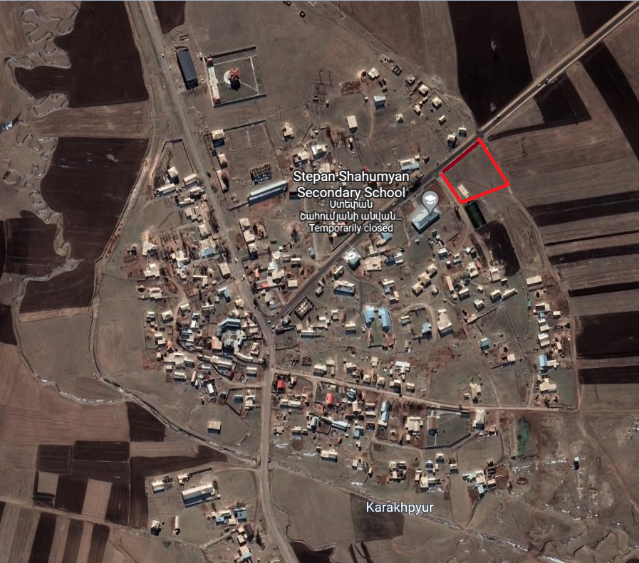

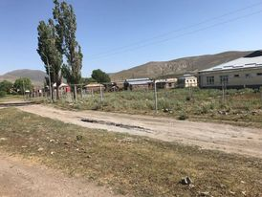 | 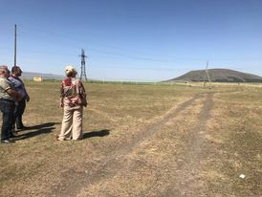
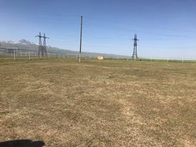 | 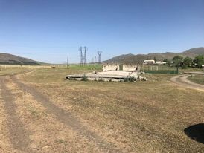

Attachment 2: Copy of an agreement for construction waste disposal

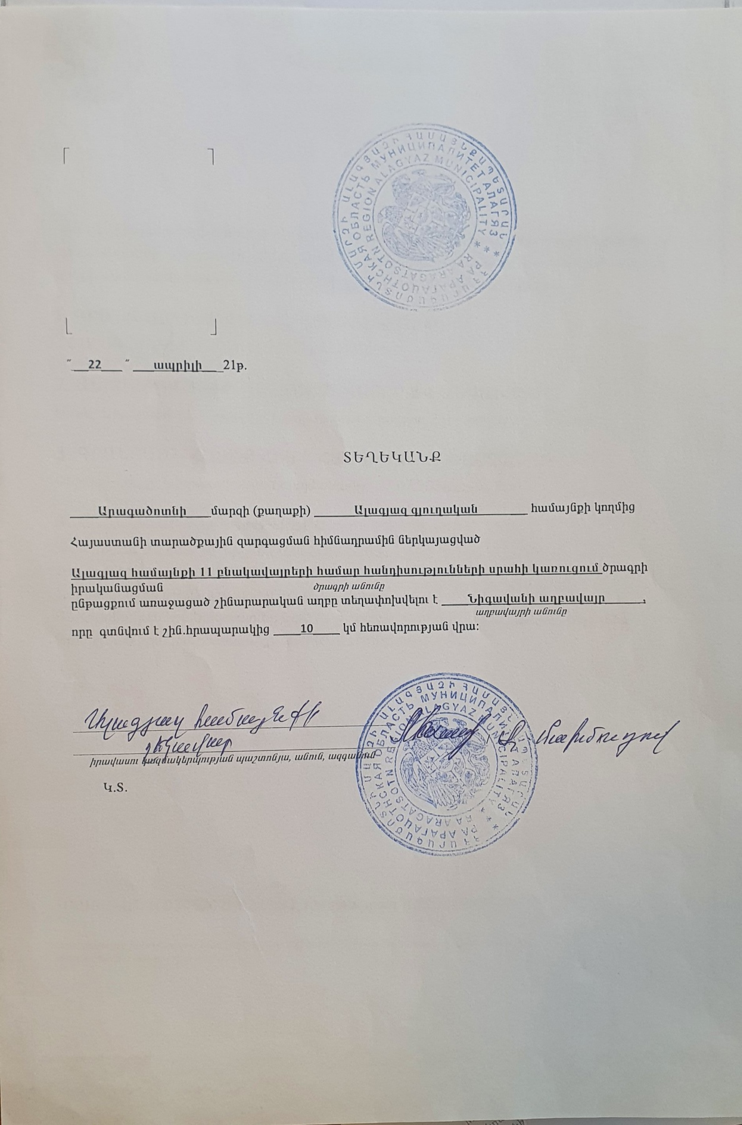
Non-official translation of the land ownership certificate:

22.04.2021
Reference

Construction waste generated during the construction will be transported to the Nigovan disposal site located 10 km far from the construction site.

Community Head Sealed/Signed M. Makhmudov

Attachment 4: Copy of the Ownership Certificate

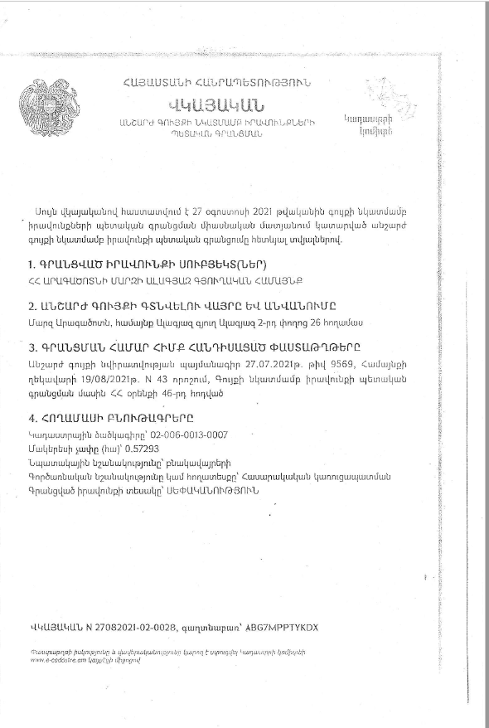
Non-official translation of the land ownership certificate:
This certificate confirms the state registration of the rights to immovable property in unified register made on August 27, 2021 with the following data.
The subject of the rights registration - Alagyaz settlement of Aragatsotn marz of RA
Address and name of the property- Aragatsotn marz, Alagyaz community, Street 2, Land plot 26
The documents that are the basis for registration- Real estate donation agreement N9569 dated on 27.07.2021. Decree N43 of the head of Alagyaz community dated on 19.08.2021.
Data on Land Plot
Cadastral Number – 02-006-0013-0007
Purpose of the land plot - Residential
Land use – Public construction
The size of land plot – 0.057293 ha
Type of right – Ownership

Attachment 5: Minutes of the public consultation of the ESMP

A public consultation was held on October 13, 2022, at the Alagyaz community administrative building with the participation of the residents and representatives of the administrative office of the community. Overall 19 people participated in the meeting of which 4 women.
The announcement of the public consultation was posted on the ATDF web page and the information board, webpage and Facebook account of the Alagyaz community on October 7.
The head of Alagyaz community opened the meeting and presented the purpose of the meeting and the concept of the micro-project.
ATDF Social Specialist Knarik Grigoryan presented the scope of construction works to be done under the micro-project and the purpose of the Environmental and Social Management Plan(ESMP) developed. She presented the expected environmental and social impacts, as well as the mitigation measures planned under the ESMP. It was noted that all the environmental impacts will be local and temporary. Expected impacts were presented, including generation and transportation of construction waste, noise and dust generation because of construction works. The safety measures to be provided were also presented, including the fencing of the area, installation of the tapes in the dangerous areas of the construction site and traffic management, as well as safety signs installation requirements. The measures on safety of labor were presented including uniform wearing and personal protective equipment, as well as the requirements on supply of construction materials and maintenance of construction equipment.
It was noted that the land plot allocated for the Community Center construction is community-owned, the proposed land plot is not formally or informally used for any private purposes. No private lands will be used during the construction period for parking of construction machinery or any other purpose, and no impacts are anticipated on the private lands.
The grievance redress mechanism (GRM) of the SILD project was presented to the participants of the meeting. The contact information of the focal point (Rezo Makhmudov) elected at the Community meeting was presented. The procedures of submitting, examining and reviewing the grievances were presented. It was mentioned that the information on the GRM will be additionally posted on the information board of the Alagyaz administrative office and the micro-project information board to be installed at the entrance of the construction site.
It was told about the supervision and monitoring procedures for the implementation of the measures provided under the ESMP.

No questions were raised.
List of participants (not subject to publishing)

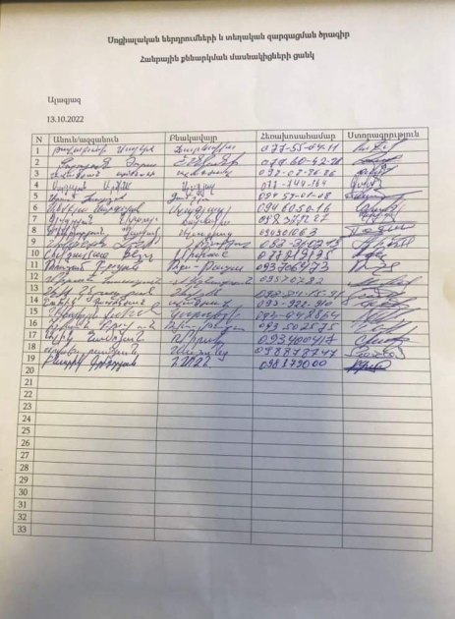
Photos (not subject to publishing)
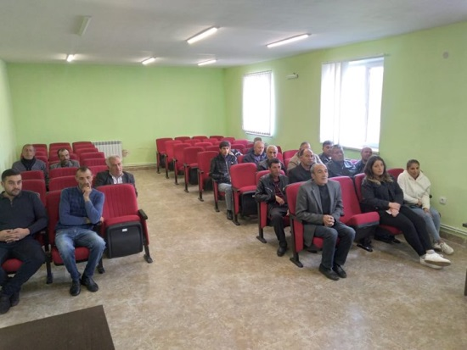

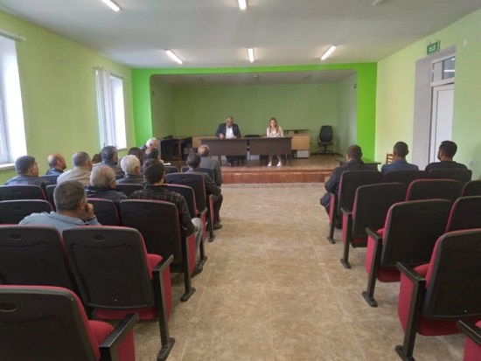
Attachment 6: Copy of the Construction Permit (to be provided)

Constructions Norms of the Republic of Armenia
Land acquisitions includes displacement of people, change of livelihood encroachment on private property this is to land that is purchased/transferred and affects people who are living and/or squatters and/or operate a business (kiosks) on land that is being acquired.
Toxic / hazardous material includes but is not limited to asbestos, toxic paints, noxious solvents, removal of lead paint, etc.

