REPUBLIC OF ARMENIA
LOCAL ECONOMY AND INFRASTRUCTURE DEVELOPMENT PROJECT

ENVIRONMENTAL AND SOCIAL MANAGEMENT PLAN
Creation of external engineering infrastructures FOR "La Valette Resorts" of DCD LLC

November 2023

PART A: General Project and Site Information
INSTITUTIONAL & ADMINISTRATIVE
Project title | LOCAL ECONOMY AND INFRASTRUCTURE DEVELOPMENT (LEID)
Sub-project number and title | Creation of External Engineering infrastructures for “La Valette Resorts” of DCD LLC
Municipality, community | Dilijan community, Tavush Marz (region), RA
Scope of site-specific activity | The scope of the construction works include:  - External sewerage system mounting։  A new sewerage system along the path of the road leading to the complex will be implemented. It will be made of polyethylene corrugated pipes with a diameter of d_{internal} = 271mm, with a total length of 1857 m, and it will include the installation of 82 pcs. of reinforced concrete manholes with d= 1000mm, d= 1500mm․  - Construction of medium-pressure underground gas pipeline and CGCP(Cabinet- type Gas Control Point):  A medium –pressure underground gas pipeline will be installed along the road leading to the complex. The pipeline will consist of polyethylene pipes with d= 160x9mm diameter, with the total length of 2534m, and an over ground steel pipes with d= 159x4.5mm, and 74m of total length. The gas pipeline is planned to be connected to an existing gas pipeline parallel to the Dilijan-Parz Lake highway, along the right side of the Aghstev River, at a distance of about 300m from the M-4 highway.  - Approaching road asphalt paving; external lighting and telecommunication systems mounting:  It is planned to reconstruct a road of 1858m length. The road from both sides is bordered with rocks and ravines, as a result of which the road driving section width is changeable. It varies in the ranges of 3.5-5.4mm, with corresponding widening in the turns. The road widening is not envisaged, the works will be carried out on the current operating road section.  The road cover is planned to be paved with 6cm thick asphalt-concrete. Along the road sides, it is planned to mount water removing drains, metallic barriers and retaining walls. Retaining walls will be built at some section of the road, where there are steep descents and ascents. During the construction works there is no impact envisaged on the vegetation. The existing storm drains will be improved, and road furnishing with road signs, road marking, and road lighting poles with underground cable will be installed. In the scopes of the component, it is also planned to lay an under-ground optical telecommunication cable. All the works are planned to be implemented up to the La Valette Resorts complex border.  The construction activities will be carried out on the existing road, which is currently in poor condition.
Institutional arrangements (WB) | Task Team Leader:  Tafadzwa Irvine Dube |  | Safeguards Specialists:  Lusine Gevorgyan (Environment)  David Jijelava (Social)  Sonya Msryan (Social)
Implementation arrangements (RA) | Implementing entity:  ATDF  Armine Gabrielyan (Environment)  Marine Vardanyan (Social) | Works supervisor:  (to be provided*) | Works contractor:  (to be provided*)
SITE DESCRIPTION
Name of institution whose premises are to be rehabilitated | Tavush Marz, Dilijan community
Address and site location of institution whose premises are to be rehabilitated | Dilijan community, Tavush Marz, Aroghjaranayin Str.
Who owns the land?  Who uses the land (formal/informal)? | Within the framework of the sub-project reconstruction works will be carried out in Aroghjaranayin 12/2, 12/3 road section in Dilijan, Tavush Marz. The road to be reconstructed (code 11-003-1765-0001) under the sub-project is owned by Dilijan Community (see cadastral photo and map screenshot in Attachment 1), reference letter confirming the property right is also attached (Attachment 2). The sub-project site is far from the residential part of Dilijan Town. The water supply and sewerage system pipelines will be mainly constructed along the existing community-owned road on the community-owned lands as well as state owned roads: construction of the sewer and water supply systems will intersect Yerevan-Ijevan M4 Highway.  The gas pipeline will be installed along the community and state-owned roads. The cabinet-type gas control point and gas meter will be installed on the community-owned lands. The lighting poles will be installed on the community owned lands.  The sub-project will not result in resettlement activities or require land acquisition.  The implementation of the sub-project will enhance area making Dilijan more attractive for tourists. The implementation of the sub-project will have positive social-economic, cultural and environmental benefits as a result of territory improvement, infrastructure development, and new jobs will be created.
Description of physical and natural environment around the site | Dilijan is a resort town and the center of enlarged Dilijan Community in Tavush Marz. Dilijan is located on the banks of Aghstev River, more than 20 kilometers (12 miles) long and 1,500 meters above the sea level. The forests of Dilijan cover an area of more than 34,000 hectares. To enrich the natural life around Dilijan, a state forest reserve was established in 1958, which became known as Dilijan National Park later in 2002. Forests cover 94% of the park area with about 40 species of trees and 18 species of shrubs being mainly oak, beech, elm, maple, elm, willow, etc.  The climate in Dilijan is characterized by a moderate, warm and humid climate. According to Construction Climatology the RAConstruction Norms (RACN) II-7.01-2011, the average temperature in July is about 18.3ºC and the relative air humidity is 74%, in January the average temperature is about -1.5ºC and the relative air humidity is 63%.  The average annual precipitation is about 639 mm. The highest amount of precipitation falls in spring (about 35 % of the annual norm), while the lowest is in winter (about 12 %).  The frost-free period ranges from 200 to 210 days. Snow cover does not occur every year, but when it does,the thickness of the snow layer ranges from 5 to 50 cm, and on the northern slopes it often exceeds 70 cm.  The studied area is located in Aroghjaranayin 12/2, 12/3, an operating road section in Dilijan, Tavush Marz. The road which belongs to the community to be reconstructed starts from Tbilisyan Highway (M4). On the right side of the road, on the land owned by the applicant, there are solar panels installed. One private owned farm and a territory with buildings are located on the left side of the road. The owners and the dwellers of the farm and the buildings will be beneficiaries of the subproject as they will use the improved reconstructed infrastructure as well. There are trees on both sides of the road at some sections.  The geological structure of the site is represented by 3 different layers of the earth.  - The groundwater in the area, according to geological data, is found at the low horizons.  - The soil in the studied area is suitable for the construction.  - The maximum depth of soil freezing, according to RAMN II-7.01-2011, in the studied area is 47 cm.  - There are no dangerous physical and geological phenomena in this area, such as landslide, rockfall and etc.
LEGISLATION
National & local legislation & permits that apply to sub-project activity | The following Armenian legislation defines a legal framework applicable to project activities:  - RA Law on Atmospheric Air Protection (1994)  The purpose of Law on Atmospheric Air Protection is to define main principles of the RA, directed to provision of purity of atmospheric air and improvement of air quality, prevention and mitigation of the chemical, physical, biological and other impacts on air quality and regulation of public relation. This Law also regulates the emission licenses and provides maximum allowed loads / concentrations for atmospheric air pollution, etc.  According to this law, contractor shall undertake construction activities as well as transportation and temporary storage of waste the way to minimize dust and other emissions.  - RA Law on Waste (2004)  The law provides the legal and economic basis for collection, transportation, disposal, treatment, re-use of wastes as well as prevention of negative impacts of waste on natural resources, human life and health. The law defines the roles and responsibilities of the state authorized bodies as well as of waste generator organizations in waste management operations.  According to this law, the waste generated from construction activities should be recycled as appropriate or disposed of in designated locations.  Disposal of the construction waste and excess material in selected locations must be approved by local municipality in writing.  - Law on Environmental Impact Assessment and Expertise of RA (2023)  The law defines type of activities which are subject to environmental impact assessment and expertise. According to point 6, Article 12 of this Law, the proposed restoration works are not subject to state environmental impact expertise, since all the construction works will be carried out on the existing community-owned asphalt road section.  - Law on Urban Development of RA (1998)  This law defines the principles and regulations of urban development activities in the RA. According to this law, planned works requires obtaining the construction permit.  - Labor Code of RA (2005)  This Code regulates collective and individual labor relations, defines the grounds for the origin, modification and termination of these relations and the procedure for their implementation, the rights and responsibilities of the parties to labor relations, as well as the conditions for ensuring the safety and health of employees. According to this law the Contractor must ensure the safety and health of the employees working on the construction site.  - Land Code of RA (2001)  This code defines the legal bases for improving the state regulation of land relations, developing different organizational and legal forms of land management, increasing soil fertility, land use efficiency, maintaining and improving the environment favorable for people's life and health, and protecting rights to land based on the important environmental, economic and social importance, due to which land is used and preserved in the Republic of Armenia as a condition of the people's livelihood.  - Forest Code of RA (2005)  This Code regulates the sustainable management of forests and forest lands of the Republic of Armenia - protection, restoration, afforestation and efficient use, as well as the relations related to forest registration, monitoring; control and forest lands. According to this law forests can be used for cultural, health, sports; recreation and tourism purposes. In areas used for cultural, health, sports, recreation and tourism purposes, natural landscapes, fauna and flora, and water bodies must be preserved. The use of forest lands, the uprooting of trees and bushes in these lands, the construction of roads, pipelines, buildings and structures, the exploitation of mines, the collection of natural wood can be carried out only with the permission of the authorized body.  - RA Law on Specially Protected Natural Areas (2006)  This Law defines legal basis and relations of State policy for development, restoration,  maintenance, reproduction and use of natural complex and separate objects, as well as  ecosystems of specially protected natural areas of the Republic. According to the law,  specially protected natural areas are divided into four categories, National Parks, State  Reserves, Natural museums and the forth category is divided into three separate types:  areas of international, republican and local importance.  This law will be used to determine the type of protected areas which the Project may deal  with under specific individual investments, and to clarity that activities suggested for the  Project support do not violate the established regime of protected areas management.  According to national legislation framework of the RA the sub-project requires:  - construction permit**  - construction waste disposal permit
PUBLIC CONSULTATION
When / where the public consultation process will take /took place | The draft ESMP was disclosed and discussed at the public consultation held in Dilijan community on December 12, 2023. Draft ESMP was disclosed on the beneficiary's website (www.dilijan.am) in Armenian language and on the ATDF (www.atdf.am) website in Armenian and English languages.  Brief information on the planned works and contact information for addressing questions and grievances will be placed on the information board of the Dilijan Community, at the worksite, and/or in its immediate surroundings.  The minutes of the public consultation meeting are presented in Attachment 4.
ATTACHMENTS
Attachment 1: Site map/photo,
Attachment 2: Cadastral Reference Letter
Attachment 3: Permission for construction waste disposal
Attachment 4: Minutes of public consultation on the draft Environmental and Social Management Plan (to be provided)
Attachment 5: Construction permit (will be provided)
*Information on works supervisor, works provider (contractor), and the attachments will be provided later, prior to mobilization of a selected works provider to a work site.
**The construction permit will be obtained before commencement of works.

PART B: safeguards information
ENVIRONMENTAL /SOCIAL SCREENING
Will the site activity include/involve any of the following? | Activity/Issue | Status | Triggered Actions
Will the site activity include/involve any of the following? | - Road rehabilitation | [x] Yes [ ] No | If “Yes”, See Section A below
Will the site activity include/involve any of the following? | - New construction | [ ] Yes [x] No | If “Yes”, See Section A below
Will the site activity include/involve any of the following? | - Individual wastewater treatment system | [ ] Yes [x] No | If “Yes”, See Section B below
Will the site activity include/involve any of the following? | - Historic building(s) and districts | [ ] Yes [x] No | If “Yes”, See Section C below
Will the site activity include/involve any of the following? | - Unexpected need for land take | [ ] Yes [x] No | If “Yes”, See Section D below
Will the site activity include/involve any of the following? | - Hazardous or toxic materials | [ ] Yes [x] No | If “Yes”, See Section E below
Will the site activity include/involve any of the following? | - Impacts on forests and/or protected areas | [x ] Yes [] No | If “Yes”, See Section F below
Will the site activity include/involve any of the following? | - Handling / management of medical waste | [ ] Yes [x] No | If “Yes”, See Section G below
Will the site activity include/involve any of the following? | - Traffic and pedestrian safety | [x] Yes [ ] No | If “Yes”, See Section H below
Will the site activity include/involve any of the following? | - Social risk management | [x] Yes [ ] No | If “Yes”, See Section I below
PART C: Mitigation measures
ACTIVITY | PARAMETER | MITIGATION MEASURES
0. General Conditions | Notification and Worker Safety | - The local construction and environment inspectorates and communities are notified of upcoming activities  - The public is notified of the works through appropriate notification in the media and/or at publicly accessible sites (including the site of the works)  - All legally required permits are acquired for construction and/or rehabilitation  - The Contractor formally agrees that all work will be carried out in a safe and disciplined manner designed to minimize impacts on neighboring residents and environment.  - Workers’ personal protection equipment complies with international good practice (always hardhats, as needed masks and safety glasses, harnesses and safety boots)  - Appropriate signposting of the sites informs workers of key rules and regulations to follow.
A. General Rehabilitation and /or construction activities | Air Quality | - During earth works, dust is suppressed by ongoing water spraying and/or installing dust screen enclosures at site.  - The surrounding environment (sidewalks, roads) is kept free of debris to minimize dust.  - There is no open burning of construction / waste material at the site.  - There is no excessive idling of construction vehicles at sites.
A. General Rehabilitation and /or construction activities | Noise | - Construction noise is limited to restricted times agreed to in the permit.  - During operations, the engine covers of generators, air compressors and other powered mechanical equipment are closed, and equipment placed as far away from residential areas as possible.
A. General Rehabilitation and /or construction activities | Water Quality | - Appropriate erosion and sediment control measures are applied such as e.g. hay bales and / or silt fences to prevent sediment from moving off site and causing excessive turbidity in nearby streams and rivers.
A. General Rehabilitation and /or construction activities | Waste Management | - Waste collection and disposal pathways and sites are identified for all major waste types expected from demolition and construction activities.  - Mineral construction and demolition wastes are separated from general refuse, organic, liquid and chemical wastes by on-site sorting and stored in appropriate containers.  - Construction waste is being collected and disposed properly by licensed collectors.  - Whenever feasible, appropriate and viable materials (except asbestos) are reused or recycled.
 | Earth Works | - Excess material and topsoil generated from earth works will be stored separately and used for backfilling and site reinstatement.  - Topsoil layer not thicker than 30 m will be stripped separately and temporary piled on-site.  - Stockpile height will not exceed 3.0 m, and the slope angle will not exceed 34º.  - Temporary stockpile will be compacted and covered with a tarp to prevent erosion caused by rain runoff.  - Topsoil will be re-used for backfilling to facilitate re-cultivation of the land plot. Excess amount of subsoil will be disposed at the agreed-upon locations.
F. Affected forests, and/or protected areas | Protection | - All recognized natural habitats, wetlands and protected areas in the immediate vicinity of the activity are not damaged or exploited; all staff is strictly prohibited from hunting, foraging, logging or other damaging activities.  - A survey and an inventory is made of large trees in the vicinity of the construction activity, large trees are marked and cordoned off with fencing; their root system protected, and any damage to the trees avoided.  - There is no unlicensed borrow pits, quarries or waste dumps in adjacent areas, especially not in protected areas.
H. Traffic and pedestrian safety | Direct or indirect hazards to public traffic and pedestrians by construction  activities | In compliance with national regulations, the construction site is properly secured, and construction related traffic regulated. This includes but is not limited to:  - Signposting, warning signs, barriers and traffic diversions: site will be clearly visible, and the public warned of all potential hazards.  - Traffic management system and staff training, especially for site access and near-site heavy traffic. Provision of safe passages and crossings for pedestrians where construction traffic interferes.  - Adjustment of working hours to local traffic patterns, e.g. avoiding major transport activities during rush hours or times of livestock movement.  - Active traffic management by trained and visible staff at the site, if required for safe and convenient passage for the public.  - Ensuring safe and continuous access to office facilities, shops and residences during renovation activities, if the buildings stay open for the public.
I. Social risk management | Public relationship management | - Assign local liaison person in charge of communication with and receiving requests/ complaints from local population.  - Consulted local communities to identify and pro-proactively manage potential conflicts between an external workforce and local people.  - Rise local community awareness about sexually disease risks associated with the presence of an external workforce and include local communities in awareness activities.  - Inform population about construction and work schedules, interruption of the services, traffic detour routes and provisional bus routes, blasting and demolition, as appropriate.  - Limit construction activities at night. When necessary, carefully schedule night-time works and inform affected community so they can take necessary measures.  - At least five days in advance of any service interruption (including water, electricity, telephone, bus routes), advise affected community through postings at the project site, at bus stops, and in affected homes/businesses.
I. Social risk management | Labor management | - To the extent possible, locate work camps away from local communities.  - Undertake sitting and operation of worker camps in consultation with neighboring communities.  - Recruit unskilled or semi-skilled workers from local communities to the extent possible. Where and when feasible, provide worker skills training to enhance participation of local people.  - Provide adequate lavatory facilities (toilets and washing areas) in the work site with adequate supplies of hot and cold running water, soap, and hand drying devices. Establish temporary septic tanks for any residential labor camp and without causing pollution of nearby watercourses.  - Raise awareness of workers on overall relationship management with local population, establish the code of conduct in line with international practice and strictly enforce them, including the dismissal of workers and financial penalties of adequate scale.
I. Social risk management | Grievance Management | - GRM is established and advertised at the local level. The Contractor is informed of his responsibility to register and communicate to the PIU received verbal and non-verbal grievances.  - GRM contact information, including local focal points, has been posted at the construction site and the local community’s administrative office.  - The Contractors' local liaison person receives and registers grievances from the population in the GRM log and communicates the grievances to the PIU regularly.

PART D: Monitoring Plan
Activity | What  (Is the parameter to be monitored?) | Where  (Is the parameter to be monitored?) | How  (Is the parameter to be monitored?) | When  (Define the frequency / or continuous?) | Why  (Is the parameter being monitored?) | Who  (Is responsible for monitoring?)
CONSTRUCTION PHASE
Supply of construction materials | Purchase of construction materials from the licensed suppliers | In supplier’s office or warehouse | Verification of labels of the materials and/or certificates if any | During conclusion of supply contracts | Ensure reliability of construction materials and their safety for human health | ATDF  Technical Supervision Company
Transportation of construction materials and waste;  Movement of construction vehicles and machinery | -Technical condition of construction vehicles and machinery;  -Coverage of loads when carrying soil, other construction material and construction waste;  -Movement of construction vehicles and machinery according to predefined traffic routes and within working hours: 9AM-6PM. | -Construction site  - Routes of transportation of construction materials and wastes | Inspection of pre-defined movement routes, entrances and exits of construction sites | Unannounced monthly inspection during work hours and beyond | - Control emissions into the environment;  - Control nuisance to local communities;  - Minimize traffic disruption, ensure pedestrian safety and prevent accidents | ATDF  Technical Supervision Company  Road Police
Maintenance of construction equipment | - Washing of cars and construction equipment outside the construction site or on maximum distance from natural streams;  - Refueling or lubrication of construction equipment outside the construction site or at the predetermined confined area. | Construction site | Inspection of activities | Selective inspections during work hours | - Avoid pollution of water and soil with oil products due to operation and maintenance of equipment and washing runoffs;  -Timely localize oil and lubricant spill-offs, and decrease expected damage in case of fire. | ATDF  Technical Supervision Company
Generation of construction waste | -Temporary storage of waste at the pre-defined areas of construction site;  -Timely disposal of waste at the permitted location. | Construction site  Waste disposal site | Inspection of site | Unannounced monthly inspection during entire construction phase | - Prevent pollution of soil, surface water and ground water;  - Avoid accidents at the construction site due to scattered fragments of construction materials and debris;  - Retain esthetic appearance of the construction site and its surroundings. | ATDF  Technical Supervision Company
Workers’ health and safety | - Provision of uniforms and safety gears to workers and enforcement of their use by the constructor;  - Provision of work-site safety instruction to contractor’s personnel and instructions proper recording;  - Installation of safety barriers, signs etc  - - Ensuring fire extinguisher and medical aid kits at work site. | Construction site | Inspection | Periodically during construction and upon its completion | - Exclude probability of accidents;  -Protect workers’ health. | ATDF  Technical Supervision Company
Works near privately-owned land plots and other property | - Avoid trespassing or incidentally damaging of private property (using small-size machinery or manual labor near walls and fences, stockpiling of construction material and waste away from private property; etc.);  -In case of unintended damage to private property, quickly restore it to the original or better status;  -In case of expected temporary impact on privately-owned property, inform owners upfront and guarantee restoration, acquire written consent of owners for intervention, and promptly restore the damage to the original or better status. | Works near privately-owned land, buildings and other assets | Monitoring and inspection | Entire period of construction | -Reduce the probability of damages on private property;  -Exclude temporary or permanent violation of ownership and/or user rights on the private property. | ATDF  Technical Supervision Company
Tree preservation | - Inventory of existing trees on sub-project site;  - Living trees located near the border of existing road shall be marked and cordoned off with fencing, their root system shall be protected, and any damage to the trees avoided;  - Permit will be obtained from Dilijan municipality before removal of any trees, bushes and stumps, if any impacts on them. | Construction site | Visual inspection | Entire period of construction | Avoid damage to existing vegetation | ATDF  Technical supervision  company  Dilijan community administrative office
Community Health and Safety | - Ensure that the project activities do not have any adverse impacts on community health and safety, including exposure to project-related traffic and road safety risks. | Construction site and its neighborhood | Inspection | Periodically during construction and upon its completion | - Exclude the  occurrence of incidents and injuries | ATDF  Technical Supervision Company
Construction site re-cultivation and landscaping | Final cleaning of the construction site and permanent access roads and landscaping-greening of the area as required | Construction site and access roads | Inspection of activities | Final period of construction | Reduce loss of aesthetical value of the landscape due to construction activities | ATDF  Technical Supervision Company
Solid waste management | Trash bins placement and arrangement on periodically transportation of waste | Construction site | Inspection | Total period of construction | - Prevent pollution of soil, surface water and ground water;  - Retain esthetic appearance of the sites area and its surroundings. | ATDF  Technical Supervision Company
Dust control | - Ensuring water spraying measures at site, and timely removal of construction debris;  - Storing bulk materials with the use of banners at site. | Construction site and access roads | Visual inspection | Total period of construction | -Prevent off-site dust spreading and pollution;  -Reduce health risks to the workers and neighboring communities related to dust exposure. | ATDF  Technical Supervision Company
Handling of chance finds | - Stoppage of works promptly upon encountering of chance finds;  - Formal communication with the Ministry of Education, Science, Culture and Sports (MoESCS) of RA on chance finds;  - Timely arrangements made for the conduct of required excavation and site conservation. | Construction site | -Inspection of chance find sites;  - Inspection of field documentation | Entire period of construction | Ensure cultural heritage is not damaged by the construction works. | ATDF  Technical Supervision Company  MoESCS
Earth work | -Topsoil removal and temporary stockpiling for re-cultivation of the land;  -Temporary storage of excavated soil at determined places;  -Backfilling of the excavated ground as needed and disposal of the excess mass to the places, approved in writing. | Construction site | Inspection of activities | During earth works | -Limit loss of vegetation and soil due to ground piling and minimization of potential pollution of surface water reservoirs with particles | ATDF  Technical Supervision Company
Operation of Grievance Redress Mechanism | -Public right to complaints or questions about the project.  - Appeal to the head of local government (community authorities)  -The appointment by the authorities of the Coordinator for the consideration of complaints (receiving complaints, reviewing and explaining, registering complaints in the log book and trying to resolve them on the spot.  -Appeal to ATDF by hot-line (010 24 01 59), postal letter (Yerevan 0037, K.Ulnetsi 31), official web page (http://atdf.am/hy/Home/ContactUs), e-mail (support@atdf.am). | Construction site | Inspection of activities | Entire period of construction | Monitor compliance with project aspects;  Timely resolve questions and complaints in the field. | ATDF  Technical Supervision Company
OPERATION PHASE
Maintenance and protection of site | Non-authorized construction and land use in the central part area | Road section | Visual inspection | Total period of operation | Prevent the loss of aesthetical and recreational value of the site | Administrative office
Solid waste management | Trash bins placement and arrangement on periodical transportation of waste | Road section | Inspection of activities | Total period of operation | - Reduce exposure to waste and disease-carrying rodents and insects;  - Maintain safe sanitary condition and prevent environmental pollution | Administrative office
Operation and maintenance of communication line | Regular servicing of the utility networks being undertaken | Road section | Regular technical inspections | Total period of operation | - Maintenance of utility networks in safe and operable condition;  - Avoid disruption of operation of central part area and inconveniences to staff and visitors. | Administrative office

Attachment 1: Site maps and photos
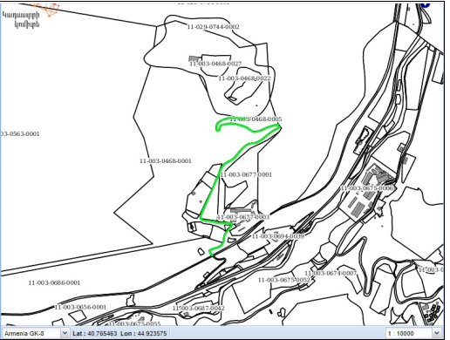
Photo 1 Cadastral map
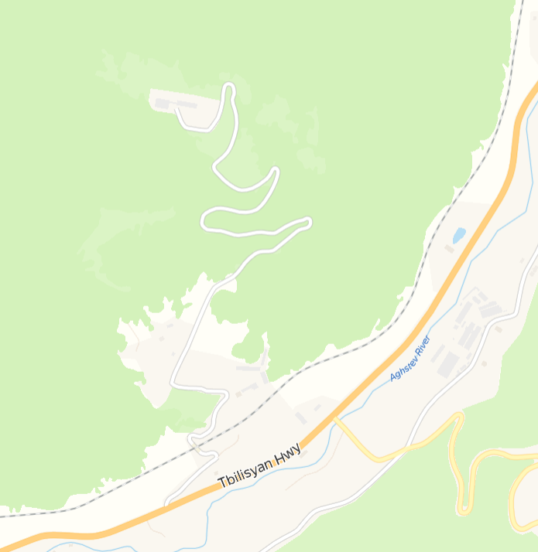
Road to be reconstructed
Photo 2 Yandex map screenshot of reconstructed area

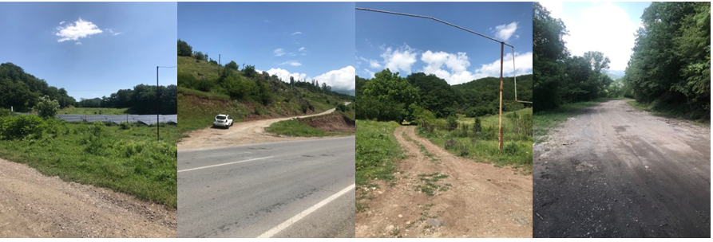
Photo 3 Photos of reconstructed area

Attachment 2. Cadastral Reference Letter
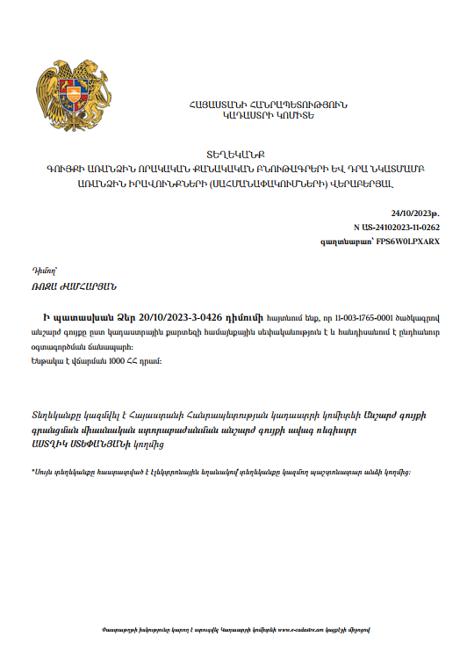
Summary of the above document
In response to your letter 20/10/2023-3-0426, we inform you, that real estate under the code 11-003-1765-0001 is community property according to the cadastral map and is a public road.
Attachment 3: Permission for construction waste disposal
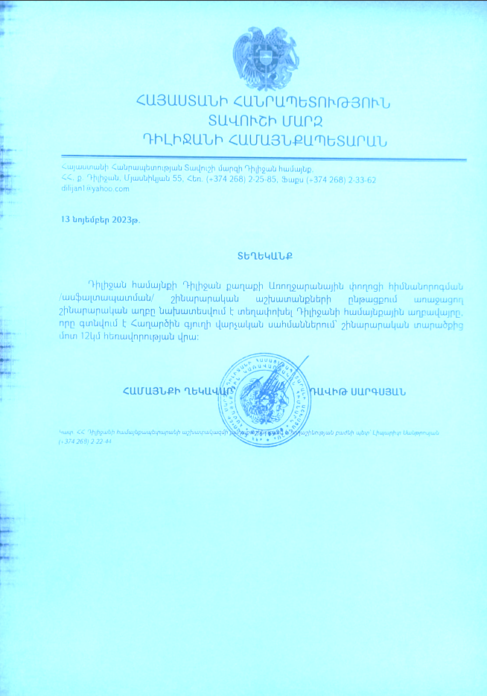
Summary of the document above.
The construction waste, generated during Dilijan Community’s Aroghjaranayin road reconstruction works, is planned to be moved to the landfill of Dilijan Community located 12 km far from the construction site, within the Haghartsin settlement.
Attachment 4: Minutes of the public consultation on the draft Environmental and Social Management Plan

On December 12, 2023, a public consultation meeting was held in Dilijan municipality with the participation of ATDF environmental and social specialists, the chief specialist of urban construction and architecture department of Dilijan municipality, personnel of the municipality, Dilijan residents and representatives of DCD LLC. Overall, 10 people participated in the meeting, of which 3 were women.
The announcement of the public consultation was posted on the ATDF webpage and the announcement with the link to the ESMP was sent to Dilijan Municipality for public announcement on December 4th, 2023.
Arsen Sargsyan, the Chief Specialist of urban construction and architecture department of Dilijan municipality, opened the meeting and presented the purpose of the meeting and the concept of the subproject.
Armine Gabrielyan, ATDF environmental specialist, informed the participants that ATDF had prepared an Environmental and Social Management Plan (ESMP) for subproject “Creation of External Engineering infrastructures for “La Valette Resorts” of DCD LLC”. She informed the participants about activities envisaged within the subproject, about all possible environmental, social, health and safety impacts and their mitigation measures to be implemented during the construction works. Armine Gabrielyan presented the environmental norms and regulations related to construction works. It was mentioned that the envisaged works will not have any impact on “Dilijan National Park” or cultural monuments as the civil works will be carried out only on the community road. She explained how the monitoring of compliance of the civil works to the requirements of the presented ESMP would be carried out.
The gas pipeline will be installed along the community and state-owned roads. The cabinet-type gas control point and gas meter will be installed on the community-owned lands. The lighting poles will be installed on the community owned lands. The water supply and sewerage system pipelines will be mainly constructed along the existing community-owned road on the community-owned lands as well as state owned roads: construction of the sewer and water supply systems will intersect Yerevan-Ijevan M4 Highway.
Marine Vardanyan presented the expected temporary social impacts, including the generation and transportation of construction waste, noise and dust generation due to construction works. She noted that the sub-project site is far from the residential part of Dilijan Town and it will not result in resettlement activities or require land acquisition.
The safety measures to be provided were also presented, including the separation of the construction site by caution tapes in dangerous areas of the construction site and traffic management, as well as the safety signs installation requirements. The measures for safety of labor were presented, including uniform wearing and personal protective equipment, as well as the requirements on the supply of construction materials and maintenance of construction equipment. She mentioned that no negative social impacts are envisaged under the project, including temporary land use during the construction period.
Ashot Boyajyan, the representative of the DDC LLC detailed the conveniences, attraction and entertainment opportunities that “La Valette Resorts” will provide to the tourists and Dilijan residents. It will also create job opportunities for more than 100 local people, as well as temporary job opportunities during the civil works.
Marine Vardanyan presented the Grievance Redress Mechanism (GRM) of the LEID project to the participants of the meeting. The ATDF safeguard specialists explained the necessity to have a GRM focal point in the municipality who will be responsible for GRM registration and submission to the ATDF.
Arsen Sargsyan was suggested and selected as a GRM focal point. The procedures of submitting Grievance, its registration in the provided GRM log, examining and reviewing the grievances were presented. It was mentioned that the information on the GRM should be posted on the information board of Dilijan Municipality and the subproject information board to be installed at the entrance of the construction site.
Arsen Sargsyan concluded that the sub-project will make Dilijan more attractive for tourists. The implementation of the sub-project will have positive social-economic, cultural and environmental benefits as a result of territory improvement, infrastructure development, and new jobs creation.

There were no questions related to environmental, social, health and safety impacts and their mitigation measures.
The photos are presented below.

Photos (not subject to publication)

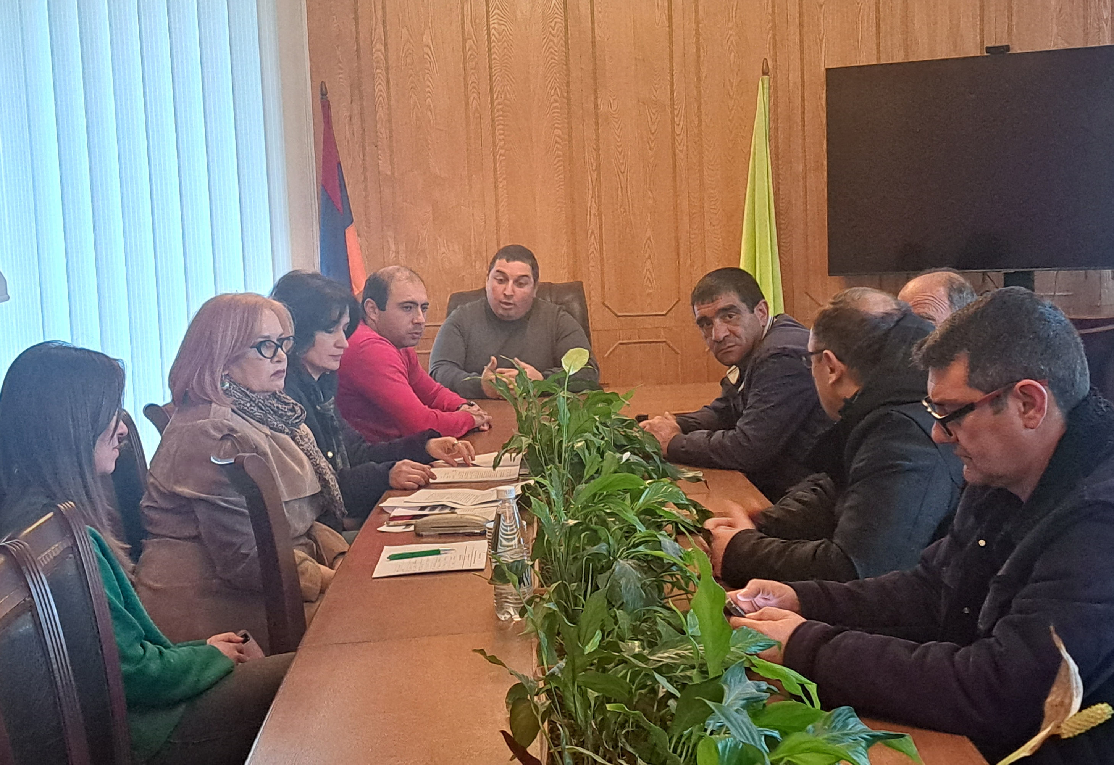  List of participants (not subject to publication) | 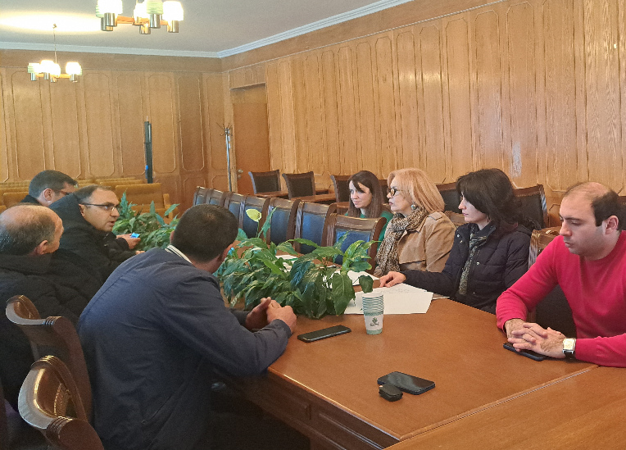
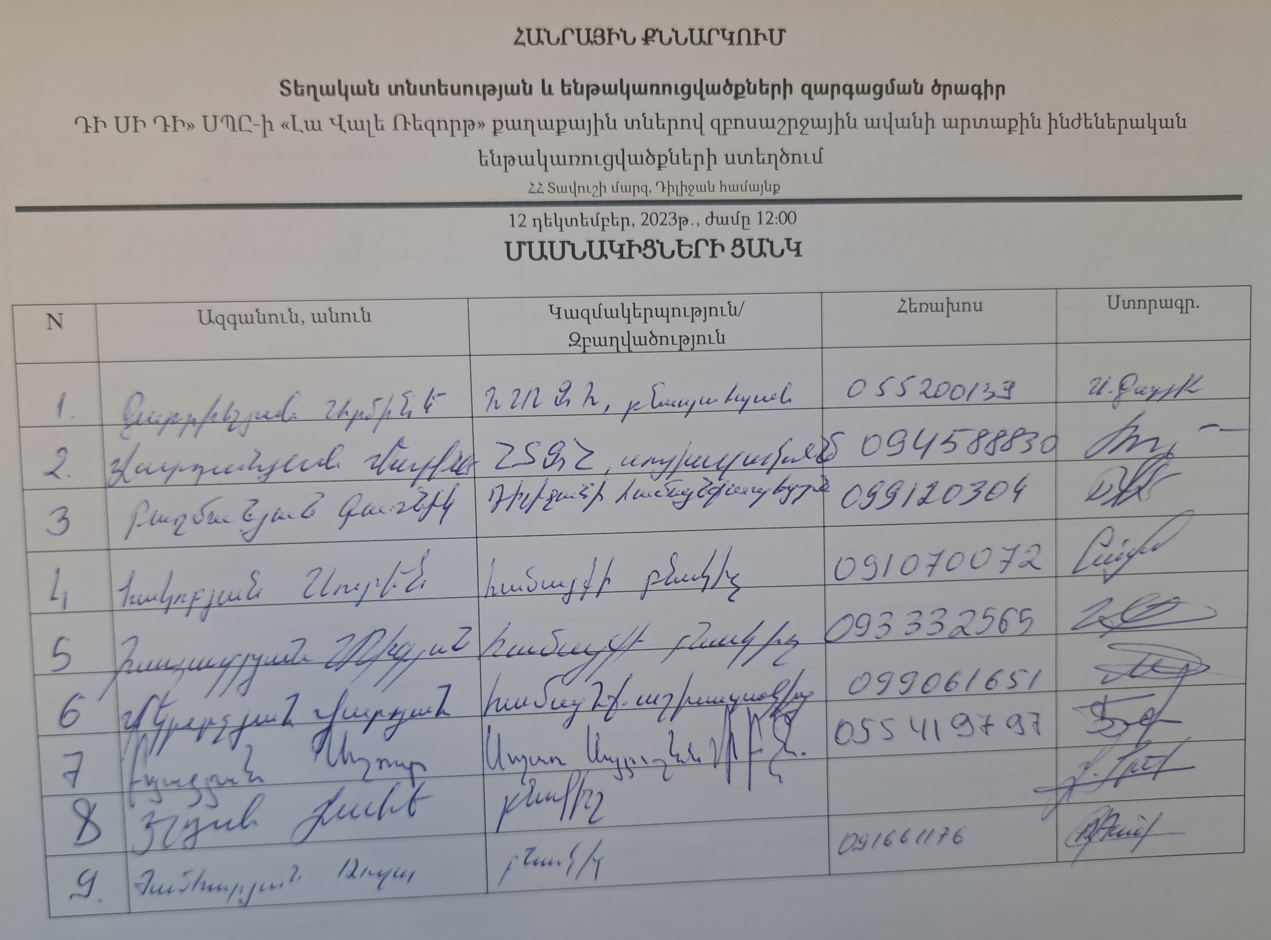
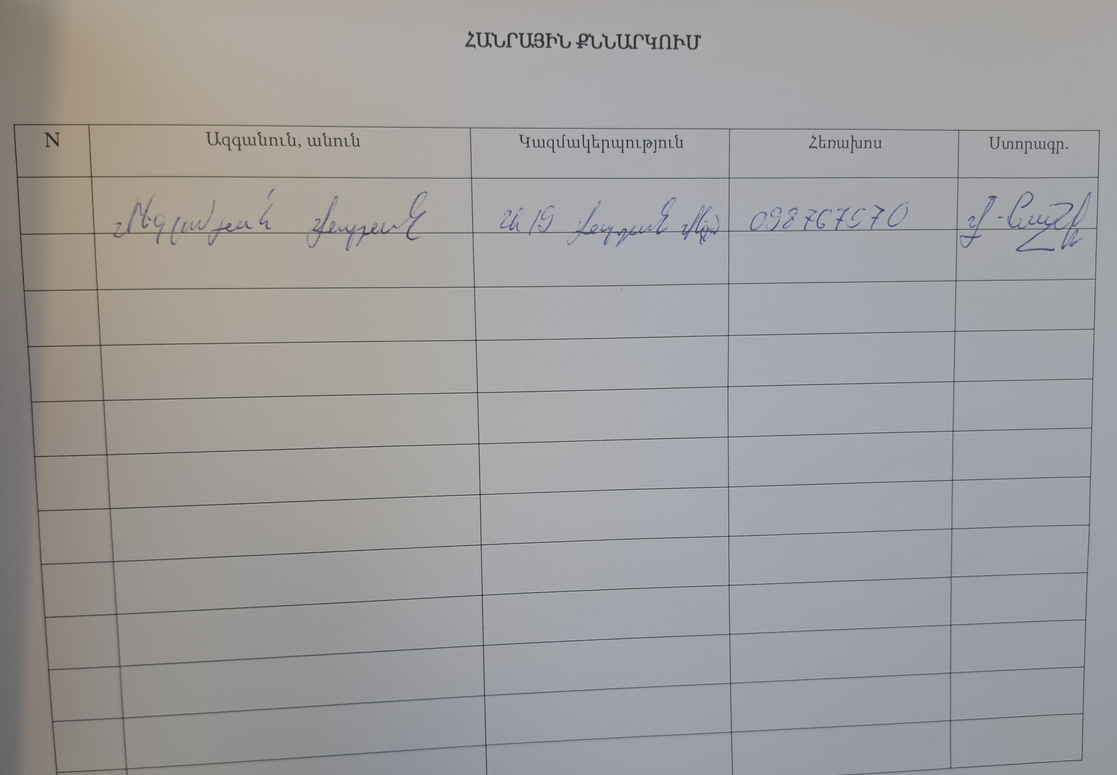

Attachment 5: Construction permit (will be provided)

Toxic / hazardous material includes but is not limited to asbestos, toxic paints, noxious solvents, removal of lead paint, etc.

