ARMENIA SOCIAL INVESTMENT AND LOCAL DEVELOPMENT PROJECT

Additional Financing

FINAL ENVIRONMENTAL AND SOCIAL REVIEW CHECKLIST

Micro-project title: “Construction of the Kindergarten of Nor Kyank
Settlement”

Micro-project #: AFT-SH-01

Is the Environmental and Social Management Plan (ESMP) developed?
Yes + No -

Does ESMP provide a full list of potential impacts and establish adequate measures for their mitigation?
Yes + No -

Conclusion of the Final Environmental and Social Assessment

Conclusion
Micro-project rejected | Micro-project approved (environmental assessment completed)
 | +

PART A: General Project and Site Information
INSTITUTIONAL & ADMINISTRATIVE
Country | Republic of Armenia (RoA)
Project title | Social Investment and Local Development Project
Micro-project number and title | AFT-SH-01 “Construction of the Kindergarten of Nor Kyank Settlement”
Municipality, community | Shirak region, Artik community, Nor Kyank settlement
Scope of site-specific activity | Under the micro-project, a new kindergarten building will be built, as the kindergarten currently operates in the municipality building. The area of the land plot to be used for the construction is 3882.4 m². According to the design, the estimated construction area is 1292 m², from which the cellar has an area of 216 m², the first floor occupies 544,8 m², and the second floor 532 m² areas. Landscaping area is 1588 m².  A complex consisting of three buildings, one administrative and two educational, will be constructed under the micro-project.  The buildings designed will be located next to each other. The administrative building of the complex will have a rectangular outline with axial dimensions of 15.0x9.0 m, and the educational buildings will also be rectangular with axial dimensions of 12.0x12.0 m and 18.0x12.0 m, respectively.  The construction works will include:  The yard area:  -The paving is planned to be made of breccia-type basalt slabs, with waterproofing being applied to the bottom;  - The installation of new metal constructions and equipment is planned, including exercise equipment, benches, covers, fences, trash cans, and more;  - Landscaping works are planned, including lawns and drainage system;  - Installation of four pavilions for children’s recreation ;  - Construction of new stairs and ramps.  Designing of the buildings:  Administrative building:  - On the first floor- a hall, a medical room, a laundry room, a kitchen and a storage room;  -On the second floor- a hall, an administrative room, an event hall.  Educational building 1:  - On the first floor- a hall, a playroom, a dressing room, a buffet, a toilet and a bedroom.  -On the second floor- a dressing room, a playroom, a buffet, a toilet and a bedroom;  Educational building 2:  -On the first floor- a hall, a dressing room, a playroom, a buffet, a toilet and a bedroom;  -On the second floor-an auxiliary room, a staff toilet, a technical room, a hall, a dressing room, a play room, a toilet and a bedroom.  The bearing walls of the kindergarten are designed to have monolithic reinforced concrete frames. The roofs of the buildings will also be made of monolithic reinforced concrete.  In accordance with the technical specifications, the water supply of the building is planned to be carried out from the water line located along the fourth street. The length of the water pipeline (d=50mm) to be constructed will be 53m. Wastewater disposal will be carried out through a biological collection station (“Topas-150”). The treated wastewater will be discharged into the ground through an unsealed drainage well, undergo additional purification by additional layer of sand and gravel, afterwards only be absorbed into the soil.  The heating of the building will be carried out by gas-heated boilers. The gas supply is planned to be connected from the existing above- ground gas pipeline passing along the fourth street and the length of the gas pipeline to be constructed will be 175 m.  The kindergarten is designed to accommodate 4 groups, with the total capacity of 100 children.
Institutional arrangements (WB) | Task Team Leader:  Ivan Drabek |  | Safeguards Specialist:  Environment –Lusine Gevorgyan  Social – David Jijelava
Implementation arrangements (RoA) | Implementing entity:  ATDF  Environment - Asya Osipova  Social - Knarik Grigoryan | Works Supervisor:  (tbd) |  | Works Contractor:  (tbd)
SITE DESCRIPTION
Name of site | Kindergarten of Nor Kyank community
Address and site location | Address : Shirak marz, Artik community, Nor Kyank settlement, Street 4, land plot 11
Who owns the land? | The land plot (Cadastral code: 08-087-0033-0020) proposed for the construction of the new kindergarten building is community owned. The area of the land plot is 0.38824 ha.  The land plot is not used for any private purposes. No private lands will be used during the construction period for parking of construction machinery or any other purpose. No impacts are anticipated on the private lands. The micro-project will not reduce other people’s access to their economic resources, such as land, pasture, water, public services or other resources that they depend on. The micro-project will not result in the temporary or permanent loss of crops, fruit trees and household infrastructure.
Description of physical and natural environment around the site | The Nor Kyank settlement is located in the Artik region of the Shirak Marz, 16 km southeast of the marz center, on the left bank of the Mantash River.  The proposed construction site is located in the center of Nor Kyank village. There are no residential buildings on the territory. Private houses are located within a radius of 50 meters, and the main road runs 30 meters from the proposed construction site. There are no terrain features; the territory is flat with sparse vegetation.  The number of preschool children in the Nor Kyank community is 133, out of which only 45 attend kindergarten. Also, the kindergarten located in the municipality building is attended by children from the neighboring community of Vardakar, as Vardakar does not have its own kindergarten. In Nor Kyank community, there is a stone building constructed in 1917, which was previously used as a kindergarten. However, after the repairs carried out by the community, the building is currently unsuitable for use as a kindergarten. The preliminary technical assessment has found that the reconstruction of the kindergarten building is impossible.  Impacts on private lands are not expected. To ensure the safety of children, staff, and other residents of the community during the construction period, traffic rules and safety measures will be applied at the construction site.  There are no historical buildings or protected natural areas in the vicinity.  Currently, the land is fenced and used as a football field, with all the necessary utilities located nearby.
LEGISLATION
National & local legislation & permits that apply to project activity | The following Armenian legislation defines a legal framework applicable to project activities:  - Law on Atmospheric Air Protection of RoA (1994)  The purpose of Law on Atmospheric Air Protection is to define main principles of the RoA, directed to provision of purity of atmospheric air and improvement of air quality, prevention and mitigation of the chemical, physical, biological and other impacts on air quality and regulation of public relation. This Law also regulates the emission licenses and provides maximum allowed loads / concentrations for atmospheric air pollution, etc.  According to this law, contractor shall undertake construction activities as well as transportation and temporary storage of waste the way to minimize dust and other emissions.  - Law on Waste of RoA (2004)  The law provides the legal and economic basis for collection, transportation, disposal, treatment, re-use of wastes as well as prevention of negative impacts of waste on natural resources, human life and health. The law defines the roles and responsibilities of the state authorized bodies as well as of waste generator organizations in waste management operations.  According to this law, the waste generated from construction activities should be recycled as appropriate or disposed of in designated locations.  Disposal of the construction waste and excess material in selected locations must be approved by local municipality in writing.  - Law on Environmental Impact Assessment and Expertise of RoA (2014)  The law defines the type of activities that are subject to environmental impact assessment and environmental expertise. According to this law, the proposed works are not subject to a state environmental impact expertise because the construction area is less than 1500 m².  - Law on Urban Development of RoA (1998)  This law defines the principles and regulations of urban development activities in the RoA. According to this law, planned works require obtaining the construction permit.
PUBLIC CONSULTATION
When / where the public consultation process will take /took place | The draft ESMP was disclosed and discussed at the public consultation meeting held in Nor Kyank settlement on June 29, 2023 with the participation of representatives from the community administrative office, local population and ATDF. Draft ESMP was disclosed on the beneficiary's website (www.artik.am). Brief information on the planned works and contact information for addressing questions and grievances will be placed on the information board of the administrative building of Nor Kyank settlement, at the worksite and/or in its immediate surroundings.
ATTACHMENTS
Annex 1: Photos and plan of the construction site
Annex 2: Copy of the land ownership certificate
Annex 3: Copy of an agreement for construction waste disposal
Annex 4: Minutes of the Public Consultation on the draft ESMP
Annex 5: Copy of the Construction Permit (to be provided)

PART B: safeguards information
ENVIRONMENTAL /SOCIAL SCREENING
Will the site activity include/involve any of the following? | Activity/Issue | Status | Triggered Actions
Will the site activity include/involve any of the following? | - Building rehabilitation | [ ] Yes [+] No | If “Yes”, See Section A below
Will the site activity include/involve any of the following? | - New construction | [+] Yes [ ] No | If “Yes”, See Section A below
Will the site activity include/involve any of the following? | - Individual wastewater treatment system | [+] Yes [ ] No | If “Yes”, See Section B below
Will the site activity include/involve any of the following? | - Historic building(s) and districts | [ ] Yes [+] No | If “Yes”, See Section C below
Will the site activity include/involve any of the following? | - Acquisition of land | [ ] Yes [+] No | If “Yes”, See Section D below
Will the site activity include/involve any of the following? | - Hazardous or toxic materials | [ ] Yes [+] No | If “Yes”, See Section E below
Will the site activity include/involve any of the following? | - Impacts on forests and/or protected areas | [ ] Yes [+] No | If “Yes”, See Section F below
Will the site activity include/involve any of the following? | - Handling / management of medical waste | [ ] Yes [+] No | If “Yes”, See Section G below
Will the site activity include/involve any of the following? | - Traffic and Pedestrian Safety | [+] Yes [ ] No | If “Yes”, See Section H below
 | - Social risk | [+] Yes [ ] No | If “Yes”, See Section I below
PART C: Mitigation measures
ACTIVITY | PARAMETER | MITIGATION MEASURES (provide costs where applicable)
0. General Conditions | Notification and Worker Safety | - The local construction and environment inspectorates and communities have been notified of upcoming activities;  - The public has been notified of the works through appropriate notification in the media and/or at publicly accessible sites (including the site of the works)  - All legally required permits have been acquired for construction;  - The Contractor formally agrees that all work will be carried out in a safe and disciplined manner designed to minimize impacts on neighboring residents and environment;  - Workers’ PPE will comply with international good practice (always hardhats, as needed masks and safety glasses, harnesses and safety boots);  - Appropriate signposting of the sites will inform workers of key rules and regulations to follow.
A. General Construction Activities | Air Quality | - During interior demolition debris-chutes shall be used above the first floor;  - Demolition debris shall be kept in controlled area and sprayed with water mist to reduce debris dust;  - During pneumatic drilling/wall destruction dust shall be suppressed by ongoing water spraying and/or installing dust screen enclosures at site;  - The surrounding environment (sidewalks, roads) shall be kept free of debris to minimize dust;  - There will be no open burning of construction / waste material at the site;  - There will be no excessive idling of construction vehicles at sites.
A. General Construction Activities | Noise | - Construction noise will be limited to restricted times agreed to in the permit;  - During operations, the engine covers of generators, air compressors and other powered mechanical equipment shall be closed, and equipment placed as far away from residential areas as possible.
A. General Construction Activities | Water Quality | - The site will establish appropriate erosion and sediment control measures such as e.g. hay bales and / or silt fences to prevent sediment from moving off site and causing excessive turbidity in nearby streams and rivers.
A. General Construction Activities | Waste Management | - Waste collection and disposal pathways and sites will be identified for all major waste types expected from demolition and construction activities;  - Mineral construction and demolition wastes will be separated from general refuse, organic, liquid and chemical wastes by on-site sorting and stored in appropriate containers;  - Construction waste will be collected and disposed properly by licensed collectors;  - The records of waste disposal will be maintained as proof for proper management as designed;  - Whenever feasible the contractor will reuse and recycle appropriate and viable materials (except asbestos).
A. General Construction Activities | Earth Works | - Excess material and topsoil generated from earth works will be stored separately and used for backfilling and site reinstatement;  - Topsoil layer not thicker than 30 m will be stripped separately and temporary piled on-site;  - Stockpile height will not exceed 3.0 m, and the slope angle will not exceed 34º;  - Temporary stockpile will be compacted and covered with a tarp to prevent erosion caused by rain runoff;  - Topsoil will be re-used for backfilling to facilitate re-cultivation of the land plot;  - Excess amount of subsoil will be disposed at the agreed-upon locations.
B. Individual wastewater treatment system | Water Quality | - The approach to handling sanitary wastes and wastewater from building sites (installation or reconstruction) must be approved by the local authorities;  - Before being discharged into receiving waters, effluents from individual wastewater systems must be treated in order to meet the minimal quality criteria set out by national guidelines on effluent quality and wastewater treatment  - Monitoring of new wastewater systems (before/after) will be carried out;  - Construction vehicles and machinery will be washed only in designated areas where runoff will not pollute natural surface water bodies.
H. Traffic and Pedestrian Safety | Direct or indirect hazards to public traffic and pedestrians by construction  activities | (a) In compliance with national regulations, the contractor will insure that the construction site is properly secured and construction related traffic regulated. This includes but is not limited to: Signposting, warning signs, barriers and traffic diversions: site will be clearly visible and the public warned of all potential hazards.  - Traffic management system and staff training, especially for site access and near-site heavy traffic. Provision of safe passages and crossings for pedestrians where construction traffic interferes.  - Adjustment of working hours to local traffic patterns, e.g. avoiding major transport activities during rush hours or times of livestock movement.  - Active traffic management by trained and visible staff at the site, if required for safe and convenient passage for the public.  - Ensuring safe and continuous access to office facilities, shops and residences during renovation activities, if the buildings stay open for the public.
I. Social risk | Public relationship management | - Consult local communities to identify and proactively manage potential conflicts between an external workforce and local people;  - Raise local community awareness about sexually transmitted disease risks associated with the presence of an external workforce and include local communities in awareness activities;  - Inform the population about construction and work schedules, interruption of services, traffic detour routes and provisional bus routes, blasting and demolition, as appropriate;  - Limit construction activities at night. When necessary, ensure that night work is carefully scheduled, and the community is properly informed, so they can take necessary measures;  - At least five days in advance of any service interruption (including water, electricity, telephone, and bus routes), advice community through postings at the work site, at bus stops, and in affected homes/businesses;  - Address concerns raised through Grievance Redress Mechanism established by the Employer within the designated timeline within the scope of Contractor’s liability;  - To the extent possible, work camps should not be located in close proximity to local communities;  - Siting and operation of worker camps should be undertaken in consultation with neighboring communities.
I. Social risk | Labor management | - The Contractor will recruit unskilled or semi-skilled workers from local communities to the extent possible. Where and when feasible, worker skills training, should be provided to enhance participation of local people;  - The Contractor will provide adequate lavatory facilities (toilets and washing areas) in the worksite with adequate supplies of hot and cold running water, soap, and hand drying devices. A temporary septic tank system should be established for any residential labor camp and without causing pollution of nearby watercourses;  - The Contractor will raise awareness of workers on overall relationship management with local population, establish the code of conduct in line with international practice and strictly enforce them, including the dismissal of workers and financial penalties of adequate scale.
 | GRM management | - Assign local liaison person within Contractor’s team to be in charge of communication with and receiving requests/ complaints from local population;  - GRM is established and advertised at the local level. The Contractor is informed of his responsibility to register and communicate to the PIU received verbal and non-verbal grievances;  - GRM contact information, including local focal points, has been posted at the construction site and the local community’s administrative office;  - The Contractors' local liaison person receives and registers grievances from the population in the GRM log and communicates the grievances to the PIU regularly.

PART D: Environmental and Social Monitoring Plan for construction and operation phases

Activity | What  (Is the parameter to be monitored?) | Where  (Is the parameter to be monitored?) | How  (Is the parameter to be monitored?) | When  (Define the frequency / or continuous?) | Why  (Is the parameter being monitored?) | Who  (Is responsible for monitoring?)
CONSTRUCTION PHASE
1. Supply of construction materials | -Purchase of the construction materials from licensed providers. | Offices and warehouses of material suppliers | Verification of labels of the materials and/or certificates if any | In the process of signing the agreements for material provision | - Ensure quality of construction materials;  - Protect human health and environment. | ATDF  Technical supervision company
2. Transportation of construction materials and waste  Movement of construction machinery | - Technical condition of construction vehicles and machinery;  - Adequacy of the loading trucks for transported types of cargo, and canopy coverage of cargo transported in open trucks;  - Movement of construction vehicles and machinery along pre-defined routes. | - Construction site;  - Routes for transportation of construction materials and construction wastes | Inspection of roads adjacent to the construction site and included in the agreed-upon routes of transportation | Unannounced checks during the working hours | - Limit pollution of soil and air from emissions;  - Reduce traffic disruption;  - Limit nuisance to local communities from noise and vibration. | ATDF  Technical supervision company  Road Police
3. Maintenance of construction equipment | - Washing of cars and construction equipment outside the construction site or on maximum distance from natural streams;  - Refueling or lubrication of construction equipment outside the construction site or at the predetermined confined area. | Construction site | Inspection of activities | Selective inspections during work hours | - Avoid pollution of water and soil with oil products due to operation of equipment;  - Timely localize and decrease expected damage in case of fire. | ATDF  Technical supervision company  Nor Kyank administrative office
4.Traffic and road safety | - Presence of traffic and road signs as needed;  - Construction site is demarcated/fenced, and all the construction activities confined to the site;  - No construction materials and waste are piled up or scattered outside the construction site. | Construction site and adjacent area | Inspection of activities | Entire period of construction | -Ensure public is secured and warned of all potential hazards;  - Prevent the violation of interests of the passengers and/or pedestrians because of the construction works. | ATDF  Technical supervision company
5. Generation of construction waste | - Temporary storage of construction waste in allocated areas;  - Timely disposal of waste to the formally designated site. | Construction site and base (if applicable);  Locations designated for waste disposal | Checking documents;  Visual observation | Entire period of construction | - Prevent pollution of soil, surface water and ground water;  - Avoid accidents at the construction site due to scattered fragments of construction materials and debris;  - Retain esthetic appearance of the construction site and its surroundings. | ATDF  Technical supervision company  Nor Kyank administrative office
6. Accumulation of household waste | -Provision of waste containers on-site;  -Agreement with local community for regular out-transporting of waste. | Construction site and base (if applicable) | Visual inspection | Entire period of construction | Avoid pollution of soil and water with household waste | ATDF  Technical supervision company  Nor Kyank administrative office
7. Safety of labor | - Construction workers wearing uniforms and PPE (hardhats, masks, safety glasses, harnesses and safety boots, etc.);  - Strict compliance with the rules of construction equipment operation and usage of PPE;  - Availability of labor safety training and instruction records;  - First aide medical kits and fire extinguishers availability at work site;  - Contact information for emergency services (medical, fire) posted on the information board at work site. | Construction site | Inspection of the activities | Entire period of construction | Reduce the probability of accidents | ATDF  Technical supervision company
8. Earthworks | - Topsoil removal and temporary stockpiling for re-cultivation of the land;  - Temporary storage of excavated soil at determined places;  - Backfilling of the excavated ground as needed and disposal of the excess mass to the places, approved in writing. | Construction site | Inspection of activities | During earth works | - Limit loss of vegetation due to ground piling and minimization of pollution of surface waters with particles;  - Limit pollution with contaminated soil of surface and ground waters. | ATDF  Technical supervision company
9.Extraction of inert material | - Purchase of inert materials from the existing suppliers, if there is such opportunity;  - Obtaining the license for production of inert materials and strict compliance with the license requirements;  - Terracing of quarries, backfilling of exploited areas and harmonization with the landscape;  - Excavating gravel outside water flow, arrangement of separating ridges between water flow and excavation area, banning entrance of vehicles and machinery to riverbank. | Quarries of inert materials | Inspection of documents  Inspection of activities | During excavation and reclamation at quarries | - Limit slope erosion and landscape damage;  - Limit erosion of riverbanks, pollution of water flow with weighted particles and disturbance of aquatic life. | ATDF  Technical supervision company
10. Handling of chance finds | - Stoppage of works promptly upon encountering of chance finds;  - Formal communication with Agency for the Protection of Monuments and Historical Sites of RoA on chance finds;  - Timely arrangements made for the conduct of required excavation and site conservation. | Construction site | -Inspection of site  -Inspection of filed document | Entire period of construction | Ensure cultural heritage is not damaged by the construction works | ATDF  Technical supervision company  Ministry of Education, Science, Culture and Sport
11. Construction site re-cultivation and landscaping | Final cleaning of the construction site and permanent access roads and landscaping-greening of the area. | Construction site, construction base and temporary access roads (if any) | Visual inspection | Final period of construction | Reduce loss of aesthetical value of the landscape due to the renovation works | ATDF  Technical supervision company  Nor Kyank аdministrative office
12. Nuisance to nearby residents caused by improper parking of construction machinery and vehicles, temporary storage of construction material and waste, or littering around the construction site by contractors | - No parking of construction vehicles and machinery outside the construction site;  - No blocking of pedestrian and vehicle movement around the construction site due to stockpiling/dumping of construction materials/waste;  - No trespassing of private land plots and/or other private property around the construction site by contractor’s personnel. | In the immediate vicinity of the construction site | Visual inspection | Entire period of construction | Prevent negative impacts on private property, assets or livelihoods of the owners/users | ATDF  Technical supervision company
13. Organization of civil works and construction site | - Observation of working hours (9AM-6PM);  - Demarcation and fencing of worksite;  - Warning signs installation and visibility to warn public of all potential hazards;  - Restriction of access to construction site to only authorized personnel involved in implementation of construction works;  - Monitoring of the access to construction site;  - Provision of safe passages for pedestrians. | Construction site | Visual inspection | Entire period of construction | Ensure public safety and minimize nuisance patterns caused by civil work | ATDF  Technical supervision company
14. Operation of the Grievance Redress Mechanism (GRM) | -ATDF and World Bank GRM information is available and visible to the public;  -The appointment by the authorities of the Coordinator for the consideration of complaints (receiving complaints, reviewing and explaining, registering complaints in the log book and trying to resolve them on the spot);  -Appeal to ATDF by hot-line (010 24 01 59), postal letter (Yerevan 0037, K.Ulnetsi 31), official web page(http://atdf.am/hy/Home/ContactUs), e-mail (support@atdf.am). | At locations for posting GRM information;  ATDF office | Inspection | Entire period of construction | Provide for all citizens in the community a channel to voice questions, feedback or complaints related to construction works | ATDF  Technical supervision company
OPERATION PHASE
1. Management of household waste | -Regular collection and disposal of household waste generated during kindergarten operation;  - Disposal arrangements are in place and operational. | Kindergarten premises | -Inspection of the site | Entire period of kintergarten operation | Maintain good sanitary conditions for kindergarten staff and children | Nor Kyank administrative office  Nor Kyank kindergarten administration
2. Safe operation and maintenance of the boilers and heating system | Regular servicing of the boilers and entire heating system being undertaken. | Kindergarten premises | Periodic inspection | Entire period of operation of heating system | Maintenance of boilers in a safe and operable condition | Nor Kyank kindergarten administration
3. Maintenance of internal communication systems | Electric wiring and water/sewage pipes mainitain in good opration condition. | Kindergarten premises | Periodic inspection | Total period of operation of kindergarten | Exclude risks of electric shocks, short circuits, and leakage of pipes | Nor Kyank kindergarten administration
4. Emergency preparedness | Presence of fire alarm and fire localization system, and emergency back-up systems for power and water supply. | Kindergarten premises | Periodic check-ups | Entire period of operation of kindergarten | - Reduce risks for the staff and children;  - Avoid disruption in the provision of utility services to the kindergarten. | Nor Kyank administrative office  Nor Kyank kindergarten administration Ministry of Internal Affairs
5. Operation and maintenance provisions of sewage treatment unit | - Sewage flow to the treatment plant is uninterrupted and leakages are avoided;  - Treatment unit receives regular maintenance and remains in a good operational mode. | Sewage scheme and treatment unit premise | Conduct quality testing of treated sewage according to approved safety parameters | Total period of operation of the sewage treatment unit | - Prevent waterlogging, spread of water born disease, and nuisance from unpleasant odor;  - Prevent pollution of surface and ground water, soils. | Nor Kyank  administrative office  Nor Kyank kindergarten administration

Annex 1: Map and Photos of the construction site

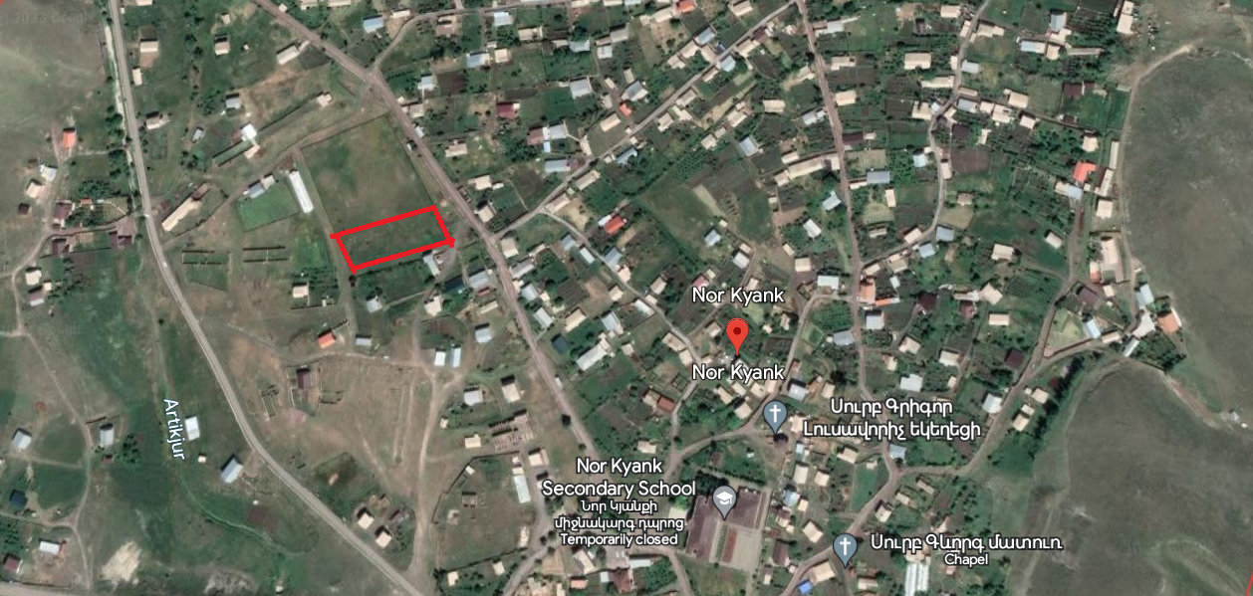

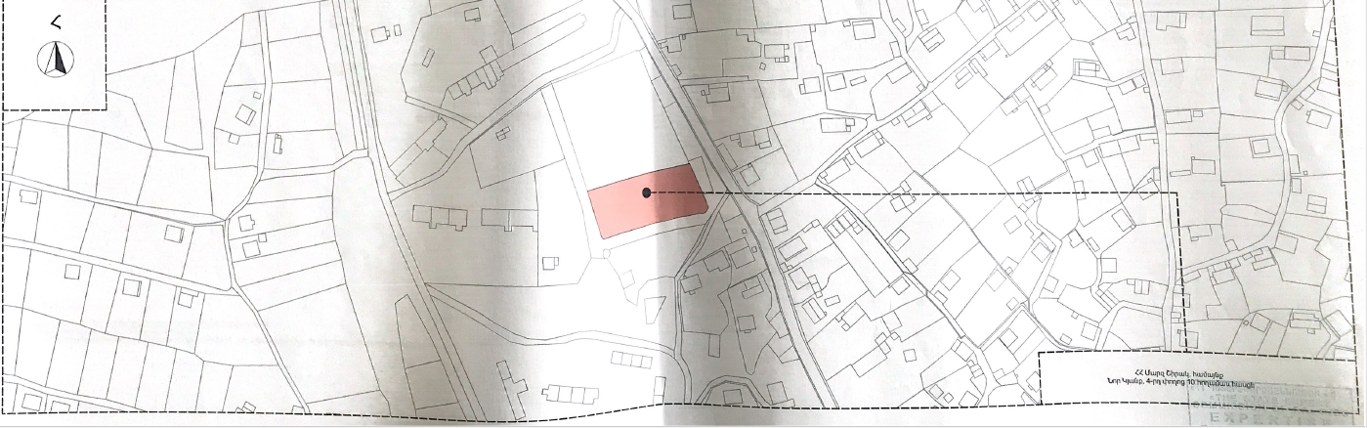

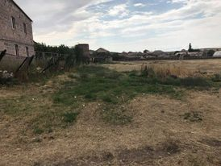 | 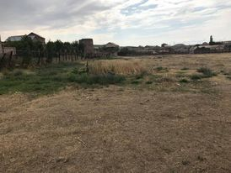

Annex 2: Copy of the land ownership certificate
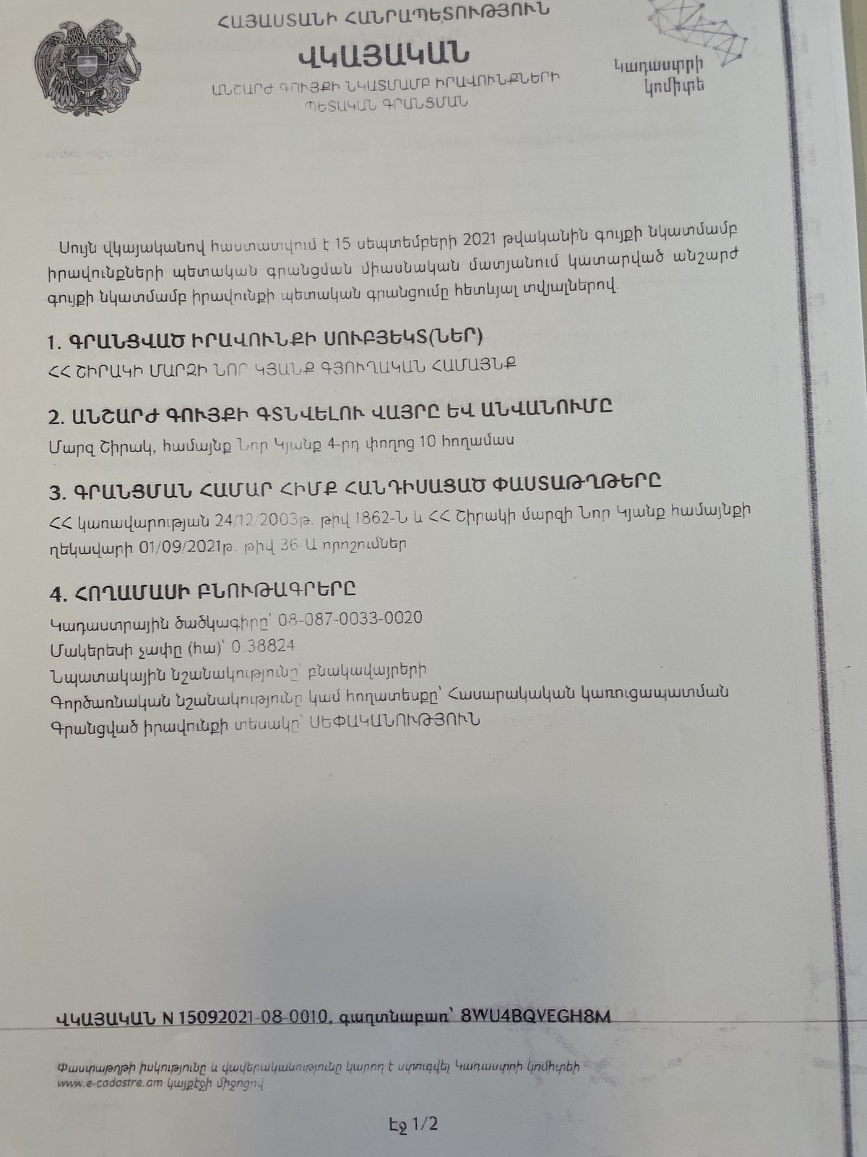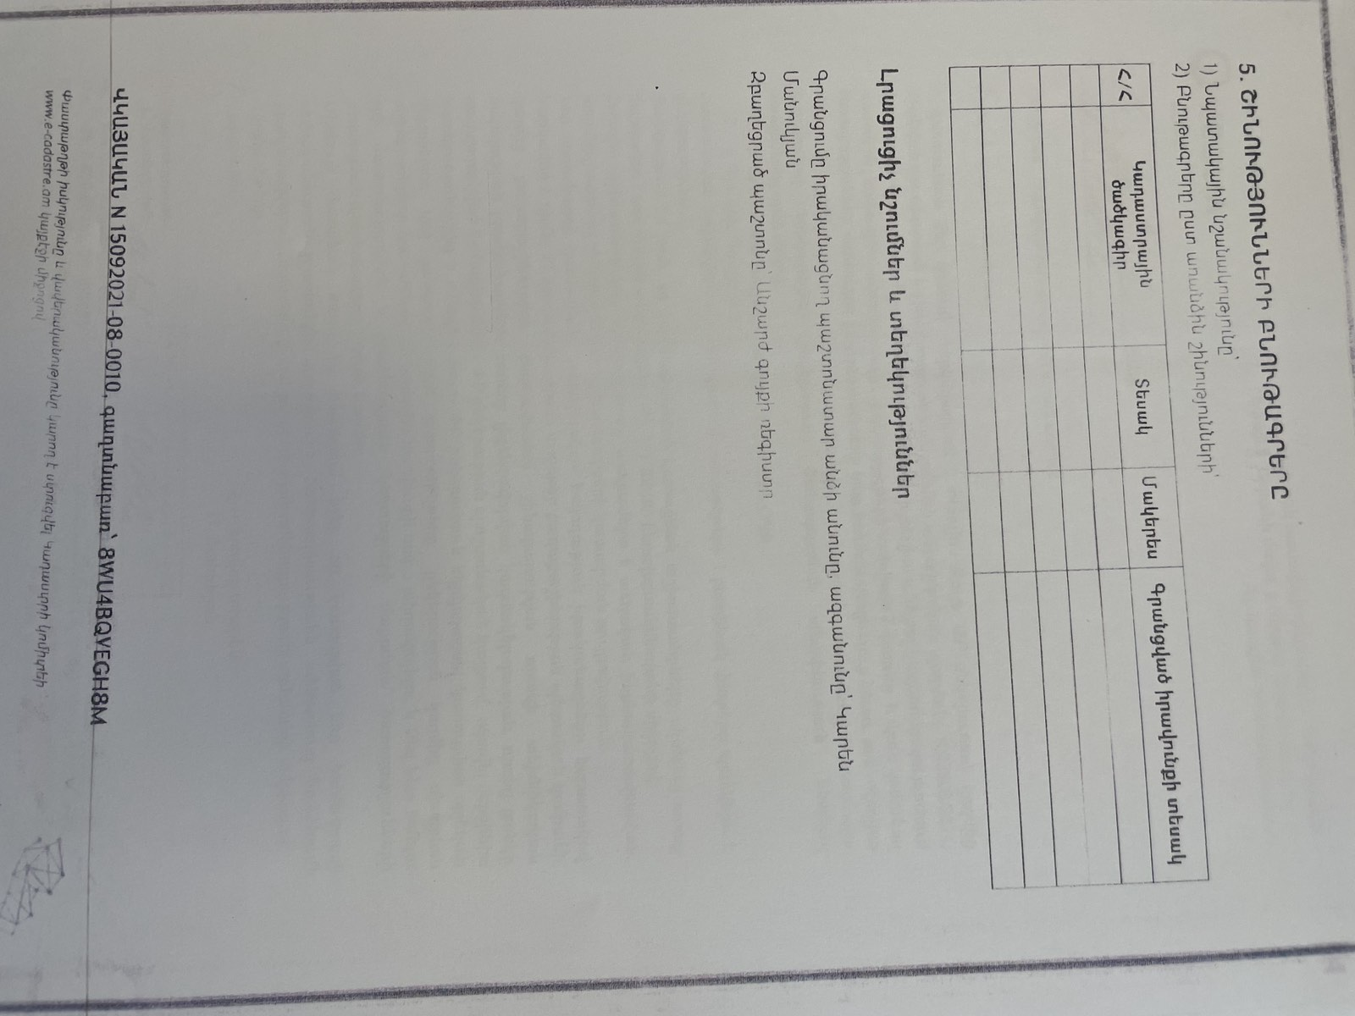

Non-official translation of the above document:
This certificate confirms the state registration of the rights to immovable property in unified register made on September 15, 2021 with the following data.
The subject of the rights registration – Nor Kyank rural community of Shirak marz of RA.
Address and name of the property- Shirak marz, Nor Kyank community, Street 4, land plot 11.
The documents that are the basis for registration-Decree of the Government of RA N1862-N, dated on 24.12.2003 and the decree N36 A of the head of Nor Kyank community of Shirak marz, dated on 01.09.2021.
Data on the Land Plot:
Cadastral Number – 08-087-0033-0020
Purpose of the land plot - Residential
Land use – Public construction
The size of the land plot – 0.38824 ha.
Type of right – ownership

Annex 3: Copy of an agreement for construction waste disposal

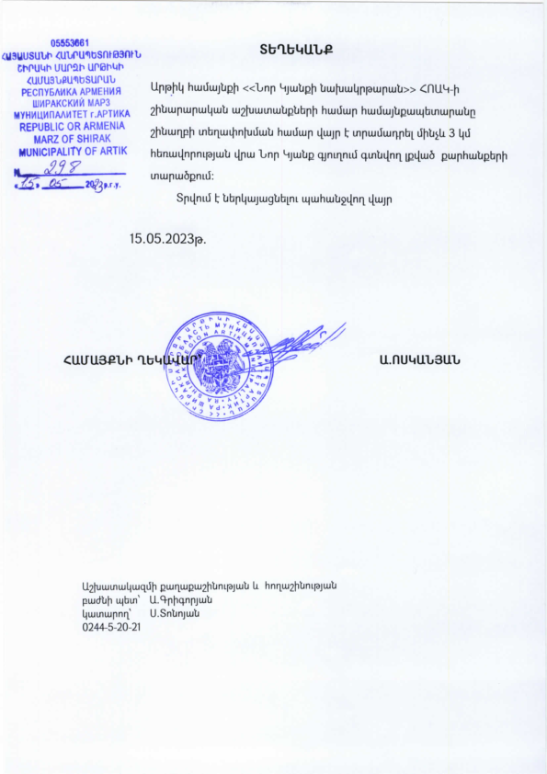

Non-official translation of the above attached document:

Construction waste generated during the construction of the kindergarten in the Nor Kyank settlement should be transported to the abandoned quarry landfill located 3 km far from the construction site.

Head of community Sealed/Signed A. Voskanyan

Annex 4: Minutes of the Public Consultation on the draft ESMP
On June 29, 2023, a public consultation meeting was held in the administrative building of Nor Kyank settlement with the participation of ATDF specialists, representatives of the administrative office of Artik consolidated community and residents of Nor Kyank settlement. Overall, 26 people participated in the meeting, of which 19 were women.
The announcement of the public consultation was posted on the webpage and Facebook account of Nor Kyank settlement on June 23, 2023.
Movses Movsisyan, the head of Development Projects department of Artik community administrative office, opened the meeting and presented the purpose of the meeting and the concept of the micro project.
ATDF appraisal engineer Karen Harutyunyan presented the design package and solutions, including the capacity of the new building, the general plan, dimensions, and the utility network . The estimated duration of the construction works was presented, which is 470 days.
ATDF environmental specialist Asya Osipova presented the expected temporary environmental impacts, including the generation and transportation of construction waste, noise and dust generation due to construction works. The safety measures to be provided were also presented, including the fencing of the construction site, installation of caution tapes in the dangerous areas of the construction site and traffic management, as well as the safety signs installation requirements. The measures for safety of labor were presented, including uniform wearing and personal protective equipment, as well as the requirements on the supply of construction materials and maintenance of construction equipment.
ATDF social specialist Knarik Grigoryan mentioned that no negative social impacts are anticipated under the project, including involuntary resettlement or temporary land use during the construction period. It was also mentioned that the land plot is sufficient for construction works, and a temporary fence and warning signs will be provided.Additionally, the entrance of children to the construction site will be strictly forbidden. It was mentioned that the kindergarten will be provided with ramps and sufficient door widths to ensure the opportunity for inclusive education in the kindergarten.
The Grievance Redress Mechanism (GRM) of the SILD project was presented to the participants of the meeting. The contact information of the local focal point (Movses Movsisyan), elected at the General Community meeting, was also presented. The procedures of submitting, examining and reviewing the grievances were presented. It was mentioned that the information on the GRM will be additionally posted on the information board of the Nor Kyank administrative office and the micro project information board to be installed at the entrance of the construction site.
The supervision and monitoring procedures for the implementation of the measures provided under the ESMP were explained.
Questions were asked.
- A question was asked about the date of launch of the construction works and the tendering process.
It was explained that the micro project is in the tendering phase and the contractor will be chosen in accordance with the procedures of the Law on Procurement of RoA and WB policy. The tendering period will last two months and it is expected that the construction works will be launched in September 2023.

Annex 5: Copy of the Construction Permit (to be provided)

Land acquisitions includes displacement of people, change of livelihood encroachment on private property this is to land that is purchased/transferred and affects people who are living and/or squatters and/or operate a business (kiosks) on land that is being acquired.
Toxic / hazardous material includes but is not limited to asbestos, toxic paints, noxious solvents, removal of lead paint, etc.

