REPUBLIC OF ARMENIA
LOCAL ECONOMY AND INFRASTRUCTURE DEVELOPMENT PROJECT

ENVIRONMENTAL AND SOCIAL MANAGEMENT PLAN
Constructing an Approaching Road for “Apaga Tour” Ltd. Hotel Complex, Communication Line Laying

NOVEMBER 2023

PART A: General Project and Site Information
INSTITUTIONAL & ADMINISTRATIVE
Project title | LOCAL ECONOMY AND INFRASTRUCTURE DEVELOPMENT (LEID)
Sub-project number and title | TUR-PPI_02: Constructing an Approaching Road for “Apaga Tour” Ltd. Hotel Complex, Communication Line Laying
Municipality, community | Yenokavan settlement of Ijevan enlarged community, Tavush Marz (region), RA
Scope of site-specific activity | In the scopes of the sub-project, it is planned to reconstruct about 3km of earth section of the road leading to “Apaga tour” hotel complex from village Yenokavan. Within reconstruction works, the narrow and impassable parts of the road are planned to be widened as much as possible, insuring radiuses, necessary for turns, as well as longitudinal slopes.  The road cover is planned to be implemented with double layer asphalt-concrete, the driveway part width is 4,5m, with ground roadsides and concrete drains for water removal. In the ravine sections, it is planned to lay water removal pipes, while alongside the ravine edge, protecting elements are planned to be installed.  Communication line is planned to be laid through Ijevan –Yenokavan overhead optical cable, alongside “Apaga Tour” hotel complex road edge with the usage of existing electrical communication pillars and installing 201 pcs of new metallic columns.  Construction works will include:  - Road paving with two layer fine grained a/concrete h=7cm- 8890 m2;  - Routes and entrances paving with two layer fine grained a/concrete h=7cm- 227 m2;  - Installation of r/concrete new pre-cast drains (30x34cm)- w-3m, 639 pcs.- 1869 l/m;  - Concrete 30x15cm curbstone laying on B15 class concrete foundation- 934,5 l/m;  - Retaining walls implementation with drainage;  - Roads furnishing with metallic blockers, with crutches concrete paving, road marking and traffic signs installation;  - Polyethylene corrugated culvert pipe D=530mm- 42.8m;  - T type manhole and cast iron covers D=700mm- 82 PCS.  The road surface will be made of two-layer asphalt concrete and be furnished by earth roadside and concrete drainage ditches. The reconstructed section of the road will be equipped with road signs and marked.
Institutional arrangements (WB) | Task Team Leader:  Tafadzwa Irvine Dube |  | Safeguards Specialists:  Lusine Gevorgyan (Environment)  David Jijelava (Social)  Sonya Msryan (Social)
Implementation arrangements (RA) | Implementing entity:  ATDF | Works supervisor:  HALDI consult LLC | Works contractor:  Veh Ishkhanasar LLC and Hydro LLC JV
SITE DESCRIPTION
Name of institution whose premises are to be rehabilitated | Tavush Marz (region), Ijevan community, Yenokavan settlement
Address and site location of institution whose premises are to be rehabilitated | Settlement Yenokavan, Ijevan community, Tavush region
Who owns the land?  Who uses the land (formal/informal)? | The sub-project is located in proximity of Ijevan State Sanctuary. The road widening will be done using community-owned lands (the reference is attached, See attachment 3).  The construction works will be carried out on the community owned lands and the neighboring forestry lands will not be affected during road widening works, A letter from the Forestry Committee, stating no objection to the works to be done under the sub-project, is attached (See Attachment 4).  There are no residential houses or cultivated lands along the road section.  Two other resort complexes are located on the section of the road, as well as a semi constructed building, two pavilions and an open air café. All the businesses located along the road to be reconstructed will benefit from the sub-project. No negative impacts are anticipated on the businesses located in the site. Road closure is not planned under the design.
Description of physical and natural environment around the site | The road to be reconstructed is located in Tavush marz, on the south-eastern slopes of the Gugarats mountain range. The original type of the relief is structural-slanted and is represented by mountains sharply cut on the terrestrial carbonate slope. The road section proposed for reconstruction starts from the existing road, Pk4+480 (Village Cemetery), passes through the outskirts of Yenokavan settlement and ends in the area of Apaga Tour hotel complex, Pk32+80. There are no buildings along the road in the section to be reconstructed. The road section to be reconstructed is an earth road. The climate of the region and the reclaimed road is characterizes by warm and dry summers and cold and windless winters. The neighboring lands of the section of the community road are state owned and "Hayantar" SNCO has given its consent to the road reconstruction works. The area of Yenokavan village including the road section proposed for reconstruction is not included in the territory of the Ijevan state sanctuary. The closest distance between the site and the border of the Ijevan state sanctuary is about 580 m in straight line. In front of "Apaga Tour" hotel is the old cemetery (mausoleum), which is located about 90 m from the road to be reconstructed The road will be widened only in the sections of the U-turns, mountain slopes will be cut and retaining walls will be constructed due to the widening of the road. The road will be widened from the side of the mountain slopes using the community owned land plots (the statement is attached). There is no reserve in the proximity of the affected area.
LEGISLATION
National & local legislation & permits that apply to sub-project activity | The following Armenian legislation defines a legal framework applicable to project activities:  - RA Law on Atmospheric Air Protection (1994)  The purpose of Law on Atmospheric Air Protection is to define main principles of the RA, directed to provision of purity of atmospheric air and improvement of air quality, prevention and mitigation of the chemical, physical, biological and other impacts on air quality and regulation of public relation. This Law also regulates the emission licenses and provides maximum allowed loads / concentrations for atmospheric air pollution, etc.  According to this law, contractor shall undertake construction activities as well as transportation and temporary storage of waste the way to minimize dust and other emissions.  - RA Law on Waste (2004)  The law provides the legal and economic basis for collection, transportation, disposal, treatment, re-use of wastes as well as prevention of negative impacts of waste on natural resources, human life and health. The law defines the roles and responsibilities of the state authorized bodies as well as of waste generator organizations in waste management operations.  According to this law, the waste generated from construction activities should be recycled as appropriate or disposed of in designated locations.  Disposal of the construction waste and excess material in selected locations must be approved by local municipality in writing.  - Law on Environmental Impact Assessment and Expertise of RA (2014)  The law defines type of activities which are subject to environmental impact assessment and expertise. According to this Law, the proposed restoration works are not subject to state environmental impact expertise because the reconstruction activities will not be carried out within the protective areas and forest lands. The reference of Ministry of Environment attached, see attachment 5.  - Law on Urban Development of RA (1998)  This law defines the principles and regulations of urban development activities in the RA. According to this law, planned works requires obtaining the construction permit.  - Labor Code of RA (2005)  This Code regulates collective and individual labor relations, defines the grounds for the origin, modification and termination of these relations and the procedure for their implementation, the rights and responsibilities of the parties to labor relations, as well as the conditions for ensuring the safety and health of employees. According to this law the Contractor must ensure the safety and health of the employees working on the construction site.  - Land Code of RA (2001)  This code defines the legal bases for improving the state regulation of land relations, developing different organizational and legal forms of land management, increasing soil fertility, land use efficiency, maintaining and improving the environment favorable for people's life and health, and protecting rights to land based on the important environmental, economic and social importance, due to which land is used and preserved in the Republic of Armenia as a condition of the people's livelihood.  - Forest Code of RA (2005)  This Code regulates the sustainable management of forests and forest lands of the Republic of Armenia - protection, restoration, afforestation and efficient use, as well as the relations related to forest registration, monitoring; control and forest lands. According to this law forests can be used for cultural, health, sports; recreation and tourism purposes. In areas used for cultural, health, sports, recreation and tourism purposes, natural landscapes, fauna and flora, and water bodies must be preserved. The use of forest lands, the uprooting of trees and bushes in these lands, the construction of roads, pipelines, buildings and structures, the exploitation of mines, the collection of natural wood can be carried out only with the permission of the authorized body.  According to national legislation framework of RA the sub-project requires:  - construction permit  - construction waste disposal permit  - no-objection reference of “Forest committee” SNCO to the planned works  - RA Law on Specially Protected Natural Areas (2006)  This Law defines legal basis and relations of State policy for development, restoration,  maintenance, reproduction and use of natural complex and separate objects, as well as  ecosystems of specially protected natural areas of the Republic. According to the law,  specially protected natural areas are divided into four categories, National Parks, State  Reserves, Natural museums and the forth category is divided into three separate types:  areas of international, republican and local importance.  This law will be used to determine the type of protected areas which the Project may deal  with under specific individual investments, and to clarity that activities suggested for the  Project support do not violate the established regime of protected areas management.  - RA Law on the Preservation and Use of Immovable Monuments of History and Culture and the Historical Environment (1998).  According to this Law the allocation of lands for construction, agricultural and other types of works in the areas of the monuments, development and design projects, engineering communication routes are coordinated with the authorized body in the prescribed manner.
PUBLIC CONSULTATION
When / where the public consultation process will take /took place | The draft ESMP was disclosed and discussed at the public consultation meeting held in Yenokavan village on November 21, 2023, with the participation of ATDF environmental and social specialists, the Head and staff of the Yenokavan Administrative Office, Ijevan Municipality staff and residents of Yenokavan Settlement. Overall, 26 people participated in the meeting, among them 12 were women.  All sub-project affected parties participated in the consultation meeting, including the owners of the private lands and businesses. Draft ESMP had been sent to the beneficiary community in Armenian language and was disclosed on the ATDF (www.atdf.am) website in Armenian and English languages.  The minutes of the meeting is presented in the Attachment 6.
ATTACHMENTS
Attachment 1: Site map/photo
Attachment 2: Permission for construction waste disposal
Attachment 3: The reference of Ijevan Community
Attachment 4: The no-objection reference of “Forest Committee” SNCO to the planned works
Attachment 5: The reference of Ministry of Environment
Attachment 6: Minutes of public consultation on the draft Environmental and Social Management Plan
Attachment 7: Construction permit

PART B: safeguards information
ENVIRONMENTAL /SOCIAL SCREENING
Will the site activity include/involve any of the following? | Activity/Issue | Status | Triggered Actions
Will the site activity include/involve any of the following? | - Road reconstruction | [x] Yes [ ] No | If “Yes”, See Section A below
Will the site activity include/involve any of the following? | - New construction | [ ] Yes [x] No | If “Yes”, See Section A below
Will the site activity include/involve any of the following? | - Individual wastewater treatment system | [ ] Yes [x] No | If “Yes”, See Section B below
Will the site activity include/involve any of the following? | - Historic building(s) and districts | [ ] Yes [x] No | If “Yes”, See Section C below
Will the site activity include/involve any of the following? | - Unexpected need for land take | [ ] Yes [x] No | If “Yes”, See Section D below
Will the site activity include/involve any of the following? | - Hazardous or toxic materials | [ ] Yes [x] No | If “Yes”, See Section E below
Will the site activity include/involve any of the following? | - Impacts on forests and/or protected areas | [X ] Yes [x] No | If “Yes”, See Section F below
Will the site activity include/involve any of the following? | - Handling / management of medical waste | [ ] Yes [x] No | If “Yes”, See Section G below
Will the site activity include/involve any of the following? | - Traffic and pedestrian safety | [x] Yes [ ] No | If “Yes”, See Section H below
Will the site activity include/involve any of the following? | - Social risk management | [x] Yes [ ] No | If “Yes”, See Section I below
PART C: Mitigation measures
ACTIVITY | PARAMETER | MITIGATION MEASURES
0. General Conditions | Notification and Worker Safety | - The local construction and environment inspectorates and communities are notified of upcoming activities  - The public is notified of the works through appropriate notification in the media and/or at publicly accessible sites (including the site of the works)  - All legally required permits are acquired for construction and/or rehabilitation  - The Contractor formally agrees that all work will be carried out in a safe and disciplined manner designed to minimize impacts on neighboring residents and environment.  - Workers’ personal protection equipment complies with international good practice (always hardhats, as needed masks and safety glasses, harnesses and safety boots)  - Appropriate signposting of the sites informs workers of key rules and regulations to follow.
A. General Rehabilitation and /or construction activities | Air Quality | - During earth works, dust is suppressed by ongoing water spraying and/or installing dust screen enclosures at site.  - The surrounding environment (sidewalks, roads) is kept free of debris to minimize dust.  - There is no open burning of construction / waste material at the site.  - There is no excessive idling of construction vehicles at sites.
A. General Rehabilitation and /or construction activities | Noise | - Construction noise is limited to restricted times agreed to in the permit.  - During operations, the engine covers of generators, air compressors and other powered mechanical equipment are closed, and equipment placed as far away from residential areas as possible.
A. General Rehabilitation and /or construction activities | Water Quality | - Appropriate erosion and sediment control measures are applied such as e.g. hay bales and / or silt fences to prevent sediment from moving off site and causing excessive turbidity in nearby streams and rivers.
A. General Rehabilitation and /or construction activities | Waste Management | - Waste collection and disposal pathways and sites are identified for all major waste types expected from demolition and construction activities.  - Mineral construction and demolition wastes are separated from general refuse, organic, liquid and chemical wastes by on-site sorting and stored in appropriate containers.  - Construction waste is being collected and disposed properly by licensed collectors.  - Whenever feasible, appropriate and viable materials (except asbestos) are reused or recycled.
 | Earth Works | - Excess material and topsoil generated from earth works will be stored separately and used for backfilling and site reinstatement.  - Topsoil layer not thicker than 30 m will be stripped separately and temporary piled on-site.  - Stockpile height will not exceed 3.0 m, and the slope angle will not exceed 34º.  - Temporary stockpile will be compacted and covered with a tarp to prevent erosion caused by rain runoff.  - Topsoil will be re-used for backfilling to facilitate re-cultivation of the land plot. Excess amount of subsoil will be disposed at the agreed-upon locations.
F. Affected forests, wetlands and/or protected areas | Protection | - All recognized natural habitats,and protected areas in the immediate vicinity of the activity are not damaged or exploited; all staff is strictly prohibited from hunting, foraging, logging or other damaging activities.  - A survey and an inventory is made of large trees in the vicinity of the construction activity, large trees are marked and cordoned off with fencing; their root system protected, and any damage to the trees avoided.  - There is no unlicensed borrow pits, quarries or waste dumps in adjacent areas, especially not in protected areas.
H. Traffic and pedestrian safety | Direct or indirect hazards to public traffic and pedestrians by construction  activities | In compliance with national regulations, the construction site is properly secured, and construction related traffic regulated. This includes but is not limited to:  - Signposting, warning signs, barriers and traffic diversions: site will be clearly visible, and the public warned of all potential hazards.  - Traffic management system and staff training, especially for site access and near-site heavy traffic. Provision of safe passages and crossings for pedestrians where construction traffic interferes.  - Adjustment of working hours to local traffic patterns, e.g. avoiding major transport activities during rush hours or times of livestock movement.  - Active traffic management by trained and visible staff at the site, if required for safe and convenient passage for the public.  - Ensuring safe and continuous access to office facilities, shops and residences during renovation activities, if the buildings stay open for the public.
I. Social risk management | Public relationship management | - Assign local liaison person in charge of communication with and receiving requests/ complaints from local population.  - Consulted local communities to identify and pro-proactively manage potential conflicts between an external workforce and local people.  - Rise local community awareness about sexually disease risks associated with the presence of an external workforce and include local communities in awareness activities.  - Inform population about construction and work schedules, interruption of the services, traffic detour routes and provisional bus routes, blasting and demolition, as appropriate.  - Limit construction activities at night. When necessary, carefully schedule night-time works and inform affected community so they can take necessary measures.  - At least five days in advance of any service interruption (including water, electricity, telephone, bus routes), advise affected community through postings at the project site, at bus stops, and in affected homes/businesses.
I. Social risk management | Labor management | - To the extent possible, locate work camps away from local communities.  - Undertake sitting and operation of worker camps in consultation with neighboring communities.  - Recruit unskilled or semi-skilled workers from local communities to the extent possible. Where and when feasible, provide worker skills training to enhance participation of local people.  - Provide adequate lavatory facilities (toilets and washing areas) in the work site with adequate supplies of hot and cold running water, soap, and hand drying devices. Establish temporary septic tanks for any residential labor camp and without causing pollution of nearby watercourses.  - Raise awareness of workers on overall relationship management with local population, establish the code of conduct in line with international practice and strictly enforce them, including the dismissal of workers and financial penalties of adequate scale.
I. Social risk management | Grievance Management | - GRM is established and advertised at the local level. The Contractor is informed of his responsibility to register and communicate to the PIU received verbal and non-verbal grievances.  - GRM contact information, including local focal points, has been posted at the construction site and the local community’s administrative office.  - The Contractors' local liaison person receives and registers grievances from the population in the GRM log and communicates the grievances to the PIU regularly.

PART D: Monitoring Plan
Activity | What  (Is the parameter to be monitored?) | Where  (Is the parameter to be monitored?) | How  (Is the parameter to be monitored?) | When  (Define the frequency / or continuous?) | Why  (Is the parameter being monitored?) | Who  (Is responsible for monitoring?)
CONSTRUCTION PHASE
Supply of construction materials | Purchase of construction materials from the licensed suppliers | In supplier’s office or warehouse | Verification of labels of the materials and/or certificates if any | During conclusion of supply contracts | Ensure reliability of construction materials and their safety for human health | ATDF  Technical Supervision Company
Transportation of construction materials and waste;  Movement of construction vehicles and machinery | -Technical condition of construction vehicles and machinery;  -Coverage of loads when carrying dust, soil, spoil and construction waste;  -Movement of construction vehicles and machinery according to predefined traffic routes and within working hours: 9AM-6PM. | -Construction site  - Routes of transportation of construction materials and wastes | Inspection of pre-defined movement routes, entrances and exits of construction sites | Unannounced monthly inspection during work hours and beyond | - Control emissions into the environment;  - Control nuisance to local communities;  - Minimize traffic disruption, ensure pedestrian safety and prevent accidents | ATDF  Technical Supervision Company  Road Police
Maintenance of construction equipment | - Washing of cars and construction equipment outside the construction site or on maximum distance from natural streams;  - Refueling or lubrication of construction equipment outside the construction site or at the predetermined confined area. | Construction site | Inspection of activities | Selective inspections during work hours | - Avoid pollution of water and soil with oil products due to operation and maintenance of equipment and washing runoffs;  -Timely localize oil and lubricant spill-offs, and decrease expected damage in case of fire. | ATDF  Technical Supervision Company
Generation of construction waste | -Temporary storage of waste at the pre-defined areas of construction site;  -Timely disposal of waste at the permitted location. | Construction site  Waste disposal site | Inspection of site | Unannounced monthly inspection during entire construction phase | - Prevent pollution of soil, surface water and ground water;  - Avoid accidents at the construction site due to scattered fragments of construction materials and debris;  - Retain esthetic appearance of the construction site and its surroundings. | ATDF  Technical Supervision Company
Workers’ health and safety | - Provision of uniforms and safety gears to workers and enforcement of their use by the constructor;  - Provision of work-site safety instruction to contractor’s personnel and instructions proper recording;  - Installation of fencing;  - - Ensuring fire extinguisher and medical aid kits at work site. | Construction site | Inspection | Periodically during construction and upon its completion | - Exclude probability of accidents;  -Protect workers’ health. | ATDF  Technical Supervision Company
Works near privately-owned land plots and other property | - Avoid trespassing or incidentally damaging of private property (using small-size machinery or manual labor near walls and fences, stockpiling of construction material and waste away from private property; etc.);  -In case of unintended damage to private property, quickly restore it to the original or better status;  -In case of expected temporary impact on privately-owned property, inform owners upfront and guarantee restoration, acquire written consent of owners for intervention, and promptly restore the damage to the original or better status. | Works near privately-owned land, buildings and other assets | Monitoring and inspection | Entire period of construction | -Reduce the probability of damages on private property;  -Exclude temporary or permanent violation of ownership and/or user rights on the private property. | ATDF  Technical Supervision Company
Tree preservation | - Inventory of existing trees on sub-project site;  - Living trees located near the border of existing road shall be marked and cordoned off with fencing, their root system shall be protected, and any damage to the trees avoided;  - Permit will be obtained from Ijevan municipality before removal of any trees, bushes and stumps. | Construction site | Visual inspection | Entire period of construction | Avoid damage to existing vegetation | ATDF  Technical supervision  company  Ijevan community administrative office
Works near the old cemetery | - stop work in case of unintentional entry into the territory  - Avoid damaging the area of the old cemetery  - Planning and implementation of the rehabilitation works in line with national legislation | The end of the road | Monitoring and inspection | Entire period of construction | To ensure the old cemetery is not damaged by the construction works | ATDF  Technical Supervisor  MoESCS
Works near the protected areas (sanctuary) | - Ensure that the project activities do not have any adverse impacts on technological hazards and environmental degradation  - Planning and implementation of the rehabilitation works in line with national legislation | In the areas of road widening | Monitoring and inspection | Entire period of construction | To ensure the protected area is not damaged by the construction works | ATDF  Technical Supervisor  Ministry of Environment
Community Health and Safety | - Ensure that the project activities do not have any adverse impacts on community health and safety, including exposure to project-related traffic and road safety risks. | Construction site and its neighborhood | Inspection | Periodically during construction and upon its completion | - Exclude the  occurrence of incidents and injuries | ATDF  Technical Supervision Company
Construction site re-cultivation and landscaping | Final cleaning of the construction site and permanent access roads and landscaping-greening of the area as required | Construction site and access roads | Inspection of activities | Final period of construction | Reduce loss of aesthetical value of the landscape due to construction activities | ATDF  Technical Supervision Company
Solid waste management | Trash bins placement and arrangement on periodically transportation of waste | Construction site | Inspection | Total period of construction | - Prevent pollution of soil, surface water and ground water;  - Retain esthetic appearance of the sites area and its surroundings. | ATDF  Technical Supervision Company
Dust control | - Ensuring water spraying measures at site, and timely removal of construction debris;  - Storing bulk materials with the use of banners at site. | Construction site and access roads | Visual inspection | Total period of construction | -Prevent off-site dust spreading and pollution;  -Reduce health risks to the workers and neighboring communities related to dust exposure. | ATDF  Technical Supervision Company
Handling of chance finds | - Stoppage of works promptly upon encountering of chance finds;  - Formal communication with the Ministry of Education, Science, Culture and Sports (MoESCS) of RA on chance finds;  - Timely arrangements made for the conduct of required excavation and site conservation. | Construction site | -Inspection of chance find sites;  - Inspection of field documentation | Entire period of construction | Ensure cultural heritage is not damaged by the construction works. | ATDF  Technical Supervision Company  MoESCS
Earth work | -  -Temporary storage of excavated soil at determined places;  -Backfilling of the excavated ground as needed and disposal of the excess mass to the places, approved in writing. | Construction site | Inspection of activities | During earth works | -Limit loss of vegetation and soil due to ground piling and minimization of potential pollution of surface water reservoirs with particles | ATDF  Technical Supervision Company
Operation of Grievance Redress Mechanism | Public right to complaints or questions about the project.  Appeal to the head of local government (community authorities)  The appointment by the authorities of the Coordinator for the consideration of complaints (receiving complaints, reviewing and explaining, registering complaints in the log book and trying to resolve them on the spot.  Appeal to ATDF by hot-line (010 24 01 59), postal letter (Yerevan 0037, K.Ulnetsi 31), official web page (http://atdf.am/hy/Home/ContactUs), e-mail (support@atdf.am). | Construction site | Inspection of activities | Entire period of construction | Monitor compliance with project aspects;  Timely resolve questions and complaints in the field. | ATDF  Technical Supervision Company
OPERATION PHASE
Maintenance and protection of site | Non-authorized construction and land use in the central part area | Road section | Visual inspection | Total period of operation | Prevent the loss of aesthetical and recreational value of the site | Administrative office
Operation and maintenance of communication line | Regular servicing of the utility networks being undertaken | Road section | Regular technical inspections | Total period of operation | - Maintenance of utility networks in safe and operable condition;  - Avoid disruption of operation of central part area and inconveniences to staff and visitors. | Administrative office

Attachment 1: Site maps and photos

Map 1: Google map snapshot
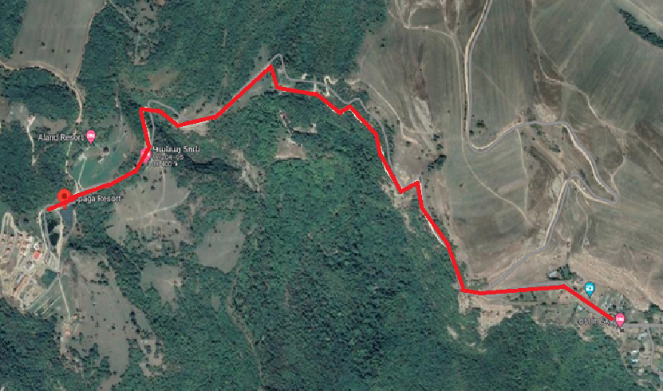

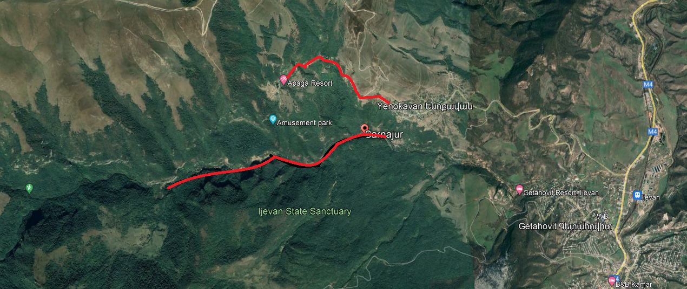
Map 2: Ijevan State Sanctuary border and Road section on the map

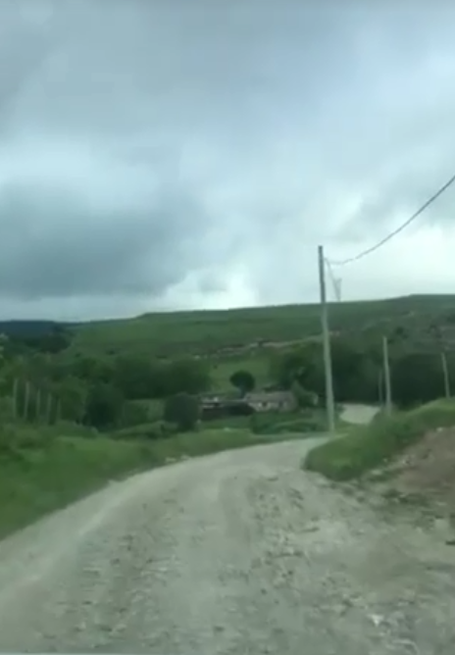  Photo 1: Start of the section | 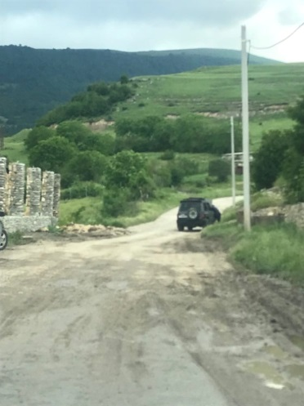  Photo 2:Road section to be rehabilitated | 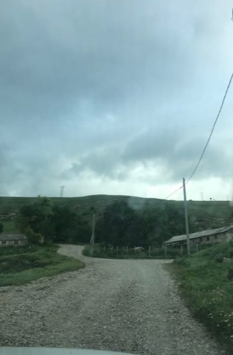  Photo 3: Road section to be rehabilitated | 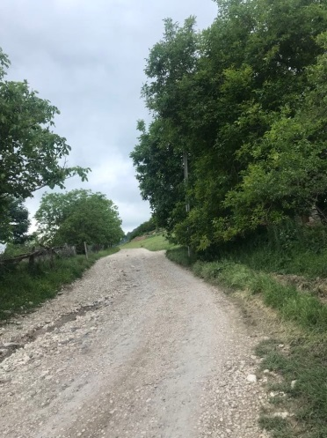  Photo 4: Road section to be rehabilitated
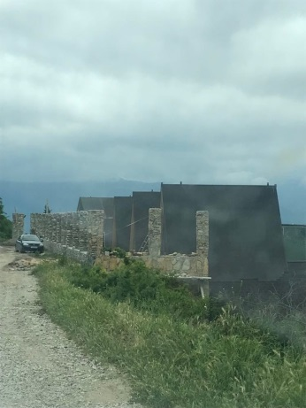  Photo 5: Semi constructed hotel building located on the start of the road | 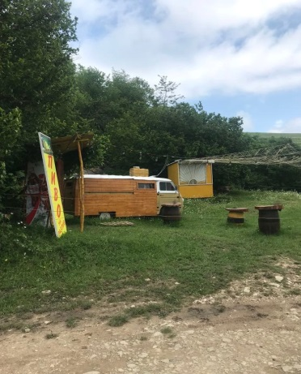  Photo 6: Café located next to the road | 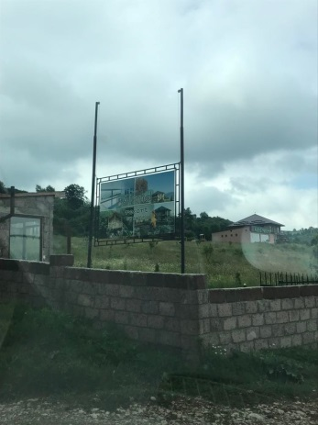  Photo 7: Resort area located along the road | 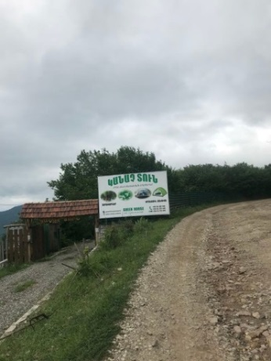  Photo 8: Resort area located along the road section
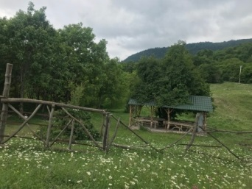
Photo 9: Resort area located along the road section

Attachment 2: Permission for construction waste disposal

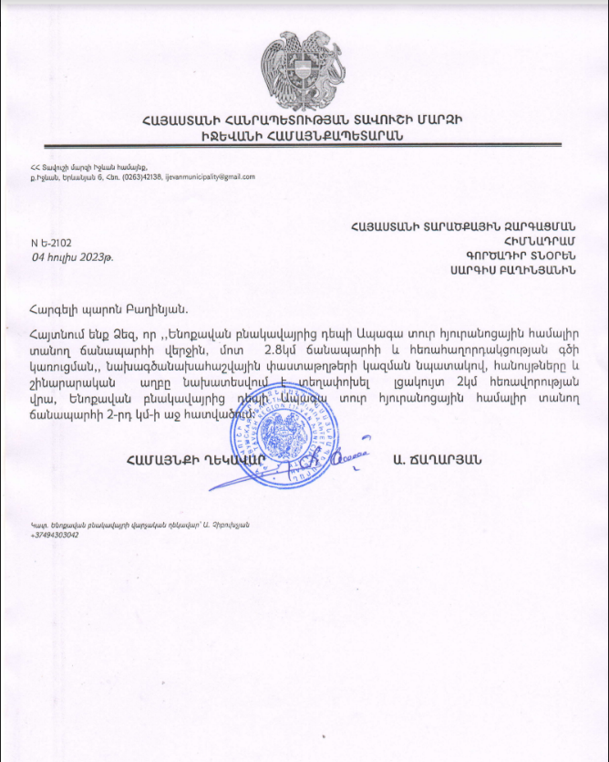

Non-official translation of the above document:
Reference N-Ե-2102
July 04, 2023
This is to certify that the construction waste, generated during the road construction work and communication lines installation is planned to be moved to a landfill located two kilometers away, on the 2nd km of the right side of the road leading from Yenokavan village to the Apaga Tour hotel complex.
Community head A. Tchagharyan /sealed and signed/

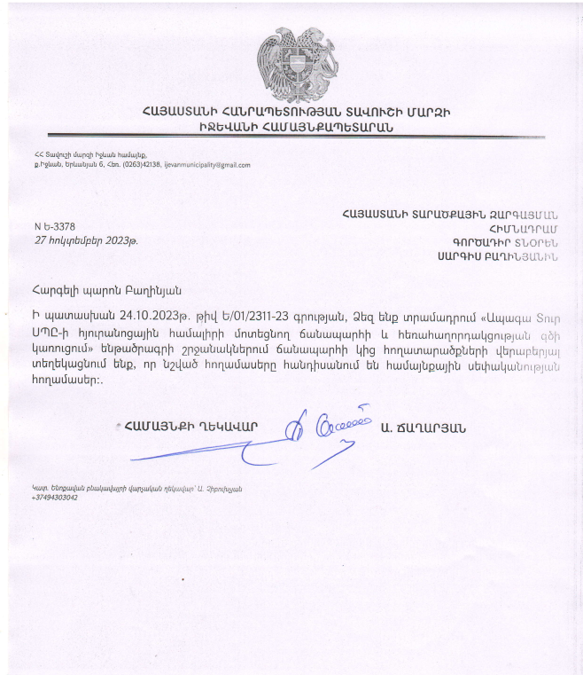
Attachment 3: The reference of Ijevan Community

Summary of the above document
In response to your letter № Ե/01/2311-23, dated on 24-Oct-2023, we inform you regarding the contiguous lands within the framework of the sub-projects “Constructing an Approaching Road for “Apaga Tour” Ltd. Hotel Complex, Communication Line Laying”, that the mentioned lands belongs to the community. Community head A. Tchagharyan /signed/

Attachment 4: The reference of Forest Committee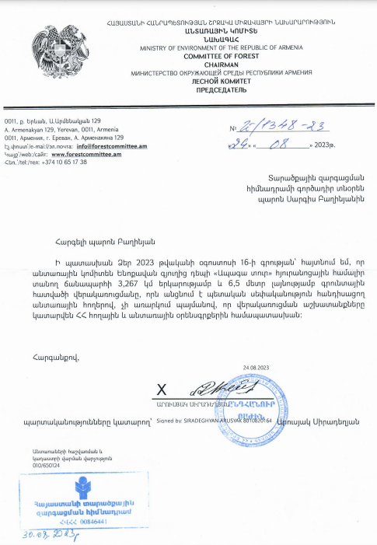

Summary of the above document

In response to your letter dated on August 16 of 2023, I inform you that Forest Committee doesn’t object to the reconstruction works of the road with 3.267km length and 6.5m width leading from Yenokavan settlement to “Apaga Tour” hotel complex, if the reconstruction works will be implemented aligned to the Land and Forestry Codes of RA.

Attachment 5: The reference of Ministry of Environment
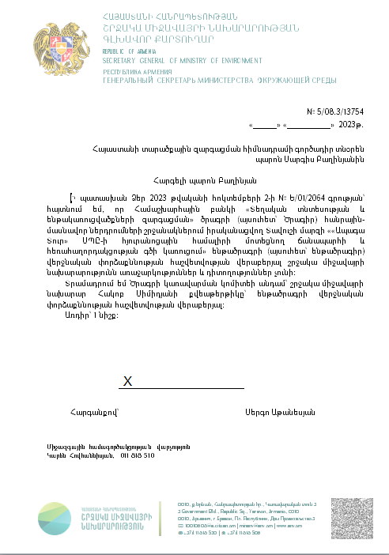Summary of the above document

In response to your letter dated on October 2, 2023 regarding “Constructing an Approaching Road for “Apaga Tour” Ltd. Hotel Complex, Communication Line Laying” subproject, implemented by World Bank “Local Economy And Infrastructure Development Project”, Ministry of Environment has no recommendations or comments about the final expertise report

Attachment 6 Minutes of the public consultation on the draft Environmental and Social Management Plan
On November 21, 2023, a public consultation meeting was held in Yenokavan with the participation of ATDF environmental and social specialists, the Head and staff of the Yenokavan Administrative Office, Ijevan Municipality staff and residents of Yenokavan Settlement. Overall, 26 people participated in the meeting, among them 12 were women.
Andranik Chibukhchyan, the Head of Yenokavan Administrative Office, opened the meeting, presented the purpose of the meeting and the concept of the subproject.
Armine Gabrielyan, ATDF environmental specialist, informed the participants that ATDF had prepared an Environmental and Social Management Plan (ESMP) for subproject “Constructing an Approaching Road for “Apaga Tour” Ltd. Hotel Complex, Communication Line Laying” recreation and entertainment zone. The public consultation meeting was held in Yenokavan to disclose the draft ESMP for the residents to inform them about conducted activities. They were informed about all possible environmental, social, health and safety impacts and their mitigation measures to be implemented during the construction works. Armine Gabrielyan presented the environmental norms and regulations related to construction works. It was mentioned that the envisaged works will not have any impact on protected areas or cultural monuments.
Sona Gevorgyan, ATDF social specialist, mentioned that there were no impacts on private lands. Possible damages caused during the construction related to private properties should be settled by the Contractor․
She emphasized the importance of recording and giving feedback to the questions, suggestions and complaints raised by all interested parties regarding the Project through the Grievance Redress Mechanism (GRM), which will contribute to the effectiveness of Project implementation. She mentioned that at the beginning of the construction works, the Contractor should organize a meeting with the residents in order to inform them about the construction. The residents got informed that their involvement during construction works was encouraged and they could reach out the Contractor for possible work if necessary. She informed the residents that no alternative road had been envisaged during the construction work, and the road should be used with certain restrictions during the construction. Road usage regulations would be provided during the construction.
Armine Gabrielyan explained how the civil works monitoring compliance to the requirements of the presented ESMP would be carried out.
Andranik Chibukhchyan was suggested and selected as a GRM focal point. The procedures of submitting Grievances, their registration in the provided GRM log, examination and review of the Grievances were presented. The information on the GRM was posted on the information board of Yenokavan Administrative Office. The subproject information board should be installed at the entrance of the construction site.
Question: Artak Chibukhchyan, director of “Apaga Tour” LLC, asked a question related to the Project. He specified that at the beginning of the Project a road with a width of 5.4 m was proposed, however in the Project signed by them a 4.5 m wide road had been indicated.
Answer: Originally, a road with a width of 4.5 m was planned, the applicant submitted a proposal for 5.4 m. Based on a number of circumstances, i.e. in order to avoid problems related to financial as well as land acquisition, a 4.5 m wide road was approved in the Project. There would be more than 4.5 m in some parts of the road, particularly in the U-turn.
Question: Tigran Chibukhchyan expressed concern about the cases when tourist buses having 50 seat could meet each other on the same road, highlighting the possibility of RTAs.
Answer: Road pockets were planned every 300m, the visibility of cars would be ensured at that distance. It was planned to widen the road up to 6m in certain sections to ensure safe transport flow.

The photos are presented below.
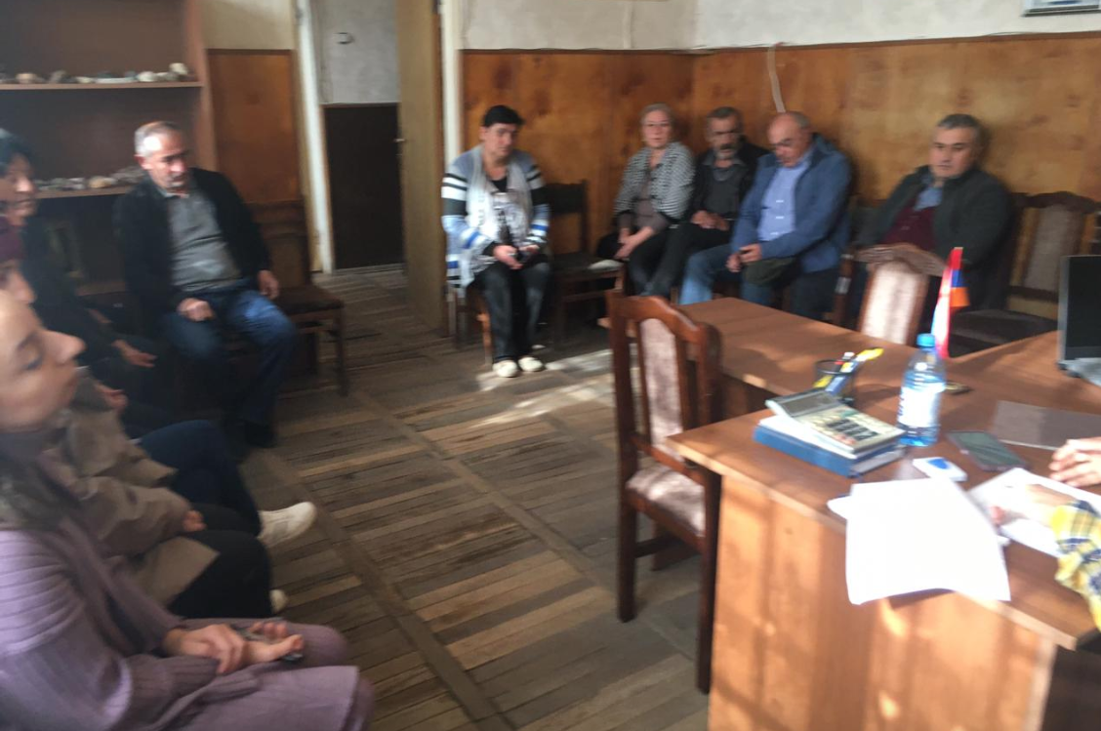 | 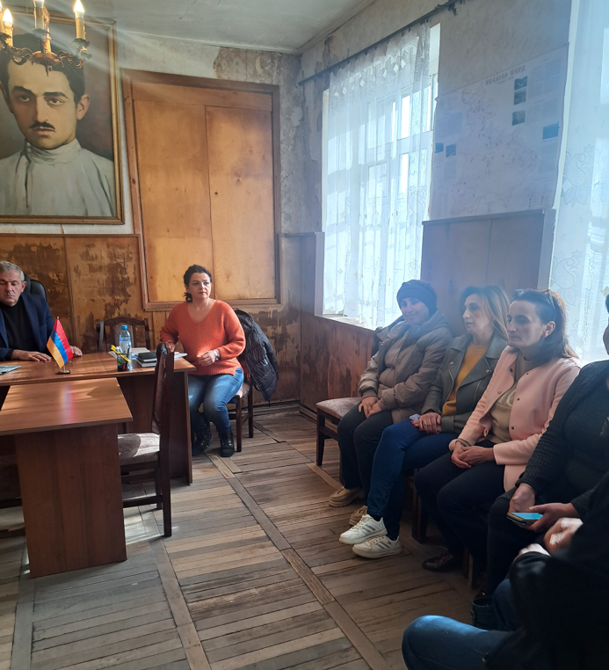
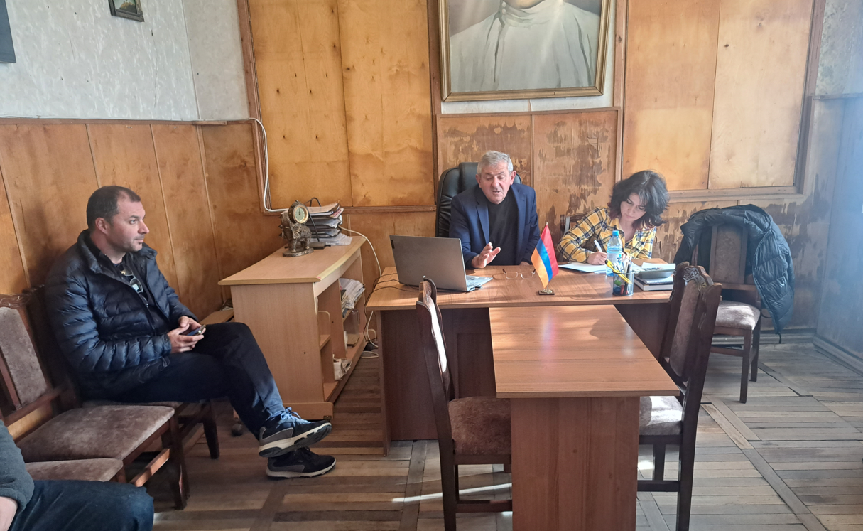 | 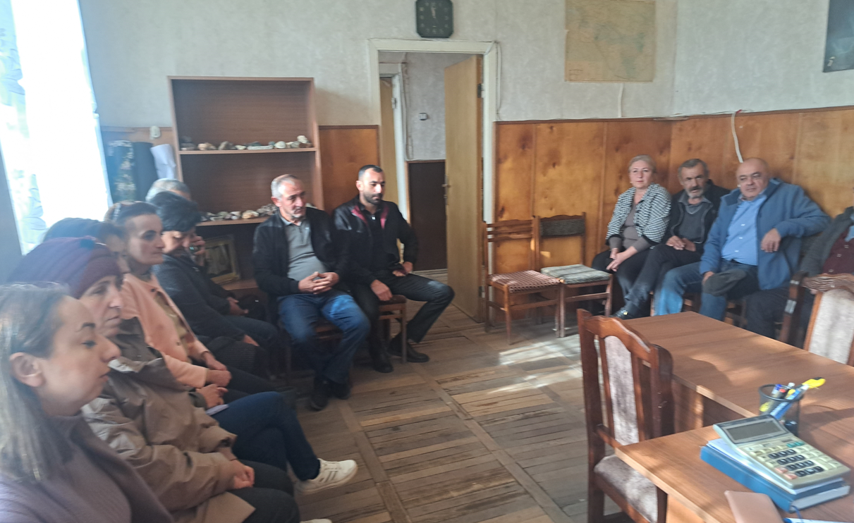

Attachment 7: Construction permit
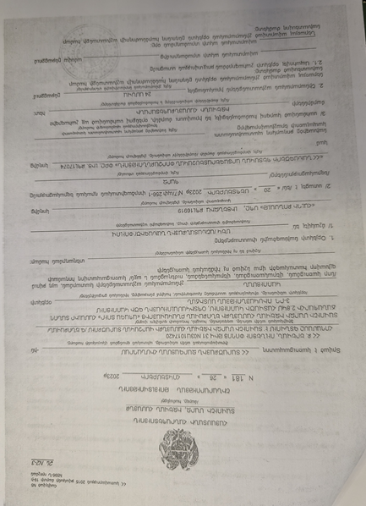

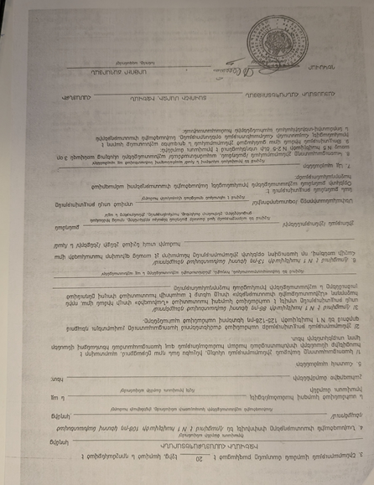
Summary of the above attached document:

Republic of Armenia
Tavush Marz, Ijevan Community
Construction Permit N 181. 26.10.2023
This is given for the “Constructing an Approaching Road for “Apaga Tour” Ltd. Hotel Complex, Communication Line Laying”.
The design documents are
1. Developed by “HALDI Consult” LLC, License 16919
2. The reconstruction will be implemented within 24 month.

A.Tshagharyan Sealed/Signed

Toxic / hazardous material includes but is not limited to asbestos, toxic paints, noxious solvents, removal of lead paint, etc.

