REPUBLIC OF ARMENIA
LOCAL ECONOMY AND INFRASTRUCTURE DEVELOPMENT PROJECT

ENVIRONMENTAL AND SOCIAL MANAGEMENT PLAN
Restoration of the cultural heritage of the Goris city

DECEMBER 2019

PART A: General Project and Site Information
INSTITUTIONAL & ADMINISTRATIVE
Project title | LOCAL ECONOMY AND INFRASTRUCTURE DEVELOPMENT (LEID)
Subproject number and title | TUR-03, Restoration of the cultural heritage of the Goris city
Municipality, community | Goris Community, Syunik marz
Scope of site-specific activity | Restoration works to be performed in the Goris city include:  Restoration of the right bank of Vararakn River  - Installation of 69 lighting poles with a height of 9 m and 36 lamps having 100 LEDs and 33 lamps with 75 LEDs.  - Construction of hiking and cycling routes of 1 km long between the old and new sections of the city of Goris. The road section of the street will be built of basalt cobblestones, sidewalks - of irregular basalt stone slabs and street drainage system - with a basalt open channel.  - Cleaning the riverbed with a length of 1 km - estimated volume of waste is approximately 10 thousand cubic meters;  - Rehabilitation of the river bank supporting walls of the right bank;  - Creating (paving) of pedestrian alleys.  Restoration of the historical-cultural environment of the central part of the Goris city Rehabilitation of the following streets with installation of lighting system is planned: Gusan Ashot-620m, Komitas - 469m, Makichi-281m, Orbelian - 182m, Mashtots - 341, Ankakhutyan - 134m, Tatevatsi- 341m. The road section of the streets will be built of basalt cobles and sidewalks - with irregular 300-600 mm basalt slabs. Totally 214 lighting poles with a height of 9 m and 75 lamps having 75 LEDs will be installed using underground cabling.  Renovation of historical residential houses in the central part of Goris town  It is planned to renovate the roofs, balconies and facades of 36 buildings constructed in 1918-1920 in the central part of Goris town.
Institutional arrangements (WB) | Task Team Leader:  Zaruhi Tokhmakhian |  | Safeguards Specialists:  Hmayak Avagyan (Environment)  Vera Dugandzic (Social)
Implementation arrangements (RoA) | Implementing entity:  ATDF  Asya Osipova (Environment)  Knarik Grigoryan (Social) | Works supervisor:  (to be determined*) |  | Works contractor:  (to be determined*)
SITE DESCRIPTION
Name of institution whose premises are to be rehabilitated | Goris Municipality  Goris City, historic district of Goris,
Address and site location of institution whose premises are to be rehabilitated | Goris City - Gusan Ashot, Komitas, Makich, Orbelyan, Mashtots, Ankakhutyan, Tatevatsi streets.  River Vararakn - street Getapnya
Who owns the land?  Who uses the land (formal/informal)? | The subproject includes restoration works in the central part of Goris and on the right bank of the Vararakn river. All cultural heritage buildings to be restored are state-owned and are in the jurisdiction of Goris municipality. The implementation of subproject does not require acquisition of private land, pastures, water, utilities or other resources. During operation, temporary closure of roads is not expected, so shops, groceries and other facilities will not be closed. The subproject will not result in temporary or permanent loss of crops, fruit trees and / or household infrastructure.  On the left side of the river, on Getapnya street, that is going to be restored in the framework of the subproject, a kiosk is installed on the community land (the total area of the kiosk is 24 square meters). The kiosk is under rent, the renters have organized a fruit and vegetable shop in the place. With the consent of the renter and community the kiosk will be moved to another equivalent community land.  Written consent is obtained from all private owners of the roofs, balconies and facades that are going to be restored in the framework of subproject.
Description of physical and natural environment around the site | The city of Goris is located on the left bank of the tributary of the Vorotan River (r.Vararak). The Vararakn River flows through the city center, has a wide, leveled floodplain, feeds on springs, snow and rainwater. 60% of the annual river flow passes during spring months. In the section of restoration and cleaning works (1 km) river fauna species are not observed, since this section of river is shallow and swampy.  The climate is characterized mainly by moderate hot summers and moderate cold winters; air humidity is 50-70%, wind - 2.5-3.0 m/s. On the territory of the city vegetation is mainly grassy with ​​xerophilous tree species, many large trees with mixed foliage species, as well as plums and pears.
LEGISLATION
National & local legislation & permits that apply to sub-project activity | The following Armenian legislation defines a legal framework applicable to project activities:  - Law on Atmospheric Air Protection of RoA (1994)  The purpose of Law on Atmospheric Air Protection is to define main principles of the RoA, directed to provision of purity of atmospheric air and improvement of air quality, prevention and mitigation of the chemical, physical, biological and other impacts on air quality and regulation of public relation. This Law also regulates the emission licenses and provides maximum allowed loads / concentrations for atmospheric air pollution, etc.  According to this law, contractor shall undertake construction activities as well as transportation and temporary storage of waste the way to minimize dust and other emissions.  - Law on Waste of RoA (2004)  The law provides the legal and economic basis for collection, transportation, disposal, treatment, re-use of wastes as well as prevention of negative impacts of waste on natural resources, human life and health. The law defines the roles and responsibilities of the state authorized bodies as well as of waste generator organizations in waste management operations.  According to this law, the waste generated from construction activities should be recycled as appropriate or disposed of in designated locations.  Disposal of the construction waste and excess material in selected locations must be approved by local municipality in writing.  - Law on Environmental Impact Assessment and Expertise of RoA (2014)  The law defines type of activities which are subject to environmental impact assessment and environmental expertise. According to this Law, the proposed restoration works are not subject to state environmental impact expertise (the buildings are not included in the state inventory lists of historical and cultural monuments.  - Law on Urban Development of RoA (1998)  According to RA national legislation the subproject requires:  - construction permit**  - construction waste disposal permit
PUBLIC CONSULTATION
When / where the public consultation process will take /took place | Public consultation on the draft Environmental and Social Management Plan was carried out in Goris city on 12.16.2019. ESMP will be disclosed on the ADTF website. Brief information on the planned works and contact information for addressing questions and grievance will be placed at the work site and/or in its immediate surroundings.
ATTACHMENTS
Attachment 1: Site map/photo
Attachment 2: Permission for construction waste disposal
Attachment 3; Agreement for the disposal of waste from riverbed cleaning
Attachment 4 : Minutes of public consultation on the draft Environmental and Social Management Plan
Attachment 5: Construction permit (to be provided)
*Information on works supervisor, works provider (contractor), and the attachments will be provided later, prior to mobilization of a selected works provider to a work site.
**The construction permit will be obtained before commencement of works.

PART B: safeguards information
ENVIRONMENTAL /SOCIAL SCREENING
Will the site activity include/involve any of the following? | Activity/Issue | Status | Triggered Actions
Will the site activity include/involve any of the following? | - Building rehabilitation | [x] Yes [] No | If “Yes”, See Section A below
Will the site activity include/involve any of the following? | - New construction | [ ] Yes [x] No | If “Yes”, See Section A below
Will the site activity include/involve any of the following? | - Individual wastewater treatment system | [ ] Yes [x] No | If “Yes”, See Section B below
Will the site activity include/involve any of the following? | - Historic building(s) and districts | [x] Yes [ ] No | If “Yes”, See Section C below
Will the site activity include/involve any of the following? | - Unexpected need for land take | [ ] Yes [x] No | If “Yes”, See Section D below
Will the site activity include/involve any of the following? | - Hazardous or toxic materials | [ ] Yes [x] No | If “Yes”, See Section E below
Will the site activity include/involve any of the following? | - Impacts on forests and/or protected areas | [ ] Yes [x] No | If “Yes”, See Section F below
Will the site activity include/involve any of the following? | - Handling / management of medical waste | [ ] Yes [ x] No | If “Yes”, See Section G below
Will the site activity include/involve any of the following? | - Traffic and pedestrian safety | [] Yes [x] No | If “Yes”, See Section H below
Will the site activity include/involve any of the following? | - Social risk management | [x] Yes [ ] No | If “Yes”, See Section I below
PART C: Mitigation measures
ACTIVITY | PARAMETER | MITIGATION MEASURES
0. General Conditions | Notification and Worker Safety | - The local construction and environment inspectorates and communities are notified of upcoming activities  - The public is notified of the works through appropriate notification in the media and/or at publicly accessible sites (including the site of the works)  - All legally required permits are acquired for construction and/or rehabilitation  - The Contractor formally agrees that all work will be carried out in a safe and disciplined manner designed to minimize impacts on neighboring residents and environment.  - Workers’ personal protection equipment complies with international good practice (always hardhats, as needed masks and safety glasses, harnesses and safety boots)  - Appropriate signposting of the sites informs workers of key rules and regulations to follow.
A. General Rehabilitation and /or construction activities | Air Quality | - During earth works, dust is suppressed by ongoing water spraying and/or installing dust screen enclosures at site.  - The surrounding environment (sidewalks, roads) is kept free of debris to minimize dust.  - There is no open burning of construction / waste material at the site.  - There is no excessive idling of construction vehicles at sites.
A. General Rehabilitation and /or construction activities | Noise | - Construction noise is limited to restricted times agreed to in the permit.  - During operations, the engine covers of generators, air compressors and other powered mechanical equipment are closed, and equipment placed as far away from residential areas as possible.
A. General Rehabilitation and /or construction activities | Water Quality | - Appropriate erosion and sediment control measures are applied such as e.g. hay bales and / or silt fences to prevent sediment from moving off site and causing excessive turbidity in nearby streams and rivers.  - Rainwater is removed from the construction site using a rainwater drainage system, and then into the Vararakn River.
A. General Rehabilitation and /or construction activities | Waste Management | - Waste collection and disposal pathways and sites are identified for all major waste types expected from demolition and construction activities.  - Mineral construction and demolition wastes are separated from general refuse, organic, liquid and chemical wastes by on-site sorting and stored in appropriate containers.  - Construction waste is being collected and disposed properly by licensed collectors.  - Whenever feasible, appropriate and viable materials (except asbestos) are reused or recycled.
B. Individual wastewater treatment system | Water Quality | - The approach to handling sanitary wastes and wastewater from building sites (installation or reconstruction) is approved by the local authorities.  - Before being discharged into receiving waters, effluents from individual wastewater systems are treated in order to meet the minimal quality criteria set out by national guidelines on effluent quality and wastewater treatment.  - Monitoring of new wastewater systems (before/after) is carried out.  - Construction vehicles and machinery are washed only in designated areas where runoff will not pollute natural surface water bodies.
C. Historic building(s) | Cultural Heritage | - If the building is a designated historic structure, very close to such a structure, or located in a designated historic district, notification is made, and approvals/permits be obtained from local authorities and all construction activities planned and carried out in line with local and national legislation.  - Provisions are put in place so that artifacts or other possible chance finds encountered in excavation or construction are noted and registered, responsible officials contacted, and works activities delayed or modified to account for such finds.
D. Unexpected need for land take | Private land ownership/use | - If expropriation of land was not expected but is required, or if loss of access or income of legal or illegal users of land was not expected but may occur, do not enter site and promptly notify the employer  - Do not commence works requiring land take prior to official notice of employer on the completion of involuntary resettlement and full provision of compensation to the affected people
E. Toxic materials | Asbestos management | - If asbestos is located on the project site, it is marked clearly as hazardous material.  - When possible, the asbestos is appropriately contained and sealed to minimize exposure.  - Prior to removal (if removal is necessary), the asbestos is treated with a wetting agent to minimize asbestos dust.  - Asbestos is handled and disposed by skilled & experienced professionals  - If asbestos material is stored temporarily, the wastes are securely enclosed inside closed containments and marked appropriately. Security measures are taken against unauthorized removal from the site.  - The removed asbestos is not reused.
E. Toxic materials | Toxic / hazardous waste management | - Temporarily storage on site of all hazardous or toxic substances is in safe containers labeled with details of composition, properties and handling information.  - The containers of hazardous substances are placed in a leak-proof container to prevent spillage and leaching.  - The wastes are transported by specially licensed carriers and disposed in a licensed facility.  - Paints with toxic ingredients or solvents or lead-based paints are not used.
F. Affected forests, wetlands and/or protected areas | Protection | - All recognized natural habitats, wetlands and protected areas in the immediate vicinity of the activity are not damaged or exploited; all staff is strictly prohibited from hunting, foraging, logging or other damaging activities.  - A survey and an inventory are made of large trees in the vicinity of the construction activity, large trees are marked and cordoned off with fencing; their root system protected, and any damage to the trees avoided.  - Adjacent wetlands and streams are protected from construction site run-off with appropriate erosion and sediment control feature to include by not limited to hay bales and silt fences.  - There is no unlicensed borrow pits, quarries or waste dumps in adjacent areas, especially not in protected areas.
G. Disposal of medical waste | Infrastructure for medical waste management | In compliance with national regulations, the newly constructed and/or rehabilitated health care facilities include sufficient infrastructure for medical waste handling and disposal; this includes and not limited to:  - Special facilities for segregated healthcare waste (including soiled instruments “sharps”, and human tissue or fluids) from other waste disposal;  - Appropriate storage facilities for medical waste are in place; and  - If the activity includes facility-based treatment, appropriate disposal options are in place and operational
H. Traffic and pedestrian safety | Direct or indirect hazards to public traffic and pedestrians by construction  activities | In compliance with national regulations, the construction site is properly secured, and construction related traffic regulated. This includes but is not limited to  - Signposting, warning signs, barriers and traffic diversions: site will be clearly visible, and the public warned of all potential hazards.  - Traffic management system and staff training, especially for site access and near-site heavy traffic. Provision of safe passages and crossings for pedestrians where construction traffic interferes.  - Adjustment of working hours to local traffic patterns, e.g. avoiding major transport activities during rush hours or times of livestock movement.  - Active traffic management by trained and visible staff at the site, if required for safe and convenient passage for the public.  - Ensuring safe and continuous access to office facilities, shops and residences during renovation activities, if the buildings stay open for the public.
I. Social risk management | Public relationship management | - Assign local liaison person in charge of communication with and receiving requests/ complaints from local population.  - Consulted local communities to identify and pro-proactively manage potential conflicts between an external workforce and local people.  - Rise local community awareness about sexually disease risks associated with the presence of an external workforce and include local communities in awareness activities.  - Inform population about construction and work schedules, interruption of the services, traffic detour routes and provisional bus routes, blasting and demolition, as appropriate.  - Limit construction activities at night. When necessary, carefully schedule night-time works and inform affected community so they can take necessary measures.  - At least five days in advance of any service interruption (including water, electricity, telephone, bus routes), advise affected community through postings at the project site, at bus stops, and in affected homes/businesses.
I. Social risk management | Labor management | - To the extent possible, locate work camps away from local communities.  - Undertake sitting and operation of worker camps in consultation with neighboring communities.  - Recruit unskilled or semi-skilled workers from local communities to the extent possible. Where and when feasible, provide worker skills training to enhance participation of local people.  - Provide adequate lavatory facilities (toilets and washing areas) in the work site with adequate supplies of hot and cold running water, soap, and hand drying devices. Establish temporary septic tanks for any residential labor camp and without causing pollution of nearby watercourses.  - Raise awareness of workers on overall relationship management with local population, establish the code of conduct in line with international practice and strictly enforce them, including the dismissal of workers and financial penalties of adequate scale.

PART D: Monitoring Plan
Activity | What  (Is the parameter to be monitored?) | Where  (Is the parameter to be monitored?) | How  (Is the parameter to be monitored?) | When  (Define the frequency / or continuous?) | Why  (Is the parameter being monitored?) |  | Who  (Is responsible for monitoring?)
CONSTRUCTION PHASE
Supply of construction materials | Purchase of construction materials from the licensed suppliers | In supplier’s office or warehouse | Verification of labels of the materials and/or certificates if any | During conclusion of supply contracts | Ensure reliability of construction materials and their safety for human health |  | ATDF  Technical Supervisor
Transportation of construction materials and waste;  Movement of construction vehicles and machinery | Technical condition of construction vehicles and machinery;  Coverage of loads when carrying dust, soil, spoil and construction waste;  Movement of construction vehicles and machinery according to predefined traffic routes and within working hours: 9AM-6PM. | - Construction site  - Routes of transportation of construction materials and wastes | Inspection of pre-defined movement routes, entrances and exits of construction sites | Unannounced monthly inspection during work hours and beyond | To control emissions into the environment;  To control nuisance to local communities;  To minimize traffic disruption, ensure pedestrian safety and prevent accidents |  | ATDF  Technical Supervisor
Maintenance of construction equipment | - Washing of cars and construction equipment outside the construction site or on maximum distance from natural streams  - Refueling or lubrication of construction equipment outside the construction site or at the predetermined confined area | Construction site | Inspection of activities | Selective inspections during work hours | - Avoid pollution of water and soil with oil products due to operation of equipment;  Timely localize and decrease expected damage in case of fire |  | ATDF  Technical Supervisor
Generation of construction waste | -Temporary storage of waste at the pre-defined areas of construction site;  -Timely disposal of waste in the permitted dumpsite | Construction site  Waste disposal site | Inspection of site | Unannounced monthly inspection during entire construction phase | - Prevent pollution of soil, surface water and ground water,  - Avoid accidents at the construction site due to scattered fragments of construction materials and debris,  - Retain esthetic appearance of the construction site and its surroundings |  | ATDF  Technical Supervisor
Works in the waterway | - Washing of construction vehicles and machinery on maximum distance from the waterway;  - Vehicles and machinery are in good technical condition and oil products do not leak to the water;  - Entry /crossing of river bed is prohibited for vehicles/machinery;  - Disposal of waste dragged out of the river at pre-identified sites | Waterway area | Visual inspection | Selective inspection during works | To prevent pollution of the river with oil products and waste |  | ATDF  Technical Supervisor
Deploying manpower for construction | - Provision of uniforms and safety gears to workers and enforcement of their use by the constructor;  - Provision of work-site safety instruction to contractor’s personnel and instructions proper recording;  - Installation of fencing;  - Provisions of nuisance activities within working hours from 9AM-6PM and in accordance with allowed norms of noise and vibrations | Construction site | Inspection | Periodically during construction and upon its completion | To minimize probability of accidents  To protect workers’ health;  To exclude nuisance to neighborhood after working hours; |  | ATDF  Technical Supervisor
Works near privately-owned land plots and other property | Avoid trespassing or incidentally damaging of private property (using small-size machinery or manual labor near walls and fences, stockpiling of construction material and waste away from private property; etc.);  In case of unintended damage to private property, quickly restore it to the original or better status;  In case of expected temporary impact on privately-owned property, inform owners upfront and guarantee restoration, acquire written consent of owners for intervention, and promptly restore the damage to the original or better status. | Works near privately-owned land, buildings and other assets | Monitoring and inspection | Entire period of construction | Reduce the probability of damages on private property  Exclude temporary or permanent violation of ownership and/or user rights on the private property |  | ATDF  Technical Supervisor
Construction site re-cultivation and landscaping | Final cleaning of the construction site and permanent access roads and landscaping-greening of the area as required | Construction site and access roads | Inspection of activities | Final period of construction | Reduce loss of aesthetical value of the landscape due to construction activities |  | ATDF  Technical Supervisor
Solid waste management | Trash bins placement and arrangement on periodically transportation of waste | Construction site | Inspection | Total period of operation | - Prevent pollution of soil, surface water and ground water;  - Retain esthetic appearance of the sites area and its surroundings |  | ATDF  Goris city administrative unit
Dust generation | Air condition on-site | Construction site and access roads | Visual inspection | Recurrent | Reduce risks for the staff and neighboring communities |  | ATDF  Technical Supervisor
Handling of chance finds | - Stoppage of works promptly upon encountering of change finds;  - Formal communication with Agency for the Protection of Monuments and Historical Sites of RA on chance finds;  - Timely arrangements made for the conduct of required excavation and site conservation | Construction site | -Inspection of chance find sites;  - Inspection of filed documentation | Entire period of construction | To ensure cultural heritage is not damaged by the construction works |  | ATDF  Technical Supervisor  Agency for the Protection of Monuments and Historical Sites
Works in the cultural heritage buildings | - Planning and implementation of rehabilitation works in line with national legislation | Construction site | -Inspection of documentation;  - Inspection of activities | Entire period of construction | Prevent loss of cultural heritage |  | ATDF  Technical Supervisor  Agency for the Protection of Monuments and Historical Sites
Earth work | -Topsoil removal and temporary stockpiling for re-cultivation of the land;  -Temporary storage of excavated soil at determined places;  -Backfilling of the excavated ground as needed and disposal of the excess mass to the places, approved in writing. | Construction site | Inspection of activities | During earth works | Limit loss of vegetation due to ground piling and minimization of pollution of surface water reservoirs with particles;  Limit pollution with contaminated soil of surface and ground waters. |  | ATDF  Technical Supervisor
Operation of Grievance Redress Mechanism | Public right to complaints or questions about the project.  Appeal to the head of local government (community authorities)  The appointment by the authorities of the Coordinator for the consideration of complaints (receiving complaints, reviewing and explaining, registering complaints in the log book and trying to resolve them on the spot.  Appeal to ATDF by hot-line (010 24 01 59), postal letter (Yerevan 0037, K.Ulnetsi 31), official web page (http://atdf.am/hy/Home/ContactUs), e-mail (support@atdf.am). | Construction site | Inspection of activities | Entire period of construction | Monitor compliance with project aspects;  Timely resolve questions and complaints in the field. |  | ATDF  Technical Supervisor
OPERATION PHASE
Maintenance and protection of site | Non-authorized construction and land use on the right bank of the river | Rehabilitated site | Inspection | Total period of operation | - Retain esthetic appearance of the sites area and its surroundings |  | Goris city municipality
Operation and maintenance of outdoor lighting system | Regular servicing of the lighting system is being undertaken | Lighting network | Periodic Inspection | Total period of operation |  | Maintenance of lighting system in safe and operable condition |  | Goris city municipality

Attachment 1: Sites photo

Old facades and roofs of 2-3-storey buildings in the historical part of the city.

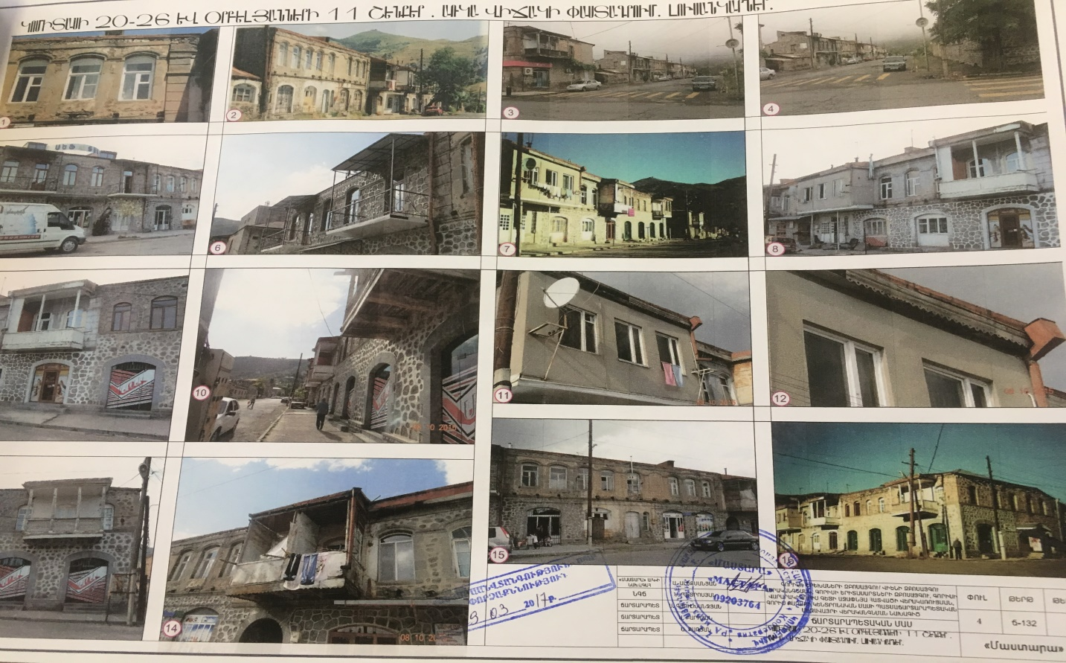
River Vararakn
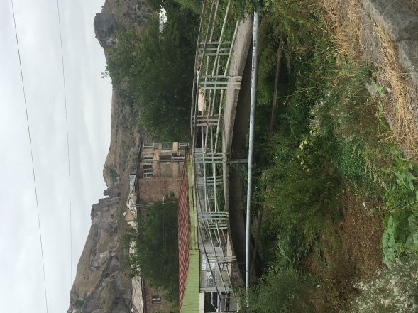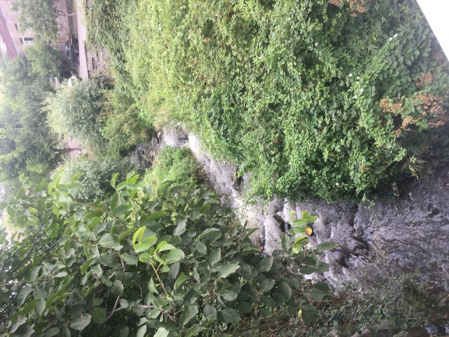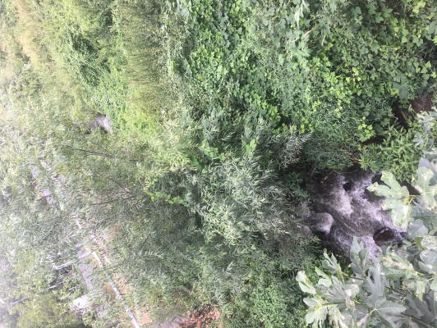

Attachment 2: Permission for construction waste disposal

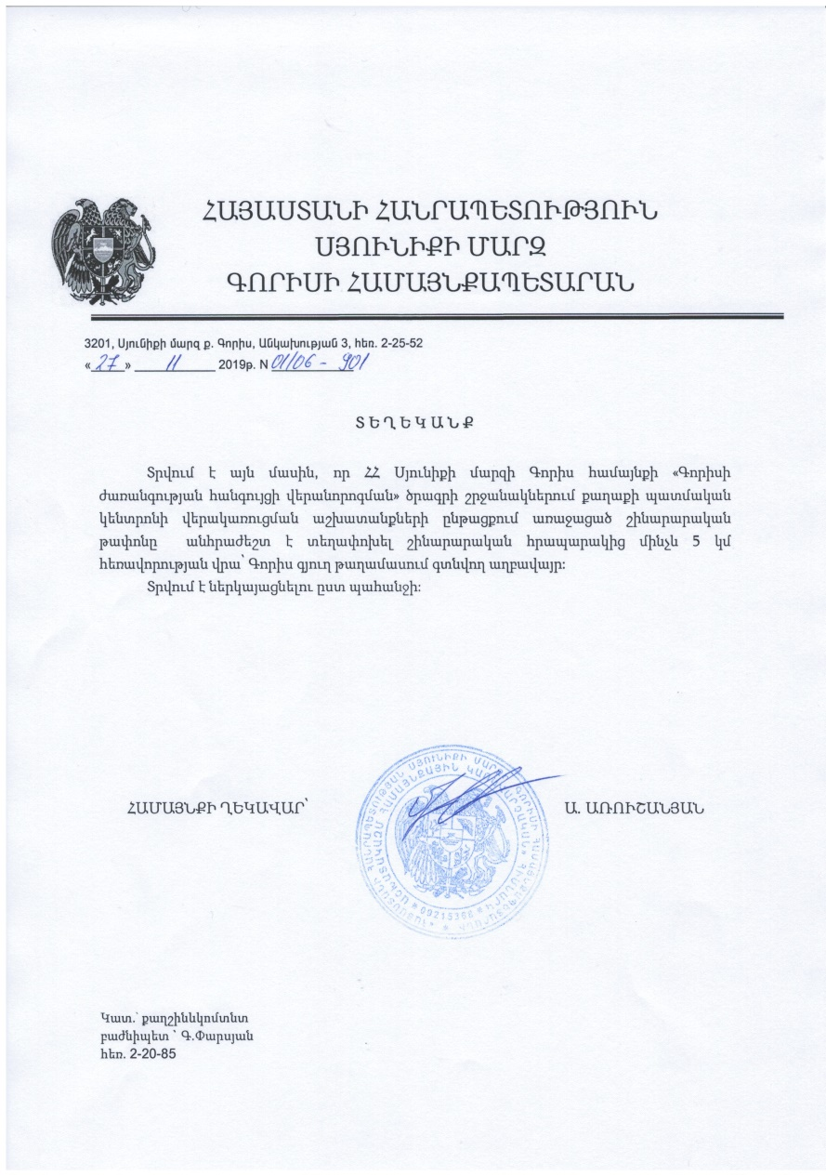
English summary of the above attached document:
27.11. 2019 N 01109-901
The construction waste generated during the implementation of “Restoration of the cultural heritage of the Goris city” Project will be transported to Goris village dumpsite which is located 5 km far from the construction site.
Head of Goris Consolidated Community (Signed) A. Arushanyan

Attachment 3; Agreement for the disposal of waste from riverbed cleaning

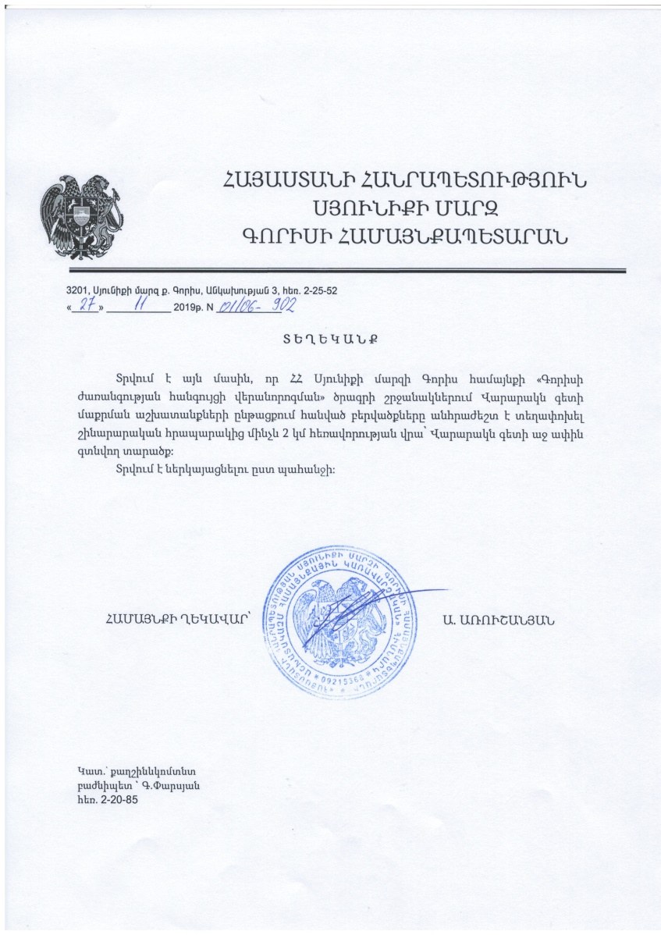

English summary of the above attached document:
27.11. 2019 N 01109-902
The disposal of sediments generated during the cleaning of the Vararak River bed will be transported 2 km to an area located on the right bank of the Vararak River.

Head of Goris Consolidated Community (Signed) A. Arushanyan

Attachment 4 : Minutes of public consultation on the draft Environmental and Social Management Plan

А public consultation meeting was held on the 16th of December, at 12:00, in Goris city Municipality within the framework of “Restoration of the cultural heritage of the Goris city” subproject to be implemented under Local Economy and Infrastructure Development (LEID) Project.
Information on the meeting day and time was posted on information boards of Goris city Municipality and other public visible places of enlarged settlements. The public consultation meeting’s announcement was posted on the website of the Armenian Territorial Development Fund (ATDF) (atdf.am) on December 6, 2019.
The public consultation meeting was carried out by ATDF Environmental Specialist Asya Osipova and Social Specialist Knarik Grigoryan. The meeting was attended by representatives of Goris municipality; overall 19 participants were present at the meeting, among which 11 women.
The chief architecture of Goris city G. Parsyan presented the purpose of the meeting and the speakers of the discussion.
ATDF environmental specialist Asya Osipova introduced the LEID project and “Restoration of the cultural heritage of the Goris city” subproject, including subproject components and the procedure of the subproject implementation.
Asya Osipova described baseline environmental conditions, biophysical and environment of the site. She duly introduced likely negative environmental impacts related to the sub-project implementation including construction and operation phases. A. Osipova outlined anticipated negative impacts including the generation of construction related waste, dust emissions and localized atmospheric air pollution, increase of noise and vibration level during the construction machinery movement and temporary distortion of natural landscape due to construction activities. A. Osipova introduced measures used by ATDF to mitigate potential negative environmental impacts, including relocation of construction waste. It was noted that the ESMP covers the issue of removal and disposal of construction waste and unnecessary soil.
A. Osipova introduced key measures to be undertaken to mitigate adverse environmental impacts and outlined that technical supervisions on monthly basis will keep under control the fulfillment of all the environmental mitigation measures included in ESMP. She highlighted that all sub-project related documents, including ESMP is available on ATDF Web-page and explained where participants can find the documents.
ATDF social specialist Knarik Grigoryan introduced the social safeguards and social impacts of the subproject, including resettlement policy framework developed in the frameworks of LEID project and the Grievance Redress Mechanism (GRM) to be applied during subproject implementation. A focal point was chosen, who will be responsible for the implementation of GRM at the community level. Mr. Parsyan was informed about the complaints receiving procedure and focal point’s responsibilities in the framework of GRM. Beneficiaries were informed that they can also contact ATDF directly to communicate their grievances if they are unable to, or do not wish to go through local point. K. Grigoryan explained all the channels of grievance submission involving the e-mail address, hot line telephone number, postal address and web-site link, outlining that ATDF contact information will also be reflected on the information desk posted in the public visible places of the Community. K. Grigoryan introduced that information on the subproject details permanently will be available on the information desks to ensure that community representatives can raise their voices in case of anxiety. K. Grigoryan also explained participants of the meeting the policy of the project and WB on resettlement issues.
G.Parsyan also proposed to take attention to the fact that construction will take place in the historic center and during the summer months when tourist flows are expected. The municipality and ATDF need to be attentive to the expected impacts of the subproject and supposed mitigation measures, especially to ensure uninterrupted and safe traffic of cars and pedestrians, taking into consideration that streets to be reconstructed are quite narrow.

Photos of the public discussion

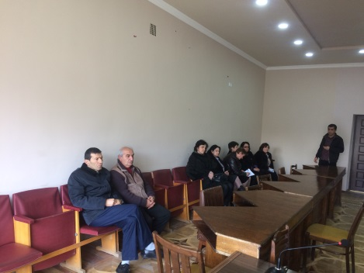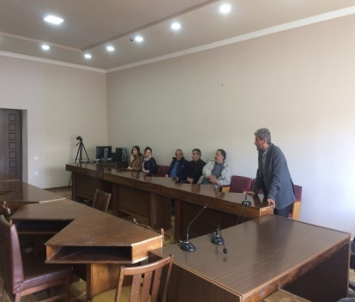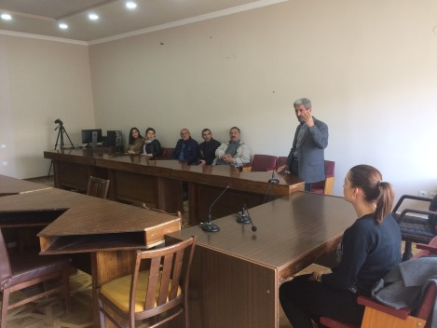

List of participants

Attachment 5: Construction permits (to be provided)

Toxic / hazardous material includes but is not limited to asbestos, toxic paints, noxious solvents, removal of lead paint, etc.

