ARMENIA SOCIAL INVESTMENT AND LOCAL DEVELOPMENT PROJECT

FINAL ENVIRONMENTAL AND SOCIAL REVIEW CHECKLIST

Micro-project title: Construction of a Sewerage System and Bio-treatment Facility in Nor Avan District of Yeghegnadzor City

Micro-project #: AFT-VZ-02

Is the Environmental and Social Management Plan (ESMP) developed?
Yes + No _____

Does ESMP provide a full list of potential impacts and establish adequate measures for their mitigation?
Yes + No _____

Conclusion of the Final Environmental and Social Assessment

Conclusion
Micro-project rejected | Micro-project approved (environmental assessment completed)
 | +

PART A: General Project and Site Information
INSTITUTIONAL & ADMINISTRATIVE
Country | Republic of Armenia
Project title | Social Investment and Local Development Project
Micro-project number and title | AFT-VZ-02 ‘’Construction of a Sewerage System and Bio-treatment Facility in Nor Avan District of Yeghegnadzor City’’
Municipality, community | Yeghegnadzor Community, Vayots Dzor Marz
Scope of site-specific activity | The following construction works are planned under the micro-project:  Construction of the main sewer collector and sixteen sewer lines connected to it, as well as installation of the bio-treatment plant. The sewer system, the total length of which is 6,245 m, is planned to be made of polyethylene corrugated pipes d=150 mm, d=200 mm and d=250 mm. The length of the main sewer collector is 1,726 m, and the total length of sewer lines/branches connecting to the collector is 3,879 m. It is planned to install 191manholes in the system. The main collector crosses the Yerevan-Meghri highway, and the sewer lines/branches cross streams and ravines. Metal protective casings and transition bridges are designed for the crossing of these parts.  At the end of the main sewer collector, it is planned to build a bio-treatment plant consisting of two modules, the productivity of which is 180 cubic meters/day (90 cubic meters/day x 2 modules). The two-module bio-treatment plant is designed for a district or settlement with a population of up to 1,000 people. The population number in the district is 701. The treated water coming out of the bio-treatment plant will be discharged into the Arpa River through a pipeline with a length of about 640 m.  A wastewater discharge permit, allowing the biological treatment plant in Yeghegnadzor to discharge purified water into a natural reservoir, will be issued by the Ministry of Environment based on the application package submitted by Yegheghnadzor community administrative office and will be attached to the ESMP
Institutional arrangements (WB) | Task Team Leader:  Ivan Drabek |  | Safeguards Specialist:  Environment – Darejan Kapanadze  Social – David Jijelava
Implementation arrangements (RoA) | Implementing entity:  ATDF  Environment - Asya Osipova  Social - Knarik Grigoryan | Works Supervisor:  (to be provided after supervisor is selected) |  | Works Contractor:  (to be provided after construction contractor is selected)
SITE DESCRIPTION
Name of institution whose assets are to be rehabilitated | The sewer system to be constructed will be operated by Veolia Jur CJSC
Address and site location | Address: Vayots Dzor region, Yeghegnadzor community, Nor Avan district
Who owns the land? | Land plots proposed to be used under the micro-project are owned by Yeghegnadzor community. The pipelines will be constructed along the existing roads. The land plot (with an area of 864 m²) proposed for the installation of the biological treatment plant is the property of the community.  Land plots proposed for the construction under the micro-project are not formally or informally used for private purposes. There are no private buildings or other assets on the lands affected. The pipeline will not pass through private land plots (see Attachment 3).
Description of physical and natural environment around the site | Nor Avan district of the Yeghegnadzor community does not have a centralized sewage system and, at present, residents of the above-mentioned district use household cesspools. The micro-project plans to construct a sewer network and instal a bio-treatment facility.  The new sewerage network will be constructed along the right bank of the Arpa River, about 120 km southeast of Yerevan.  The climate is subtropical, dry. It is dry here in summer and cold in winter. The average air temperature in January is -5-6°C, the minimum is -22°C, in July +35°C. The average annual rainfall is 300-400 mm, and part of the water penetrates through the minerals and soil. From a geological point of view, the study area is characterized by a sandy-gravel composition. The geological conditions for the work are favorable - landslides, mudflows, saline soils are not observed in the area.  Tree removal is not expected during construction works. Endemic species and plants do not grow on the site. The animal world is scarce - a wolf, a fox, a squirrel, a rabbit are rarely found. There are areas where construction works will be carried out near the carriageway, disruption to local traffic can be expected. In accordance with national legislation, the Contractor will be required to ensure adequate security of the construction site and control of traffic associated with construction. Signs, warning signs, barriers and detours will be in place and the public will be alerted to all potential hazards.  After the construction works, work sites will be reinstated to bled with the natural relief.
LEGISLATION
National & local legislation & permits that apply to project activity | The following Armenian legislation defines a legal framework applicable to project activities:  - Law on Atmospheric Air Protection of RoA (1994)  The purpose of Law on Atmospheric Air Protection is to define the main principles of the RoA, directed to the provision of purity of atmospheric air and improvement of air quality, prevention, and mitigation of the chemical, physical, biological and other impacts on air quality and regulation of public relation. This Law also regulates the emission licenses and provides maximum allowed loads/concentrations for atmospheric air pollution, etc.  According to this law, the contractor shall undertake construction activities as well as transportation and temporary storage of waste the way to minimize dust and other emissions.  - Law on Waste of RoA (2004)  The law provides the legal and economic basis for the collection, transportation, disposal, treatment, re-use of wastes as well as prevention of negative impacts of waste on natural resources, human life, and health. The law defines the roles and responsibilities of the state authorized bodies as well as of waste generator organizations in waste management operations.  According to this law, the waste generated from construction activities should be recycled as appropriate or disposed of in designated locations.  Disposal of the construction waste and excess material in selected locations must be approved by the local municipality in writing.  - Water Code of the RoA (2002)  The Water Code regulates water relations in the RoA. According to article 97, part 7 of the Code, waste water discharge into a water resource is allowed only in the presence of a discharge permit, based on the review of water quality standards.  - Law on Environmental Impact Assessment and Expertise of RoA (2014)  The law defines the type of activities that are subject to environmental impact assessment and environmental expertise. According to this law, the proposed works are not subject to state environmental impact assessment expertise.  Law on Urban Development of RoA (1998)  According to this law, planned works require obtaining a construction permit.
PUBLIC CONSULTATION
When / where the public consultation process will take /took place | The draft ESMP will be disclosed and discussed at the public consultation to be held at the Yeghegnadzor community administrative office with the participation of local residents. Draft ESMP will be disclosed on the ATDF website (www.atdf.am) and the beneficiary's website (www.yeghegnadzor.am).  Brief information on the planned works and contact information for addressing questions and grievances will be placed at the worksite and on the information board of the community administrative office and/or in its immediate surroundings.
ATTACHMENTS
Attachment 1: Photos and maps of the construction site
Attachment 2: Copy of permit for construction waste disposal
Attachment 3: Copy of the reference on ownership of land plots for construction works
Attachment 4: Copy of Wastewater Discharge Permit of the Ministry of Environment (to be provided)
Attachment 5: Minutes of the public consultation on the draft ESMP (to be provided)
Attachment 6: Copy of Construction Permit (to be provided)

PART B: safeguards information
ENVIRONMENTAL /SOCIAL SCREENING
Will the site activity include/involve any of the following? | Activity/Issue | Status | Triggered Actions
Will the site activity include/involve any of the following? | - Reconstruction/ construction of the sewerage system | [+ ] Yes [ ] No | If “Yes”, See Section A, below
Will the site activity include/involve any of the following? | - New construction | [ ] Yes [+ ] No | If “Yes”, See Section A below
Will the site activity include/involve any of the following? | - Individual wastewater treatment system | [+] Yes [ ] No | If “Yes”, See Section B below
Will the site activity include/involve any of the following? | - Historic building(s) and districts | [ ] Yes [+] No | If “Yes”, See Section D below
Will the site activity include/involve any of the following? | - Acquisition of land | [ ] Yes [+] No | If “Yes”, See Section E below
Will the site activity include/involve any of the following? | - Hazardous or toxic materials  - Impacts on forests and/or \protected areas | [ ] Yes [+] No  [ ] Yes [+] No | If “Yes”, See Section F below  If “Yes”, See Section G below
Will the site activity include/involve any of the following? | - Handling / management of medical waste | [ ] Yes [+] No | If “Yes”, See Section H below
Will the site activity include/involve any of the following? | - Traffic and Pedestrian Safety | [+] Yes [ ] No | If “Yes”, See Section I below
Will the site activity include/involve any of the following? | - Social risk | [+] Yes [ ] No | If “Yes”, See Section J below
PART C: Mitigation measures
ACTIVITY | PARAMETER | MITIGATION MEASURES (provide costs where applicable)
0. General Conditions | Notification and Worker Safety | - The local construction and environment inspectorates and communities have been notified of upcoming activities  - The public has been notified of the works through appropriate notification in the media and/or at publicly accessible sites (including the site of the works)  - All legally required permits have been acquired for construction  - The Contractor formally agrees that all work will be carried out in a safe and disciplined manner designed to minimize impacts on neighboring residents and environment.  - Workers’ PPE will comply with international good practice (always hardhats, as needed masks and safety glasses, harnesses and safety boots)  - Appropriate signposting of the sites will inform workers of key rules and regulations to follow.
A. General Construction Activities | Air Quality | - During interior demolition, debris chutes shall be used above the first floor  - Demolition debris shall be kept in controlled area and sprayed with water mist to reduce debris dust  - During pneumatic drilling/wall destruction dust shall be suppressed by ongoing water spraying and/or installing dust screen enclosures at site  - The surrounding environment (sidewalks, roads) shall be kept free of debris to minimize dust  - There will be no open burning of construction / waste material at the site  - There will be no excessive idling of construction vehicles at sites
A. General Construction Activities | Noise | - Construction noise will be limited to restricted times agreed to in the permit  - During operations the engine covers of generators, air compressors and other powered mechanical equipment shall be closed, and equipment placed as far away from residential areas as possible
A. General Construction Activities | Water Quality | - The site will establish appropriate erosion and sediment control measures such as e.g. hay bales and / or silt fences to prevent sediment from moving off site and causing excessive turbidity in nearby streams and rivers.
A. General Construction Activities | Waste Management | - Waste collection and disposal pathways and sites will be identified for all major waste types expected from demolition and construction activities.  - Mineral construction and demolition wastes will be separated from general refuse, organic, liquid and chemical wastes by on-site sorting and stored in appropriate containers.  - Construction waste will be collected and disposed properly by licensed collectors  - The records of waste disposal will be maintained as proof for proper management as designed.  - Whenever feasible the contractor will reuse and recycle appropriate and viable materials (except asbestos)
A. General Construction Activities | Earth Works | - Excess material and topsoil generated from earth works will be stored separately and used for backfilling and site reinstatement  - Topsoil layer not thicker than 30 m will be stripped separately and temporary piled on-site  - Stockpile height will not exceed 3.0 m, and the slope angle will not exceed 34o  - Temporary stockpile will be compacted and covered with a tarp to prevent erosion caused by rain runoff  - Topsoil will be re-used for backfilling to facilitate re-cultivation of the land plot  - Excess amount of subsoil will be disposed at the agreed-upon locations.
B. Individual wastewater treatment system | Water Quality | - The approach to handling sanitary wastes and wastewater from building sites (installation or reconstruction) is approved by the local authorities.  - Before being discharged into receiving waters, effluents from individual wastewater systems are treated in order to meet the minimal quality criteria set out by national guidelines on effluent quality and wastewater treatment.  - Monitoring of new wastewater systems (before/after) is carried out.  Construction vehicles and machinery are washed only in designated areas where runoff will not pollute natural surface water bodies.
H. Traffic and pedestrian safety | Direct or indirect hazards to public traffic and pedestrians because of construction  activities | - In compliance with national regulations the Contractor will ensure that the construction site is properly secured and construction-related traffic is regulated. This includes but is not limited to:  - Signposting, warning signs, barriers and traffic diversions: site will be clearly visible and the public warned of all potential hazards;  - Traffic management system and staff training, especially for site access and near-site heavy traffic;  - Provision of safe passages and crossings for pedestrians where construction traffic interferes;  - Adjustment of working hours to local traffic patterns, e.g. avoiding major transport activities during rush hours or times of livestock movement;  - If required, active traffic management by trained and visible staff at the site for safe passage for the public.  - Ensuring safe and continuous access to all adjacent office facilities, shops and residences during construction.
J. Social risk | Public relationship management | - Assign local liaison person within Contractor’s team to be in charge of communication with and receiving requests/ complaints from local population  - Consult local communities to identify and proactively manage potential conflicts between an external workforce and local people  - Raise local community awareness about sexually transmitted disease risks associated with the presence of an external workforce and include local communities in awareness activities.  - Inform the population about construction and work schedules, interruption of services, traffic detour routes and provisional bus routes, blasting and demolition, as appropriate.  - Limit construction activities at night. When necessary ensure that night work is carefully scheduled, and the community is properly informed, so they can take necessary measures.  - At least five days in advance of any service interruption (including water, electricity, telephone, and bus routes), advice community through postings at the work site, at bus stops, and in affected homes/businesses.  - Address concerns raised through Grievance Redress Mechanism established by the Employer within the designated timeline within the scope of Contractor’s liability  - To the extent possible, work camps should not be located in close proximity to local communities  - Siting and operation of worker camps should be undertaken in consultation with neighboring communities
 | Labor management | - The Contractor will recruit unskilled or semi-skilled workers from local communities to the extent possible. Where and when feasible, worker skills training, should be provided to enhance participation of local people.  - The Contractor will provide adequate lavatory facilities (toilets and washing areas) in the work site with adequate supplies of hot and cold running water, soap, and hand drying devices. A temporary septic tank system should be established for any residential labor camp and without causing pollution of nearby watercourses  - The Contractor will raise awareness of workers on overall relationship management with local population, establish the code of conduct in line with international practice and strictly enforce them, including the dismissal of workers and financial penalties of adequate scale.

Environmental and Social Monitoring Plan for construction and operation phases.

Activity |  |  | What  (Is the parameter to be monitored?) | Where  (Is the parameter to be monitored?) |  | How  (Is the parameter to be monitored?) |  |  | When  (Define the frequency / or continuous?) |  | Why  (Is the parameter being monitored?) |  | Who  (Is responsible for monitoring?)
CONSTRUCTION PHASE
1. Supply of construction materials |  | Purchase of the construction materials from registered suppliers |  | Offices and warehouses of material suppliers |  | Verification of labels of the materials and/or certificates if any |  | In the process of signing the agreements for material provision |  |  | - Ensure technical quality of construction  - Protect human health and environment |  | ATDF  Technical supervision company
2. Transportation of construction materials and waste  Movement of construction equipment |  | - Technical condition of construction vehicles and machinery;  - Adequacy of the loading trucks for transported types of cargo, and canopy coverage of cargo transported in open trucks;  - Movement of construction vehicles and machinery along pre-defined routes |  | Routes for transportation of construction materials and construction wastes |  | Inspection of roads adjacent to the construction site and included in the agreed-upon routes of transportation |  | Unannounced checks during the working hours |  |  | - Avoid air and road pollution with dust and solid matter;  - Reduce traffic disruption  - Limit nuisance to local communities from noise |  | ATDF  Technical supervision company  Road Police
3. Maintenance of construction equipment |  | - Washing of cars and construction equipment outside the construction site or on maximum distance from natural streams;  - Refuelling or lubrication of construction equipment outside the construction site or at the predetermined confined area. |  | Construction site |  | Inspection of activities |  | Selective inspections during work hours |  |  | - Avoid pollution of water and soil with oil products due to operation of equipment;  - Timely localize and decrease expected damage in case of fire. |  | ATDF  Technical supervision company
4. Generation of construction waste |  | - Temporary storage of construction waste in especially allocated areas;  - Temporary storage of inert and hazardous wastes separately at the designated locations;  - Timely disposal of waste to the formally designated landfills |  | Construction site and base (if applicable);  Locations designated for waste disposal |  | Checking documents  Visual observation |  | Entire period of construction |  |  | - Prevent pollution of soil, surface water and ground water,  - Avoid accidents at the construction site due to scattered fragments of construction materials and debris,  - Retain aesthetic appearance of the construction site and its surroundings |  | ATDF  Technical supervision company  Yeghegnadzor administrative office
5. Accumulation of household waste |  | - Provision of waste containers on-site;  - Agreement with local municipality for regular out-transporting of waste |  | Construction site and base (if applicable) |  | Visual inspection |  | Entire period of construction |  |  | Avoid pollution of soil and water with household waste |  | ATDF  Technical supervision company  Yeghegnadzor administrative office
6. Safety of labor |  | - Construction workers wearing uniforms and PPE (hardhats, masks, safety glasses, harnesses and safety boots, etc.);  - Strict compliance with the rules of construction equipment operation and usage of PPE;  - Availability of labor safety training and instruction records;  - First aide medical kits and fire extinguishers are available at work site;  - Contact information for emergency services (medical, fire) posted on the information board at work site. |  | Construction site |  | Inspection of the activities |  | Entire period of construction |  |  | Reduce the probability of accidents |  | ATDF  Technical supervision company
7. Earthworks |  | Topsoil removal and temporary stockpiling for re-cultivation of the land;  - Temporary storage of excavated soil at determined places;  - Backfilling of the excavated ground as needed and disposal of the excess mass to the places, approved in writing |  | Construction site |  | Inspection of activities |  | During earth works |  |  | - Limit loss of vegetation due to ground piling and minimization of pollution of surface waters with particles;  - Limit pollution with contaminated soil of surface and ground waters |  | ATDF  Technical supervision company
8. Extraction of inert material |  | - Purchase of inert materials from the existing suppliers, if there is such opportunity;  - Obtaining the license for production of inert materials and strict compliance with the license;  - Terracing of quarries, backfilling of exploited areas and harmonization with the landscape;  - Excavating gravel outside water flow, arrangement of separating ridges between water flow and excavation area, banning entrance of watery by vehicles and machinery |  | Quarries of inert materials |  | Inspection of documents  Inspection of activities |  | During excavation and reclamation at quarries |  |  | - Limit slope erosion and landscape damage  - Limit erosion of riverbanks, pollution of water flow with weighted particles and disturbance of aquatic life |  | ATDF  Technical supervision company
9.Works near privately-owned land plots and other property |  | - Avoid trespassing or incidentally damaging of private property (using small-size machinery or manual labor near walls and fences, stockpiling of construction material and waste away from private property; etc.);  - In case of unintended damage to private property, quickly restore it to the original or better status;  - In case of expected temporary impact on privately-owned property, inform owners upfront and guarantee restoration, acquire written consent of owners for intervention, and promptly restore the damage to the original or better status;  - If an unexpected need for land take emerges in the course of works, do not enter the affected site before development and full implementation of the Resettlement Action Plan by ATDF |  | Works near privately-owned land, buildings and other assets |  | Monitoring and inspection |  | Entire period of construction |  |  | Reduce the probability of damages on private property  Exclude temporary or permanent violation of ownership and/or user rights on the private property |  | ATDF  Techncial Supervision company
10. Handling of chance finds |  | - Stoppage of works promptly upon encountering of chance finds;  - Formal communication with Agency for the Protection of Monuments and Historical Sites of RA on chance finds;  - Timely arrangements made for the conduct of required excavation and site conservation |  | Construction site |  | -Inspection of chance find sites;  - Inspection of filed document |  | Entire period of construction |  |  | Ensure cultural heritage is not damaged by the construction works |  | ATDF  Technical supervision company  Agency for the Protection of Monuments and Historical Sites
11.Construction site re-cultivation and landscaping |  | Final cleaning of the rehabilitation site and permanent access roads and landscaping-greening of the area as required |  | Construction site and access roads |  | Inspection of activities |  | Final period of construction |  |  | Reduce loss of aesthetical value of the landscape due to construction activities |  | ATDF  Technical supervision company
12.Grievance redress mechanism (GRM) |  | - ATDF GRM information is available and visible to the public;  - The appointment by the authorities of the Coordinator for the consideration of complaints (receiving complaints, reviewing and explaining, registering complaints in the log book and trying to resolve them on the spot);  - Appeal to ATDF by hot-line (010 24 01 59), postal letter (Yerevan 0037, K.Ulnetsi 31), official web page (http://atdf.am/hy/Home/ContactUs), e-mail (support@atdf.am) |  | At locations for posting GRM information;  ATDF office |  | Inspection |  | Monthly visits during construction |  |  | Provide for all citizens in the community a channel to voice questions, feedback or complaints related to construction works |  | ATDF  Technical supervision company
13.Nuisance to nearby residents caused by improper parking of construction machinery and vehicles, temporary storage of construction material and waste, or littering around the construction site by contractors |  | - No parking of construction vehicles and machinery outside the construction site;  - No blocking of pedestrian and vehicle movement around the construction site due to stockpiling/ dumping of construction materials/waste;  - No trespassing of private land plots and/or other property around the construction site by contractor’s personnel. |  |  | In the immediate vicinity of the construction site | Visual inspection |  | Monthly visits, or if notified by contractor or citizens |  |  | Prevent negative impacts on property, assets or livelihoods |  | ATDF  Technical supervision company
OPERATION PHASE
Operation and maintenance of sewage collection piping and treatment unit | - Leakages of waste water from sewage scheme;  - Smoothly operation of sewage water treatment unit. |  |  | Sewage scheme and installed treatment facility |  | Instrumental quality testing of treated sewage according to approved safety parameters. | During operation phase |  |  | Prevent water-borne diseases  Prevent pollution of surface and ground water, soils |  | Yeghegnadzor administrative office  Veolia Jur CJSC

Attachment 1: Photos and maps of the construction site

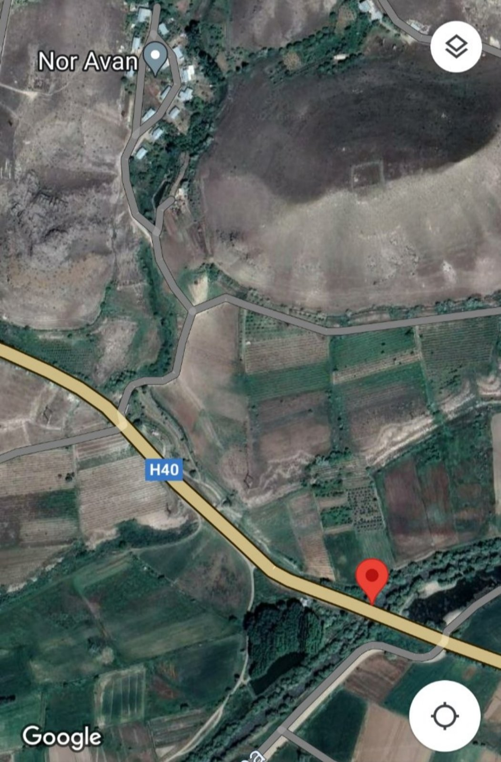

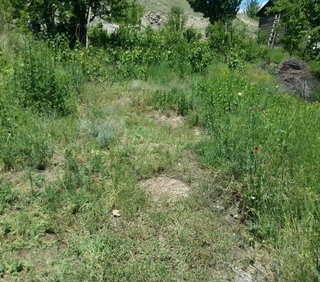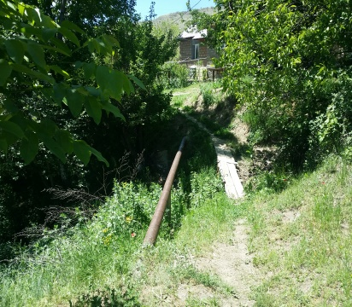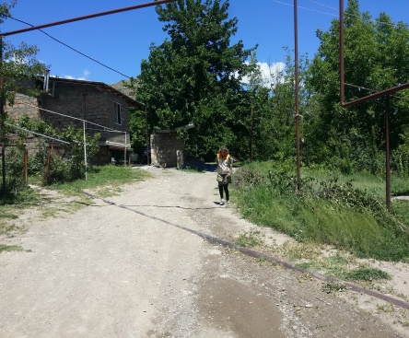
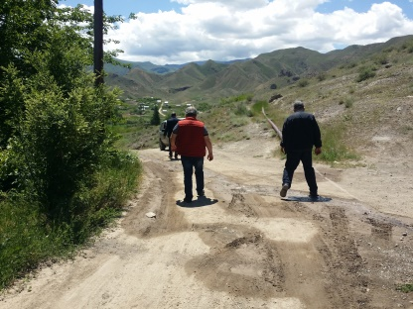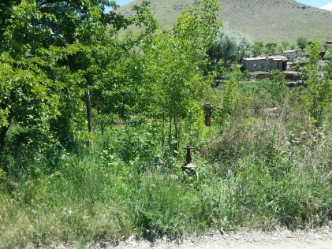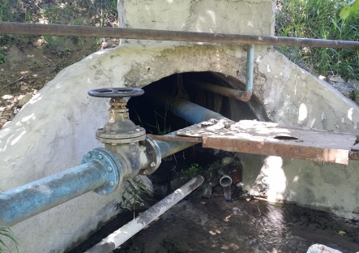
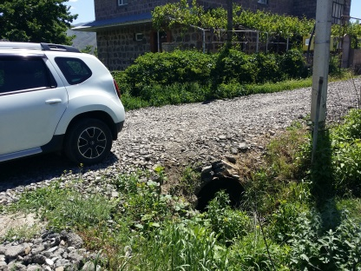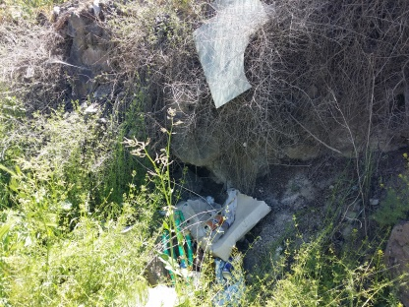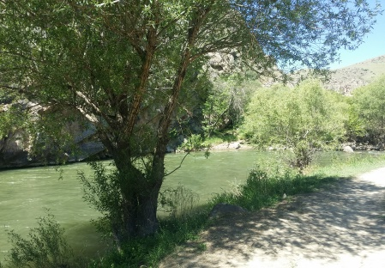
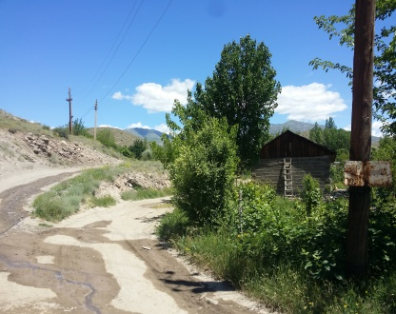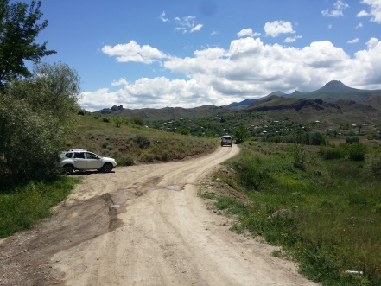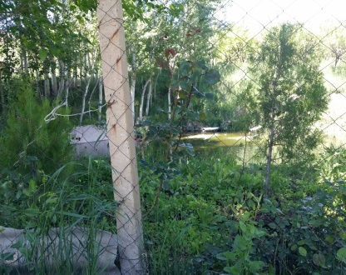
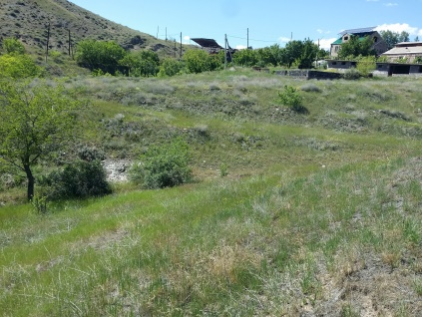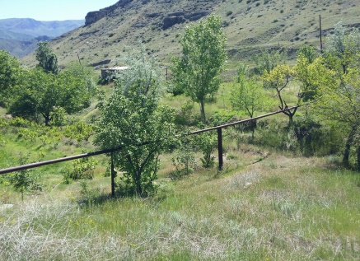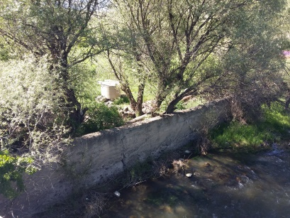

Attachment 2: Copy of construction waste disposal permit

English summary of the above document:

REFERENCE
Is given to state that the construction waste generated during the civil works under the “Construction of a Sewerage System and Bio-treatment Station in Nor Avan District of Yeghegnadzor City” micro-project will be transported to the municipal landfil located in600-800 m distance from the construction site.

Head of the Community Sealed/Signed D. Harutyunyan

Attachment 3: Reference on the ownership of land plots for construction works

Non-official translation:
REFERENCE
Is given to state that the construction works planned under the “Construction of a Sewerage System and Bio-treatment Station in Nor Avan District of Yeghegnadzor City” micro-project will be conducted on the community-owned lands, and the designed sewer pipeline will not cross any private owned or rented land plot.

Head of the Community Sealed/Signed D. Harutyunyan

Attachment 4: Copy of Wastewater Discharge Permit of the Ministry of Environment

Attachment 5: Minutes of the public consultation on the draft Environmental and Social Management Plan

Attachment 6: Copy of the Construction Permit

Land acquisitions includes displacement of people, change of livelihood encroachment on private property this is to land that is purchased/transferred and affects people who are living and/or squatters and/or operate a business (kiosks) on land that is being acquired.
Toxic / hazardous material includes but is not limited to asbestos, toxic paints, noxious solvents, removal of lead paint, etc.

