REPUBLIC OF ARMENIA
LOCAL ECONOMY AND INFRASTRUCTURE DEVELOPMENT PROJECT

ENVIRONMENTAL AND SOCIAL MANAGEMENT PLAN

“Reconstruction of tourism infrastructure and roads of Gyumri city”

Component1: Restoration of Khanjyan and Tchaykovski streets.
Component4: Restoration of the Haghtanak avenue

MArch 2023

PART A: General Project and Site Information
INSTITUTIONAL & ADMINISTRATIVE
Project title | LOCAL ECONOMY AND INFRASTRUCTURE DEVELOPMENT
Subproject number and title | TUR-13, Reconstruction of Tourism Infrastructure and Roads of Gyumri City  Component1: Restoration of Khanjyan and Tchaykovski streets.  Component4: Restoration of the Haghtanak avenue
Municipality, community | Gyumri city, Shirak marz
Scope of site-specific activity | The revival of the cultural center "Kumayri" is the main goal of this subproject. The streets of Khanjyan, Tchhaikovsky, as well as Haghtanak avenue are part of the small center of the city of Gyumri and are an integral part of the cultural center of Kumayri.  The components include the following activities:  On Khanjyan Street: replacement of the asphalt cover of the traffic area with all sub-layers; rehabilitation of the sidewalks by paving with concrete slabs/ tiles; expansion of the traffic area at the left sidewalk (7m) for parking spaces; furnishing of the Street, road marking, installation of traffic signs; adaptation of the area for the people with limited mobility (construction of ramps, installation of special paving intended for people with impaired vision); reconstruction of the rainwater drainage system; rehabilitation/ reconstruction of the sewer line; arrangement of water line manholes; organization of external lighting; replacement of some sections of the existing overground gas supply lines by underground pipes; dismantling of the non-operational lines/poles of the electric transport; improvement of the area - installation of benches, trash cans, tourist signboards.  On Tchaikovsky Street: revision of the dimensions of the traffic area and sidewalks; rehabilitation of the street section along “Friendship” park with construction of an U-turn platform at the end; implementation of asphalt cover with all sub-layers; construction of sidewalks with concrete slab paving; relocation of the power supply line from the left sidewalk to the right sid; replacement of some sections of the existing over ground communication lines by underground lines; street furnishing, road marking, installation of traffic signs; adaptation of the area for people with limited mobility (construction of ramps, installation of pavement intended for people with impaired vision); arrangement of water line manholes; organization of external lighting; improvement of the area - installation of trash cans.  Haghtanak avenue: rehabilitation/ reconstruction of two traffic areas of Haghtanak avenue and of the short sections of the road connecting these areas; furnishing and marking the avenue; installation of street lights and traffic signs; reconstruction and pavement of the sidewalks with concrete tiles; construction/ rehabilitation of the fence of Haghtanak (Friendship) park; construction of two new storm-water sewer systems; reconstruction/ rehabilitation of the sewer line; organization of external lighting; installation of modern lighting fixtures; regulation of the existing power supply and communication lines; dismantling of the non-operational electric lines/poles; adaptation of the area for people with limited mobility; improvement of sidewalks - installation of benches, trash cans, tourist signboards.
Institutional arrangements (WB) | Task Team Leader:  Tafadzwa Dube | Safeguards Specialists:  Oksana Rakovych (Environment)  Lusine Gevorgyan (Environment)  David Jijelava (Social)
Implementation arrangements (RoA) | Implementing entity:  ATDF  Asya Osipova (Environment)  Knarik Grigoryan (Social) | Works supervisor:  C1&C4:Haldi Consult LLC | Works contractor:  C1: Merdzmoskovyan OJSC  C4: Bilder Construction LLC
SITE DESCRIPTION
Name of institution whose premises are to be rehabilitated | Gyumri city
Address and site location | Khanjyan and Tchaikovsky streets (between the "Barekamutyun" park) and Haghtanak avenue in Gyumri city.
Who owns the land?  Who uses the land (formal/informal)? | The sub-project implementation does not require acquisition of private land, pasture, water, public services, or other resources. The roads to be rehabilitated are public property. During the reconstruction activities, temporary closure of roads is not anticipated; thus, shops, groceries, kiosks and other objects along the roads under reconstruction will not stop operating. Kiosks and other businesses are located on the sites.  Khanjyan street: The land plots on the Khanjyan street where the two immovable kiosks are located are privately owned; thus, the mentioned land plots are not included in the design. There is one small movable kiosk located on the community-owned land plot near the same area, which is not operating and will be removed by the owner. The metal sheds that were located on Khanjyan Street belong to the owner of the metal collection point, who moved them about three meters back on his own land. A movable car wash located on the sidewalk area near the fuel filling station will also be relocated on the owner's land plot in the premises of the station. The owner has enough space to install the car wash. According to the design project, appropriate entrances and exits for the car fuel charging station are planned.  There will be no cases of loss of livelihood or business operation interruptions occurred because of the subproject Component implementation. There may be some inconveniences for the businesses operating on the site during the construction works that will be mitigated according to the mitigation plan.  The consultations with the owners of the mentioned businesses were made in place, no grievances or issues were raised.  Tchaikovsky street: Houses/shelters of people affected by the earthquake are located on Khanjyan and Tchaikovsky streets, which according to the Municipality are listed in the housing allocation program, the houses will not be affected because of the construction works. The back entrance of the Hospital and several private houses are located on Tchaikovski street. A Car service is located on the site, at the beginning of Tchaikovski street that will not be affected, because of its location; it has an alternative entrance from Garegin Nzhdeh avenue.  Landscaping will be done under the Component, including improvement of lawns (approximately 1578, 2 m²).  Haghtanak avenue: Kiosks (overall 31, 5 of which are located at the Haghtanak-Mayakovsky intersection) are located along the Haghtanak avenue. The design of the sidewalks was carried out in a way not to disrupt the operation of the kiosks; relocation of businesses is not expected.  The sub-project will not result in the temporary or permanent loss of crops, fruit trees and/or household infrastructure. No resettlement is anticipated. During reconstruction activities, the roads will not be completely closed. Temporary traffic signs and safe accesses will be provided to regulate traffic of vehicles and pedestrians during the reconstruction activities. Landscaping will be done under the Component, including improvement of lawns (637.2 m²).
Description of physical and natural environment around the site | Khanjyan and Tchaikovsky streets are located in the center of Gyumri, and the city park of "Barekamutyun” is situated between these streets. There are several houses, a car service and a hospital on Tchaikovsky street. A petrol station, metal collection point and two operating kiosks are located on Khanjyan street. The roads are under the administrative ownership of the Gyumri community. There are several trees along the roads that will not be affected. The rehabilitation of these roads will improve the quality and reliability of public infrastructure; support the development of tourism, especially the tourist flow to “Barekamutyun” Park. The restoration works of “Barekamutyun” park are currently undergoing under LEID sub-project . The increase in tourist flow will directly affect the local community through increased income from the tourism sector and improved infrastructure. Short-term benefits are also expected from the participation of local residents in the repair and construction works.  Haghtanak avenue is a street with two-way traffic (1.45 km.). Haghtanak avenue is located within the “Kumayri” historic district, which is under the state protection. The street is quite dark, not crowded, asphalt and sidewalks require repair and reconstruction. There are many large trees that will not be damaged during the construction works. The available information on the environment is sufficient for describing baseline conditions in the sub-project areas and the scope of impacts on the ecosystem from proposed activities. There is no designated natural protected area in the proximity of the sub-project site. The negative environmental impacts of the sub-project are expected to be small, temporary and not spreading beyond the scope of sub-project area.
LEGISLATION
National & local legislation & permits that apply to sub-project activity | The following Armenian legislation defines a legal framework applicable to project activities:  - Law on Atmospheric Air Protection of RoA (1994)  The purpose of the Law on Atmospheric Air Protection is to define the main principles of the RoA, directed to the provision of purity of atmospheric air and improvement of air quality, prevention and mitigation of the chemical, physical, biological and other impacts on air quality and regulation of public relation. This Law also regulates the emission licenses and provides maximum allowed loads/concentrations for atmospheric air pollution, etc.  According to this law, the contractor shall undertake construction activities as well as transportation and temporary storage of waste the way to minimize dust and other emissions.  - Law on Waste of RoA (2004)  The law provides the legal and economic basis for the collection, transportation, disposal, treatment, re-use of wastes as well as prevention of negative impacts of waste on natural resources, human life and health. The law defines the roles and responsibilities of the state authorized bodies as well as of waste generator organizations in waste management operations.  According to this law, the waste generated from construction activities should be recycled as appropriate or disposed of in designated locations.  Disposal of the construction waste and excess material in selected locations must be approved by the local municipality in writing.  - Law on Environmental Impact Assessment and Expertise of RoA (2014)  The law defines the type of activities that are subject to environmental impact assessment and environmental expertise.  According to this law, the proposed works are subject to environmental impact assessment and expert examination, as Haghtanak avenue is located within the “Kumayri” historic district, also known as Kumayri Historical and Cultural Museum-Reserve, which is under the state protection. The positive conclusion of the State Environmental Impact Expertise is attached (Attachment 3).  - Law on Urban Development of RoA (1998)  According to this law, planned works require obtaining the construction permit.
PUBLIC CONSULTATION
When / where the public consultation process will take /took place | Five public consultation meetings have been conducted under the sub-project covering the Component design solutions and mitigation measures of expected environmental and social impacts. The public consultation meetings were broadcasted on the official web page and YouTube channel of Gyumri municipality. Four public consultation meetings were conducted under state EIA and expertise procedure with the participation of residents of the streets to be rehabilitated under the Components, Administrative office of Gyumri and director of "Kumayri" Historical and Cultural Reserve-Museum public non-profit organization. One more public consultation meeting was conducted (on September 8, 2022) with the participation of the owners of the houses whose staircases and entrances will be rehabilitated under the sub project. The design solutions and the content of the consents to be signed were presented during the meeting.  The draft ESMP was disclosed and discussed at the public consultation meeting held in Gyumri city on April 14, 2023. ATDF put efforts to ensure participation of all sub project affected parties in the consultation meeting. ATDF invited the owners of the businesses located at Khanjyan street to the consultation meeting by phone. The owners of the kiosks located at Haghtanak avenue were invited to the consultation meeting by the Gyumri municipality. Draft ESMP was disclosed in Armenian and English languages on the ATDF website (atdf.am) and in the Armenian language on the beneficiary's website (gyumrycity.am) and social media account.  The draft ESMP hard copies and GRM information will be handed over to the affected kiosk owners.  Brief information on the planned works and contact information for addressing questions and grievances will be placed on the information board of the Gyumri municipality, at the worksite, and/or in its immediate surroundings.
ATTACHMENTS
Attachment 1: Site map/photo
Attachment 2: Copy of permission for construction waste disposal
Attachment 3: The positive conclusion of the State Environmental Impact Expertise
Attachment 4: Minutes of the public consultation on the draft ESMP
Attachment 5: Construction permit
Attachment 6: Letter of the Gyumri Administrative Office on the resettlement issues

PART B: safeguards information
ENVIRONMENTAL /SOCIAL SCREENING
Will the site activity include/involve any of the following? | Activity/Issue | Status | Triggered Actions
Will the site activity include/involve any of the following? | - Road rehabilitation | [x] Yes [ ] No | If “Yes”, See Section A below
Will the site activity include/involve any of the following? | - New construction | [ ] Yes [x] No | If “Yes”, See Section A below
Will the site activity include/involve any of the following? | - Individual wastewater treatment system | [ ] Yes [x] No | If “Yes”, See Section B below
Will the site activity include/involve any of the following? | - Historic building(s) and districts | [x] Yes [] No | If “Yes”, See Section C below
Will the site activity include/involve any of the following? | - Unexpected need for land take | [ ] Yes [x] No | If “Yes”, See Section D below
Will the site activity include/involve any of the following? | - Hazardous or toxic materials | [ ] Yes [x] No | If “Yes”, See Section E below
Will the site activity include/involve any of the following? | - Impacts on forests and/or protected areas | [ ] Yes [x] No | If “Yes”, See Section F below
Will the site activity include/involve any of the following? | - Traffic and pedestrian safety | [x] Yes [ ] No | If “Yes”, See Section H below
Will the site activity include/involve any of the following? | - Social risk management | [x] Yes [ ] No | If “Yes”, See Section I below
PART C: Mitigation measures
ACTIVITY | PARAMETER | MITIGATION MEASURES
0. General Conditions | Notification and Worker Safety | - The local construction and environment inspectorates and communities are notified of upcoming activities  - The public is notified of the works through appropriate notification in the media and/or at publicly accessible sites (including the site of the works)  - All legally required permits are acquired for construction and/or rehabilitation  - The Contractor formally agrees that all work will be carried out in a safe and disciplined manner designed to minimize impacts on neighboring residents and environment.  - Workers’ personal protection equipment complies with international good practice (always hardhats, as needed masks and safety glasses, harnesses and safety boots)  - Appropriate signposting of the sites informs workers of key rules and regulations to follow.
A. General Rehabilitation and /or construction activities | Air Quality | - During earth works, dust is suppressed by ongoing water spraying and/or installing dust screen enclosures at site.  - The surrounding environment (sidewalks, roads) is kept free of debris to minimize dust.  - There is no open burning of construction / waste material at the site.  - There is no excessive idling of construction vehicles at sites.
A. General Rehabilitation and /or construction activities | Noise | - Construction noise is limited to restricted times agreed to in the permit.  - During operations, the engine covers of generators, air compressors and other powered mechanical equipment are closed, and equipment placed as far away from residential areas as possible.
A. General Rehabilitation and /or construction activities | Water Quality | - Appropriate erosion and sediment control measures are applied such as e.g. hay bales and / or silt fences to prevent sediment from moving off site and causing excessive turbidity in nearby streams and rivers.  - Rainwater is removed from the construction site using a rainwater drainage system.
A. General Rehabilitation and /or construction activities | Waste Management | - Waste collection and disposal pathways and sites are identified for all major waste types expected from demolition and construction activities.  - Mineral construction and demolition wastes are separated from general refuse, organic, liquid and chemical wastes by on-site sorting and stored in appropriate containers.  - Construction waste is being collected and disposed properly by licensed collectors.  - Whenever feasible, appropriate and viable materials (except asbestos) are reused or recycled.
 | Earth Works | - Excess material and topsoil generated from earth works will be stored separately and used for backfilling and site reinstatement  - Topsoil layer not thicker than 30 m will be stripped separately and temporary piled on-site  - Stockpile height will not exceed 3.0 m, and the slope angle will not exceed 34º  - Temporary stockpile will be compacted and covered with a tarp to prevent erosion caused by rain runoff  - Topsoil will be re-used for backfilling to facilitate re-cultivation of the land plot  - Excess amount of subsoil will be disposed at the agreed-upon locations.
H. Traffic and pedestrian safety | Direct or indirect hazards to public traffic and pedestrians by construction  activities | In compliance with national regulations, the construction site is properly secured, and construction related traffic regulated. This includes but is not limited to  - Signposting, warning signs, barriers and traffic diversions: site will be clearly visible, and the public warned of all potential hazards.  - Traffic management system and staff training, especially for site access and near-site heavy traffic. Provision of safe passages and crossings for pedestrians where construction traffic interferes.  - Adjustment of working hours to local traffic patterns, e.g. avoiding major transport activities during rush hours or times of livestock movement.  - Active traffic management by trained and visible staff at the site, if required for safe and convenient passage for the public.  - Ensuring safe and continuous access to office facilities, shops and residences during renovation activities, if the buildings stay open for the public.
I. Social risk management | Public relationship management | - Before the start of construction works ensure that the construction site is clean of privately owned kiosks located on the public land, according to the design solutions.  - Inform ATDF if usage of private land is required during the construction activities and/or in case construction activities impact private property or business.  - Assign local liaison person in charge of communication with and receiving requests/ complaints from local population.  - Consult local communities to identify and proactively manage potential conflicts between an external workforce and local people.  - Raise local community awareness about sexually transmitted disease risks associated with the presence of an external workforce and includes local communities in awareness activities.  - Inform population about construction and work schedules, interruption of the services, traffic detour routes and provisional bus routes, blasting and demolition, as appropriate.  - Limit construction activities at night. When necessary, carefully schedule night-time works and inform affected community so they can take necessary measures.  - At least five days in advance of any service interruption (including water, electricity, telephone, bus routes), advice affected community through postings at the project site, at bus stops, and in affected homes/businesses.
I. Social risk management | Labor management | - To the extent possible, locate work camps away from local communities.  - Undertake sitting and operation of worker camps in consultation with neighboring communities.  - Recruit unskilled or semi-skilled workers from local communities to the extent possible. Where and when feasible, provide worker skills training to enhance participation of local people.  - Provide adequate lavatory facilities (toilets and washing areas) in the work site with adequate supplies of hot and cold running water, soap, and hand drying devices. Establish temporary septic tanks for any residential labor camp and without causing pollution of nearby watercourses.  - Raise awareness of workers on overall relationship management with local population, establish the code of conduct in line with international practice and strictly enforce them, including the dismissal of workers and financial penalties of adequate scale.
 | Grievance Management | - GRM is established and advertised at the local level. The Contractor is informed of his responsibility to register and communicate to the PIU received verbal and non-verbal grievances.  - GRM contact information, including local focal points, has been posted at the construction site and the local community’s administrative office.  - The Contractors' local liaison person receives and registers grievances from the population in the GRM log and communicates the grievances to the PIU regularly.

PART D: Monitoring Plan
Activity | What  (Is the parameter to be monitored?) | Where  (Is the parameter to be monitored?) | How  (Is the parameter to be monitored?) |  |  | When  (Define the frequency / or continuous?) |  | Why  (Is the parameter being monitored?) |  | Who  (Is responsible for monitoring?)
CONSTRUCTION PHASE
Supply of construction materials | Purchase of construction materials from the registered suppliers. | In supplier’s office or warehouse | Verification of labels of the materials and/or certificates if any |  |  | During conclusion of supply contracts |  | Ensure reliability of construction materials and their safety for human health |  | ATDF  Technical  supervision  company
Transportation of construction materials and waste  Movement of construction vehicles and machinery | - Technical condition of construction vehicles and machinery;  - Confinement and protection of truckloads with lining;  - Movement of construction vehicles and machinery according to predefined traffic routes and within working hours: 9AM-6PM. | -Construction site  -Routes of transportation of construction materials and wastes | Inspection of pre-defined movement routes, entrances and exits of construction sites |  |  | Unannounced monthly inspection during work hours and beyond |  | -Limit pollution of soil and air from emissions;  -Limit nuisance to local communities;  -Minimize traffic disruption, ensure pedestrian safety and prevent accidents. |  | ATDF  Technical supervision  company  Road Police
Maintenance of construction equipment | - Washing of cars and construction equipment outside the construction site or on maximum distance from natural streams;  - Refueling or lubrication of construction equipment outside the construction site or at the predetermined confined area. | Construction site | Inspection of activities |  |  | Selective inspections during work hours |  | -Avoid pollution of water and soil with oil products due to operation of equipment;  -Timely localize and decrease expected damage in case of fire |  | ATDF  Technical supervision  company
Generation of construction waste | - Temporary storage of waste at the pre-defined areas of construction site;  - Timely disposal of waste to the formally designated locations. | - Construction site  - Waste disposal site | Inspection of site |  |  | Unannounced monthly inspections during entire construction phase |  | -Prevent pollution of soil, surface water and ground water;  - Avoid accidents at the construction site due to scattered fragments of construction materials and debris;  - Retain esthetic appearance of the construction site and its surroundings. |  | ATDF  Technical supervision  company
Generation of run off | - Arrangement and regular cleaning of drainage system for rainwater and construction runoff collection and drain. | Construction site and construction base | Visual observation |  |  | Total period of works |  | - Prevent flooding of construction site and disruption of works due to water logging;  - Reduce pollution of surface and groundwater, soil. |  | ATDF  Technical supervision company
Workers’ health and safety | - Provision of uniforms and safety gears to workers and enforcement of their use by the constructor;  - Provision of work-site safety instruction to contractor’s personnel and instructions proper recording;  - Strict compliance with the national regulations for construction works;  - Presence of fire extinguishing and medical aid kits at work site. | Construction site | Inspection of activities  Inspection of records |  |  | Periodically during construction and upon its completion |  | -Minimize probability of accidents;  -Protect workers’ health. |  | ATDF  Technical supervision  company
Works near private land plots and other property | - Provisions of nuisance activities within working hours from 9AM-6PM and in accordance with allowed norms of noise and vibrations;  - Installation of fences;  - No parking of construction vehicles and machinery outside the construction site;  - No blocking of pedestrian and vehicle movement around the construction site due to stockpiling/ dumping of construction materials/waste;  - No trespassing of private land plots and/or other property around the construction site by contractor’s personnel. | Works near privately-owned land, buildings and other assets | Inspection of activities |  |  | Entire period of construction |  | -Reduce risks for the neighboring communities;  -Reduce the probability of damages to private property  -Exclude temporary or permanent violation of ownership and/or user rights on the private property |  | ATDF  Technical supervision  company
Tree preservation | - Inventory of existing trees on sub-project site;  - Living trees shall be marked and cordoned off with fencing, their root system shall be protected, and any damage to the trees avoided;  - Permit will be obtained from the Gyumri municipality before removal of any trees, bushes and stumps. | Construction site | Visual inspection |  |  | Entire period of construction |  | Avoid damage to existing vegetation. |  | ATDF  Technical supervision  company r  Gyumri municipality
Construction site re-cultivation | Final cleaning of the site and permanent access roads | Construction site and access roads | Inspection of activities |  |  | Final period of construction |  | Reduce loss of aesthetical value of the landscape due to construction activities. |  | ATDF  Technical supervision  company
Solid waste management | Trash bins placement and arrangement on periodical transportation of waste | Construction site | Inspection |  |  | Total period of works |  | - Prevent pollution of soil, surface water and ground water;  - Retain esthetic appearance of the sites area and its surroundings. |  | ATDF  Technical supervision  company  Gyumri municipality
Dust generation | Dust suppression measures at worksites | Construction site and access roads | Visual inspection |  |  | Entire period of construction |  | Prevent off-site dust spreading and pollution;  Reduce health risks to the workers and neighboring communities related to dust exposure. |  | ATDF  Technical supervision  company
Handling of chance finds | - Stoppage of works promptly upon encountering of chance finds;  - Formal communication with the Ministry of Science, Education, Culture and Sports (MoSECS). ofRoA on chance findsTimely arrangements made for the conduct of required excavation and site conservation. | Construction site | -Inspection of chance find sites;  - Inspection of filed document. |  |  | Entire period of construction |  | Ensure cultural heritage is not damaged by the construction works |  | ATDF  Technical supervision  company  MoSECS
Earthwork | - Topsoil removal and  temporary stockpiling for cultivation of the land;  - Temporary storage of excavated soil at determined places;  - Backfilling the excavated ground using subsoil and topsoil from the designated locations and disposal of the excess mass to the places, as stated in the reference letter attached. | Construction site  Designated sites of soil retention | Inspection of activities |  |  | During earth works |  | - Limit loss of vegetation due to ground piling and  minimization of pollution of surface  water reservoirs  with particles;  - Limit pollution with  contaminated soil of surface and  ground waters. |  | ATDF  Technical supervision  company
Operation of Grievance Redress Mechanism | - Public right to complaints or questions about the project.  - Appeal to the head of local government (community authorities)  - The appointment by the authorities of the Coordinator for the consideration of complaints (receiving complaints, reviewing and explaining, registering complaints in the logbook and trying to resolve them on the spot.  - Appeal to ATDF by hot-line (010 24 01 59), postal letter (Yerevan 0037, K.Ulnetsi 31), official web page (http://atdf.am/hy/Home/ContactUs), e-mail (support@atdf.am). | Construction site | Inspection of activities |  |  | Entire period of construction |  | -Monitor compliance with project aspects;  -Timely resolve questions and complaints in the field. |  | ATDF  Technical supervision  company
Traffic and pedestrian safety | - Signposting, warning signs, barriers and traffic diversions: construction site visible and the public warned of all potential hazards;  - Traffic management by trained and visible staff at the site for safe passage for the public;  - Provision of safe passages and crossings for pedestrians where construction traffic interferes;  - Adjustment of working hours to local traffic patterns to avoid major transport activities during rush hours;  - Safe and continuous access to nearby office facilities, shops and residences during construction works. | Construction site | Inspection of activities |  |  | During the works |  | - Minimize direct or indirect hazards to public traffic and pedestrians by construction activities;  - Minimize traffic disruption. |  | ATDF  Technical supervision  company  Road Police
OPERATION PHASE
Operation and maintenance of lighting system | Regular servicing of the lighting system is being undertaken. | Construction site |  | Periodic inspection of lighting network | Total period of operation |  | Maintenance of road lighting system in safe and operable condition. |  | Gyumri Municipality
Maintenance and protection of site | Non-authorized construction and land use along the reconstructed roads. | Construction site |  | Visual inspection | Total period of operation |  | Prevent the loss of aesthetical and functional value of the roads. |  | Gyumri Municipality
Solid waste management | Trash bins placement and arrangement on periodical transportation of waste. | Construction site |  | Inspection of activities | Total period of operation |  | Maintain safe sanitary condition and prevent environmental pollution. |  | Gyumri Municipality
Operation and maintenance of utility networks (water supply, sewage, power supply) | Regular servicing of the utility networks being undertaken. | Construction site |  | Regular technical inspections | Total period of operation |  | - Maintenance of utility networks in safe and operable condition;  - Prevent traffic disruption and inconvenience to pedestrians and drivers. |  | Gyumri Municipality

Attachment 1: Sites maps and photos
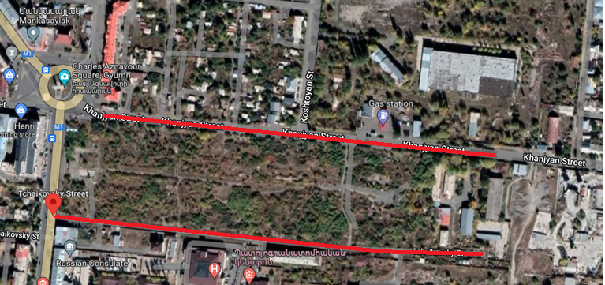
Picture 1: Component 1 site
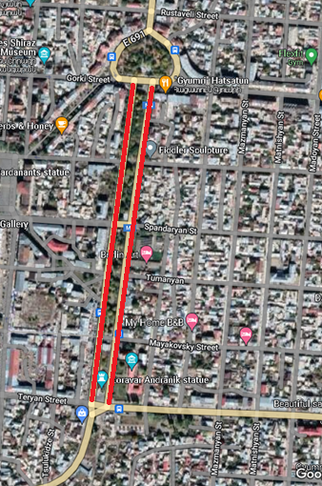
Picture 2: Component 4 site

Haghtanak avenue
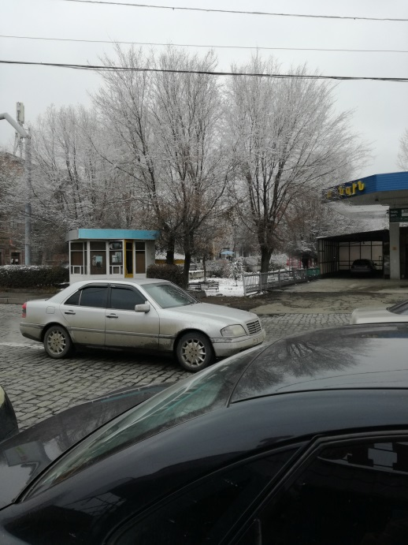 | 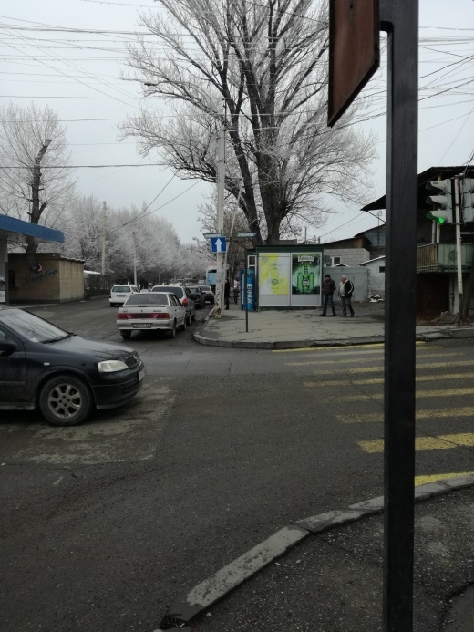
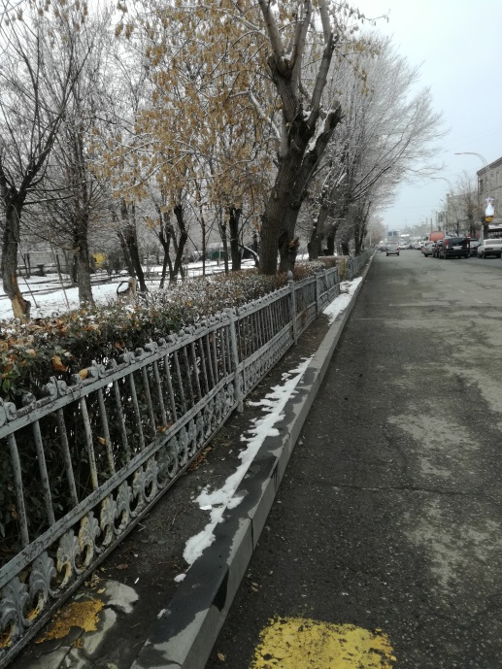 | 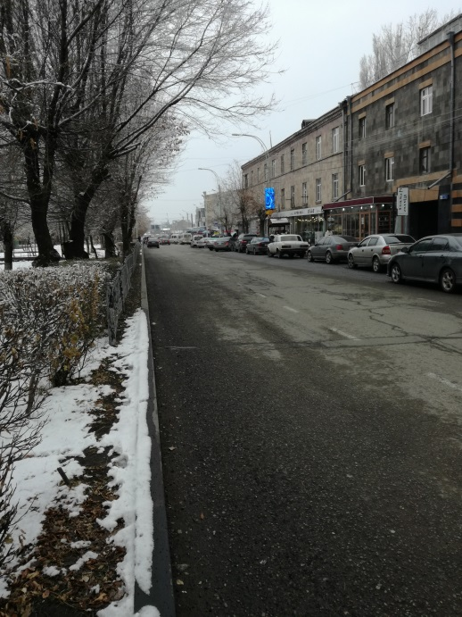
Khanjyan street
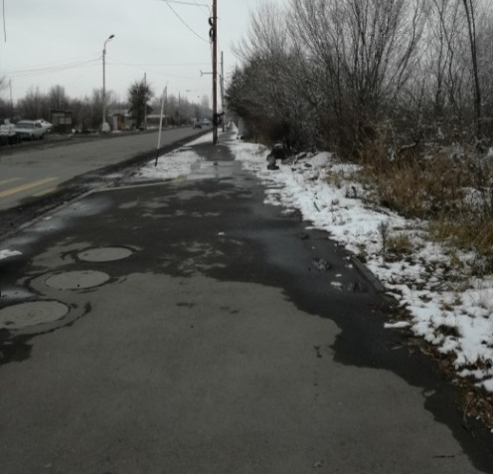 | 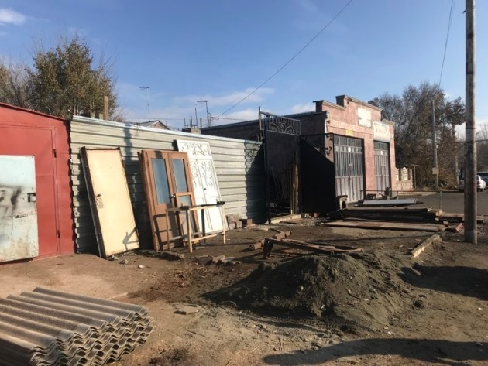
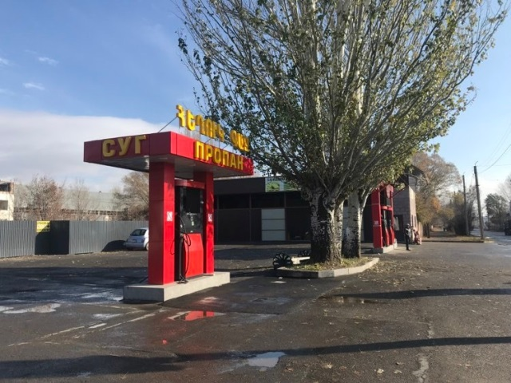 | 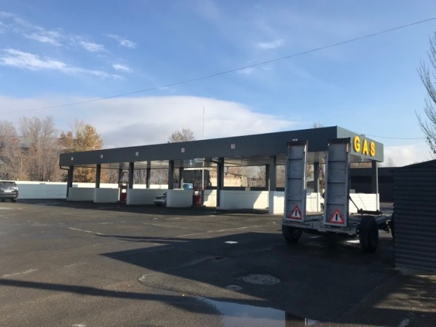
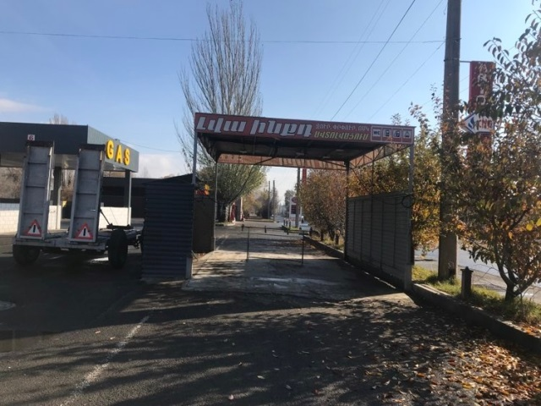 | 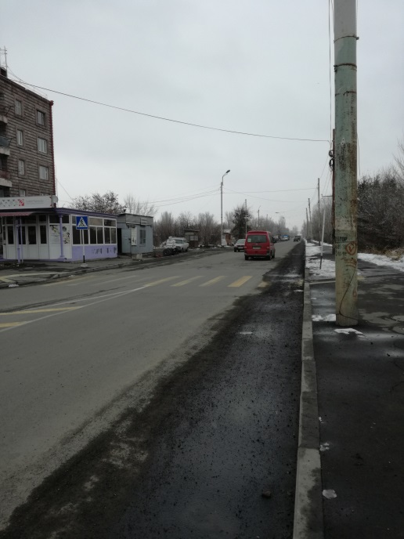
Tchaikovsky street
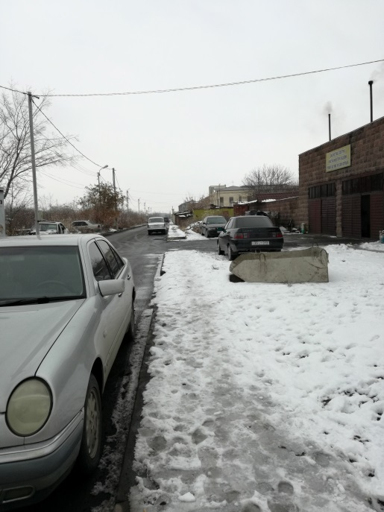 | 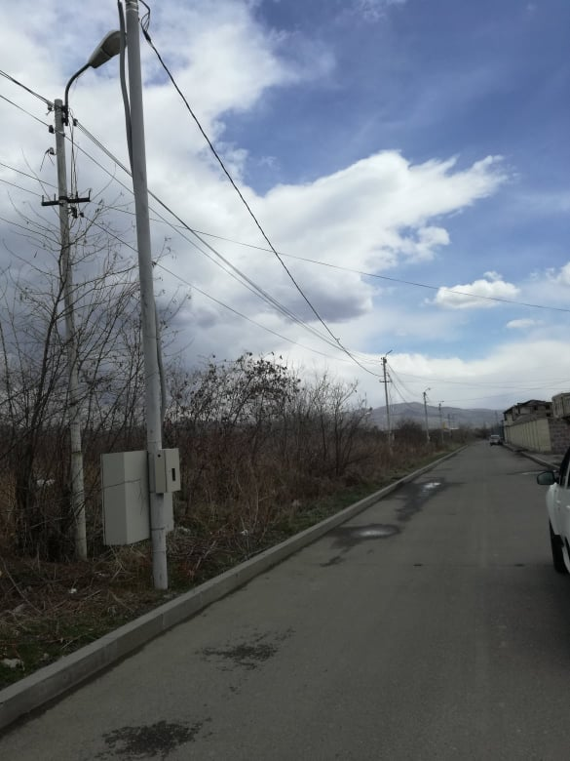
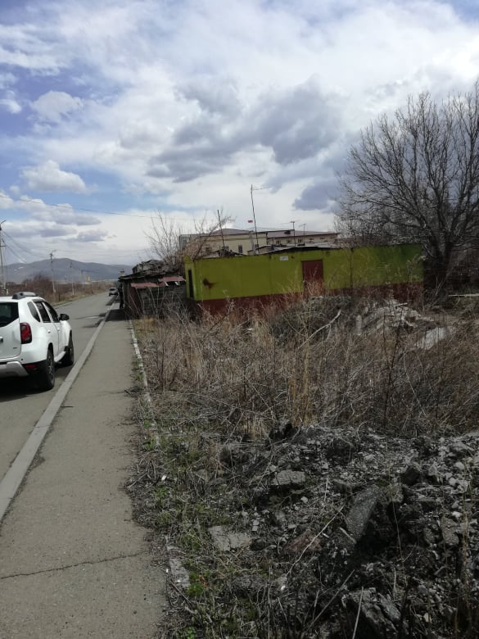 | 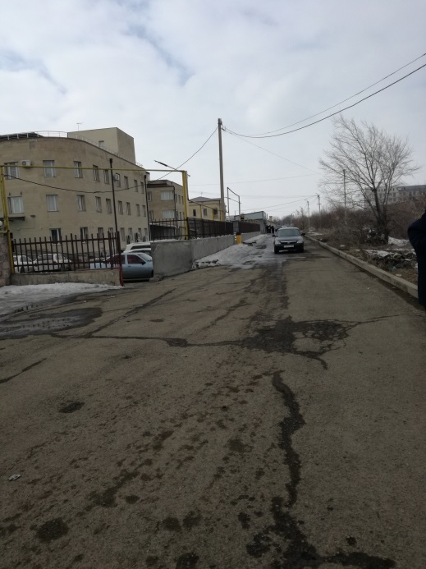

Attachment 2: Permission for construction waste disposal
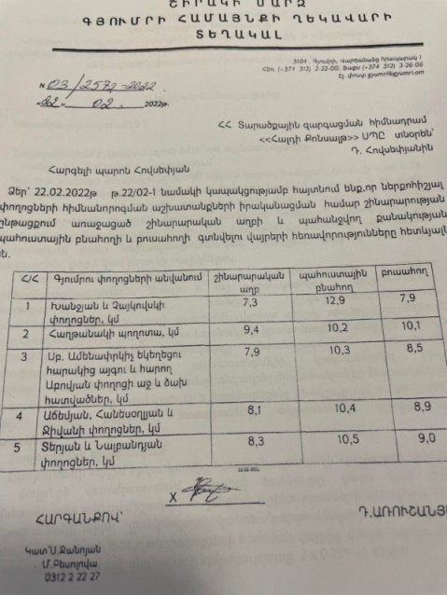

English summary of the above document:

REPUBLIC OF ARMENIA, SHIRAK MARZ, GYUMRI CITY
22.02.2022
REFERENCE N 03/2572-2022
In connection with your letter, we inform you that for the transportation of the construction waste generated during the construction works and the required amount of topsoil reserve subsoil for the implementation of the restoration works of the streets mentioned in your letter we suggest the following locations:.
N | Street name | Construction waste | Reserveof subsoil | Topsoil
1 | Khanjyan, Chaykovsky st/km | 7.3 | 12.9 | 7.9
2 | Haghtanak avenue, km | 9.4 | 10.2 | 10.1
3 | The right and left parts of the park adjacent to St. Amenprkich Church and the adjacent Abovyan Palace, km | 7.9 | 10.3 | 8.5
4 | Ajemyan, Hamesoglyan and Jivan st/km | 8.1 | 10.4 | 8.9
5 | Teryan and Nalbandyan st/km | 8.3 | 10.5 | 9.0

Leader Sealed/Signed D.Arushanyan

Attachment 3: The positive conclusion of State Environmental Impact Expertise

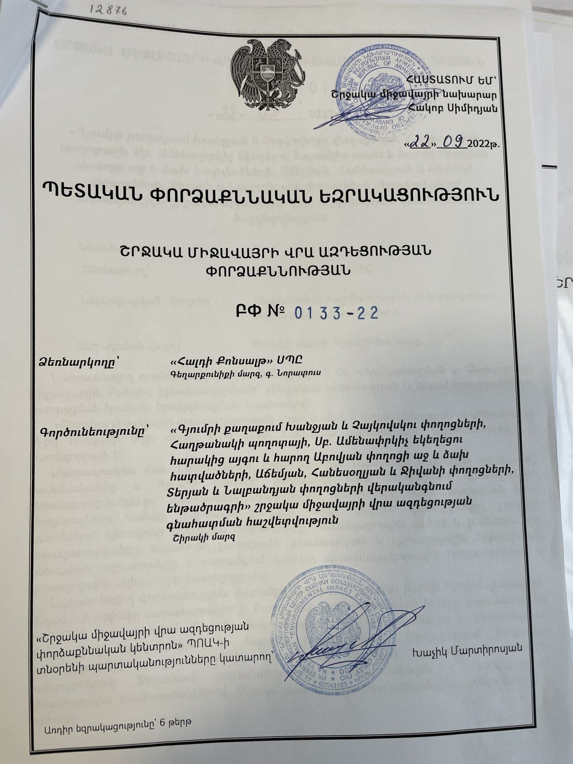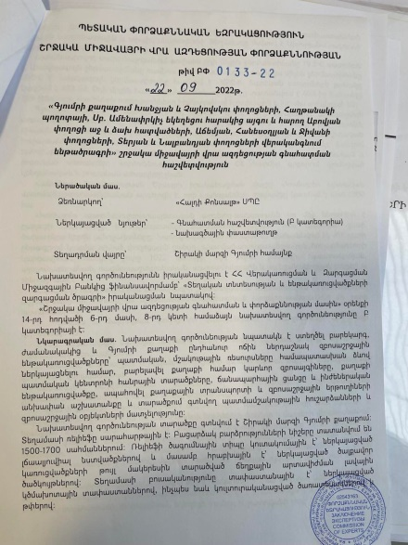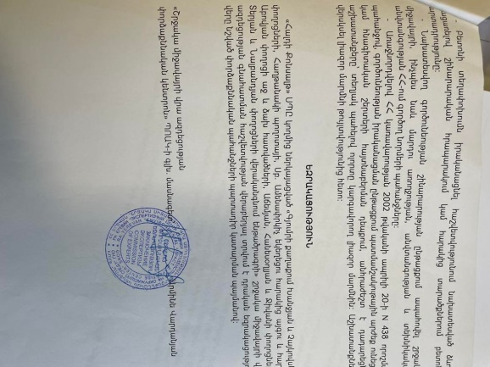

Summary of the above document

EE No 0133-22
Expertise Initiator: "Haldi Consalt" LLC, Gegharquniq marz, Noratus village.
Activity: Environmental Impact Assessment Report for ”Restoration of Khanjyan and Tchaikovski Streets, Haghtanak Avenue, the Park Adjacent to St Savior Church and Right and Left sides of Abovyan Street, Achemyan, Hanesoghlyan and Jivani Streets, Teryan and Nalbandyan Streets of Gyumri City” sub project.
The expertise requirements:
- During the implementation of the construction works, it is necessary to monitor the sanitary norms of the area, to implement the environmental measures specified in the assessment report, and in case of non-satisfaction, to plan additional measures.
- It is necessary to carry out the planned construction works during the specified hours of the day, minimizing as much as possible the noise and the maximum load on the roads.
- Carry out concrete transportation in the manner specified in the report byexcluding concrete production at the construction site or adjacent areas.
- During the construction works, ensure the requirements on the environment, as well as human health, safety and technical safety standards of the RoA.
- In accordance with the request of the RoA Government's decision N 438 dated April 20, 2002, in case of discovery of historical-cultural or archaeological layers during the implementation of activities, it is necessary to stop the works, informing the authorized body. Resume the works only after the permission of the authorized body.

EXPERTISE CONCLUSION
A positive conclusion is given to the Environmental Impact Assessment report of the Reconstruction of Tourism Infrastructure and Roads of Gyumri sub-project, submitted by the "Haldi Consult" LLC, with the obligatory fulfillment of expert requirements.
"Environmental Impact Assessment and Expertise Center" SNCO, senior specialist Armen Vardanyan.

Attachment 4: Minutes of the public consultation on the draft ESMP

Public consultation was held in the Gyumri community municipality office on March 24, 2023, within the framework of the "Reconstruction of tourism infrastructures and roads of Gyumri city" subproject of the Local Economy and Infrastructure Development Program.
The announcement of the public consultation was posted on the ATDF and Gyumri municipality websites on March 15. The draft ESMPs were posted on the web pages of ATDF and Gyumri community.
Overall, 20 participants were present at the public consultation, of which 6 were women. The representative from ATDF (social specialist), "Haldi Consult" design organization, Gyumri Administrative office, civil society and media, and members of the City council, were present at the discussion. The owners of the kiosks located on the sites were notified of the date of the public consultation by the Administrative office of Gyumri. A representative of the traders was present at the meeting.
The public consultation was broadcasted on the official YouTube channel of Gyumri municipality and was viewed more than 600 times during the following five days. Within the five days following the public consultation, ATDF has not received any additional observations or comments.
During the public consultation, the three ESMPs covering five Components of the subproject were presented, which included the restoration works planned for the park of the St. Amenaprkich Church and the right and left sides of Abovyan Street, Khanjian and Chaikovsky Streets, “Haghtanak” Avenue, Teryan and Nalbandyan, Achemyan, Jivan and Hanesoghlian streets.
The deputy head of Gyumri community opened the meeting by presenting the purpose of the public consultation and the aim of the subproject.
The Social Specialist of ATDF presented the expected environmental and social impacts and mitigation measures within the framework of the above-mentioned components of the sub-project, including air, water quality, noise, traffic and waste management, ensuring the provision of safe access to kiosks located in the sub project sites, as well as occupational health and safety measures.
It was mentioned that no impact on the private lands is anticipated under the Components.
The GRM procedures were presented. The focal point of the subproject was presented and additionally informed about his responsibilities.

Questions and Answers:
- Question- Is it planned to plant new trees and landscaping the area adjacent to the Amenaprkich Church? Is an irrigation system planned?
Answer- Planting of new trees is not envisaged under the subproject, and tree cutting is not planned either. The area does not have an irrigation system, green areas and trees will be watered using watering machines.
- Question - There is a problem of water accumulation in the basements of the buildings on Abovyan Street, is there any measures planned in this regard within the framework of the subproject?
Answer - The sub project provides for a proper drainage system for that road section. As a result of improperly organized drainage of the road water accumulated fills the basement of the building located on Abovyan Street. The solutions provided under the new design, including the replacement of the manholes and the underground pipeline will provide proper drainage of the road and prevent the flow of water to the basement of the building.
- Question- What solutions have been given regarding the temporary kiosks located along the roads?
Answer: In accordance with the scope of the Resettlement Policy Framework of the Project, a screening of all possible negative social impacts was carried out. This sub-project does not suppose the relocation of the kiosks. At the preliminary stage of the evaluation of the subproject, the Gyumri municipality submitted a statement to ATDF, according to which if any unexpected resettlement come up, compensation would be carried out by the municipality. A particularly large number of kiosks are located along Haghtanak avenue, but no relocation is planned under the Component. All works on site will be organized in a way that the works do not harm any businesses; and a safe access will be provided to all kiosks.
- Question: When will construction works begin? How long will the works last?
Answer: It is planned to start the construction works under all components during the next quarter. Construction should be completed by the end of 2024.
- Question: Is the culvert passing through the middle section of Haghtanak Avenue included in the project?
Answer: The drainage system of the two road sections of Haghtanak avenue will be completely reconstructed including the drainage system, which will be carried out through an underground system., but the intermediate park section Victory park under which the separate culvert passes is not included in the sub project, only the fences of the park will be repaired. The new underground drainage system of the road to be constructed under the sub project and the existing culvert passing under the park are not connected. The park section of the avenue was not included in the sub project.

Attachment 5: Construction permits
Khanjyan-Chaykovski
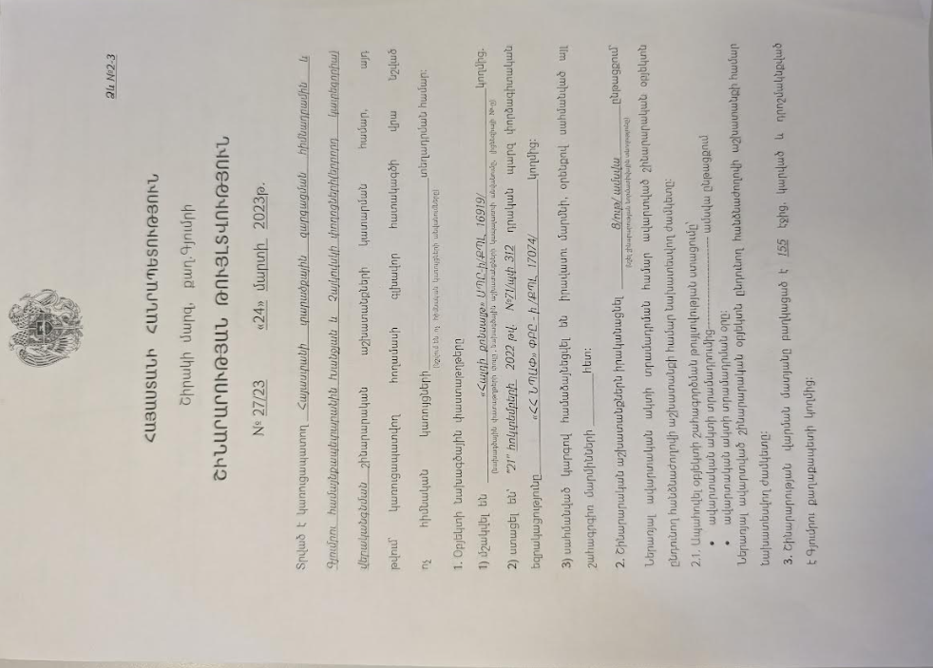
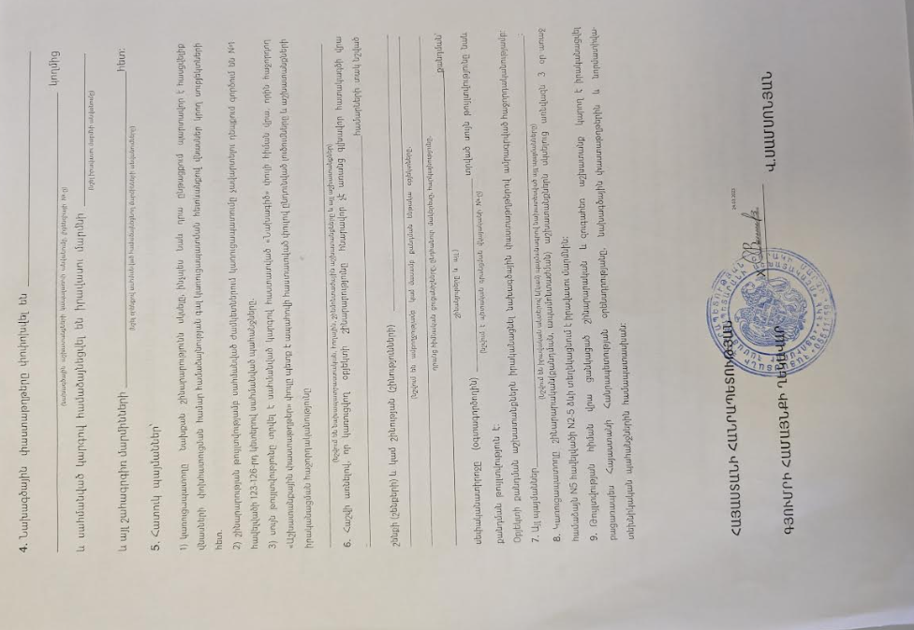

Summary of the above attached document:

Republic of Armenia
Shirak Marz, Gyumri Community
Construction Permit N 27/23. 24-March-2023
This is given for the “Restoration of Khanjyan and Tchaykovski Streets”.
The design documents are
1. Developed by “HALDI Consult” LLC, License 16919
2. The reconstruction will be implemented within 8 month.

V.Samsonyan Sealed/Signed

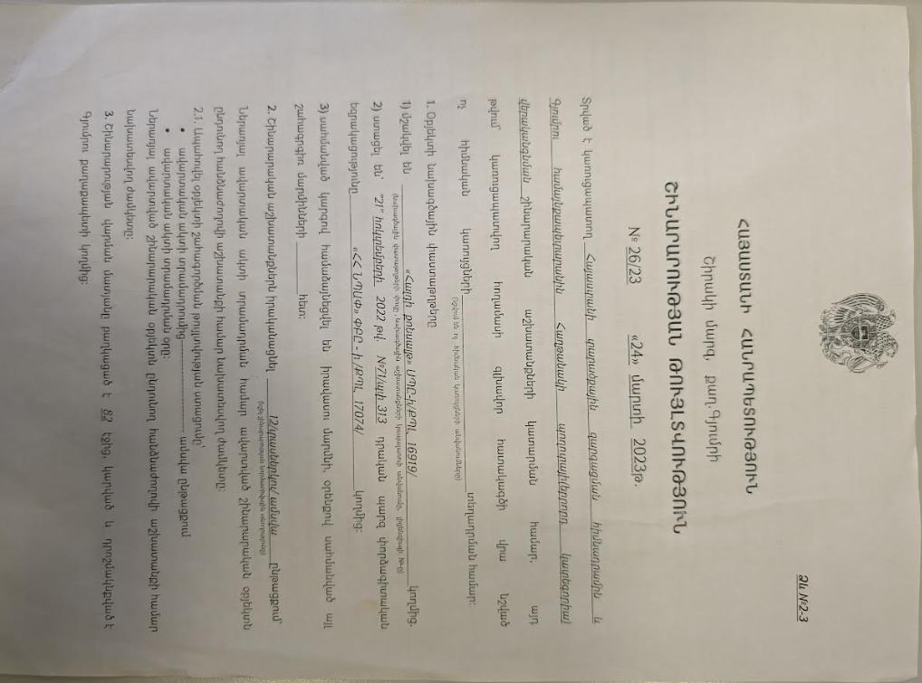
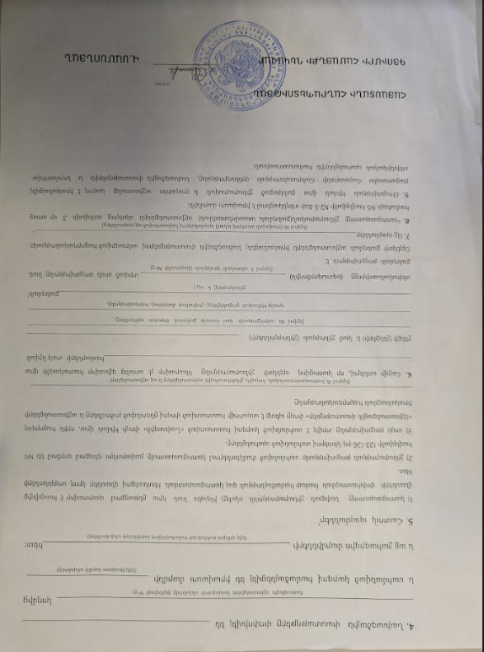
Summary of the above attached document:

Republic of Armenia
Shirak Marz, Gyumri Community
Construction Permit N 26/23. 24-March-2023
This is given for the “Restoration of Haghtanak Avenue”.
The design documents are
1. Developed by “HALDI Consult” LLC, License 16919
2. The reconstruction will be implemented within 12 month.

V.Samsonyan Sealed/Signed

Attachment 6: Letter of the Gyumri Administrative Office on the resettlement issues
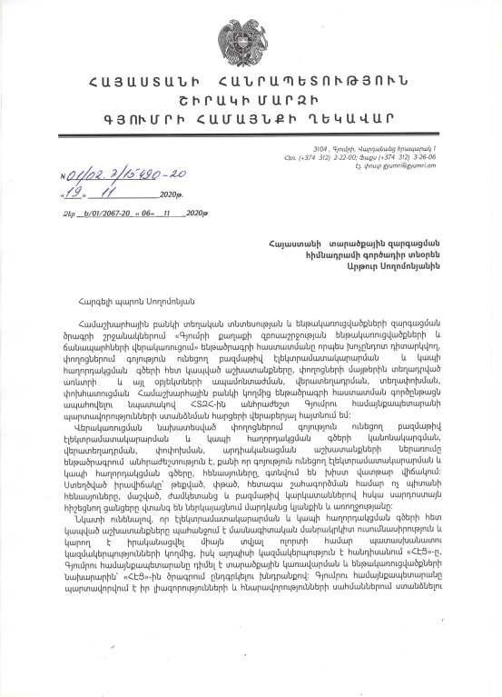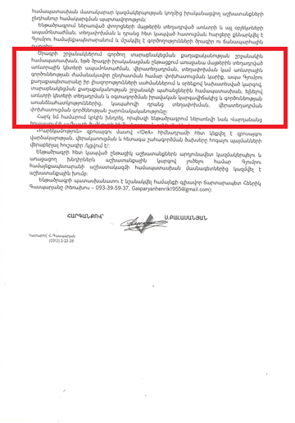
Translation of the section on the resettlement issues:
In accordance with the Resettlement Policy Framework of the Project, if in the course of the implementation of the sub project there is a need for dismantling, re-installation, relocation, compensation for the temporary interruption of commercial activity of the kiosks installed on the sidewalks, the Gyumri Municipality, in accordance with the law and requirements of the Resettlement Policy Framework, based on the legal status of installation and use of the kiosks and specifics of operation, will ensure the relocation of the kiosks, compensation and continuity of operation.

Toxic / hazardous material includes but is not limited to asbestos, toxic paints, noxious solvents, removal of lead paint, etc.

