REPUBLIC OF ARMENIA
LOCAL ECONOMY AND INFRASTRUCTURE DEVELOPMENT PROJECT

ENVIRONMENTAL AND SOCIAL MANAGEMENT PLAN
Rehabilitation Of Meghri Pokr Tagh (Small district) tourism infrastructure SUBPROJECT

January 2024

PART A: General Project and Site Information
INSTITUTIONAL & ADMINISTRATIVE
Project title | LOCAL ECONOMY AND INFRASTRUCTURE DEVELOPMENT (LEID)
Subproject number and title | TUR-16, Rehabilitation of Meghri Pokr Tagh (Small district) tourism infrastructure
Municipality, community | RA, Syunik Marz (province ), Meghri town (community)
Scope of site-specific activity | The subproject includes the restoration of Mejlumyan and Vazants streets in “Pokr Tagh” (Small district) of Meghri town, which envisages the following main works:  - Restoration of asphalt-concrete and stone paved sections of Mejlumyan and Vazants streets and their branching;  - Moving Mejlumyan street anti-fire hydrant and installing it into the manhole;  - Mejlumyan and Vazants streets sewerage network sectional reconstruction;  - Constructing a new retaining wall in Mejlumayn and Vazants streets as well as existing retaining walls fortification;  - External lighting system mounting in Mejlumyan and Vazants streets (2270m underground line, excavating of trenches- 431 m³, installation of 31 poles);  - Establishing a parking lot for a long term stay of buses (overnight or several days) on Mejlumyan street; constructing a parking lot for a short stay of cars in “Chinari Tsar” (platen tree) adjacent area.  - Establishing a rest zone (recreation area) next to Mejlumyan Street Chinari Tsar adjacent square (near the fountain);  - Rehabilitation of communityowned two-storied building in the territory of Mejlumyan street, “Chinari Tsar” adjacent area. The rehabilitated building will serve as an information center.  - Pokr Tagh area furnishing with touristic and road signs, as well as with benches and trash cans.  Most part of the subproject planned works are implemented in the historic-cultural part of Meghri “Pokr Tagh” district.  *Pokr Tagh= small neighborhood in translation from Armenian  **Chinar Tsar= plan tree in translation from Armenian
Institutional arrangements (WB) | Task Team Leader:  Tafadzwa Irvin Dube |  | Safeguards Specialists:  Lusine Gevorgyan (Environment)  Sonya Msryan (Social)  David Jijelava (Social)
Implementation arrangements (RA) | Implementing entity:  ATDF  Armine Gabrielyan (Environment)  Marine Vardanyan (Social) | Works supervisor:  Haldi Consult LLC |  | Works contractor:  Meghri CHSHSHZ (LLC)
SITE DESCRIPTION
Name of institution whose premises are to be rehabilitated | Meghri community  Meghri town
Address and site location of institution whose premises are to be rehabilitated | Mezhlumyan and Vazants streets in “Pokr Tagh” (Small district) of Meghri town
Who owns the land?  Who uses the land (formal/informal)? | The roads and parking areas as well as the two-storied building belong to Meghri community.  An elderly woman lives in the building to be rehabilitated under the subproject. The building is the property of Meghri community. The woman will be provided with another shelter owned by the community that will be repaired by the community means. The resettlement will be organized and financed by Meghri municipality under supervision and support of the ATDF.  The ATDF prepared an ARAP for relocation of the old woman.
Description of physical and natural environment around the site | The territory to be rehabilitated is administratively located in Pokr Tagh District, Meghri town. Meghri is situated in the South of Armenia, in Syunik Marz. From the south, it borders with Iran through the state border (the length of the border is 42 km). Meghri is considered one of the oldest settlements in RA. Meghri is a town with mountainous terrain. It is distinguished by its mild climate, the coldest month of the year is January and the hottest is July, the average temperature in January is 1.5º C, in July is 26.3º C. The average relative humidity ranges from 38% (in August) to 56% (in January).  The most famous historical, cultural and touristic part of the town is the old district called “Pokr Tagh”, Old Meghri. Pokr Tagh district is located in the south-west of the center of Meghri (1 km), in the south of M2 Highway. Mejlumyan and Vazants Streets leading to Pokr Tagh are in the administrative area of Meghri and are subject to restoration, since neither cars, nor pedestrians can move along these streets. There is neither lighting along roads, nor road signs. St. Hovhannes Church, an old basilica church dating back to the 17th century, is in Poqr Tagh. Mezhlumyan Street starts from the interstate highway. Khachikyan’s old “Khachats Tun” which according to the cadastral data is more than 200 years old, is considered the oldest inhabited house in Meghri.  On the right-side branch of Mejlumyan Street there is “White House” (community-owned building) that will be rehabilitated under the subproject. There is no topsoil, according to the EIA and expertise conclusion issued by the Ministry of Environment,, in the area. envisaged for a parking lot. No bushes and trees are envisaged to be cut. There are two old sycamore (Chinari) trees in Mejlumyan Street, where the rest zone will be built (photo 1). This subproject is expected to improve quality and reliability of infrastructure, support the development of tourism, and create conditions for attracting private sector investment.  The increase in tourist flow will directly affect the local community through increased income from the tourism sector. Short-term benefits are also expected from the participation of local residents in the restoration and reconstruction work. There are residential houses along the entire road to be reconstructed, therefore the improvement will have the best effect on the quality of the resident’s life, as the road to be rehabilitated is now in very poor condition.
LEGISLATION
National & local legislation & permits that apply to sub-project activity | The following Armenian legislation defines a legal framework applicable to project activities:  - Law on Atmospheric Air Protection of RA (1994)  The purpose of the Law on Atmospheric Air Protection is to define the main principles of the RA, directed to the provision of purity of atmospheric air and improvement of air quality, prevention and mitigation of the chemical, physical, biological and other impacts on air quality and regulation of public relation. This Law also regulates the emission licenses and provides maximum allowed loads/concentrations for atmospheric air pollution, etc.  According to this law, the contractor shall undertake construction activities as well as transportation and temporary storage of waste the way to minimize dust and other emissions.  - Law on Waste of RA (2004)  The law provides the legal and economic basis for collection, transportation, disposal, treatment, re-use of wastes as well as prevention of negative impacts of waste on natural resources, human life and health. The law defines the roles and responsibilities of the state authorized bodies as well as of waste generator organizations in waste management operations.  According to this law, the waste generated from construction activities should be recycled as appropriate or disposed of in designated locations.  Disposal of the construction waste and excess material in selected locations has approved by local municipality’s reference letter, sealed and signed (attachment 2).  - Law on Environmental Impact Assessment and Expertise of RA (2023)  The law defines the type of activities that are subject to environmental impact assessment and environmental expertise.  According to this law, the proposed reconstruction and improvement works are subject to an environmental impact assessment and expertise, because the proposed work will be carried out in the territory of St. Hovhannes church, which is included in the state list of Historical and Cultural Monuments and the streets to be rehabilitated under the Components are included in list of immovable monuments of Meghri Poqr Tagh, .  The positive conclusion of the State Environmental Impact Assessment and Expertise issued by the Ministry of Environment is attached (Attachment 3).  - Labor Code of RA (2005)  This Code regulates collective and individual labor relations, defines the grounds for the origin, modification and termination of these relations and the procedure for their implementation, the rights and responsibilities of the parties to labor relations, as well as the conditions for ensuring the safety and health of employees. According to this law the Contractor must ensure the safety and health of the employees working on the construction site.  - Law on Urban Development of RA (1998)  This law defines urban construction activity provisions in the Republic of Armenia and regulates relations connected with that activity. The Article 23 of the Law defines the order and procedure for issuing construction permit.  - Law on the Preservation and Use of Immovable Monuments of History and Culture and the Historical Environment (1998).  According to this Law the allocation of lands for construction, agricultural and other types of works in the areas of the monuments, development and design projects, engineering communication routes are coordinated with the authorized body in the prescribed manner. The conclusion regarding the reconstruction of roads and other infrastructures within the protection zone of St. Hovhannes (St. Sargis) Church of Small District of Meghri is issued by the Institute of Archeology and Ethnography  of the National Academy of Sciences of the RA (Attachment 6).
PUBLIC CONSULTATION
When / where the public consultation process will take /took place | On January 16, 2024, a public consultation meeting was held in the municipality of Meghri community to disclose the draft ESMP with the participation of ATDF specialists, the head of Meghri community, and residents of “Pokr Tagh” district of Meghri town. Overall, 22 people participated in the meeting, of which 6 were women.  The announcement of the public consultation was posted on the webpages of the ATDF and Meghri community on January 3, 2023. The draft ESMP will be disclosed in Armenian and English languages on the ATDF website (www.atdf.am) and in the Armenian language on the beneficiary’s website (www.meghri.am).  The minutes of the PC meeting are attached (see Attachment 4)
ATTACHMENTS
Attachment 1: Site map/photo,
Attachment 2: Permission for construction waste disposal
Attachment 3: Positive conclusion of the Environmental Impact Assessment and State Expertise
Attachment 4 : Minutes of public consultation on the draft Environmental and Social Management Plan
Attachment 5: Construction permit
Attachment 6: Conclusion about reconstruction of roads and other infrastructures within the protection zone of St. Hovhannes (St. Sargis) Church of Small District of Meghri
*Information on works supervisor, works provider (contractor), and the attachments will be provided later, prior to mobilization of a selected works provider to a work site.
**The construction permit will be obtained before commencement of works.

PART B: safeguards information
ENVIRONMENTAL /SOCIAL SCREENING
Will the site activity include/involve any of the following? | Activity/Issue | Status | Triggered Actions
Will the site activity include/involve any of the following? | - Building rehabilitation | [x] Yes [] No | If “Yes”, See Section A below
Will the site activity include/involve any of the following? | - New construction | [x] Yes []No | If “Yes”, See Section A below
Will the site activity include/involve any of the following? | - Individual wastewater treatment system | [ ] Yes [x] No | If “Yes”, See Section B below
Will the site activity include/involve any of the following? | - Historic building(s) and districts | [x] Yes [ ] No | If “Yes”, See Section C below
Will the site activity include/involve any of the following? | - Unexpected need for land take | [ ] Yes [x] No | If “Yes”, See Section D below
Will the site activity include/involve any of the following? | - Hazardous or toxic materials | [ ] Yes [x] No | If “Yes”, See Section E below
Will the site activity include/involve any of the following? | - Impacts on forests and/or protected areas | [ ] Yes [x] No | If “Yes”, See Section F below
Will the site activity include/involve any of the following? | - Handling / management of medical waste | [ ] Yes [x] No | If “Yes”, See Section G below
Will the site activity include/involve any of the following? | - Traffic and pedestrian safety | [x] Yes [ ] No | If “Yes”, See Section H below
Will the site activity include/involve any of the following? | - Social risk management | [x] Yes [ ] No | If “Yes”, See Section I below
PART C: Mitigation measures
ACTIVITY | PARAMETER | MITIGATION MEASURES
0. General Conditions | Notification and Worker Safety | - The local construction and environment inspectorates and communities are notified of upcoming activities  - The public is notified of the works through appropriate notification in the media and/or at publicly accessible sites (including the site of the works)  - All legally required permits are acquired for construction and/or rehabilitation  - The Contractor formally agrees that all work will be carried out in a safe and disciplined manner designed to minimize impacts on neighboring residents and environment.  - Workers’ personal protection equipment complies with international good practice (always hardhats, as needed masks and safety glasses, harnesses and safety boots)  - Appropriate signposting of the sites informs workers of key rules and regulations to follow.
A. General Rehabilitation and /or construction activities | Air Quality | - During earth works, dust is suppressed by ongoing water spraying and/or installing dust screen enclosures at site.  - The surrounding environment (sidewalks, RAds) is kept free of debris to minimize dust.  - There is no open burning of construction / waste material at the site.  - There is no excessive idling of construction vehicles at sites.
A. General Rehabilitation and /or construction activities | Noise | - Construction noise is limited to restricted times agreed to in the permit.  - During operations, the engine covers of generators, air compressors and other powered mechanical equipment are closed, and equipment placed as far away from residential areas as possible.
A. General Rehabilitation and /or construction activities | Water Quality | - Appropriate erosion and sediment control measures are applied such as e.g. hay bales and / or silt fences to prevent sediment from moving off site and causing excessive turbidity in nearby streams and rivers.
A. General Rehabilitation and /or construction activities | Waste Management | - Waste collection and disposal pathways and sites are identified for all major waste types expected from demolition and construction activities.  - Mineral construction and demolition wastes are separated from general refuse, organic, liquid and chemical wastes by on-site sorting and stored in appropriate containers.  - Construction waste is being collected and disposed properly by licensed collectors.  - Whenever feasible, appropriate and viable materials (except asbestos) are reused or recycled.
C. Historic building(s) | Cultural Heritage | - If the building is a designated historic structure, very close to such a structure, or located in a designated historic district, notification is made, and approvals/permits be obtained from local authorities and all construction activities planned and carried out in line with local and national legislation.  - Provisions are put in place so that artifacts or other possible chance finds encountered in excavation or construction are noted and registered, responsible officials contacted, and works activities delayed or modified to account for such finds.
H. Traffic and pedestrian safety | Direct or indirect hazards to public traffic and pedestrians by construction  activities | In compliance with national regulations, the construction site is properly secured, and construction related traffic regulated. This includes but is not limited to  - Signposting, warning signs, barriers and traffic diversions: site will be clearly visible, and the public warned of all potential hazards.  - Traffic management system and staff training, especially for site access and near-site heavy traffic. Provision of safe passages and crossings for pedestrians where construction traffic interferes.  - Adjustment of working hours to local traffic patterns, e.g. avoiding major transport activities during rush hours or times of livestock movement.  - Active traffic management by trained and visible staff at the site, if required for safe and convenient passage for the public.  - Ensuring safe and continuous access to office facilities, shops and residences during renovation activities, if the buildings stay open for the public.
I. Social risk management | Public relationship management | - Assign local liaison person in charge of communication with and receiving requests/ complaints from local population.  - Consulted local communities to identify and pro-proactively manage potential conflicts between an external workforce and local people.  - Rise local community awareness about sexually disease risks associated with the presence of an external workforce and include local communities in awareness activities.  - Inform population about construction and work schedules, interruption of the services, traffic detour routes and provisional bus routes, blasting and demolition, as appropriate.  - Limit construction activities at night. When necessary, carefully schedule night-time works and inform affected community so they can take necessary measures.  - At least five days in advance of any service interruption (including water, electricity, telephone, bus routes), advise affected community through postings at the project site, at bus stops, and in affected homes/businesses.
I. Social risk management | Labor management | - To the extent possible, locate work camps away from local communities.  - Undertake sitting and operation of worker camps in consultation with neighboring communities.  - Recruit unskilled or semi-skilled workers from local communities to the extent possible. Where and when feasible, provide worker skills training to enhance participation of local people.  - Provide adequate lavatory facilities (toilets and washing areas) in the work site with adequate supplies of hot and cold running water, soap, and hand drying devices. Establish temporary septic tanks for any residential labor camp and without causing pollution of nearby watercourses.  - Raise awareness of workers on overall relationship management with local population, establish the code of conduct in line with international practice and strictly enforce them, including the dismissal of workers and financial penalties of adequate scale.
I. Social risk management | Grievance Management | - GRM is established and advertised at the local level. The Contractor is informed of his responsibility to register and communicate to the ATDF received verbal and non-verbal grievances.  - GRM contact information, including local focal points, has been posted at the construction site and the local community’s administrative office.  - The Contractors' local liaison person receives and registers grievances from the population in the GRM log and communicates the grievances to the ATDF regularly.

PART D: Monitoring Plan
Activity | What  (Is the parameter to be monitored?) | Where  (Is the parameter to be monitored?) | How  (Is the parameter to be monitored?) | When  (Define the frequency / or continuous?) | Why  (Is the parameter being monitored?) |  | Who  (Is responsible for monitoring?)
CONSTRUCTION PHASE
Supply of construction materials | Purchase of construction materials from the licensed suppliers | In supplier’s office or warehouse | Verification of labels of the materials and/or certificates if any | During conclusion of supply contracts | Ensure reliability of construction materials and their safety for human health |  | ATDF  Technical supervision  company
Transportation of construction materials and waste  Movement of construction vehicles and machinery | - Technical condition of construction vehicles and machinery;  - Coverage of loads when carrying soil, and construction waste;  - Movement of construction vehicles and machinery according to predefined traffic routes and within working hours: 9AM-6PM. | Construction site;  Routes of transportation of construction materials and wastes | Inspection of pre-defined movement routes, entrances and exits of construction sites | Unannounced monthly inspection during work hours and beyond | - Control emissions into the environment;  - Control nuisance to local communities;  - Minimize traffic disruption, ensure pedestrian safety and prevent accidents |  | ATDF  Technical supervision  company  Road Police
Maintenance of construction equipment | - Washing of cars and construction equipment outside the construction site or on maximum distance from natural streams;  - Refueling or lubrication of construction equipment outside the construction site or at the predetermined confined area. | Construction site | Inspection of activities | Selective inspections during work hours | - Avoid pollution of water and soil with oil products due to operation and maintenance of equipment and washing runoffs;  -Timely localize oil and lubricant spill-offs, and decrease expected damage in case of fire. |  | ATDF  Technical supervision  company
Generation of construction waste | - Temporary storage of waste at the pre-defined areas of construction site;  - Timely disposal of waste to the formally designated locations. | Construction site  Waste disposal site | Inspection of site | Unannounced monthly inspection during entire construction phase | -Prevent pollution of soil, surface water and ground water;  - Avoid accidents at the construction site due to scattered fragments of construction materials and debris;  - Retain esthetic appearance of the construction site and its surroundings. |  | ATDF  Technical supervision  company
Workers’ health and safety | - Provision of uniforms and safety gears to workers and enforcement of their use by the constructor;  - Provision of work-site safety instruction to contractor’s personnel and instructions proper recording;  - Installation of fencing;  - Ensuring fire extinguisher and medical aid kits at work site | Construction site | Inspection | Periodically during construction and upon its completion | - Exclude probability of accidents;  -Protect workers’ health. |  | ATDF  Technical supervision  company
Works near privately-owned land plots and other property | - Avoid trespassing or incidentally damaging of private property (using small-size machinery or manual labor near walls and fences, stockpiling of construction material and waste away from private property; etc.);  - In case of unintended damage to private property, quickly restore it to the original or better status;  In case of expected temporary impact on privately-owned property, inform owners upfront and guarantee restoration, acquire written consent of owners for intervention, and promptly restore the damage to the original or better status. | Works near privately-owned land, buildings and other assets | Monitoring and inspection | Entire period of construction | -Reduce the probability of damages on private property;  -Exclude temporary or permanent violation of ownership and/or user rights on the private property. |  | ATDF  Technical supervision  company
Construction site re-cultivation and landscaping | Final cleaning of the construction site and permanent access roads as required | Construction site and access roads | Inspection of activities | Final period of construction | Reduce loss of aesthetical value of the landscape due to construction activities |  | ATDF  Technical Supervisor
Tree preservation | - Inventory of existing trees on subproject site;  - “Chinary “ trees area shall be marked and cordoned off with fencing, their root system protected, and any damage to the trees avoided;  - Permit will be obtained from the Meghri municipality before removal of any tree, bush and stump hindering reconstruction works.  -It is planned to organize and carry out a training for the people involved in construction works related to the preservation of trees and bushes in the area, especially the Chinary Trees,  In case of accidental damage, immediately stop the works and inform the ATDF. | Construction site | Visual inspection | Entire period of construction | Avoid damage to existing vegetation |  | - ATDF  - Technical supervision  - company  - Meghri community
Solid waste management | Trash bins placement and arrangement on periodical transportation of waste | Construction site | Inspection | Total period of works | - Prevent pollution of soil, water;  - Retain esthetic appearance of the sites area and its surroundings. |  | ATDF  Technical supervision  company  Megri community
Dust generation | - Ensuring water spraying measures at site, and timely removal of construction debris;  - Storing bulk materials with the use of banners at site | Construction site and access roads | Visual inspection | Total period of construction | -Prevent off-site dust spreading and pollution;  -Reduce health risks to the workers and neighboring communities related to dust exposure. |  | ATDF  Technical Supervision Company
Handling of chance finds | - Stoppage of works promptly upon encountering of chance finds;  - Formal communication with the Ministry of Education, Science, Culture and Sports (MoESCS) of RA on chance finds;  - Timely arrangements made for the conduct of required excavation and site conservation. | Construction site | -Inspection of chance find sites;  - Inspection of field documentation | Entire period of construction | Ensure cultural heritage is not damaged by the construction works. |  | ATDF  Technical Supervision Company  MoESCS
Works in and adjacent area of “Pokr Tagh”, Old Meghri district | - Planning and implementation of rehabilitation works in line with national legislation and regulations on preservation of historical and cultural monument. | Construction site | -Inspection of documentation;  - Inspection of activities | Entire period of construction | Prevent loss of cultural heritage |  | ATDF  Technical Supervisor  MoESCS
Earth work | -Temporary storage of excavated soil at determined places;  -Backfilling of the excavated ground as needed and disposal of the excess mass to the places, approved in writing. | Construction site | Inspection of activities | During earth works | Limit loss of vegetation due to ground piling and minimization of pollution of surface water reservoirs with particles;  Limit pollution with contaminated soil of surface and ground waters. |  | ATDF  Technical Supervisor
Operation of Grievance Redress Mechanism | Public right to complaints or questions about the project.  Appeal to the head of local government (community authorities)  The appointment by the authorities of the Coordinator for the consideration of complaints (receiving complaints, reviewing and explaining, registering complaints in the log book and trying to resolve them on the spot.  Appeal to ATDF by hot-line (010 24 01 59), postal letter (Yerevan 0037, K. Ulnetsi 31), official web page (http://atdf.am/hy/Home/ContactUs), e-mail (support@atdf.am). | Construction site | Inspection of activities | Entire period of construction | Monitor compliance with project aspects;  Timely resolve questions and complaints in the field. |  | ATDF  Technical Supervisor
Traffic and pedestrian safety | - Signposting, warning signs, barriers and traffic diversions;  Provision of safe passages and crossings for pedestrians where construction traffic interferes | Construction site | Inspection of activities | During the works | Reduce probability of accidents to constructors and local population |  | ATDF  Technical Supervisor
OPERATION PHASE
Maintenance and protection of site | Non authorized construction and land use along the reconstructed roads. | Rehabilitated site | Inspection | Total period of operation | - Retain esthetic appearance of the sites area and its surroundings |  | Meghri town community
Operation and maintenance of outdoor lighting system | Regular servicing of the lighting system is being undertaken | Lighting network | Periodic Inspection | Total period of operation |  | Maintenance of lighting system in safe and operable condition |  | Meghri town community
Exploitation and maintenance of road | - Cleaning road surface and shoulders from litter deposited out of moving vehicles and from bodies of animals accidentally overrun by vehicles;  - Timely confinement, deactivation, and removal of liquid or powder spills of cargo in case of road accidents;  Collection and timely disposal of waste from road maintenance works to a designated landfill. | Carriageway of the road | Visual inspection | As required in response to an accident  Regular, to be determined by local municipality |  | -Ensure safety of traffic and prevent environmental pollution;  -Ensure aesthetic appearance of the road |  | Meghri town community
Operation and maintenance of lighting system | - Regular servicing of the lighting system is being undertaken. | Construction site | Periodic inspection of lighting network | Total period of operation |  | Maintain road lighting system in safe and operable condition. |  | Meghri town community
Operation and maintenance of utility networks (water supply, sewage, power supply) | -Regular servicing of the utility networks being undertaken. | Construction site | Regular technical inspections | Total period of operation |  | - Maintainutility networks in safe and operable condition;  - Prevent traffic disruption and inconvenience to pedestrians and drivers. |  | Meghri town community
Disposal of household waste | - Regular collection and disposal of household waste generated during community center operation is provided;  -Arrangements are in place and operational for removal of household waste from community center | Information center land plot and its immediate surroundings | Inspection of Information center area | During entire period of information center building operation |  | Ensure good sanitary conditions at information center;  Prevent environmental pollution. |  | Meghri town community
Operation and maintenance of the air conditioner | - Regular maintenance of the air conditioner is provided and prompt repair is undertaken in case of damage or malfunction | Premises of the Information center | Inspection of Information center area | Total period of operation of air conditioner |  | Deliver operation of the air conditioner in safe and operable condition. |  | Meghri town community
Emergency preparedness | - Presence of fire alarm and fire localization system, and emergency back-up systems for power and water supply | Premises of the Information center | Periodic check-ups | Total period of operation of the facility |  | - Reduce risks for the staff and visitors;  - Avoid disruption in the provision of utility services to the Information center. |  | Meghri town community  Ministry of Internal Affairs

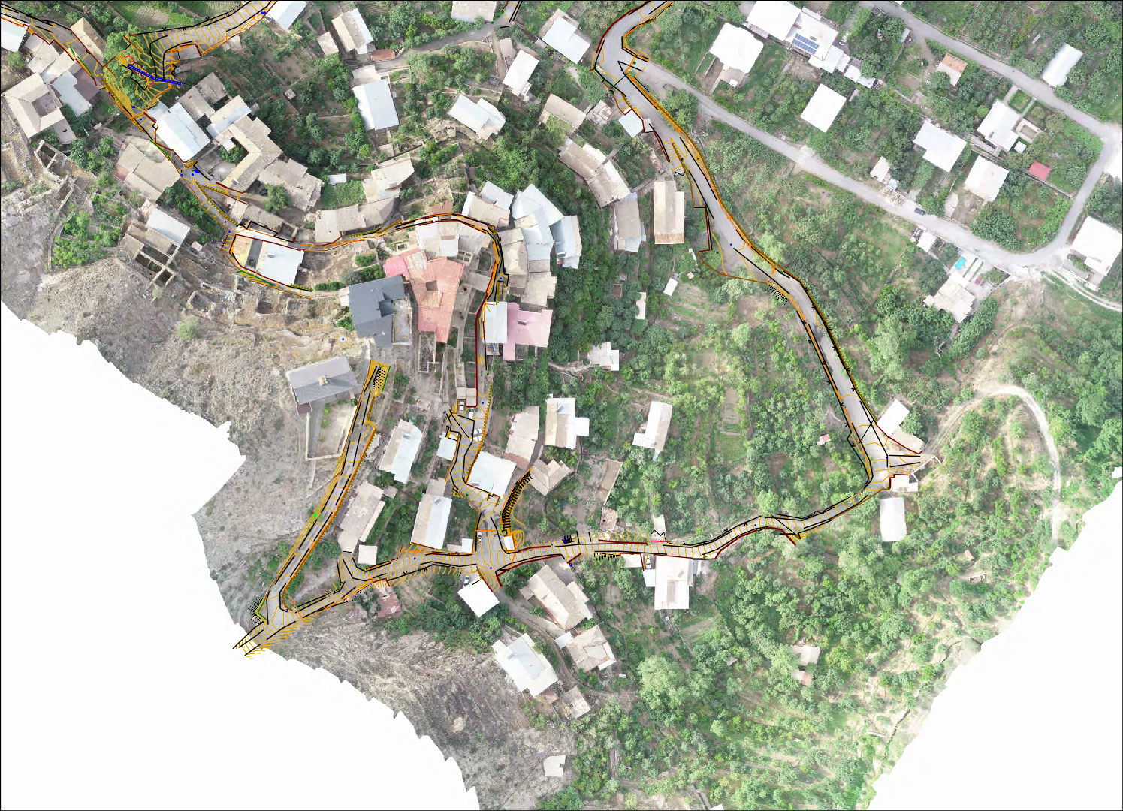
Attachment 1: Sites photo

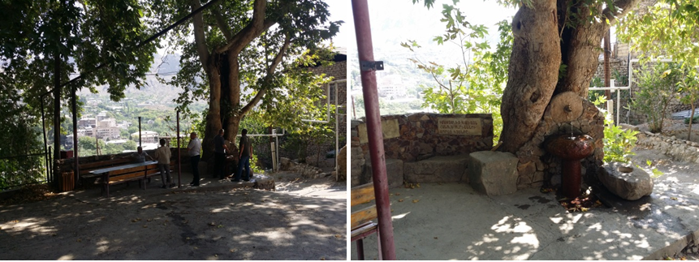
Photo 1 The territory near water fountain of the sycamore tree

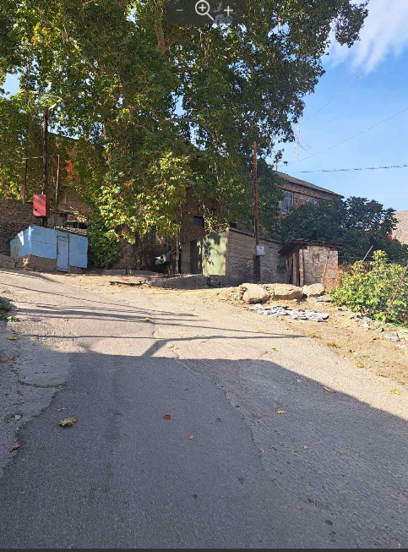
Photo 2 Sanitation place and pump station at Mezhlumyan str.

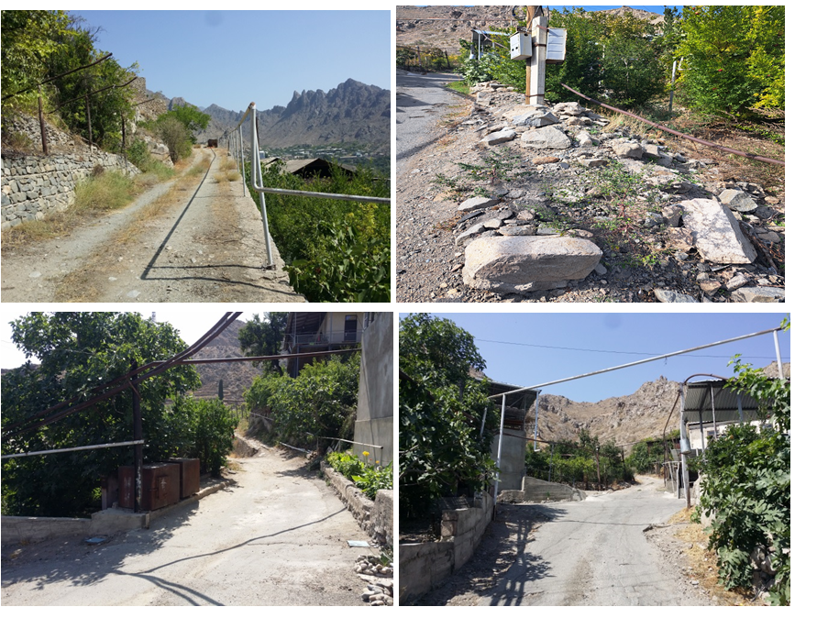
Photo 3 Vazants Str.

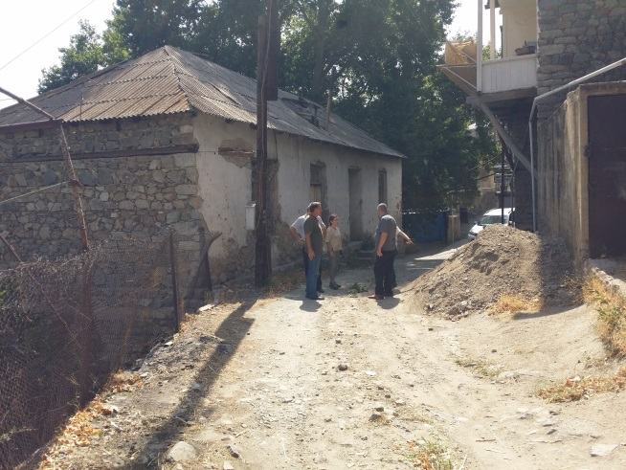
Photo 4 White building
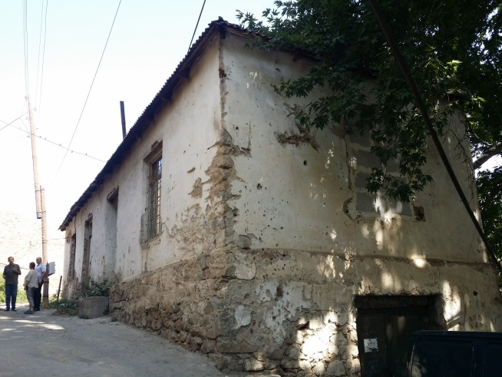
Photo 5 White building

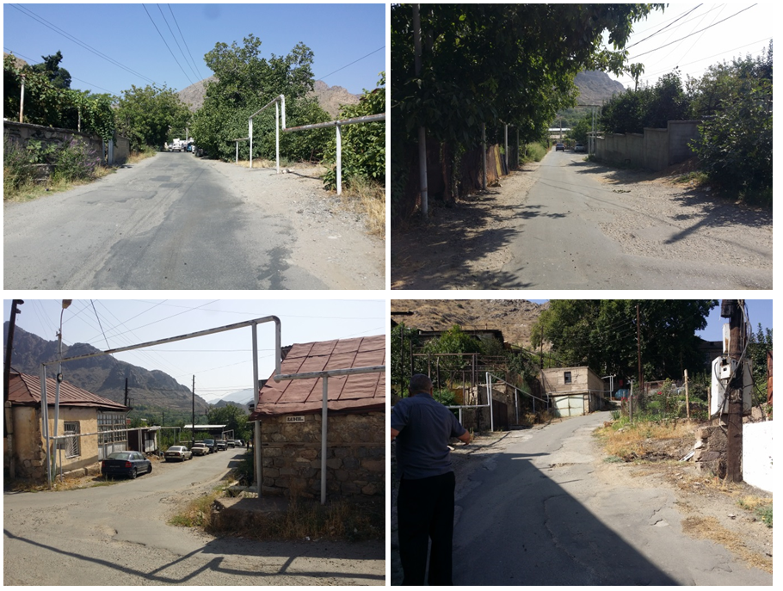
Photo 6 Mezhlumyan Str.

Attachment 2: Permission for construction waste disposal
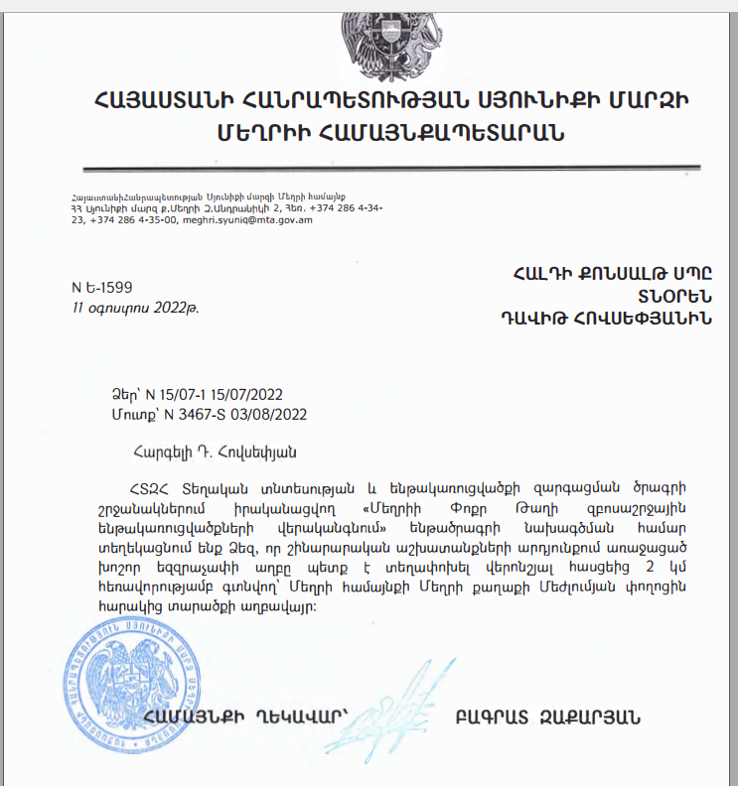

English summary of the above attached document:

August 11, 2023 Reference N-E 1599

This is to certify that the construction waste generated as a result of the construction activities carried out within the framework of the “Meghri Pokr Tag (Small District) Tourism Infrastructure Rehabilitation” project must be removed 2 km from the construction site to a garbage dump located on Meghlumyan Street, Meghri town.

Community chief Bagrat Zaqaryan /sealed and signed/

Attachment 3: Positive conclusion of the Environmental Impact Assessment and State Expertise

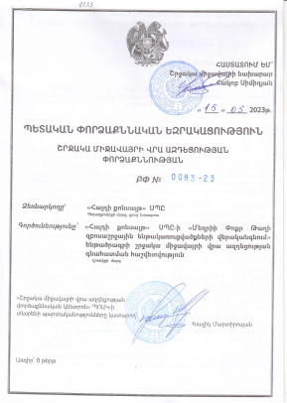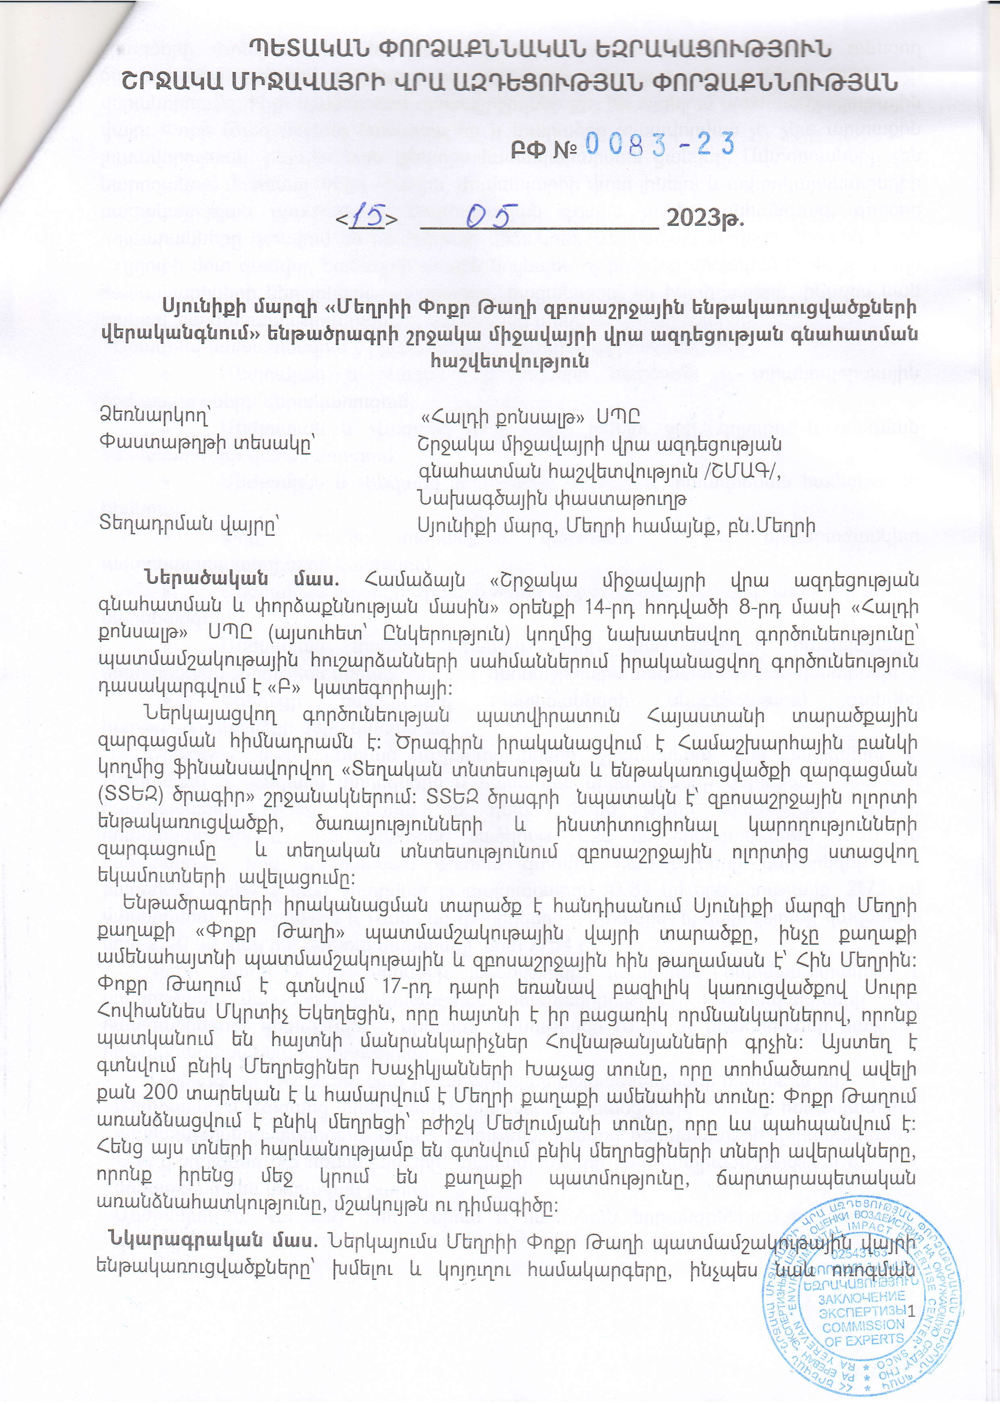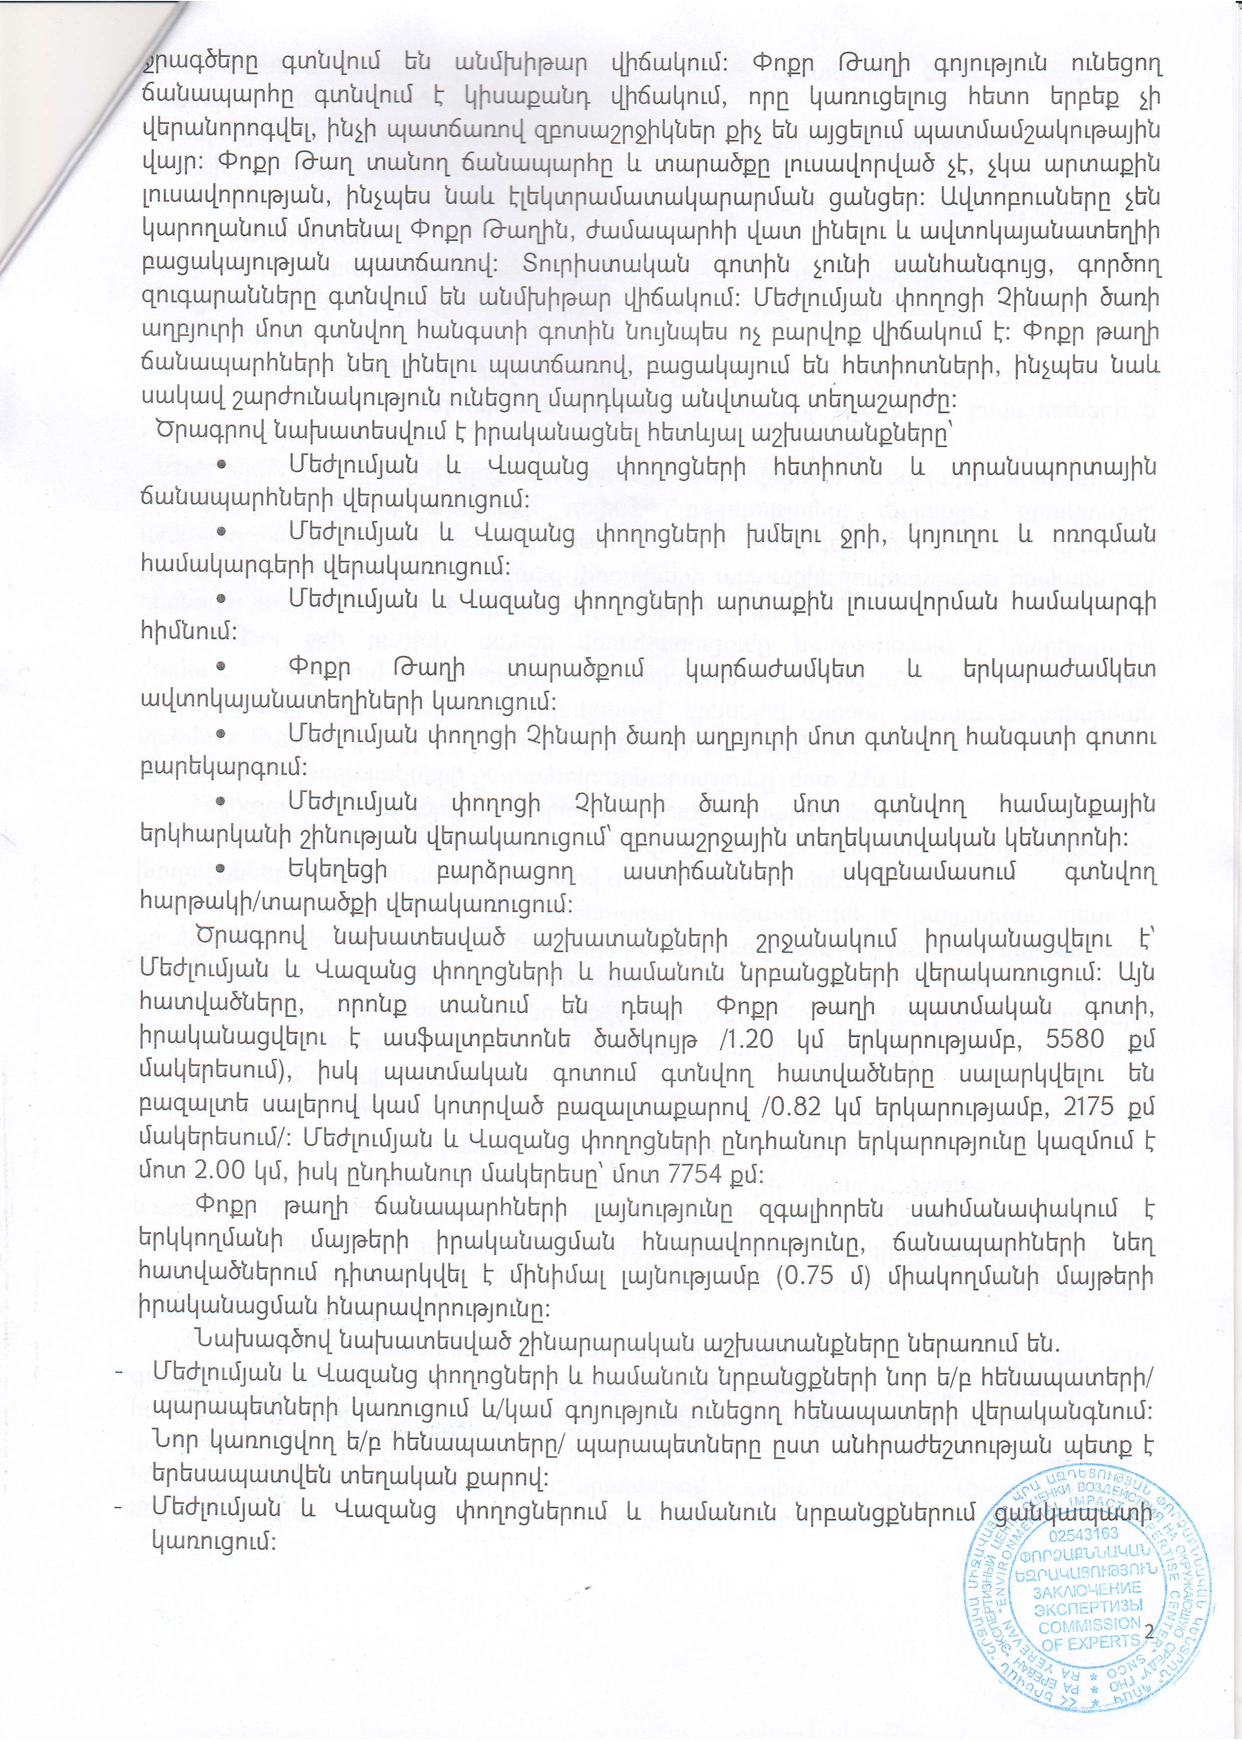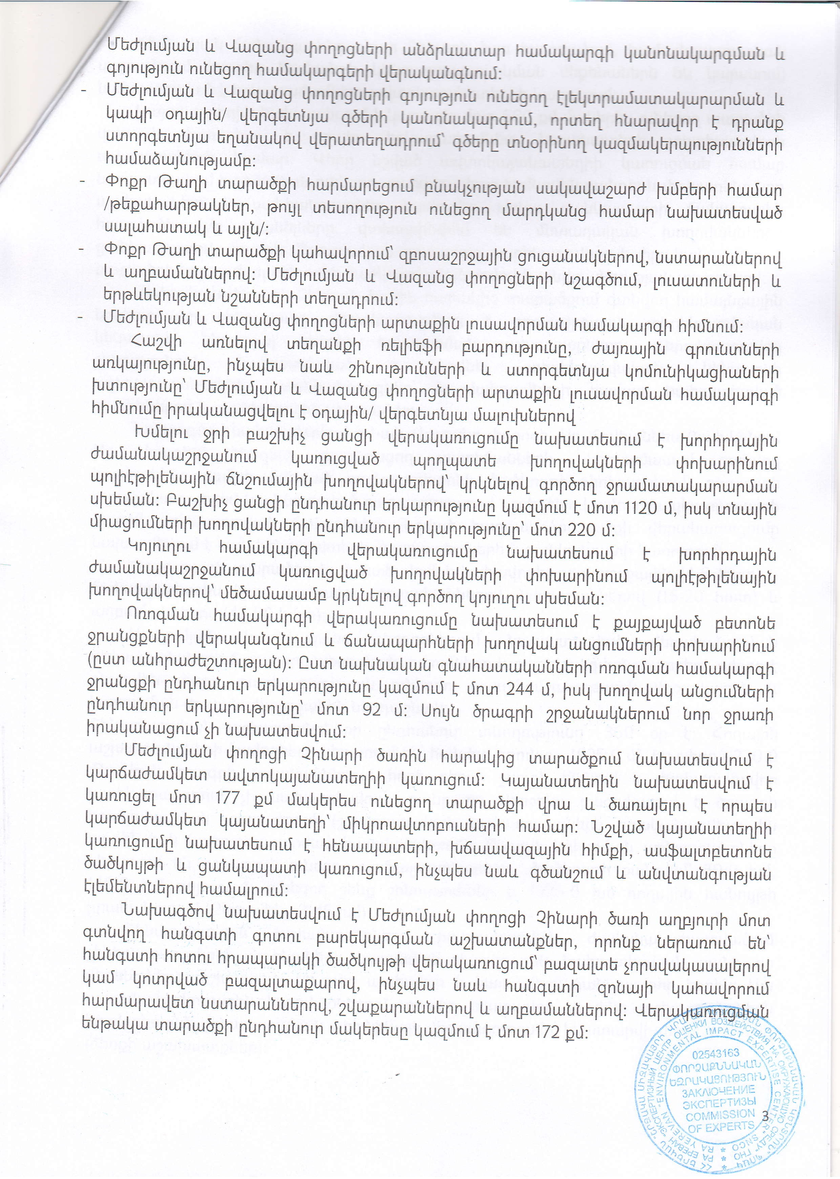
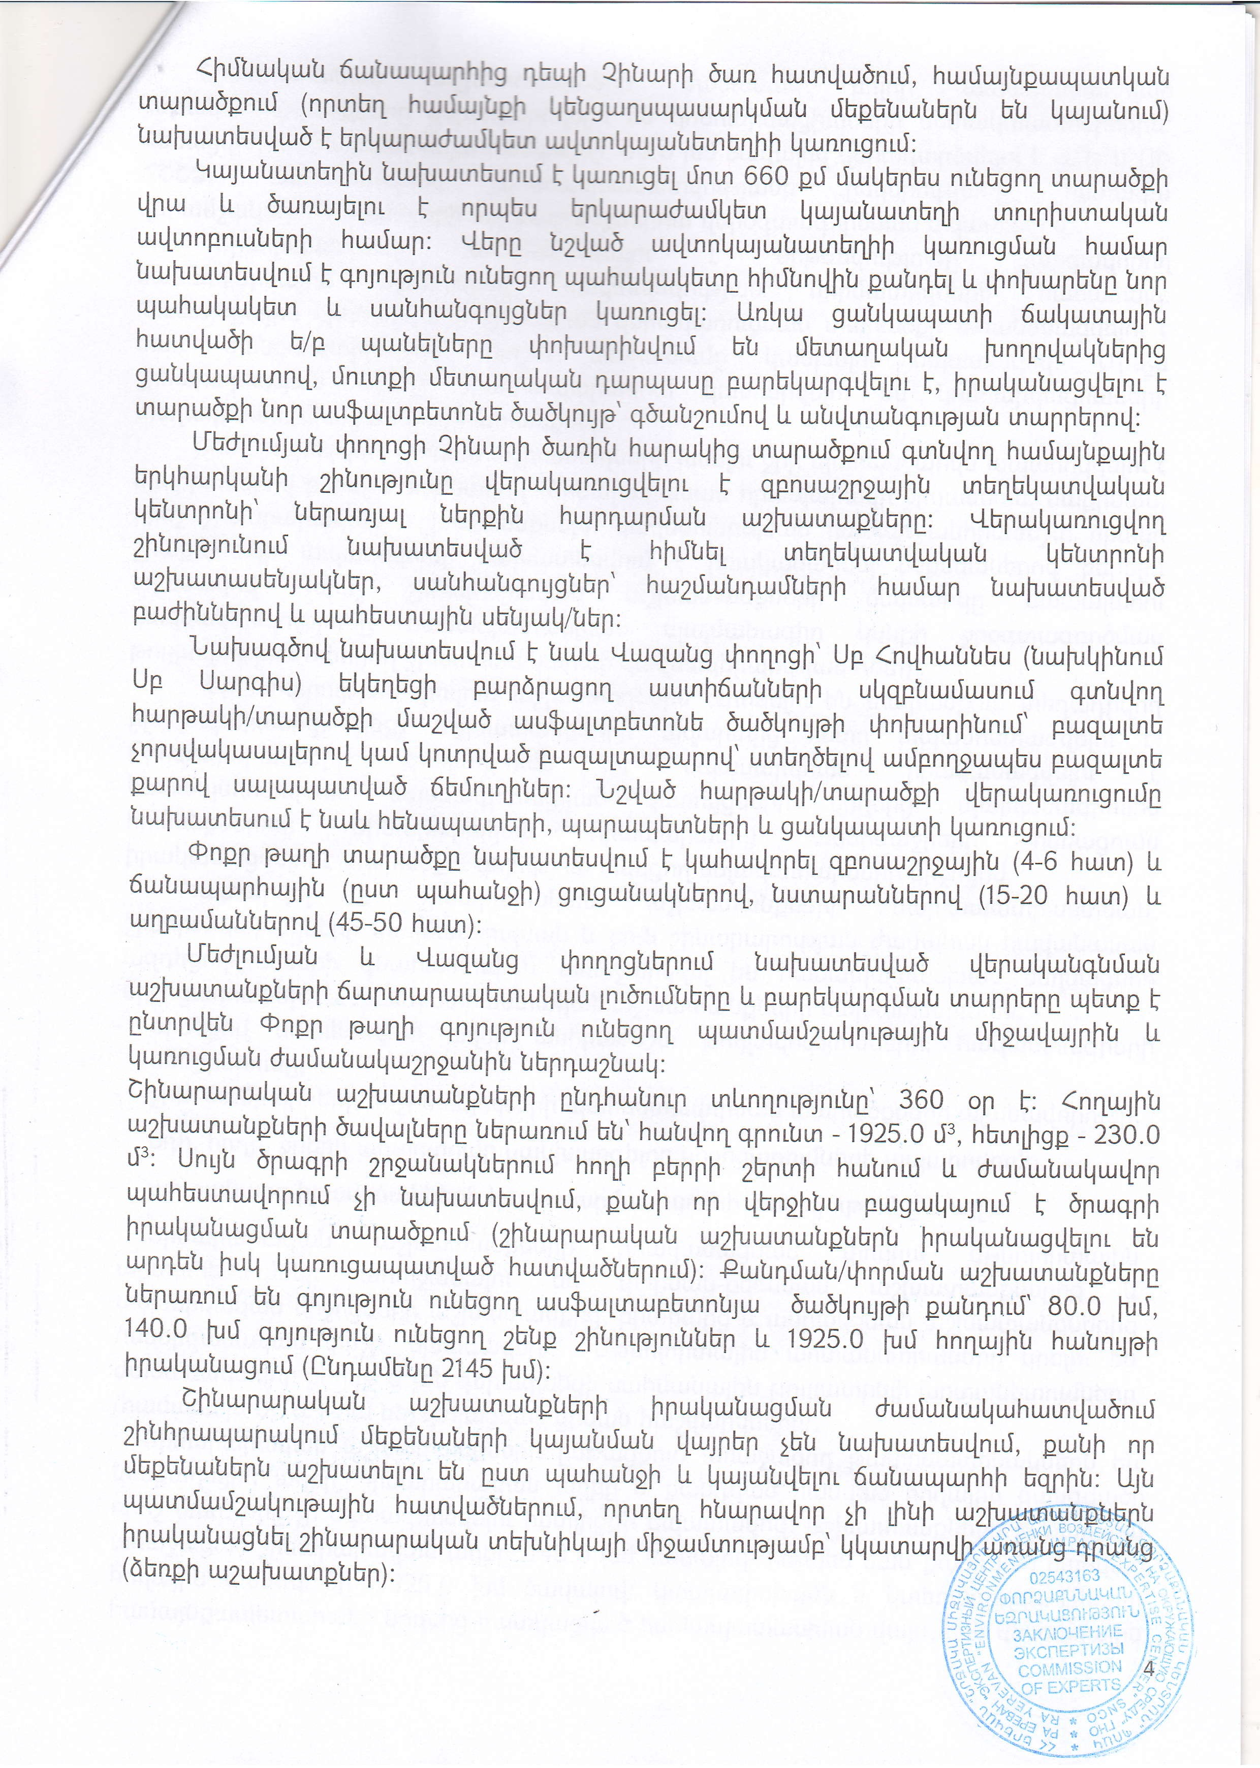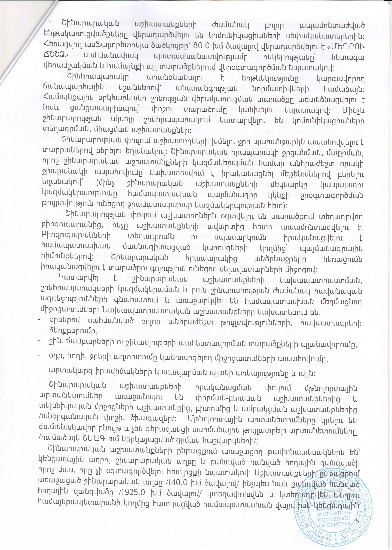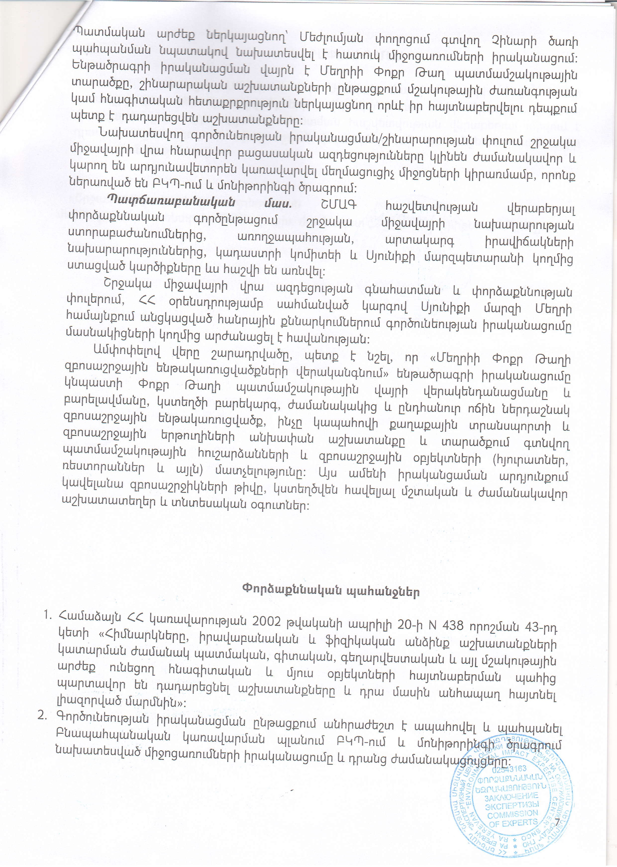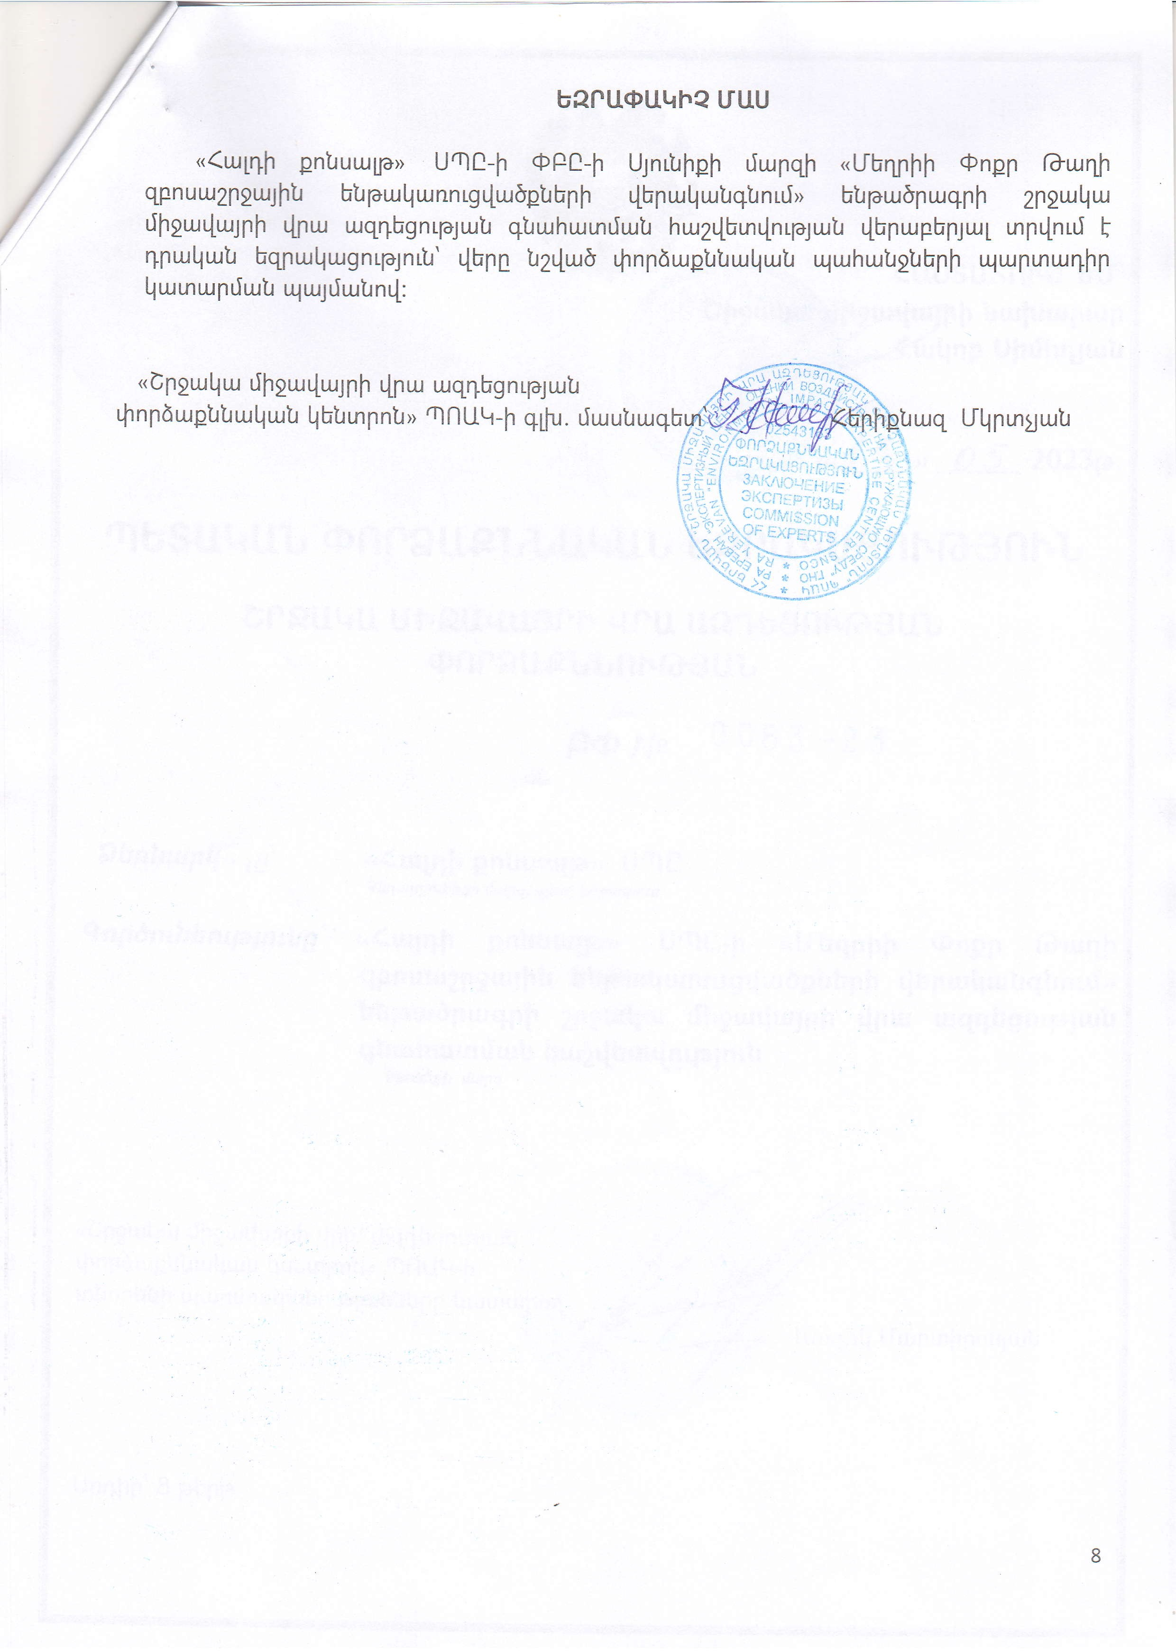

English summary of the above attached document:

No 0083-23
Date issued: 15.05.2023
Expertise Initiator: "Haldi Consult "LTD
Type of activity: Environmental Impact Assessment Report for the
Rehabilitation of Meghri Pokr Tagh (Small district) tourism infrastructure

The expertise requirements:
− During the implementation of the construction works, it is necessary to monitor the sanitary norms of the area, to implement the environmental measures specified in the assessment report, and in case of non-satisfaction, to plan additional measures.
− It is necessary to carry out the planned construction works during the specified hours of the day, minimizing as much as possible the noise and the maximum load on the roads.
− Carry out concrete transportation in the manner specified in the report, excluding concrete production at the construction site or adjacent areas.
− During the construction works, ensure the requirements on the environment, as well as human health, safety and technical safety standards of the RA.
− Be guided by the requirements set by the law "Law on the Preservation and Use of Immovable Monuments of History and Culture and the Historical Environment (1998). ".
− In accordance with the request of the RA Government's decision N 438 dated April 20, 2002, in case of discovery of historical-cultural or archaeological layers during the implementation of activities, it is necessary to stop the works, and inform the authorized body regulating the sector. Resume the works only after the permission of the authorized body.

CONCLUSION
A positive opinion is given on the Environmental Impact Assessment report of the rehabilitation of Meghri Pokr Tagh (Small district) tourism infrastructure, submitted by the " Haldi konsalt " LTD, with the obligatory fulfillment of expert requirements.
"Environmental Impact Expertise Center" SNOC

Specialist of the first category Hericnaz Mkrtchyan.

Attachment 4: Minutes of public consultation on the draft Environmental and Social Management Plan

On January 16, 2024, a public consultation meeting was held in the municipality of Meghri community with the participation of ATDF specialists, the head of Meghri community, and residents of “Pokr Tagh” district of Meghri town. Overall, 22 people participated in the meeting, of which 6 were women.
The announcement of the public consultation meeting and the draft ESMP were posted on the webpages of the ATDF and Meghri community on January 3, 2024․
Bagrat Zakaryan, the head of Meghri community, opened the meeting and presented the purpose of the meeting and the concept of the sub-project.
Marine Vardanyan, the Social Specialist of the Environmental and Social Unit of the ATDF, informed the participants that the ATDF had prepared an Environmental and Social Management Plan (ESMP) for sub-component “Rehabilitation of Meghri Pokr Tagh (Small district) tourism infrastructure”. The public consultation meeting was held in Meghri to disclose the draft ESMP to the community so that the community could raise their concerns and make suggestions. She noted that the ESMP includes all possible environmental, social, health and safety impacts and their mitigation measures to be implemented during the construction works.
Marine Vardanyan presented the expected temporary environmental and social impacts, including the generation and transportation of construction waste, noise and dust generation due to construction works. The safety measures to be provided were also presented, including the fencing of the construction site, installation of caution tapes in dangerous areas of the construction site and traffic management, as well as the safety signs installation requirements. The measures for safety of labor were presented, including wearing uniform and personal protective equipment, as well as the requirements on the supply of construction materials and maintenance of construction equipment.
Marine Vardanyan mentioned that no negative social impacts are anticipated under the project. However, there is a case for resettlement which she talked about later during the meeting. It was also mentioned that in cases when the stone fences of the residents of Vazants street had to be removed and renovated, written consent of the owners had to be taken from the owners beforehand.
Sona Gevorgyan, the Social Specialist of the Environmental and Social Unit of the ATDF, presented the Grievance Redress Mechanism (GRM) of the LEID project to the participants of the meeting. She also noted that the community had to appoint a GRM focal point who would be responsible for recording the grievances from the community and to pass them to the ATDF. She also added that the GRM focal person’s contact information should be available for the community. It was mentioned that the information on the GRM will be additionally posted on the information board of Meghri Municipality and the sub-project information board to be installed at the entrance of the construction site.
Thus, Mariam Hakobyan, the PR officer of the Municipality was appointed as the GRM focal point for Meghri sub-project. And the GRM information was placed on the info board immediately after the meeting and was posted on Meghri community website.
Marine Vardanyan also presented the supervision and monitoring procedures for the implementation of the measures provided under the ESMP were explained.
There was also a discussion about the resettlement of Zoya Grigoryan who has been residing in the community building included in the subproject for rehabilitation and use as an info center. Marine Vardanyan noted that the municipality has undertaken the responsibility for resettlement of the old woman to other premises with better communal conditions compared to her current conditions.
Bagrat Zakaryan informed the participants that Zoya Grigoryan had refused to move to the suggested 2 premises (in a hotel and in the territory of the communal services) so now the municipality is in search for a proper apartment that can be rented for her.
Marine Vardanyan reminded the participants and the mayor that the condition of the suggested premises should be better than that of her current place and there should be written obligation from the municipality that the woman could live at the new place all her life.
There were no questions related to environmental, social, health and safety impacts and their mitigation measures. However, there were lots of questions about the design solutions so the community head presented some details about the design. The main questions were as follows:
Q1 – What kind of stone will be used at stone paved sections?
A1 – It will be basalt but the stones will not be smoothly polished tiles but roughly grounded pieces.
Q2 – Is the rehabilitation of old houses in “Poqr Tagh” included in the sub-project?
A2 – No, apart from the rehabilitation of community owned two-storied building on Mezhlumyan Street.
Q3 – Does the sub-project include underground reinstallation of the gas pipes?
A3 – The question was raised also during the EIA meetings, but it was impossible to include in the design as the gas pipelines have to be installed on safe distance from houses which cannot be kept in case of underground installation.
After the meeting the ATDF Social specialists visited Zoya Grigoryan and talked to her. She confirmed her readiness to move to another flat rented by the municipality or even to the hotel if all the arrangements for her stay there are provided.

The photos and the list of participants are presented below.

Photos (not subject to publication)

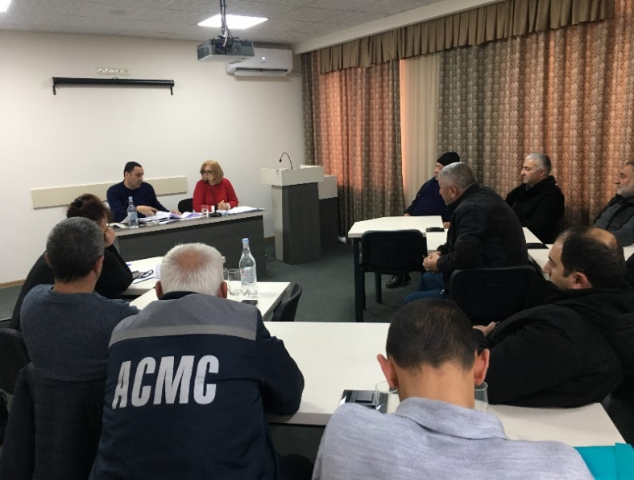 | 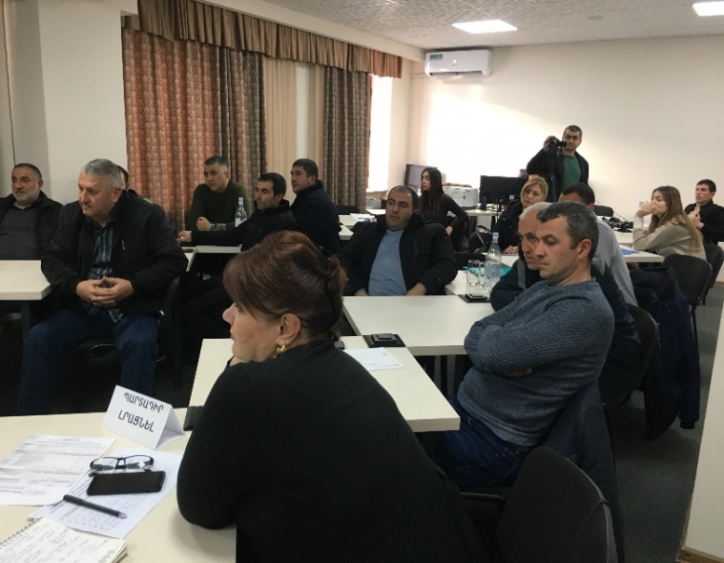
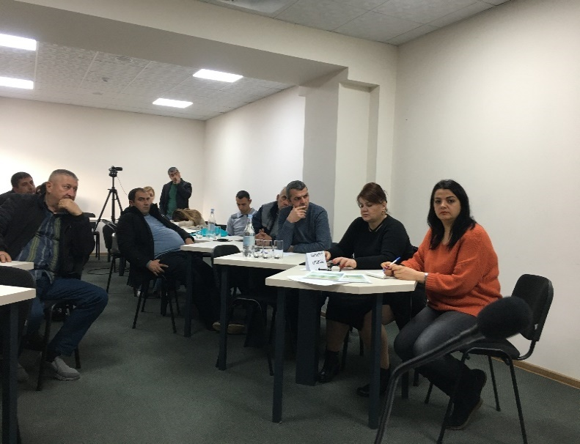 | 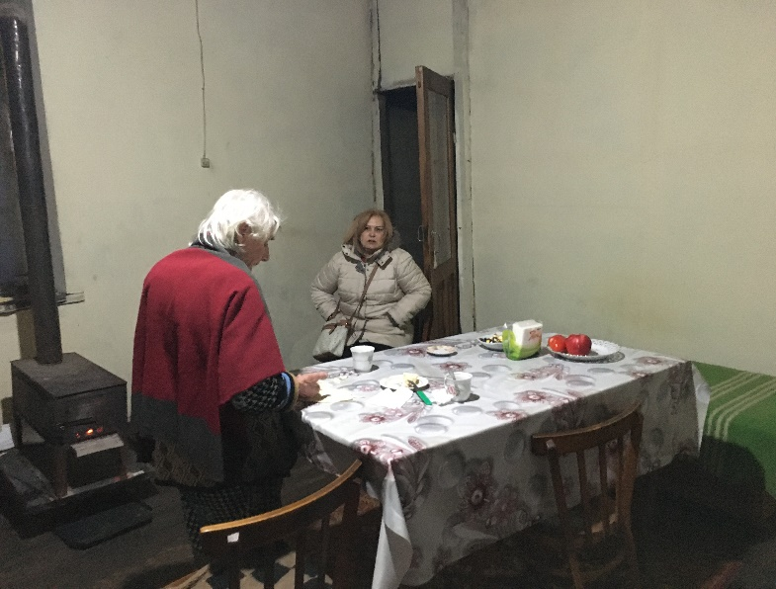

List of Participants (not subject to publication)

Attachment 5: Construction permits 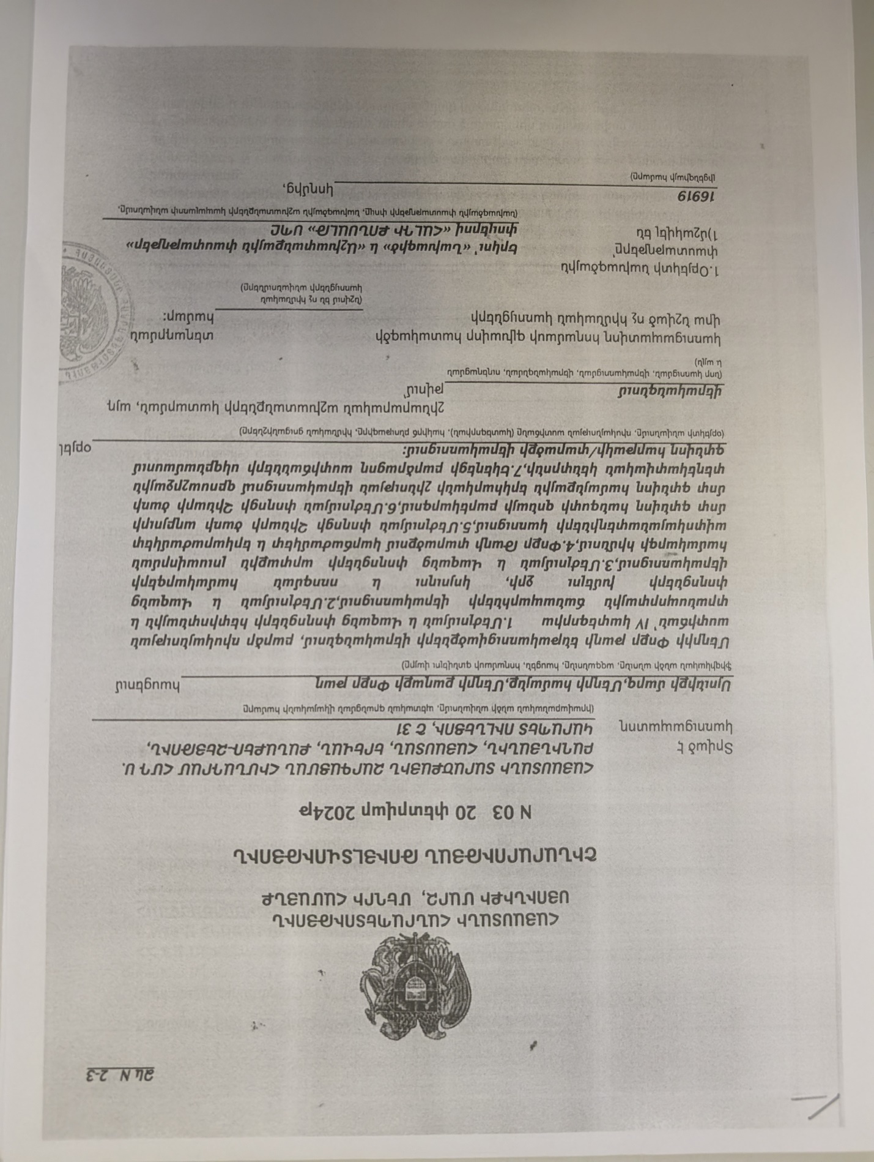
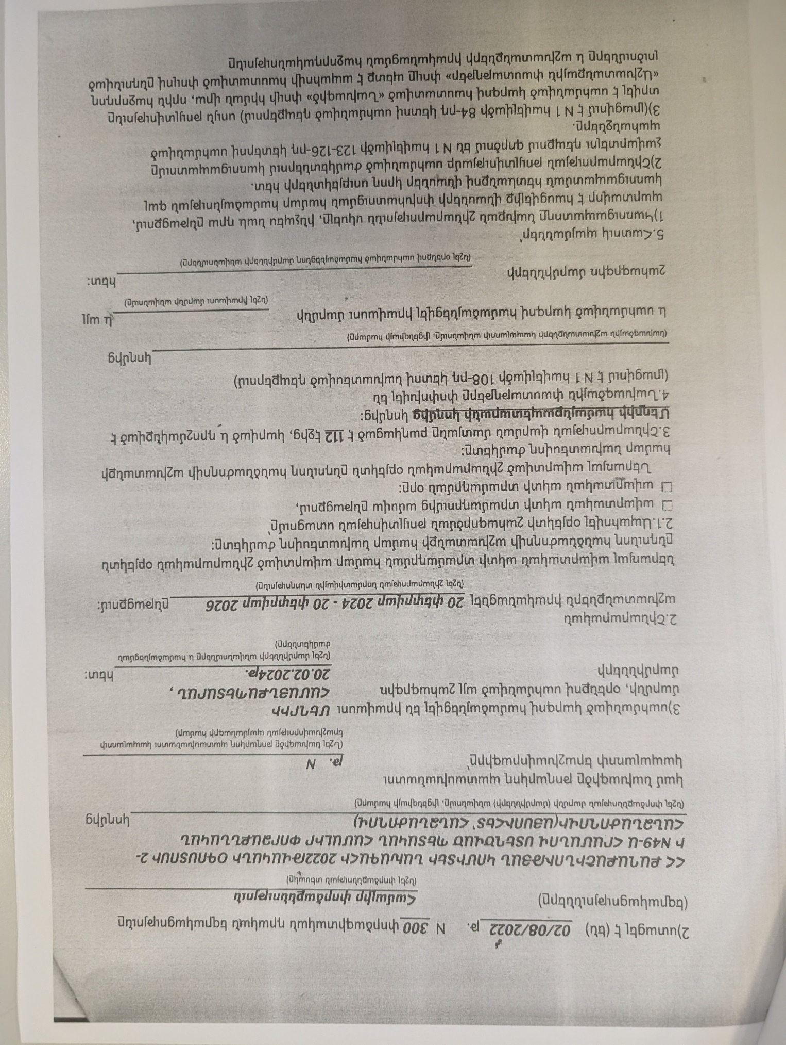
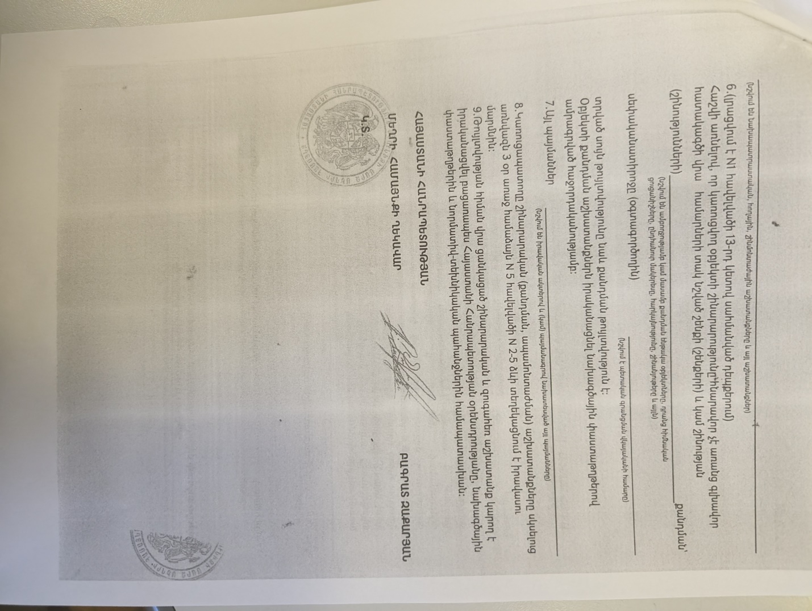

Summary of the above attached document:

Republic of Armenia
Syunik Region, Meghri Community
Construction Permit N 03. 20.02.2024
This is given for the “Rehabilitation of Meghri Pokr Tagh”.
The design documents are
1. Developed by “HALDI Consult” LLC, License 16919
2. The reconstruction will be implemented within 24 month.

B.Zakaryan Sealed/Signed

Attachment 6: Conclusion about reconstruction of roads and other infrastructures within the protection zone of St. Hovhannes (St. Sargis) Church of Small District of Meghri
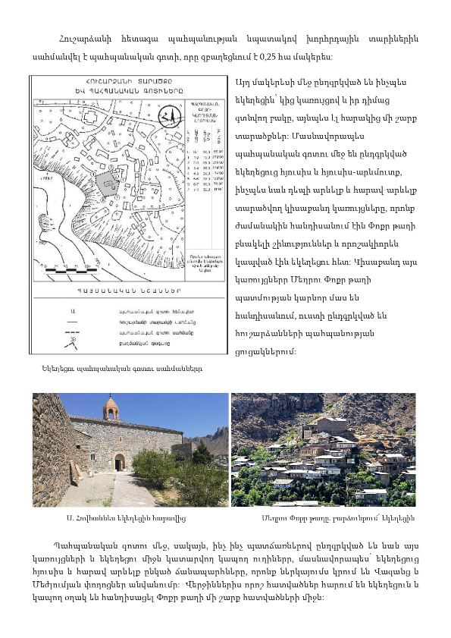
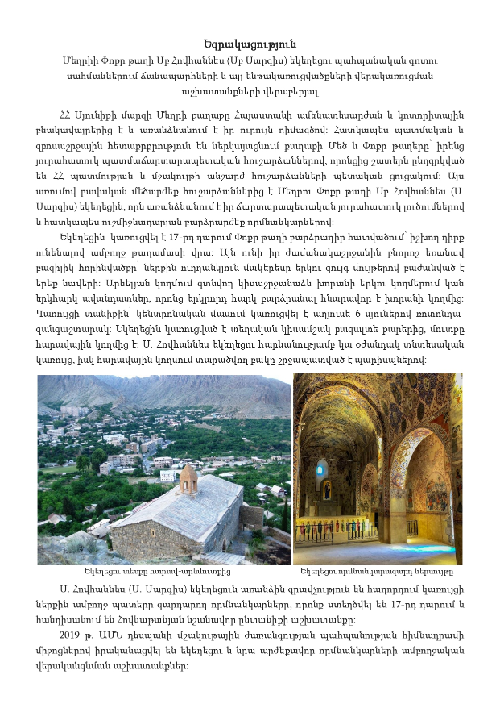

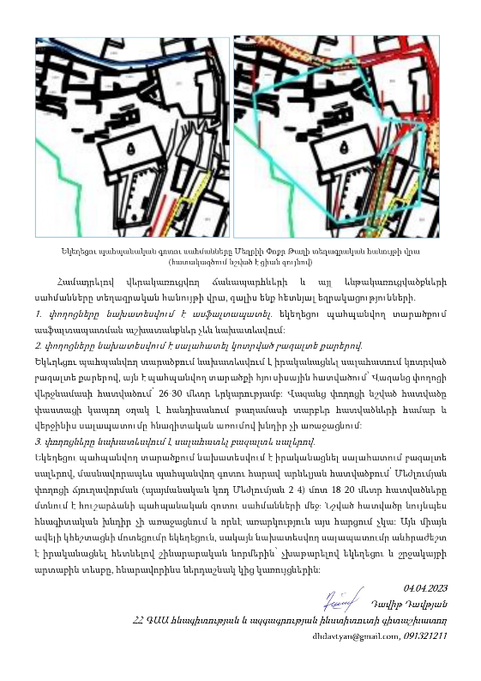

Non-official translation

Summary on Conclusion
Regarding the works of reconstruction of roads and other infrastructures within the protection zone of St. Hovhannes (St. Sargis) Church of Small District of Meghri
The city of Meghri, Syunik Marz, RA is one of the most scenic and popular settlements in Armenia and is distinguished by its unique appearance. The Great and Small districts of the city are of particular historical and tourist interest with their unique historical and architectural monuments, many of which are included in the state list of monuments of history and culture of the Republic of Armenia. In this regard, the church of St. Hovhannes (St. Sargis) of Meghri Small District is one of the most valuable monuments, which is distinguished by its unique architectural solutions and especially high value wall paintings of the late Middle Ages. The church was built in the 17th century on the elevated part of the Small District, having a commanding position over the whole district.
In order to further preserve the monument, a conservation zone was established during the Soviet years, which covers an area of 0.25 hectares. This area includes both the church with the adjacent structure and the yard in front of it, as well as a number of adjacent areas. In particular, the conservation zone includes the half-demolished structures to the north and northwest of the church, as well as to the east and southeast, which were once residential buildings of the Small District and were somehow connected to the church. These semi-destroyed structures are an important part of the history of Meghri Small District, so they are included in the lists of monuments. However, for some reason, the connecting roads between these structures and the church are also included in the protection zone, in particular, the roads north and southeast of the church, which are currently named Vazants and Mezhlumyan streets. Some parts of the latter are adjacent to the church and were a connecting link between some sections of the small neighborhood.
By comparing the boundaries of the reconstructed roads and other infrastructures on the topographic map, we come to the following conclusions:
1. It is planned to pave the streets with asphalt. Asphalting works are not planned in the protected area of the church.
2. It is planned to pave the streets with broken basalt stones.
Paving with broken basalt stones is planned for the protected area of the church, that is, in the northern part of the protected area, at the end of Vazants Street, with a length of 26-30 meters. The mentioned section of Vazants Street is a real connecting link for different parts of the district and its paving does not pose a problem from an archaeological point of view.
3. It is planned to pave the streets with basalt slabs.
In the protected area of the church, it is planned to carry out paving with basalt slabs, particularly in the southeastern part of the protected zone, the 18-20 meter sections of the Mezhlumyan street branching (conditional code Mezhlumyan 2-4) are within the boundaries of the protected zone of the monument. The mentioned part also does not pose an archaeological problem and there is no objection in this regard. It will only make the approach to the church easier, but the planned paving must be carried out in accordance with construction norms, without disturbing the appearance of the church and its surroundings, as harmoniously as possible with the adjacent structures.
04.04.2023
Davit Davtyan
Researcher of the Institute of Archeology and Ethnography
of the National Academy of Sciences of the Republic of Armenia

Toxic / hazardous material includes but is not limited to asbestos, toxic paints, noxious solvents, removal of lead paint, etc.

