REPUBLIC OF ARMENIA
LOCAL ECONOMY AND INFRASTRUCTURE DEVELOPMENT PROJECT

ENVIRONMENTAL AND SOCIAL MANAGEMENT PLAN
“RECONSTRUCTION OF THE TOURISM INFRASTRUCTURE AND ROADS OF THE JERMUK CITY”
SUB-PROJECT
Component 4
Renovation and Improvement of the Alley from Shahumyan Street to the Drinking Gallery, Construction of Pavilions and Information Center

Component 5
Construction of the Access Road to “Yeghnik” Statue and the Observation Deck

JUly 2022

PART A: General Project and Site Information
INSTITUTIONAL & ADMINISTRATIVE
Project title | LOCAL ECONOMY AND INFRASTRUCTURE DEVELOPMENT (LEID)
Subproject number and title | ТUR-11 “Reconstruction of the Tourism Infrastructure and Roads of the Jermuk City”
Municipality, community | Jermuk Community, Vayots Dzor marz
Scope of site-specific activity | The ESMP covers the construction works planned under the two components of the sub-project:  TUR-11. 4. Renovation and Improvement of the Alley from Shahumyan Street to the Drinking Gallery, Construction of Pavilions and Information Center;  ТUR-11.5. Construction of the Access Road to “Yeghnik” Statue and the Observation Deck.  Component 4. It is planned to rehabilitate, improve and landscape the alleys leading to the drinking gallery from Shahumyan street. 20 pavilions will be installed and an information center with an area of 13.7 m² will be constructed. The alleys extending from the drinking gallery to the square consist of three sections.  Section 1 – a semi-circle square area with a radius of 25.5m. Four lawns (7m wide) will be established at this site.  Section 2 – a 12.5 m wide alley will be constructed from the square to the artificial pond site. Four lawns will be arranged in the central part of the alley (5m wide and 15-21m long).  Section 3 – an alley (2.1-4.25m wide) will be constructed in the area adjacent to the “Yotnaghbyur” artificial pond. It is planned to cover the alleys with concrete slabs.  Overall the construction works under the Component 4 include:  - Covering of alleys by concrete tiles/slabs (2442 m2);  - Landscaping (545.15 m2 );  - Bicycle parking rack installation;  - Installation of benches and trash bins (18);  - Construction of information center (13.7m2);  - Installation of external power supply system (320 m ).  Component 5. Construction of the access road to “Yeghnik” statue and the observation deck.  It is planned to reconstruct the existing earth road (1.6 km) to the “Yeghnik” (deer) statue with the following road layers: sand gravel layer h=10cm; crushed stone base h=15cm with bitumen spray (4.12t/1000 m2); fine grained asphalt/concrete, h=5cm. A drainage system will be constructed consisting of concrete flumes B-2-20; 126m polyethylene corrugated pipes to the nearest storm water flow channel; metal half-pipes (to the forest). Monolithic concrete retaining walls will be constructed with the length of 640m to avoid future collapses of the slope. Rubble concrete/ concrete parapets will be built and road signs will be installed for traffic safety.  A parking lot, a toilet and a glass scenic viewpoint are planned in the area of the observation deck. The parking lot is designed with dimensions of 25x31.5m. There will also be 1.0-1.5m wide sidewalks. The cross-section of the parking lot driving area was designed with a transverse slope of 4% for earthwork and drainage considerations. The drainage of the parking will be implemented by a surface method. The water will be removed through a flume with concrete bottom and walls made of stones 15x30cm constructed in the area adjoining to the toilet.  For safety reasons, it is planned to install metal railings on the outer edge of the pavement of the fill to be made for the parking lot.  The toilet will be constructed in the north-eastern part of the observation deck. It is planned to have a compartment for people with disabilities, as well. The water supply to the toilet will be organized by a water tank with a capacity of 5 cubic meters to be installed under the Component. The water will be supplied to the tank by the municipality through a water truck. Installation of a sewage treatment plant with a capacity of 1.5 cubic meters is planned under the sub-project.  A scenic viewpoint will be constructed within the area of the observation deck next to the “Yeghnik”statue. Three benches with tents will be installed at the scenic viewpoint.  Stairs and a ramp with basalt tiles will be provided to go down to the deer statue and scenic viewpoints of the observation deck. Metal railings have also been planned for safety. The parking surface will be made of fine-grained asphalt/concrete; the landing will be made of basalt tiles.  External lighting system will be installed along the road to be reconstructed.  Overall the construction works under the Component 5 include:  - Reconstruction of the road to the “Yeghnik” statue with drainage system (5185 m2);  - Construction of drainage system (126 m);  - Asphalt covering of observation deck (836,6 m2);  - Construction of scenic viewpoint, stairs and ramp (109.5 m2);  - Construction of the toilet (21,5 m2);  - Sewerage treatment plant installation;  - Installation of a water tank;  - Installation of lighting pillars (43);  - Installation of power substation (160/10/0.4kv).  - External power supply (10 kV) underground line construction (1200 m);  - External power supply (0.4 kV) underground line construction (675 m).
Institutional arrangements (WB) | Task Team Leader:  Tafadzwa Dube |  | Safeguards Specialists:  Oksana Rakovych (Environment)  David Jijelava (Social)
Implementation arrangements (RoA) | Implementing entity:  ATDF | Works supervisor:  “HALDI Consult” LLC |  | Works contractor:  “Arhovshin” LLC
SITE DESCRIPTION
Name of institution whose premises are to be rehabilitated | Jermuk community
Address and site location of institution whose premises are to be rehabilitated | Jermuk town, alley from Shahumyan Street to the drinking gallery and road leading to the “Yeghnik” statue.
Who owns the land?  Who uses the land (formal/informal)? | The construction works planned under Component 4 including the rehabilitation, improvement and landscaping of the Drinking Gallery alleys and construction of the information center will be done on the community-owned land plots. The pavilions will be installed inside the park, on the right side of the alley leading to the Drinking Gallery (See the Map 4).  The construction works planned under the Component 5 including the road rehabilitation, drainage system, toilet and observation deck construction, lighting pillars installation will be done on the community-owned land plots.  No private land will be used for the implementation of the components. The components will not result in the temporary or permanent loss of crops, fruit trees, and/or household infrastructure.  14 movable kiosks and one coffee machine are installed on the communal land plot near the seven-spring artificial lake, on the one side of the alley leading to the Drinking Gallery, where construction works are planned to be done under the Component 4. The market mostly works in summer when the tourism flow is active. The land is not rented by the sellers. The kiosks will be relocated to another alley near the Drinking Gallery at a 10m distance from the current place. A public consultation meeting was held on May 5 with the participation of traders. Leaflets with GRM information were given to the traders with the contact and procedural information. The old kiosks will be relocated during the mobilization stage of the construction works under the assistance of the Jermuk administrative office. The new 20 pavilions planned under the sub-project will be installed within 2-3 days. The operation of the traders will not be disabled for more than 4 days. The number of the new pavilions to be installed under the sub-project is more than the number of currently operating kiosks. The new pavilions to be installed will be given to the traders for rent. The traders are informed about the operation conditions of the new kiosks. The Jermuk community administration office has submitted a statement that all the relocation activities planned under the sub-project will be done without any negative impacts on the livelihood of the traders (See Annex 3). The relocation of the old kiosks will have no negative impact on the livelihood of the traders, especially taking into consideration that the construction works are supposed to launch in the non-touristic season.
Description of physical and natural environment around the site | The Jermuk town is located at a height of 2080 meters above sea level, within the mountains of Vayots Dzor, among thick forests, on a plateau divided into two parts by the gorge of Arpa River, 170 km south-east of Yerevan. The town is dominated by the Vardenis mountain range from the north and the Vayk range from the south. The height of the surrounding mountains ranges between 2500 and 3500 meters, all covered with forests and alpine meadows. The town is mainly famous with its hot springs (geysers).  The Jermuk Hydrological Sanctuary and mineral hot spring-fed basins located in Jermuk administrative area are protected areas. The Jermuk Hydrological Sanctuary is located on the upper stream of Arpa river, at altitudes of 2100-2470m above sea level. The Drinking Gallery located in the center of the Jermuk town is included in the state list of cultural monuments.  Reconstructing works under the Component 4 of the sub-project will be expanded in the center of Jermuk town, in a picturesque place, along the alleys of Shahumyan streets leading to the Drinking Gallery. It is a crowded place frequented by tourists and locals.  The earth road leading to the statue of a deer (Yeghnik) to be reconstructed under the Component 5 starts at the left of the entrance to the Jermuk water factory. The statue of “Yeghnik” is also a favorite place for tourists.  The rehabilitated road sections are under the administrative ownership of the Jermuk community. There are trees along the roads that will not be affected.  The construction site is located out of the preservation area of the Drinking Gallery. The distance from the Jermuk Hydrological Sanctuary to the nearest point of the construction site is 11.4 km.  The implementation of the subproject will, first of all, contribute to the creation of a developed, improved tourism infrastructure and the provision of quality tourism services. Favorable conditions will be created for the development of the business and investment environment in the historical and cultural zone. Since Jermuk is an attractive tourist destination, the number of local and foreign tourists will increase every year.
LEGISLATION
National & local legislation & permits that apply to sub-project activity | The following Armenian legislation defines a legal framework applicable to project activities:  - Law on Atmospheric Air Protection of RoA (1994)  The purpose of the Law on Atmospheric Air Protection is to define the main principles of the RoA, directed to the provision of purity of atmospheric air and improvement of air quality, prevention and mitigation of the chemical, physical, biological, and other impacts on air quality and regulation of public relation. This Law also regulates the emission licenses and provides maximum allowed loads/concentrations for atmospheric air pollution, etc.  According to this law, the contractor shall undertake construction activities as well as transportation and temporary storage of waste the way to minimize dust and other emissions.  - Law on Waste of RoA (2004)  The law provides the legal and economic basis for the collection, transportation, disposal, treatment, re-use of wastes, as well as prevention of negative impacts of waste on natural resources, human life and health. The law defines the roles and responsibilities of the state authorized bodies as well as of waste generator organizations in waste management operations.  According to this law, the waste generated from construction activities should be recycled as appropriate or disposed of in designated locations.  Disposal of the construction waste and excess material in selected locations must be approved by the local municipality in writing.  - Law on Environmental Impact Assessment and Expertise of RoA (2014)  The law defines the type of activities that are subject to environmental impact assessment and environmental expertise.  According to this law, the proposed activities are not subject to environmental impact assessment and expertise  - Law on Urban Development of RoA (1998) According to this law, planned works require obtaining a construction permit.
PUBLIC CONSULTATION
When / where the public consultation process will take /took place | The draft ESMP was disclosed and discussed at the public consultation meeting held on 28 July in Jermuk town with the participants from the administration office of Jermuk, project-affected local traders and other residents.  Draft ESMP was disclosed in Armenian and English languages on the ATDF website (www.atdf.am) and in Armenian language on the beneficiary's website (www.jermuk.am). Brief information on the planned works and contact information for addressing questions and grievances will be placed at the worksite, on the information board of Jermuk municipality office and/or in its immediate surroundings.
ATTACHMENTS
Attachment 1: Site map/photo
Attachment 2: Permission for construction waste disposal
Attachment 3: Statement of the head of Jermuk community
Attachment 4: Minutes of public consultation on the draft ESMP
Attachment 5: Construction permit

PART B: safeguards information
ENVIRONMENTAL /SOCIAL SCREENING
Will the site activity include/involve any of the following? | Activity/Issue | Status | Triggered Actions
Will the site activity include/involve any of the following? | - Road rehabilitation | [x] Yes [ ] No | If “Yes”, See Section A below
Will the site activity include/involve any of the following? | - New construction | [x] Yes [ ] No | If “Yes”, See Section A below
Will the site activity include/involve any of the following? | - Individual wastewater treatment system | [ ] Yes [x] No | If “Yes”, See Section B below
Will the site activity include/involve any of the following? | - Historic building(s) and districts | [x] Yes []No | If “Yes”, See Section C below
Will the site activity include/involve any of the following? | - Unexpected need for land take | [ ] Yes [x] No | If “Yes”, See Section D below
Will the site activity include/involve any of the following? | - Hazardous or toxic materials | [ ] Yes [x] No | If “Yes”, See Section E below
Will the site activity include/involve any of the following? | - Impacts on forests and/or protected areas | [ ] Yes [x] No | If “Yes”, See Section F below
Will the site activity include/involve any of the following? | - Traffic and pedestrian safety | [x] Yes [ ] No | If “Yes”, See Section H below
Will the site activity include/involve any of the following? | - Social risk management | [x] Yes [ ] No | If “Yes”, See Section I below
PART C: Mitigation measures
ACTIVITY | PARAMETER | MITIGATION MEASURES
0. General Conditions | Notification and Worker Safety | - The local construction and environment inspectorates and communities are notified of upcoming activities  - The public is notified of the works through an appropriate notification in the media and/or at publicly accessible sites (including the site of the works)  - All legally required permits are acquired for construction and/or rehabilitation  - The Contractor formally agrees that all work will be carried out in a safe and disciplined manner designed to minimize impacts on neighboring residents and the environment.  - Workers’ personal protection equipment complies with international good practice (always hardhats, as needed masks and safety glasses, harnesses and safety boots)  - Appropriate signposting of the sites informs workers of key rules and regulations to follow.
A. General Rehabilitation and /or construction activities | Air Quality | - During earthworks, dust is suppressed by ongoing water spraying and/or installing dust screen enclosures at site.  - The surrounding environment (sidewalks, roads) is kept free of debris to minimize dust.  - There is no open burning of construction / waste material at the site.  - There is no excessive idling of construction vehicles at sites.
A. General Rehabilitation and /or construction activities | Noise | - Construction noise is limited to restricted times agreed to in the permit.  - During operations, the engine covers of generators, air compressors and other powered mechanical equipment are closed, and equipment placed as far away from residential areas as possible.
A. General Rehabilitation and /or construction activities | Water Quality | - Appropriate erosion and sediment control measures are applied such as e.g. hay bales and / or silt fences to prevent sediment from moving off site and causing excessive turbidity in nearby streams and rivers.  - Rainwater is removed from the construction site using a rainwater drainage system, and then into the Vararakn River.
A. General Rehabilitation and /or construction activities | Waste Management | - Waste collection and disposal pathways and sites are identified for all major waste types expected from demolition and construction activities.  - Mineral construction and demolition wastes are separated from general refuse, organic, liquid and chemical wastes by on-site sorting and stored in appropriate containers.  - Construction waste is being collected and disposed properly by licensed collectors.  - Whenever feasible, appropriate and viable materials (except asbestos) are reused or recycled.
C. Historic building(s) | Cultural Heritage | - If the building is a designated historic structure, very close to such a structure, or located in a designated historic district, notification shall be made and approvals/permits be obtained from local authorities and all construction activities planned and carried out in line with local and national legislation.  - It shall be ensured that provisions are put in place so that artifacts or other possible “chance finds” encountered in excavation or construction are noted and registered, responsible officials contacted, and works activities delayed or modified to account for such finds.
H. Traffic and pedestrian safety | Direct or indirect hazards to public traffic and pedestrians by construction  activities | In compliance with national regulations, the construction site is properly secured, and construction related traffic regulated. This includes but is not limited to  - Signposting, warning signs, barriers and traffic diversions: site will be clearly visible, and the public warned of all potential hazards.  - Traffic management system and staff training, especially for site access and near-site heavy traffic. Provision of safe passages and crossings for pedestrians where construction traffic interferes.  - Adjustment of working hours to local traffic patterns, e.g. avoiding major transport activities during rush hours or times of livestock movement.  - Active traffic management by trained and visible staff at the site, if required for safe and convenient passage for the public.  - Ensuring safe and continuous access to office facilities, shops and residences during renovation activities, if the buildings stay open for the public.
I. Social risk management | Public relationship management | - Assign local liaison person in charge of communication with and receiving requests/ complaints from local population.  - Consulted local communities to identify and pro-proactively manage potential conflicts between an external workforce and local people.  - Rise local community awareness about sexually disease risks associated with the presence of an external workforce and include local communities in awareness activities.  - Inform population about construction and work schedules, interruption of the services, traffic detour routes and provisional bus routes, blasting and demolition, as appropriate.  - Limit construction activities at night. When necessary, carefully schedule night-time works and inform affected community so they can take necessary measures.  - At least five days in advance of any service interruption (including water, electricity, telephone, bus routes), advise affected community through postings at the project site, at bus stops, and in affected homes/businesses.
I. Social risk management | Labor management | - To the extent possible, locate work camps away from local communities.  - Undertake sitting and operation of worker camps in consultation with neighboring communities.  - Recruit unskilled or semi-skilled workers from local communities to the extent possible. Where and when feasible, provide worker skills training to enhance participation of local people.  - Provide adequate lavatory facilities (toilets and washing areas) in the work site with adequate supplies of hot and cold running water, soap, and hand drying devices. Establish temporary septic tanks for any residential labor camp and without causing pollution of nearby watercourses.  - Raise awareness of workers on overall relationship management with local population, establish the code of conduct in line with international practice  - and strictly enforce them, including the dismissal of workers and financial penalties of adequate scale.
 | GRM management | - GRM is established and advertised at the local level. The Contractor is informed of his responsibility to register and communicate to the PIU received verbal and non-verbal grievances.  - GRM contact information, including local focal points, has been posted at the construction site and the local community’s administrative office.  - The Contractors' local liaison person receives and registers grievances from the population in the GRM log and communicates the grievances to the PIU regularly.

PART D: Monitoring Plan
Activity | What  (Is the parameter to be monitored?) | Where  (Is the parameter to be monitored?) | How  (Is the parameter to be monitored?) | When  (Define the frequency / or continuous?) | Why  (Is the parameter being monitored?) | Who  (Is responsible for monitoring?)
CONSTRUCTION PHASE
- Supply of construction  materials | Purchase of construction materials from the licensed suppliers | In supplier’s office or warehouse | Verification of labels of the materials and/or certificates if any | During conclusion of supply contracts | Ensure reliability of construction materials and their safety for human health | ATDF  Technical Supervisor
- Transportation  of construction  materials and  waste;  Movement of  construction  vehicles and  machinery | - Technical condition of construction vehicles and machinery;  - Confinement and protection of truck loads with lining  - Movement of construction vehicles and machinery according to predefined traffic routes and within working hours: 9AM-6PM. | -Construction site  -Routes of transportation of construction materials and wastes | Inspection of pre-defined movement routes, entrances and exits of construction sites | Unannounced monthly inspection during work hours and beyond | -Limit pollution of soil and air from emissions;  -Limit nuisance to local communities;  -Minimize traffic disruption, ensure pedestrian safety and prevent accidents | ATDF  Technical Supervisor
- Maintenance of construction equipment | - Washing of cars and construction equipment outside the construction site or on maximum distance from natural streams  - Refueling or lubrication of construction equipment outside the construction site or at the predetermined confined area | Construction site | Inspection of activities | Selective inspections during work hours | -Avoid pollution of water and soil with oil products due to operation of equipment;  -Timely localize and decrease expected damage in case of fire | ATDF  Technical Supervisor
- Generation of construction waste | - Temporary storage of waste at the pre-defined areas of construction site;  - Timely disposal of waste to the formally designated locations | Construction site  Waste disposal site | Inspection of site | Unannounced monthly inspection during entire construction phase | -Prevent pollution of soil, surface water and ground water,  - Avoid accidents at the construction site due to scattered fragments of construction materials and debris,  - Retain esthetic appearance of the construction site and its surroundings | ATDF  Technical Supervisor
- Deploying manpower for construction | - Provision of uniforms and safety gears to workers and enforcement of their use by the constructor;  - Provision of work-site safety instruction to contractor’s personnel and instructions proper recording;  - Installation of fencing;  - Provisions of nuisance activities within working hours from 9AM-6PM and in accordance with allowed norms of noise and vibrations | Construction site | Inspection | Periodically during construction and upon its completion | -Minimize probability of accidents  -Protect workers’ health;  -Limit nuisance to local communities from noise and vibration. | ATDF  Technical Supervisor
- Works near the cultural heritage buildings | - Avoid incidentally damage to the cultural heritage buildings | Construction site | -Inspection of documentation  - Inspection of activities | Entire period of construction | Prevent damage to the drinking Gallery by restricting movement of construction vehicles and machinery to designated routes of transporation, undertake on-site storage of construction materials and goods to designated locations, confine construction activities to the designated and demarkated construction site. | ATDF  Technical Supervisor  Agency for the Protection of Monuments and Historical Sites
- Works near privately-owned  land plots and other property | - Avoid trespassing or incidentally damaging of private property (using small-size machinery or manual labor near walls and fences, stockpiling of construction material and waste away from private property; etc.);  - In case of unintended damage to private property, quickly restore it to the original or better status;  - In case of expected temporary impact on privately-owned property, inform owners upfront and guarantee restoration, acquire written consent of owners for intervention, and promptly restore the damage to the original or better status. | Works near privately-owned land, buildings and other assets | Monitoring and inspection | Entire period of construction | -Reduce the probability of damages on private property  -Exclude temporary or permanent violation of ownership and/or user rights on the private property | ATDF  Technical Supervisor
- Construction site re-cultivation  and landscaping | Final cleaning of the rehabilitation site and permanent access roads and landscaping-greening of the area as required | Construction site and access roads | Inspection of activities | Final period of construction | Reduce loss of aesthetical value of the landscape due to construction activities | ATDF  Technical Supervisor
- Solid waste management | Trash bins placement and arrangement on periodically transportation of waste | Construction site | Inspection | Total period of works | - Prevent pollution of soil, surface water and ground water;  - Retain esthetic appearance of the sites area and its surroundings | ATDF  Technical Supervisor  Jermuk municipality
- Handling of chance finds | - Stoppage of works promptly upon encountering of change finds;  - Formal communication with Agency for the Protection of Monuments and Historical Sites of RA on chance finds;  - Timely arrangements made for the conduct of required excavation and site conservation | Construction site | -Inspection of chance find sites;  - Inspection of filed documentation | Entire period of construction | Ensure cultural heritage is not damaged by the construction works | ATDF  Technical Supervisor  Agency for the Protection of Monuments and Historical Sites
- Earthwork | - Temporary storage of excavated soil at determined places;  - Backfilling of the excavated ground as needed and disposal of the excess mass to the places, approved in writing. | Construction site | Inspection of activities | During earth works | Limit pollution with contaminated soil of surface and ground waters. | ATDF  Technical Supervisor
- Production of  liquid wastes | - Arrangement and maintenance of toilets in compliance with sanitation norms at the construction site and construction base if any | Construction site and construction base (if any) | Visual observation | Total period of construction | - Reduce pollution of surface and ground waters | ATDF  Technical Supervisor
- Operation of Grievance Redress  Mechanism | - Public right to complaints or questions about the project.  - Appeal to the head of local government (community authorities)  - The appointment by the authorities of the Coordinator for the consideration of complaints (receiving complaints, reviewing and explaining, registering complaints in the logbook and trying to resolve them on the spot.  - Appeal to ATDF by hot-line (010 24 01 59), postal letter (Yerevan 0037, K.Ulnetsi 31), official web page (http://atdf.am/hy/Home/ContactUs), e-mail (support@atdf.am). | Construction site | Inspection of activities | Entire period of construction | -Monitor compliance with project aspects;  -Timely resolve questions and complaints in the field. | ATDF  Technical Supervisor  Jermuk municipality
- Traffic and pedestrian safety | - Signposting, warning signs, barriers and traffic diversions;  - Provision of safe passages and crossings for pedestrians where construction traffic interferes | Construction site | Inspection of activities | During the works | Reduce probability of accidents to constructors and local population | ATDF  Technical Supervisor
OPERATION PHASE
- Operation and maintenance of  outdoor lighting system | Regular maintenance of the lighting system is provided | Street lighting network | Visual Inspection | Entire period of operation | Deliver lighting system in safe and operable condition to Jermuk communituy | Jermuk  municipality
- Unauthorized  construction | -Unauthorized construction is unacceptable; all construction activities must be implemented strictly according to the project. | All over the territory | Visual Inspection | Entire period of operation | Protect aesthetic appearance of site, surrounding area, and the architectural environment | Jermuk municipality
- Solid waste  management | -Trash bins are placed, and periodically transportation of waste is provided | All over the territory | Visual Inspection | Entire period of operation | - Prevent pollution of soil, surface water and ground water;  - Retain esthetic appearance of the sites area and its surroundings | Jermuk municipality
- Exploitation  and  maintenance of the road and alley | - Cleaning of road surface and shoulders from litter deposited out of moving vehicles and from bodies of animals accidentally overrun by vehicles is undertaken;  - Timely deactivation, and removal of liquid or powder spills of cargo in case of road accidents are undertaken.  - Collection and timely disposal of waste from road maintenance works to a designated landfill is provided. | Carriageway of the road | Visual inspection | As required in response to an accident  Regular, to be determined by local municipality | -Ensure safety of traffic and prevent environmental pollution;  -Ensure aesthetic appearance of the road | Jermuk  municipality

Attachment 1: Sites maps and photos
Maps of the sites
Component 4
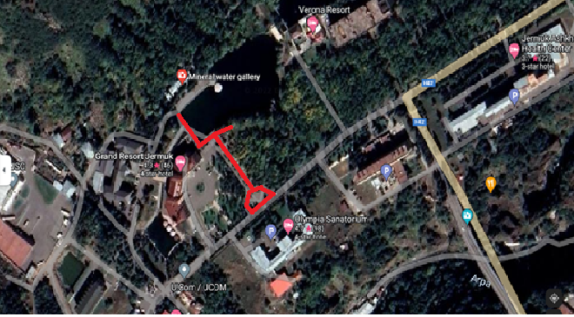
Map 1

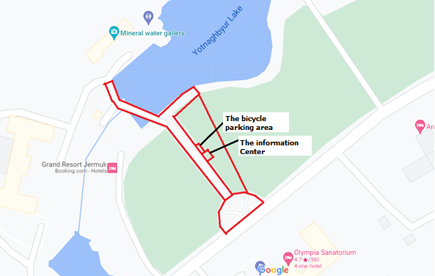
Map2.
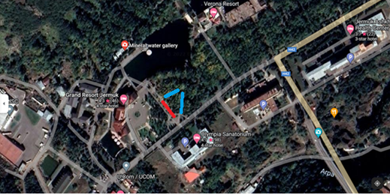
Old location
New location
Map 3
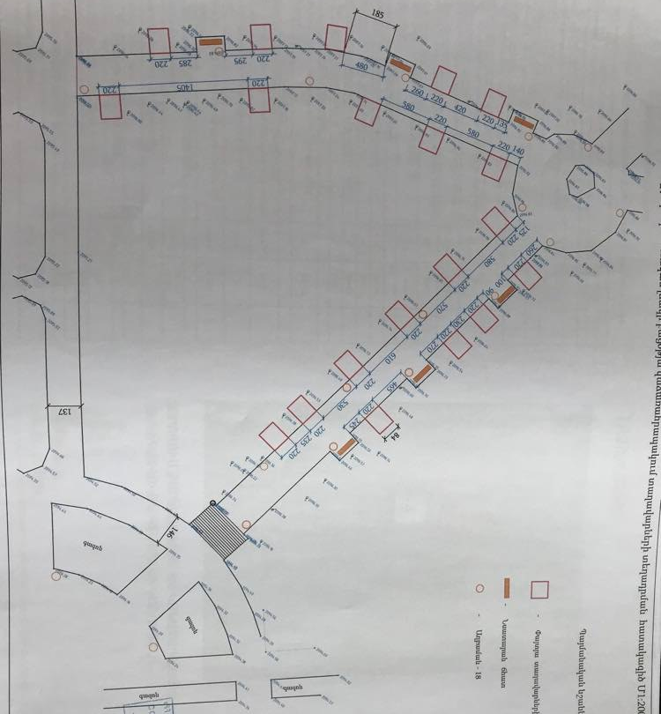

The area of wooden pavilions installation

Map 4

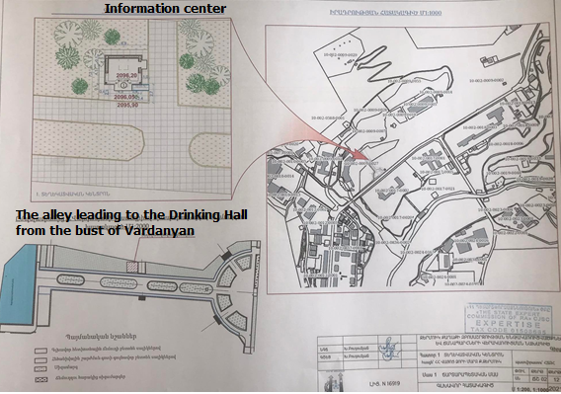
Map 6. Location of the information center on the Cadastral map

Component 5
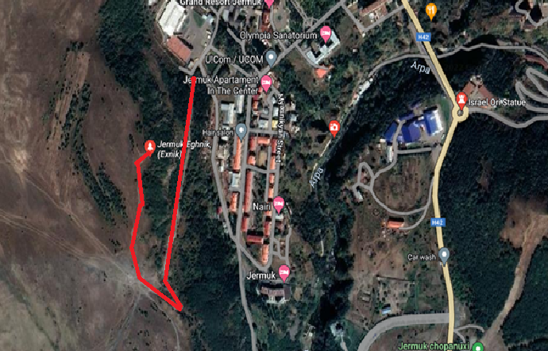
Map 7. Component 5
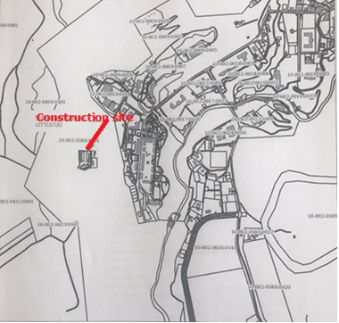
Map 8. Location of the construction site on the cadastral map

Photos of the site
Component 4
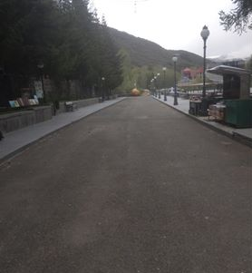  Picture 5.Alley leading to the drinking Hall | 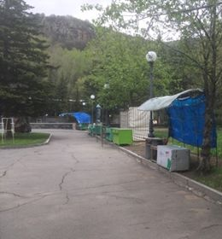  Picture 6.Alley leading to the Drinking hall
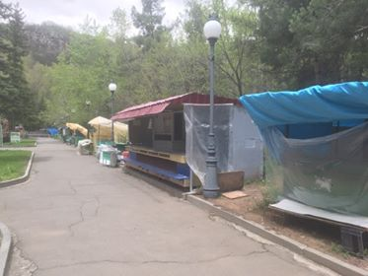
Picture 7:Alley leading to the Drinking hall

Component 5
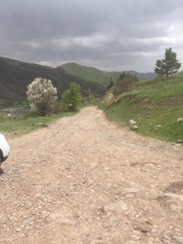  Picture 8: Road leading to the Yeghnik statue | 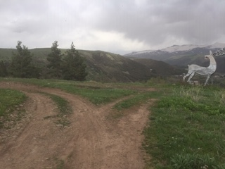  Picture 9. Yeghnik statue

Attachment 2: Construction waste disposal permit

Non-official translation of the above document:

Construction waste generated during the construction works under the “Reconstruction of the Tourism Infrastructure and Roads of the Jermuk City” subproject should be transported to the Ziraki landfill which is located 5 km far from the construction site of the city of Jermuk.

Head of community Sealed/Signed V.Hovhannisyan

Attachment 3: Statement of the head of Jermuk community
Summary of the statement
With this statement we want to inform you that during the construction works to be conducted under the Component 4: “Renovation, Improvement and landscaping of the Drinking Gallery Alleys, Construction of Pavilions and Information Center” of Jermuk sub-project to be implemented in the frameworks of Local Investment and Infrastructure Development project the municipality will provide community owned land area for the allocation of the trade tables and kiosks operating on the site at present; and will assure uninterrupted continuation of the activities of traders.

Attachment 4: Minutes of the public consultation on the draft Environmental and Social Management Plan
The public consultation (PC) meeting was held in Jermuk town on July 28, 2022. The representatives of Jermuk administrative office, ATDF, traders operating on the site and the local residents participated in the meeting. Overall 16 people participated in the meeting, from which 7 women.
The Public consultation announcement was posted on ATDF web page and Jermuk municipality web page and social media page on July 22.
The general architecture of Jermuk community opened the meeting by presenting the aim of the meeting, purpose of the sub project and the Component 4 and Component 5 of the sub project.
ATDF social specialist presented the measures provided under the ESMP. The expected environmental impacts were presented including generation of construction waste, noise, movement of vehicles and vibrations. As well as the mitigation measures were presented including construction waste transportation to designated landfill, management of working hours, management of the manpower and safety measures, operation of vehicles, and transportation of construction materials under cover, as well as the watering of the construction site. The measures were presented to avoid any negative impact on the Drinking Gallery including restricting movement of construction vehicles and machinery to designated routes of transportation, on-site storage of construction materials and goods to designated locations.
The old and new locations of the pavilions was presented and discussed including the design of the new pavilions. It was mentioned and one more time approved by the Jermuk administrative office representatives that municipality will assist the traders during the relocation of currently operating pavilions. The representatives of the traders to be impacted did not raise any grievance.
It was mentioned that no impact on the private lands is planned under the Components.
The GRM procedures were presented. The focal point of the sub project was presented and additionally informed about his responsibilities.
No questions were raised.

Photo (not subject to publication)
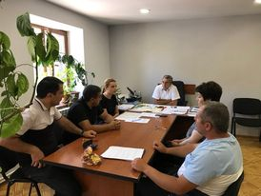

List of participants (not subject to publication)
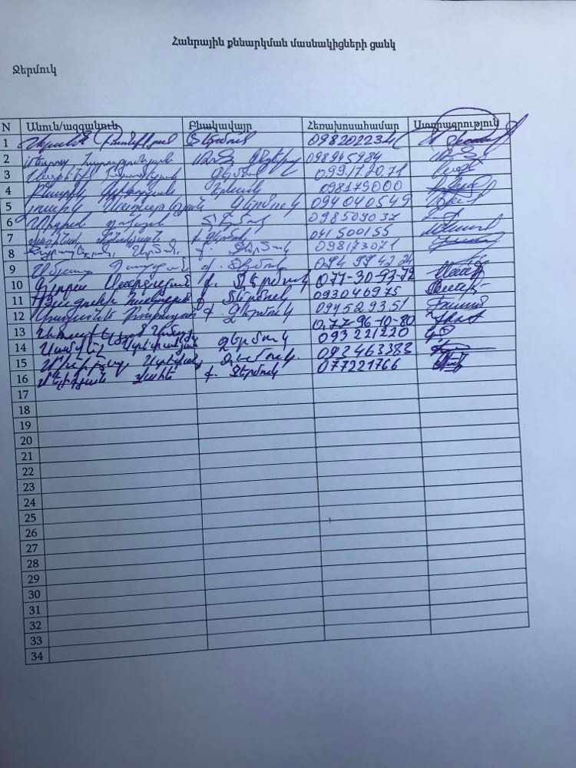

Attachment 5: Construction permits for Component 4 and Component 5
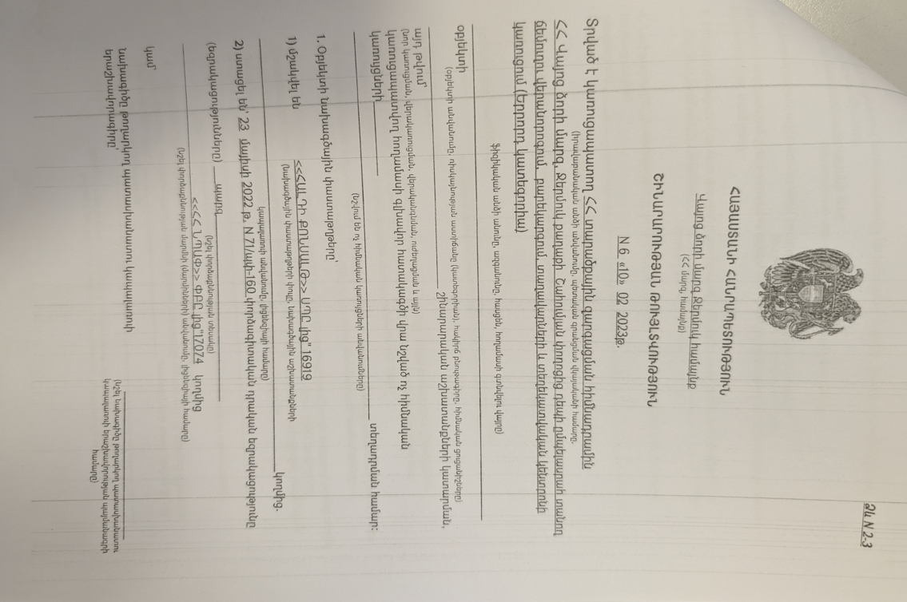
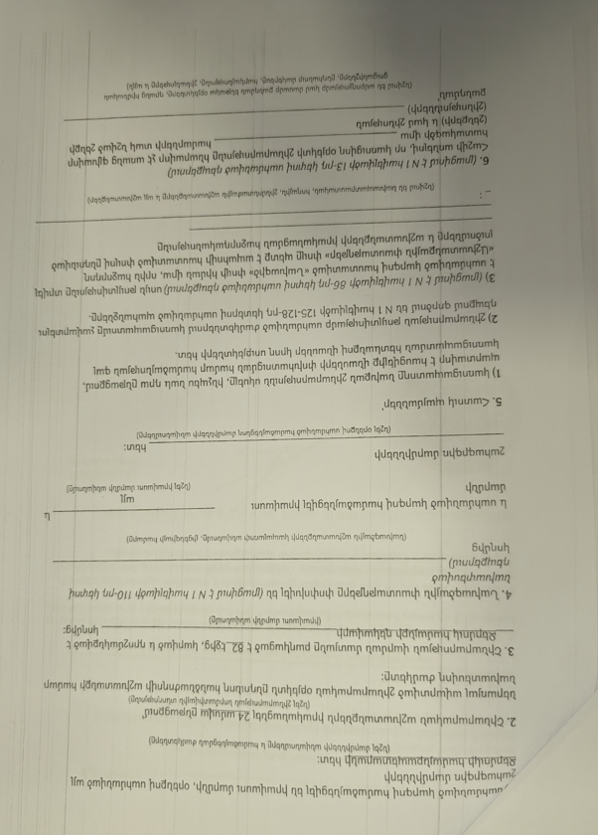

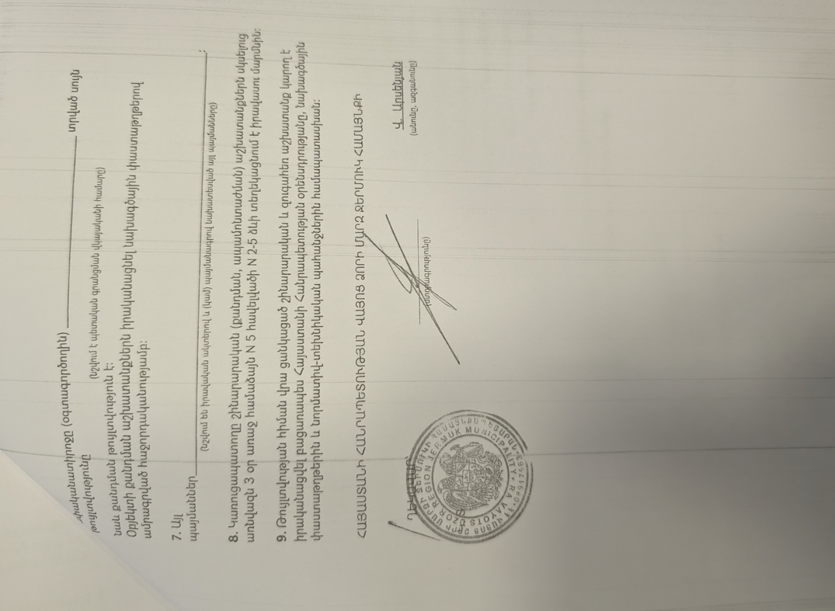
Summary of the above attached document:

Republic of Armenia
Vayoc Dzor Region, Jermuk Community
Construction Permit N6. 10.02.2023
This is given for the “Renovation and Improvement of the Alley from Shahumyan Street to the Drinking Gallery, Construction of Pavilions and Information Center”.
The design documents are
1. Developed by “Haldi Consult” LLC, license 16919
2. The reconstruction will be implemented within 24 month.

V.Arsenyan Sealed/Signed

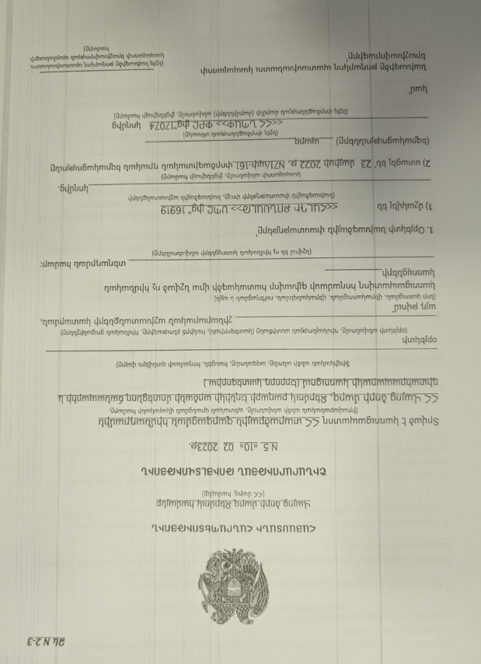

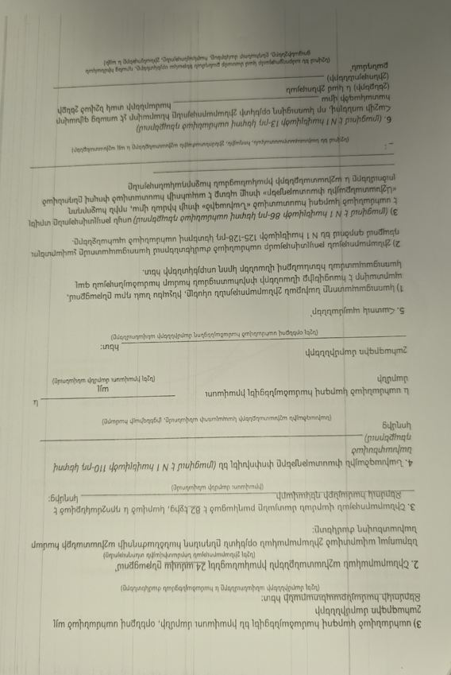
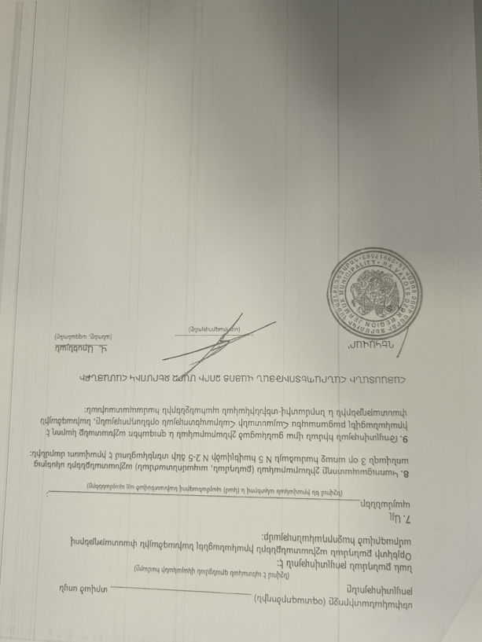
Summary of the above attached document:

Republic of Armenia
Vayoc Dzor Region, Jermuk Community
Construction Permit N5. 10.02.2023
This is given for the “Construction of the Access Road to “Yeghnik” Statue and the Observation Deck”.
The design documents are
1. Developed by “Haldi Consult” LLC, license 16919
2. The reconstruction will be implemented within 24 month.

V.Arsenyan Sealed/Signed

Toxic / hazardous material includes but is not limited to asbestos, toxic paints, noxious solvents, removal of lead paint, etc.

