REPUBLIC OF ARMENIA
LOCAL ECONOMY AND INFRASTRUCTURE DEVELOPMENT PROJECT

ENVIRONMENTAL AND SOCIAL MANAGEMENT PLAN
TUR-21
COMPONENT 2: “aRENI VILLAGE STREETS RENOVATION, LOCATED IN VAYOTS DZOR, RA”

September 2023

PART A: General Project and Site Information
INSTITUTIONAL & ADMINISTRATIVE
Project title | LOCAL ECONOMY AND INFRASTRUCTURE DEVELOPMENT (LEID)
Subproject number and title | TUR-21, Component 2  “Areni village streets renovation, located in Vayots Dzor, RA”
Municipality, community | Areni enlarged community, Vayots Dzor marz
Scope of site-specific activity | The subproject provides for rehabilitation of the existing roads, construction of sewerage system, construction of lighting system along the roads, furnishing the roads with drainage elements, reconstruction of water and gas supply networks, furnishing with tourist and road signs, installation of benches, trash cans.  The following works are planned to be implemented within the subproject:  ROAD PART  Road leading to the Church (KM0+000-KM0+570) - 570m long, 5,4m wide, cover construction with tufa stone of high density 180x200x400mm and fine grained a/c h=5cm;  Road leading to the community administration (KM0+000-KM0+126-1)- 26m long, 4m wide, fine grained a/c h=5cm;  Road leading to the bridge 5.4m wide with downs, 4m wide – 267m long, fine grained a/c h=5cm.  TARSAYICH DISTRICT  Cover implementation with tufa stone of high density 180x200x400mm.  At the beginning and at the end of all sidewalks, ramps will be constructed according to construction norms.  GAS SUPPLY  - The underground gas supply pipeline is being laid in Tarsayich district;  - Over ground gas supply pipeline, 456 m;  - Under -ground gas supply pipeline is out of polyethylene– 1314m.  LIGHTING  The total length of under-ground cable is planned as 2261m;  It is planned to have 70 pcs. of metallic column with the height of 7m, out of which 1m will be in the trench;  LED light fixture power is 120 Vt, the distance between light fixtures is 30-35m.  WATER SUPPLY  - Polyethylene waterline– 651m.  Water supply will be made from the existing Daily Regulation Pool (DRP) ().  WATER REMOVAL  - A wastewater line with d=200 type of polyethylene pipe, and a length of 1445m will be constructed. There will be an installation of reinforced concrete (R/C) wells,( 54pcs).  - Water treatment plant installation ( 1pcs), НСПС 219/200, (production capacity is 210m³, divided into 3 modules, each with the production capacity of 70m³)  - Removal line with a length of 85m will be constructed.  The sewer line will be built from the central intersection of the village and will be directed to the treatment plant from the street branching off from the second intersection. The basement of the waste water treatment plant will be concreted with 200 mm double reinforced concrete slab over a 200 mm concrete preparation layer. Retaining walls will be constructed using concrete after placing the station on the ground. A sand protective layer will be implemented on the treatment plant. The area surrounding the treatment plant will be fenced.  The wastewater treatment plant will be installed to accommodate the treatment needs of 250 households.
Institutional arrangements (WB) | Task Team Leader:  Tafadzwa Dube |  | Safeguards Specialists:  Lusine Gevorgyan (Environment)  David Jijelava (Social)
Implementation arrangements (RA) | Implementing entity:  ATDF | Works supervisor:  “HALDI consult” LLC |  | Works contractor:  “BLESK” LLC
SITE DESCRIPTION
Name of institution whose premises are to be rehabilitated | Areni enlarged community
Address and site location of institution whose premises are to be rehabilitated | Vayots Dzor marz, Areni community
Who owns the land?  Who uses the land (formal/informal)? | The streets rehabilitation activities will not reduce people’s access to their economic resources. The rehabilitation works include existing roads. The widening of the road is planned only in two sections: on the right section of the road leading from the square to the 3rd street, in the section km 0+276-km 0+358, as well as in the section km 0+373-km 0+387. The widening is carried out for construction of a sidewalk. The land used for the purpose of widening belongs to the community. The land plots intended for sewer pipeline construction and treatment plant installation are community property.  There are no operating shops, kiosks or other businesses to be negatively impacted under the subproject. The subproject component will not result in resettlement activities. All the activities planned under the subproject will be done on the community-owned land plots. The subproject will not result in the temporary or permanent loss of crops, fruit trees or any other household infrastructure.  Since the streets of the Tarsayich district are narrow and densely constructed, and the existing fences are mostly in poor condition, therefore, the design envisages the implementation of a monolithic concrete border of 10x25 cm at the edges of the wall. Moreover, in those areas where there is a need to strengthen the fences and walls of the houses in order to avoid further deterioration, it is planned to make the border 10-15 cm higher. In some areas, a partial repair of the existing retaining walls is planned, which will be carried out by hand using local stones, in order to preserve the cultural appearance of the old district as much as possible.
Description of physical and natural environment around the site | Areni community is located in the southern part of the Republic of Armenia, 110 km far from Yerevan and 20 km far from the regional center Yeghegnadzor. Areni is a community of the Vayots Dzor marz, it is located on both sides of the lower reaches of the Arpa River.  The climate of the area is characterized by mild and short winters and hot summers. The annual average air temperature is 12⁰C, the absolute minimum temperature is -24⁰C, the absolute maximum is +42⁰C. The coldest month of the year is January, the warmest is July. The average annual relative humidity of the air is 59%. Annual atmospheric precipitation is 385mm. Annually, the main rainfall occurs in April-May. The maximum depth of ground freezing in the area is 21cm. From the hydrogeological point of view, depending on the relief and geological section, the area is considered as a low-water zone. The groundwater horizon is 15-20 m in the riverbed, and 100-120 m in the other parts.  The road leading to St. Astvatsatsin (Holy Mother of God) Church of Areni village, built in 1321 will be rehabilitated. No construction works will be done in the territory of the church. The distance of the closest point from the construction site to the church will be 90 m in a straight line.  The roads leading to the church and the administrative office are asphalted, the cover has worn out, and in some areas large potholes have appeared. The roads of Tarsayich district to be rehabilitated are earth built. Tarsayich district is the oldest one in Areni, it has narrow streets, which are heavily constructed.  The designed sewerage treatment plant is planned to be built in the southwestern part of Tarasich district of Areni village, on the left bank of the Arpa river, approximately 180-200 m north-west to the school. The sewerage treatment plant will serve approximately 60 households. The area of the proposed treatment plant is swampy and covered with reeds. Groundwater level in the area is 0.7 m on average. According to the available data, gravel soils will serve as the foundation for the treatment plant with additional engineering solutions to support the treatment plant’s structural integrity.  Nests of storks can be found in the observed area. Nests are installed on electric poles along the 1st (5 pieces) and 3rd (2 pieces) Streets. No impact on the poles of 1st street is anticipated under the subproject, according to the design. Dismantling of the existing cables of the 3rd street are supposed to occur under the project (see Attachment 1/photos), while the poles are not subject to dismantling under the subproject.  No trees will be impacted because of the construction works, because there are no trees observed on the areas to be used under the sub-project. Tree cutting is not envisaged under the sub-project.  Tarsayich district does not have gas supply system and sewerage system at present. No water outages are planned under the subproject, the existing drinking water pipelines will be dismantled after the new pipelines are constructed. However, if any outage comes out, the residents of the Tarsayich district will be informed in advance. The Local administration office will inform the public by posting the announcements on the information board of the administrative office building, as well as Facebook page, Web page. The Contractor will post the information including the duration of the works on the subproject information board.
LEGISLATION
National & local legislation & permits that apply to subproject activity | The following Armenian legislation defines a legal framework applicable to project activities:  - Law on Atmospheric Air Protection of RA (1994)  The purpose of Law on Atmospheric Air Protection is to define main principles of the RA, directed to provision of purity of atmospheric air and improvement of air quality, prevention and mitigation of the chemical, physical, biological and other impacts on air quality and regulation of public relation. This Law also regulates the emission licenses and provides maximum allowed loads / concentrations for atmospheric air pollution, etc.  According to this law, contractor shall undertake construction activities as well as transportation and temporary storage of waste the way to minimize dust and other emissions.  - Law on Waste of RA (2004)  The law provides the legal and economic basis for collection, transportation, disposal, treatment, re-use of wastes as well as prevention of negative impacts of waste on natural resources, human life and health. The law defines the roles and responsibilities of the state authorized bodies as well as of waste generator organizations in waste management operations.  According to this law, the waste generated from construction activities should be recycled as appropriate or disposed of in designated locations.  Disposal of the construction waste and excess material in selected locations must be approved by local municipality in writing.  - Law on Environmental Impact Assessment and Expertise of RA (2023)  The law defines type of activities which are subject to environmental impact assessment and expertise. According to this Law, the proposed restoration works are not subject to state environmental impact expertise. The reference of the Ministry of Environment of RA is attached.  - Water Code of RA (2002)  The Water Code regulates water relations in the RA. According to article 97, part 7 of the Code, waste water discharge into a water resource is allowed only in the presence of a discharge permit, based on the review of water quality standards.  - Law on Urban Development of RA (1998)  This law defines the principles and regulations of urban development activities in the RA. According to this law, planned works requires obtaining the construction permit.  - Labor Code of RA (2005)  This Code regulates collective and individual labor relations, defines the grounds for the origin, modification and termination of these relations and the procedure for their implementation, the rights and responsibilities of the parties to labor relations, as well as the conditions for ensuring the safety and health of employees. According to this law the Contractor must ensure the safety and health of the employees working on the construction site.  According to national legislation framework of RA the subproject requires:  - construction permit  - construction waste disposal permit;  - wastewater discharge permit*.
PUBLIC CONSULTATION
When / where the public consultation process will take /took place | The draft design was presented at the public consultation meeting conducted on 18.04.2023 in Areni community administrative office with participation of Areni Administrative office and design company representatives, ATDF specialists and local residents. The design solutions and environmental impacts were discussed. No issues or grievances were raised.  Written consents will be obtained from the residents whose fences or retaining walls will be considered for rehabilitation before any construction work is done on the private property. The draft ESMP will be disclosed and discussed at the public consultation to be held in Areni community with the participation of the community administrative office, local NGOs and local population.  Draft ESMP will be disclosed in Armenian and English languages on the ATDF website (www.atdf.am) and in the Armenian language on the beneficiary's website (www.areni.am). Brief information on the planned works and contact information for addressing questions and grievances will be placed at the worksite, on the information board of the Areni administrative office and/or in its immediate surroundings. Subproject information will be regularly disseminated through community websites and social media pages.
ATTACHMENTS
Attachment 1: Site map/photo
Attachment 2: Copy of permit for construction waste disposal
Attachment 3: Statement of the Ministry of Environment on the state EIA and Expertise
Attachment 4: Wastewater discharge permit (to be provided*)
Attachment 5: Minutes of the public consultation on the draft ESMP (to be provided)
Attachment 6: Construction permit
* The Areni community administrative office has sent the request for permit to the ministry of Environment of RA. The permit will be obtained before the launch of construction activities.

PART B: safeguards information
ENVIRONMENTAL /SOCIAL SCREENING
Will the site activity include/involve any of the following? | Activity/Issue | Status | Triggered Actions
Will the site activity include/involve any of the following? | - Road rehabilitation | [x] Yes [ ] No | See Section A below
Will the site activity include/involve any of the following? | - Individual wastewater treatment system | [x] Yes [ ] No | See Section B below
Will the site activity include/involve any of the following? | - Historic building(s) and districts | [] Yes [x] No | See Section C below
Will the site activity include/involve any of the following? | - Unexpected need for land take | [ ] Yes [x] No | See Section D below
Will the site activity include/involve any of the following? | - Hazardous or toxic materials | [ ] Yes [x] No | See Section E below
Will the site activity include/involve any of the following? | - Impacts on forests and/or protected areas | [ ] Yes [x] No | See Section F below
Will the site activity include/involve any of the following? | - Handling / management of medical waste | [ ] Yes [x] No | See Section G below
Will the site activity include/involve any of the following? | - Traffic and pedestrian safety | [x] Yes [ ] No | See Section H below
Will the site activity include/involve any of the following? | - Social risk management | [x] Yes [ ] No | See Section I below
PART C: Mitigation measures

ACTIVITY | PARAMETER | MITIGATION MEASURES
0. General Conditions | Notification and Worker Safety | - The local construction and environment inspectorates and communities are notified of upcoming activities  - The public is notified of the works through appropriate notification in the media and/or at publicly accessible sites (including the site of the works)  - All legally required permits are acquired for construction and/or rehabilitation  - The Contractor formally agrees that all work will be carried out in a safe and disciplined manner designed to minimize impacts on neighboring residents and environment.  - Workers’ personal protection equipment complies with international good practice (always hardhats, as needed masks and safety glasses, harnesses and safety boots)  - Appropriate signposting of the sites informs workers of key rules and regulations to follow.
A. General Rehabilitation and /or construction activities | Air Quality | - During earth works, dust is suppressed by ongoing water spraying and/or installing dust screen enclosures at site.  - The surrounding environment (sidewalks, roads) is kept free of debris to minimize dust.  - There is no open burning of construction / waste material at the site.  - There is no excessive idling of construction vehicles at sites.
A. General Rehabilitation and /or construction activities | Noise | - Construction noise is limited to restricted times agreed to in the permit.  - During operations, the engine covers of generators, air compressors and other powered mechanical equipment are closed, and equipment placed as far away from residential areas as possible.
A. General Rehabilitation and /or construction activities | Water Quality | - Appropriate erosion and sediment control measures are applied such as e.g. hay bales and / or silt fences to prevent sediment from moving off site and causing excessive turbidity in nearby streams and rivers.  - Rainwater is removed from the construction site using a rainwater drainage system.
A. General Rehabilitation and /or construction activities | Waste Management | - Waste collection and disposal pathways and sites are identified for all major waste types expected from demolition and construction activities.  - Mineral construction and demolition wastes are separated from general refuse, organic, liquid and chemical wastes by on-site sorting and stored in appropriate containers.  - Construction waste is being collected and disposed properly by licensed collectors.  - Whenever feasible, appropriate and viable materials (except asbestos) are reused or recycled.
A. General Rehabilitation and /or construction activities | Earth Works | - Excess material and topsoil generated from earth works will be stored separately and used for backfilling and site reinstatement  - Topsoil layer not thicker than 30 m will be stripped separately and temporary piled on-site  - Stockpile height will not exceed 3.0 m, and the slope angle will not exceed 34o  - Temporary stockpile will be compacted and covered with a tarp to prevent erosion caused by rain runoff  - Topsoil will be re-used for backfilling to facilitate re-cultivation of the land plot  - Excess amount of subsoil will be disposed at the agreed-upon locations.
B. Individual wastewater treatment system | Water Quality | - The approach to handling sanitary wastes and wastewater from building sites (installation or reconstruction) is approved by the local authorities.  - Before being discharged into receiving waters, effluents from individual wastewater systems are treated in order to meet the minimal quality criteria set out by national guidelines on effluent quality and wastewater treatment.  - Monitoring of new wastewater systems (before/after) is carried out.  - Construction vehicles and machinery are washed only in designated areas where runoff will not pollute natural surface water bodies.
H. Traffic and pedestrian safety | Direct or indirect hazards to public traffic and pedestrians by construction  activities | (a) In compliance with national regulations, the construction site is properly secured, and construction related traffic regulated. This includes but is not limited to  - Signposting, warning signs, barriers and traffic diversions: site will be clearly visible, and the public warned of all potential hazards.  - Traffic management system and staff training, especially for site access and near-site heavy traffic. Provision of safe passages and crossings for pedestrians where construction traffic interferes.  - Adjustment of working hours to local traffic patterns, e.g. avoiding major transport activities during rush hours or times of livestock movement.  - Active traffic management by trained and visible staff at the site, if required for safe and convenient passage for the public.  - Ensuring safe and continuous access to office facilities, shops and residences during renovation activities, if the buildings stay open for the public.
I. Social risk management | Public relationship management | - Assign local liaison person in charge of communication with and receiving requests/ complaints from local population.  - Consulted local communities to identify and pro-proactively manage potential conflicts between an external workforce and local people.  - Rise local community awareness about sexually disease risks associated with the presence of an external workforce and includes local communities in awareness activities.  - Inform population about construction and work schedules, interruption of the services, traffic detour routes and provisional bus routes, blasting and demolition, as appropriate.  - Limit construction activities at night. When necessary, carefully schedule night-time works and inform affected community so they can take necessary measures.  - At least five days in advance of any service interruption (including water, electricity, telephone, bus routes), advice affected community through postings at the project site, at bus stops, and in affected homes/businesses.
I. Social risk management | Labor management | - To the extent possible, locate work camps away from local communities.  - Undertake sitting and operation of worker camps in consultation with neighboring communities.  - Recruit unskilled or semi-skilled workers from local communities to the extent possible. Where and when feasible, provide worker skills training to enhance participation of local people.  - Provide adequate lavatory facilities (toilets and washing areas) in the work site with adequate supplies of hot and cold running water, soap, and hand drying devices. Establish temporary septic tanks for any residential labor camp and without causing pollution of nearby watercourses.  - Raise awareness of workers on overall relationship management with local population, establish the code of conduct in line with international practice  - and strictly enforce them, including the dismissal of workers and financial penalties of adequate scale.
I. Social risk management | Grievance Management | - GRM is established and advertised at the local level. The Contractor is informed of his responsibility to register and communicate to the PIU received verbal and non-verbal grievances.  - GRM contact information, including local focal points, has been posted at the construction site and the local community’s administrative office.  - The Contractors' local liaison person receives and registers grievances from the population in the GRM log and communicates the grievances to the PIU regularly.

PART D: Monitoring Plan

Activity | What  (Is the parameter to be monitored?) | Where  (Is the parameter to be monitored?) | How  (Is the parameter to be monitored?) | When  (Define the frequency / or continuous?) | Why  (Is the parameter being monitored?) | Who  (Is responsible for monitoring?)
CONSTRUCTION PHASE
Supply of construction materials | Purchase of construction materials from the licensed suppliers | In supplier’s office or warehouse | Verification of labels of the materials and/or certificates if any | During conclusion of supply contracts | Ensure reliability of construction materials and their safety for human health | ATDF  Technical supervision  company
Transportation of construction materials and waste  Movement of construction vehicles and machinery | - Technical condition of construction vehicles and machinery;  - Coverage of loads when carrying dust, soil, spoil and construction waste; Movement of construction vehicles and machinery according to predefined traffic routes and within working hours: 9AM-6PM. | -Construction site  -Routes of transportation of construction materials and wastes | Inspection of pre-defined movement routes, entrances and exits of construction sites | Unannounced monthly inspection during work hours and beyond | - Control emissions into the environment;  - Control nuisance to local communities;  - Minimize traffic disruption, ensure pedestrian safety and prevent accidents | ATDF  Technical supervision  company  Road Police
Maintenance of construction equipment | - Washing of cars and construction equipment outside the construction site or on maximum distance from natural streams;  - Refueling or lubrication of construction equipment outside the construction site or at the predetermined confined area. | Construction site | Inspection of activities | Selective inspections during work hours | - Avoid pollution of water and soil with oil products due to operation and maintenance of equipment and washing runoffs;  -Timely localize oil and lubricant spill-offs, and decrease expected damage in case of fire. | ATDF  Technical supervision  company
Generation of construction waste | - Temporary storage of waste at the pre-defined areas of construction site;  - Timely disposal of waste to the formally designated locations. | Construction site  Waste disposal site | Inspection of site | Unannounced monthly inspection during entire construction phase | -Prevent pollution of soil, surface water and ground water;  - Avoid accidents at the construction site due to scattered fragments of construction materials and debris;  - Retain esthetic appearance of the construction site and its surroundings. | ATDF  Technical supervision  company
Workers’ health and safety | - Provision of uniforms and safety gears to workers and enforcement of their use by the constructor;  - Provision of work-site safety instruction to contractor’s personnel and instructions proper recording;  - Installation of fencing;  - Ensuring fire extinguisher and medical aid kits at work site | Construction site | Inspection | Periodically during construction and upon its completion | - Exclude probability of accidents;  -Protect workers’ health. | ATDF  Technical supervision  company
Works near privately-owned land plots and other property | - Avoid trespassing or incidentally damaging of private property (using small-size machinery or manual labor near walls and fences, stockpiling of construction material and waste away from private property; etc.);  - In case of unintended damage to private property, quickly restore it to the original or better status;  - In case of expected temporary impact on privately-owned property, inform owners upfront and guarantee restoration, acquire written consent of owners for intervention, and promptly restore the damage to the original or better status. | Works near privately-owned land, buildings and other assets | Monitoring and inspection | Entire period of construction | -Reduce the probability of damages on private property;  -Exclude temporary or permanent violation of ownership and/or user rights on the private property. | ATDF  Technical supervision  company
Works done near the nests of the storks | - Nuisance activities, like, noise, dust and vibration are limited next to the places were the nests are located that ;  - The pole on which the nest is installed is not moved or dismantled without special permission;  - The nests are relocated only with permission of RA Ministry of Environment strictly following the relocation good practice rules provided and guided by RA Ministry of Environment;  - Periodically monitoring the stork poles and mitigating risks for any signs of damage and hazards  - The works of dismantling of cables will be conducted during the season of storks' migration additionally consulted with Ministry of Environment regarding the migration period. | Locations of stork poles | Inspection of activities | Entire period of construction | - Reduce the probability of damages on the storks nests and poles and ensure storks access to nesting sites;  - Prevent negative impact on the breeding, spawning and feeding processes of the storks and any disturbance to nesting behavior. | ATDF  Technical supervision  company  Ministry of Environment of RA
Construction site re-cultivation and landscaping | Final cleaning of the rehabilitated site and permanent access roads | Construction site and access roads | Inspection of activities | Final period of construction | Reduce loss of aesthetical value of the landscape due to construction activities. | ATDF  Technical supervision  company
Works causing nuisance | - Nuisance activities, like, noise, dust and vibration should be limited to working hours from 9AM-6PM and compiled with allowed norms of noise and vibrations levels | Construction site | Monitoring and inspection | Entire period of construction | - Exclude nuisance to neighborhood after working hours. | ATDF  Technical Supervision Company
Solid waste management | Trash bins placement and arrangement on periodical transportation of waste | Construction site | Inspection | Total period of works | - Prevent pollution of soil, water;  - Retain esthetic appearance of the sites area and its surroundings. | ATDF  Technical supervision  company  Akhuryan community
Dust generation | - Ensuring water spraying measures at site, and timely removal of construction debris;  - Storing bulk materials with the use of banners at site | Construction site and access roads | Visual inspection | Total period of construction | -Prevent off-site dust spreading and pollution;  -Reduce health risks to the workers and neighboring communities related to dust exposure. | ATDF  Technical Supervision Company
Handling of chance finds | - Stoppage of works promptly upon encountering of chance finds;  - Formal communication with the Ministry of Education, Science, Culture and Sports (MoESCS) of RA on chance finds;  - Timely arrangements made for the conduct of required excavation and site conservation. | Construction site | -Inspection of chance find sites;  - Inspection of field documentation | Entire period of construction | Ensure cultural heritage is not damaged by the construction works. | ATDF  Technical Supervision Company  MoESCS
Earthwork | -Topsoil removal and temporary stockpiling for re-cultivation of the land;  -Temporary storage of excavated soil at determined places;  -Backfilling of the excavated ground as needed and disposal of the excess mass to the places, approved in writing. | Construction site | Inspection of activities | During earth works | -Limit loss of vegetation and soil due to ground piling and minimization of potential pollution of surface water reservoirs with particles; | ATDF  Technical Supervision Company
Operation of Grievance Redress Mechanism | - Public right to complaints or questions about the project.  - Appeal to the head of local government (community authorities)  - The appointment by the authorities of the Coordinator for the consideration of complaints (receiving complaints, reviewing and explaining, registering complaints in the logbook and trying to resolve them on the spot.  - Appeal to ATDF by hot-line (010 24 01 59), postal letter (Yerevan 0037, K.Ulnetsi 31), official web page (http://atdf.am/hy/Home/ContactUs), e-mail (support@atdf.am). | Construction site | Inspection of activities | Entire period of construction | -Monitor compliance with project aspects;  -Timely resolve questions and complaints in the field. | ATDF  Technical supervision  company
OPERATION PHASE
Operation and maintenance of lighting system | Regular servicing of the lighting system is being undertaken | Rehabilitated roads of Areni | Periodic inspection of lighting network | Total period of operation | Maintenance of lighting system in safe and operable condition |  | Areni  Administrative office
Maintenance and protection of site | Non-authorized construction and land use | Rehabilitated roads of Areni | Visual inspection | Total period of operation | Prevent the loss of aesthetical and recreational value of the central part area |  | Areni Administrative office
Solid waste management | Trash bins placement and arrangement on periodical transportation of waste | Rehabilitated roads of Areni | Inspection of activities | Total period of operation | - Reduce exposure to waste and disease-carrying rodents and insects;  - Maintain safe sanitary condition and prevent environmental pollution. |  | Areni Administrative office
Operation and maintenance of local sewage treatment plant | - Leakages of waste water from sewage scheme;  - Smoothly operation of sewage water treatment plant. | Installed treatment facility | Instrumental quality testing of treated sewage according to approved safety parameters | During operation phase | -Prevent water-borne diseases  -Prevent pollution of surface and ground water, soils. |  | Areni  Administrative office
Operation and maintenance of utility networks (water supply, sewage, power and gas supply) | Regular servicing of the utility networks being undertaken | Rehabilitated roads of Areni | Regular technical inspections | Total period of operation | - Maintenance of utility networks in safe and operable condition;  - Avoid disruption of operation of area and inconveniences to residents. |  | Areni  Administrative office

Attachment 1: Site map/photos
Drinking water and sewerage system drawing
Drinking water line
Sewer line
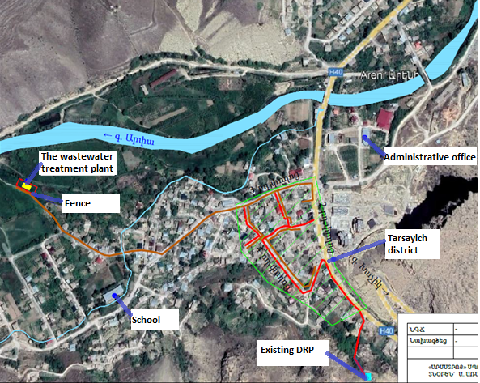
The drawing of gas supply network
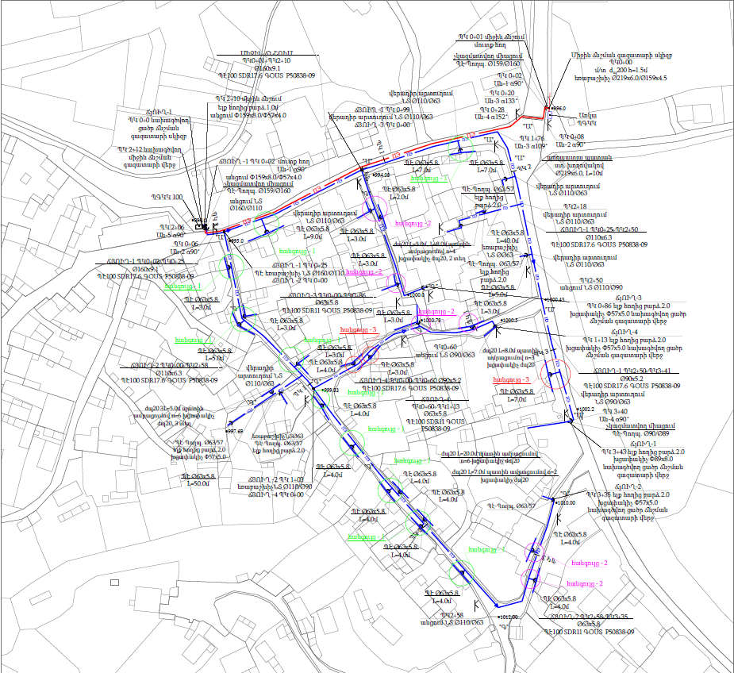

The roads to be rehabilitated (coloured with red)
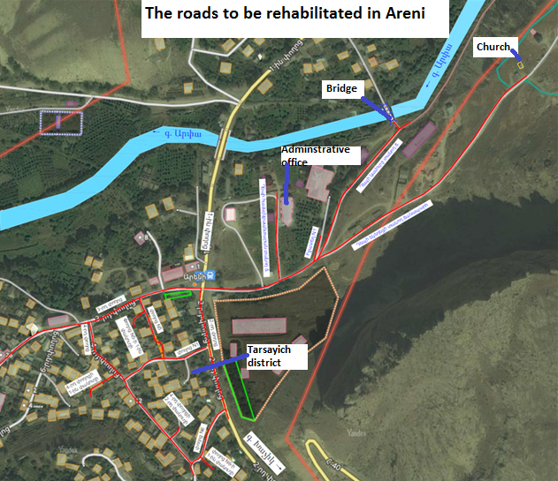
Site map (Google map snapshot)
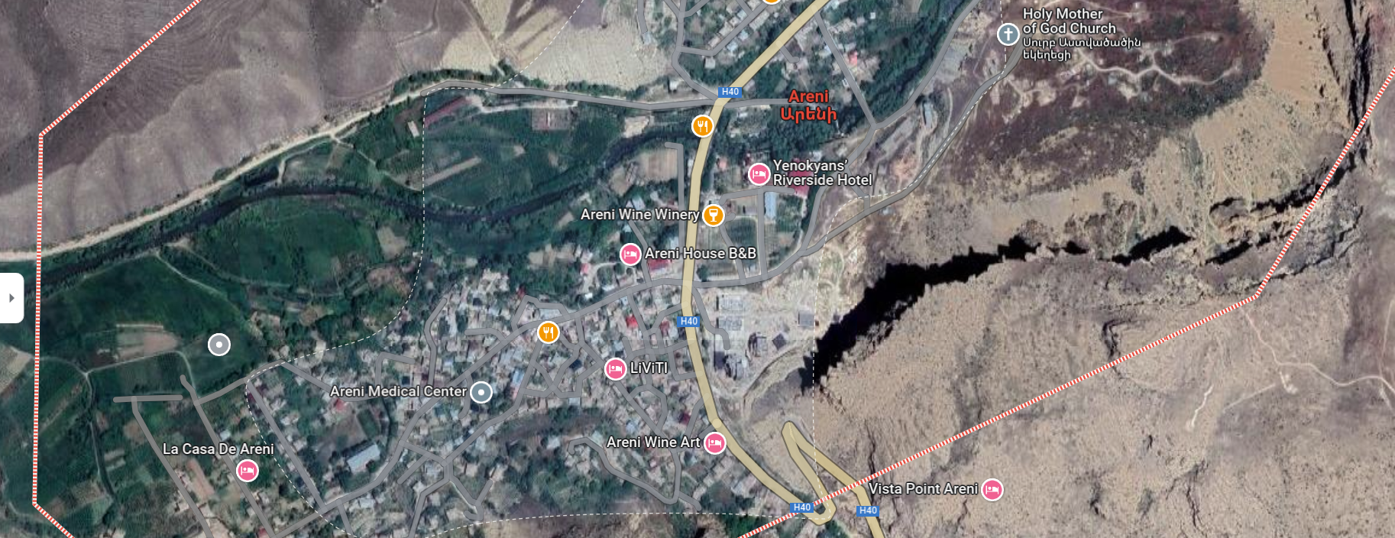
Photos
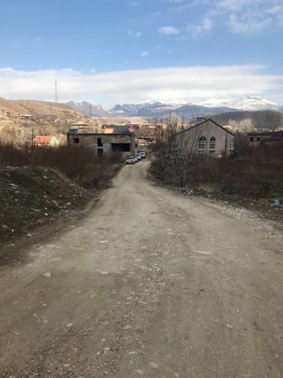  Photo 1: The road leading to the Administrative office | 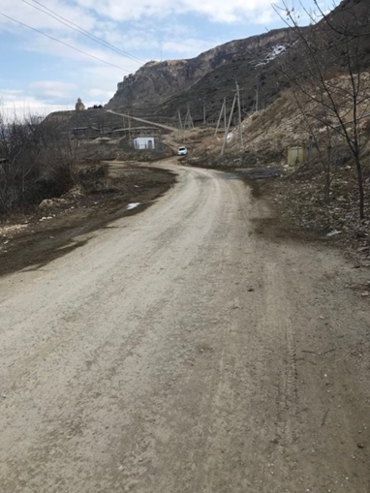  Photo 2: The road leading to the Church
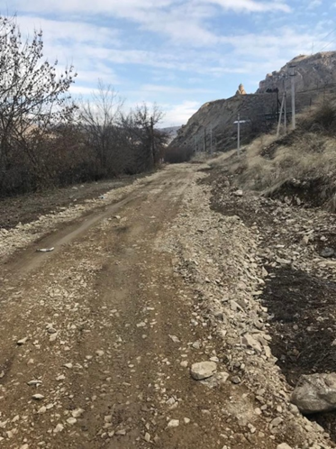  Photo 3: The road leading to the bridge | 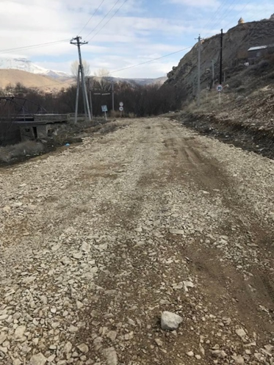  Photo 4: The road leading to the bridge
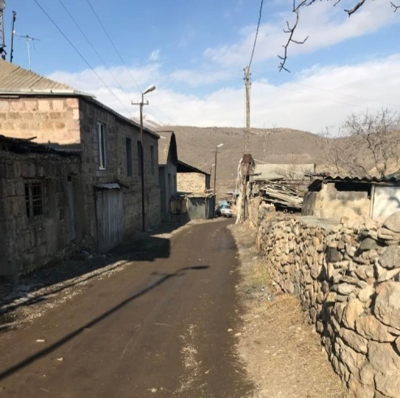  Photo 5: Tarsayich district | 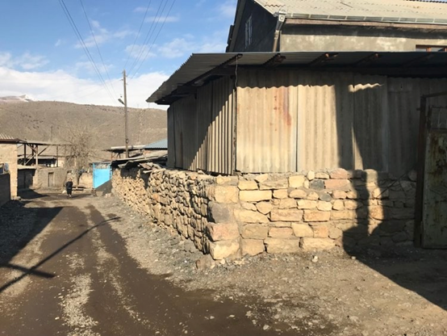  Photo 6: Tarsayich district
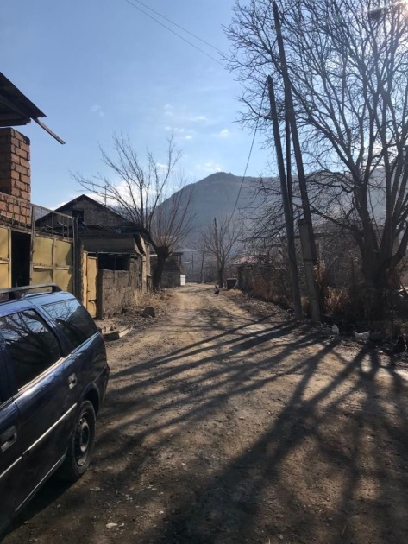  Photo 7: Tarsayich district | Photo 8: Road widening part
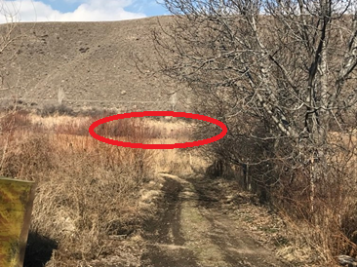  Photo 9: The area for waste water treatment plant installation | 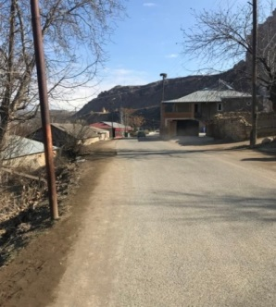  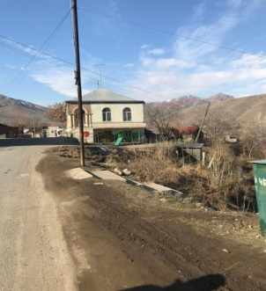  Photo 10: Sewer pipeline construction areas
Photo 11: Stork nests on the 1st street
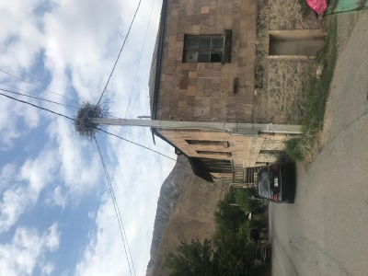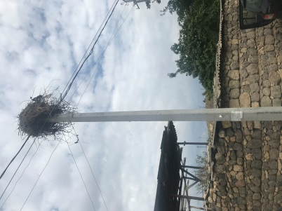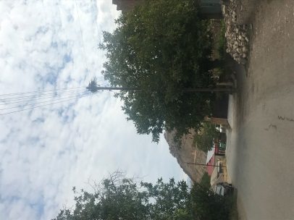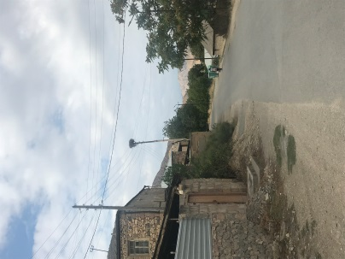
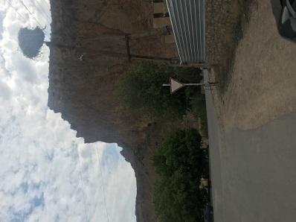
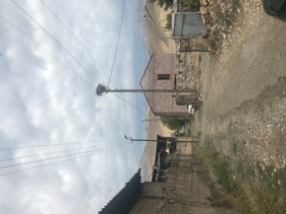
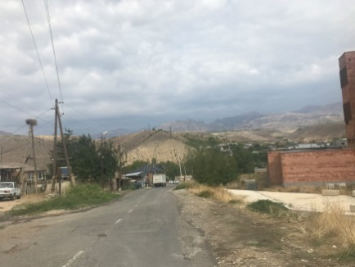
Photo 12: Stork nests on the 3rd street

Attachment 2: Copy of permit for construction waste disposal
Summary of the above document
Reference
Is given to state that the construction waste accumulated during the construction works to be conducted in Areni in the frameworks of “Local Economy and Infrastructure Development Project” will be transported to the old landfill of Areni settlement of Areni community located in 1.5 km distance to the west from the residential part of the settlement.
Head of the community Husik Sahakyan

Attachment 3: Reference of the Ministry of Environment
Summary of the above document
In response to your letter N 138/23 dated on July 19 of 2023, the design of reconstruction of the streets, water, gas and electricity supply, sewerage of Tarsayich district of Areni community, Vayots Dzor marz submitted to the environmental expertise, according to the presented technical and economic indicators, in accordance with Article 14 of the Law of “Environmental Impact Assessment and Expertise", is not subject to the state expertise. It is necessary to provide justification for considering the intended activity as a category C type of activity.

Attachment 4: Wastewater discharge permit (to be provided)

Attachment 5: Minutes of the public consultation on the draft ESMP
On September 26, 2023, a public consultation meeting was held in the administrative building of Areni consolidated community with the participation of ATDF specialists, the head of consolidated Areni community, and representatives of Areni community administration and residents of Areni settlement. Overall, 20 people participated in the meeting, of which 9 were women.
The announcement of the public consultation was posted on the webpage and Facebook account of Areni community on September 20, 2023.
Husik Sahakyan, the head of Areni community, opened the meeting and presented the purpose of the meeting and the concept of the sub-project.
Knarik Grigoryan, the head of Environmental and Social Unit of the ATDF, informed the participants that the ATDF had prepared an Environmental and Social Management Plan (ESMP) for sub-component “Rehabilitation of Roads in Areni Village of Vayots Dzor Marz”. The public consultation meeting was held in Areni to disclose the draft ESMP to the community so that the community could raise their concerns and make suggestions. She noted that the ESMP includes all possible environmental, social, health and safety impacts and their mitigation measures to be implemented during the construction works.
Knarik Grigoryan presented the expected temporary environmental and social impacts, including the generation and transportation of construction waste, noise and dust generation due to construction works. The safety measures to be provided were also presented, including the fencing of the construction site, installation of caution tapes in dangerous areas of the construction site and traffic management, as well as the safety signs installation requirements. The measures for safety of labor were presented, including uniform wearing and personal protective equipment, as well as the requirements on the supply of construction materials and maintenance of construction equipment.
Knarik Grigoryan mentioned that no negative social impacts are anticipated under the project, including involuntary resettlement or temporary land use during the construction period. It was also mentioned that some fences which are in poor condition might be replaced with new ones with the written consent of the owners taken beforehand.
The Grievance Redress Mechanism (GRM) of the LEID project was presented to the participants of the meeting. The contact information of the local focal point (Norayr Grigoryan) was also presented. The procedures of submitting, examining and reviewing the grievances were presented. It was mentioned that the information on the GRM will be additionally posted on the information board of the Areni administrative office and the sub-project information board to be installed at the entrance of the construction site.
The supervision and monitoring procedures for the implementation of the measures provided under the ESMP were explained.
There were no questions related to environmental, social, health and safety impacts and their mitigation measures.
The photos and the list of participants are presented below.

Photos (not subject to publication)

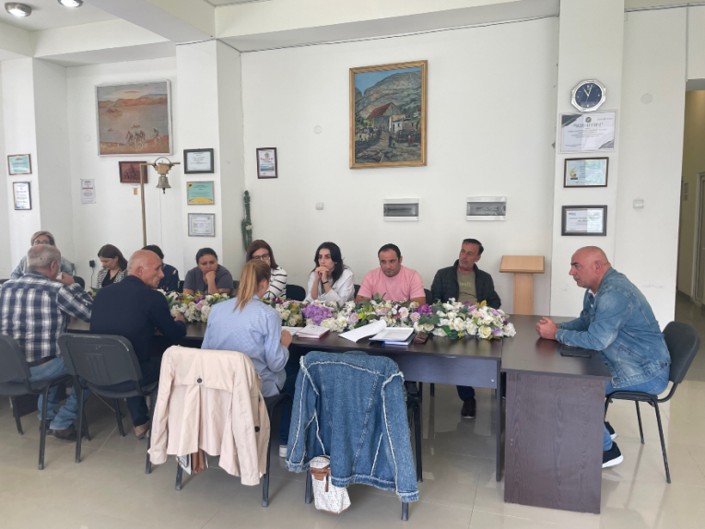 | 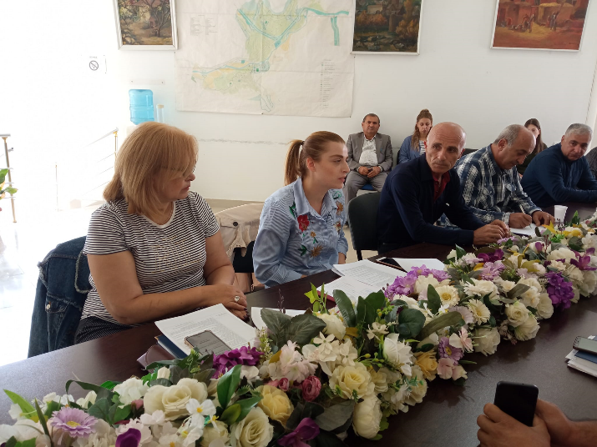
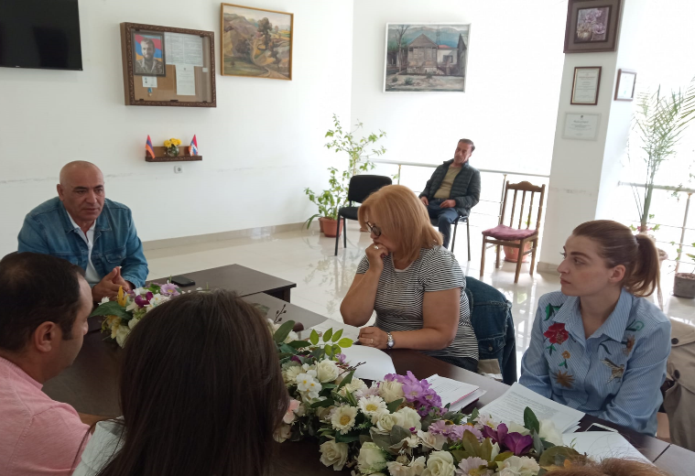

List of Participants (not subject to publication)
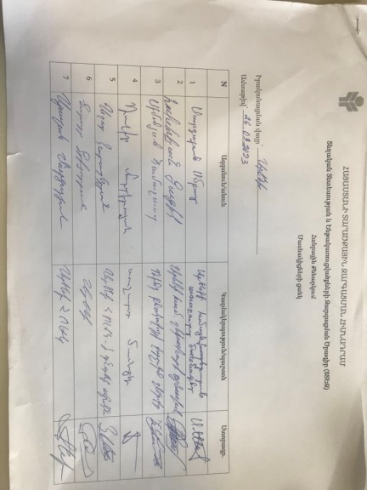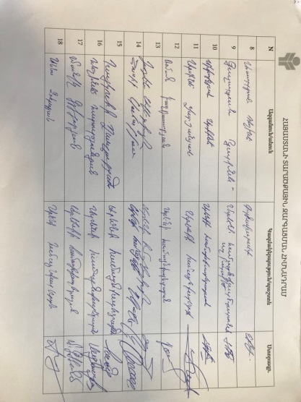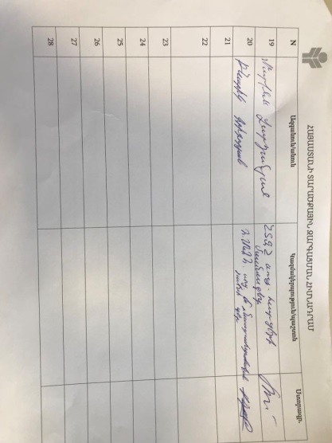

Attachment 6: Construction permit
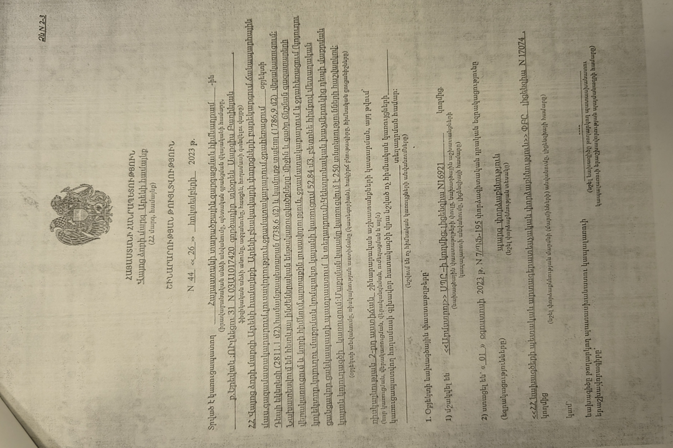
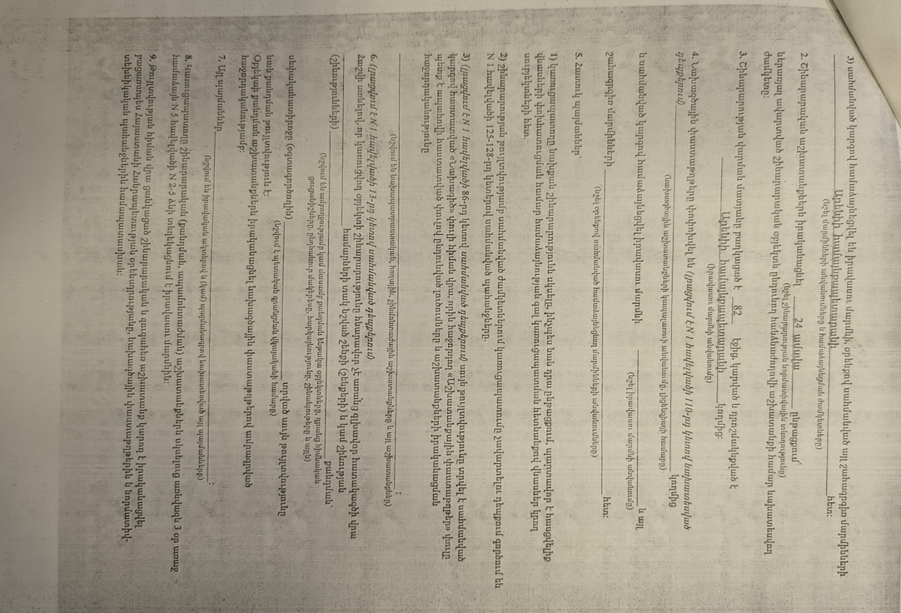



Republic of Armenia
Vayoc Dzor Marz, Areni Community
Construction Permit N 44. 26.10.2023
This is given for the ““Areni village streets renovation, located in Vayots Dzor, RA””.
The design documents are
1. Developed by “Armstroy” LLC, License 16921
2. The reconstruction will be implemented within 24 month.

H.Sahakyan Sealed/Signed

Toxic / hazardous material includes but is not limited to asbestos, toxic paints, noxious solvents, removal of lead paint, etc.

