REPUBLIC OF ARMENIA
LOCAL ECONOMY AND INFRASTRUCTURE DEVELOPMENT PROJECT

ENVIRONMENTAL AND SOCIAL MANAGEMENT PLAN
“Rehabilitation and improvement of Shahumyan and Myasnikyan Streets in Jermuk city”

MARCH 2021

PART A: General Project and Site Information
INSTITUTIONAL & ADMINISTRATIVE
Project title | LOCAL ECONOMY AND INFRASTRUCTURE DEVELOPMENT (LEID)
Subproject number and title | “Rehabilitation and improvement of Shahumyan and Myasnikyan Streets in Jermuk city”
Municipality, community | Jermuk Community, Vayots Dzor marz
Scope of site-specific activity | The scope of rehabilitation works at Shahumyan Street includes the section from the ''Jermuk'' hotel complex on Myasnikyan street, which crosses Shahumyan street and continues for about 3.2 km along Shahumyan street.  Rehabilitation works on Shahumyan street include:  - Asphalting of the roadway (3.2 km long and 6-10 m wide) - 25947 sq.m;  - Restoration of sidewalks - 7233 sq.m;  - Installation of road signs - 153 pcs;  - Restoration of the retaining wall - 453 sq.m;  - Improvement of street lighting system, installation of lamps on existing poles- 422 pcs.  Rehabilitation works on Myasnikyan street include:  - Asphalting of the roadway (0.642 km long and 6 m wide)- 650 sq. m;  - Installation of road signs - 11 pcs;  - Restoration of the retaining wall - 40 sq.m;  - Installation of lamps on existing poles - 11 pcs;  - Improvement of the 89 m long and 2 m wide walking path leading to "Karayts" statue.
Institutional arrangements (WB) | Task Team Leader:  Tafadzwa Dube | Safeguards Specialists:  Hmayak Avagyan (Environment)  Vera Dugandzic (Social)
Implementation arrangements (RoA) | Implementing entity:  ATDF  Asya Osipova (Environment)  Knarik Grigoryan (Social) |  | Works supervisor:  ‘’HALDI QONCALT’’ LTD, D.Hovsepyan,  lic.N 13466, 06.10.2009 | Works contractor:  “VAYQI JSHSH’’ LTD, K.Gevorgyan, lic. N 11593, 18.01.2008
SITE DESCRIPTION
Name of institution whose premises are to be rehabilitated | Jermuk community
Address and site location of institution whose premises are to be rehabilitated | Jermuk City, Shahumyan and Myasnikyan Streets
Who owns the land?  Who uses the land (formal/informal)? | The roads and the path to be rehabilitated are community property. No private land will be used for the implementation of the subproject. The subproject will not result in the temporary or permanent loss of crops, fruit trees, and/or household infrastructure. There are several shops located on the first floors of the buildings along Myasnikyan street. Safe and continuous access will be provided to the shops during the civil works. The closure of the roads is not anticipated.
Description of physical and natural environment around the site | The roads to be rehabilitated are administratively owned by the Jermuk community. There are several trees along the roads. There are no kiosks, shops or other businesses, as well as houses on the streets. No shops, kiosks or other private objects could be affected.  This subproject is expected to improve the quality and reliability of public infrastructure, support tourism and agribusiness development, and create conditions for attracting private sector investment. It is expected that this subproject will improve the quality and reliability of community infrastructure, support the development of tourism and agribusiness, and create conditions for attracting private sector investments. The increase in tourist flow will directly affect the local community through increased income from the tourism sector and improved infrastructure. Short-term benefits are also expected from the participation of local residents in the rehabilitation/construction works.
LEGISLATION
National & local legislation & permits that apply to sub-project activity | The following Armenian legislation defines a legal framework applicable to project activities:  - Law on Atmospheric Air Protection of RoA (1994)  The purpose of the Law on Atmospheric Air Protection is to define the main principles of the RoA, directed to the provision of purity of atmospheric air and improvement of air quality, prevention and mitigation of the chemical, physical, biological and other impacts on air quality and regulation of public relation. This Law also regulates the emission licenses and provides maximum allowed loads/concentrations for atmospheric air pollution, etc.  According to this law, the contractor shall undertake construction activities as well as transportation and temporary storage of waste the way to minimize dust and other emissions.  - Law on Waste of RoA (2004)  The law provides the legal and economic basis for the collection, transportation, disposal, treatment, re-use of wastes as well as prevention of negative impacts of waste on natural resources, human life and health. The law defines the roles and responsibilities of the state authorized bodies as well as of waste generator organizations in waste management operations.  According to this law, the waste generated from construction activities should be recycled as appropriate or disposed of in designated locations.  Disposal of the construction waste and excess material in selected locations must be approved by the local municipality in writing.  - Law on Environmental Impact Assessment and Expertise of RoA (2014)  The law defines the type of activities that are subject to environmental impact assessment and environmental expertise.  According to this law, the proposed construction works are not subject to environmental impact assessment and expert examination.  - Law on Urban Development of RoA (1998) According to this law, planned works require obtaining the construction permit.
PUBLIC CONSULTATION
When / where the public consultation process will take /took place | The draft ESMP was disclosed and discussed at the virtual meeting held via Zoom with the participants from the municipality of Jermuk and local communities (Kechut, Gndevaz, Karmrashen, Herher) on April 2, 2021.  Draft ESMP was disclosed in Armenian and English languages on the ATDF website (atdf.am) and in the Armenian language on the beneficiary's website (jermuk.am). Brief information on the planned works and contact information for addressing questions and grievances will be placed at the worksite, on the information board of the Jermuk municipality office and/or in its immediate surroundings.
ATTACHMENTS
Attachment 1: Site map/photo
Attachment 2: Permission for construction waste disposal
Attachment 3: Minutes of the public consultation on the draft Environmental and Social Management Plan
Attachment 4: Construction permit
*Information on works supervisor, works provider (contractor), and the attachments will be provided later, prior to mobilization of a selected works provider to a work site.
**The construction permit will be obtained before the commencement of works.

PART B: safeguards information
ENVIRONMENTAL /SOCIAL SCREENING
Will the site activity include/involve any of the following? | Activity/Issue | Status | Triggered Actions
Will the site activity include/involve any of the following? | - Building rehabilitation | [ ] Yes [x] No | If “Yes”, See Section A below
Will the site activity include/involve any of the following? | - Road rehabilitation | [x] Yes [ ] No | If “Yes”, see Section A below
Will the site activity include/involve any of the following? | - New construction | [ ] Yes [x] No | If “Yes”, See Section A below
Will the site activity include/involve any of the following? | - Individual wastewater treatment system | [ ] Yes [x] No | If “Yes”, See Section B below
Will the site activity include/involve any of the following? | - Historic building(s) and districts | [ ] Yes [x] No | If “Yes”, See Section C below
Will the site activity include/involve any of the following? | - Unexpected need for land take | [ ] Yes [x] No | If “Yes”, See Section D below
Will the site activity include/involve any of the following? | - Hazardous or toxic materials | [ ] Yes [x] No | If “Yes”, See Section E below
Will the site activity include/involve any of the following? | - Impacts on forests and/or protected areas | [ ] Yes [x] No | If “Yes”, See Section F below
Will the site activity include/involve any of the following? | - Traffic and pedestrian safety | [x] Yes [ ] No | If “Yes”, See Section H below
Will the site activity include/involve any of the following? | - Social risk management | [x] Yes [ ] No | If “Yes”, See Section I below
PART C: Mitigation measures
ACTIVITY | PARAMETER | MITIGATION MEASURES
0. General Conditions | Notification and Worker Safety | - The local construction and environment inspectorates and communities are notified of upcoming activities  - The public is notified of the works through appropriate notification in the media and/or at publicly accessible sites (including the site of the works)  - All legally required permits are acquired for construction and/or rehabilitation  - The Contractor formally agrees that all work will be carried out in a safe and disciplined manner designed to minimize impacts on neighboring residents and environment.  - Workers’ personal protection equipment complies with international good practice (always hardhats, as needed masks and safety glasses, harnesses and safety boots)  - Appropriate signposting of the sites informs workers of key rules and regulations to follow.
A. General Rehabilitation and /or construction activities | Air Quality | - During earth works, dust is suppressed by ongoing water spraying and/or installing dust screen enclosures at site.  - The surrounding environment (sidewalks, roads) is kept free of debris to minimize dust.  - There is no open burning of construction / waste material at the site.  - There is no excessive idling of construction vehicles at sites.
A. General Rehabilitation and /or construction activities | Noise | - Construction noise is limited to restricted times agreed to in the permit.  - During operations, the engine covers of generators, air compressors and other powered mechanical equipment are closed, and equipment placed as far away from residential areas as possible.
A. General Rehabilitation and /or construction activities | Water Quality | - Appropriate erosion and sediment control measures are applied such as e.g. hay bales and / or silt fences to prevent sediment from moving off site and causing excessive turbidity in nearby streams and rivers.  - Rainwater is removed from the construction site using a rainwater drainage system.
A. General Rehabilitation and /or construction activities | Waste Management | - Waste collection and disposal pathways and sites are identified for all major waste types expected from demolition and construction activities.  - Mineral construction and demolition wastes are separated from general refuse, organic, liquid and chemical wastes by on-site sorting and stored in appropriate containers.  - Construction waste is being collected and disposed properly by licensed collectors.  - Whenever feasible, appropriate and viable materials (except asbestos) are reused or recycled.
H. Traffic and pedestrian safety | Direct or indirect hazards to public traffic and pedestrians by construction  activities | In compliance with national regulations, the construction site is properly secured, and construction related traffic regulated. This includes but is not limited to  - Signposting, warning signs, barriers and traffic diversions: site will be clearly visible, and the public warned of all potential hazards.  - Traffic management system and staff training, especially for site access and near-site heavy traffic. Provision of safe passages and crossings for pedestrians where construction traffic interferes.  - Adjustment of working hours to local traffic patterns, e.g. avoiding major transport activities during rush hours or times of livestock movement.  - Active traffic management by trained and visible staff at the site, if required for safe and convenient passage for the public.  - Ensuring safe and continuous access to office facilities, shops and residences during renovation activities, if the buildings stay open for the public.
I. Social risk management | Public relationship management | - Assign local liaison person in charge of communication with and receiving requests/ complaints from local population.  - Consulted local communities to identify and pro-proactively manage potential conflicts between an external workforce and local people.  - Rise local community awareness about sexually disease risks associated with the presence of an external workforce and includes local communities in awareness activities.  - Inform population about construction and work schedules, interruption of the services, traffic detour routes and provisional bus routes, blasting and demolition, as appropriate.  - Limit construction activities at night. When necessary, carefully schedule night-time works and inform affected community so they can take necessary measures.  - At least five days in advance of any service interruption (including water, electricity, telephone, bus routes), advice affected community through postings at the project site, at bus stops, and in affected homes/businesses.
I. Social risk management | Labor management | - To the extent possible, locate work camps away from local communities.  - Undertake sitting and operation of worker camps in consultation with neighboring communities.  - Recruit unskilled or semi-skilled workers from local communities to the extent possible. Where and when feasible, provide worker skills training to enhance participation of local people.  - Provide adequate lavatory facilities (toilets and washing areas) in the work site with adequate supplies of hot and cold running water, soap, and hand drying devices. Establish temporary septic tanks for any residential labor camp and without causing pollution of nearby watercourses.  - Raise awareness of workers on overall relationship management with local population, establish the code of conduct in line with international practice  - and strictly enforce them, including the dismissal of workers and financial penalties of adequate scale.

PART D: Monitoring Plan
Activity | What  (Is the parameter to be monitored?) | Where  (Is the parameter to be monitored?) | How  (Is the parameter to be monitored?) | When  (Define the frequency / or continuous?) | Why  (Is the parameter being monitored?) | Who  (Is responsible for monitoring?)
CONSTRUCTION PHASE
Supply of construction materials | Purchase of construction materials from the licensed suppliers | In supplier’s office or warehouse | Verification of labels of the materials and/or certificates if any | During conclusion of supply contracts | Ensure reliability of construction materials and their safety for human health | ATDF  Technical Supervisor
Transportation of construction materials and waste;  Movement of construction vehicles and machinery | - Technical condition of construction vehicles and machinery;  - Confinement and protection of truckloads with lining  - Movement of construction vehicles and machinery according to predefined traffic routes and within working hours: 9AM-6PM. | -Construction site  -Routes of transportation of construction materials and wastes | Inspection of pre-defined movement routes, entrances and exits of construction sites | Unannounced monthly inspection during work hours and beyond | -Limit pollution of soil and air from emissions;  -Limit nuisance to local communities;  -Minimize traffic disruption, ensure pedestrian safety and prevent accidents | ATDF  Technical Supervisor
Maintenance of construction equipment | - Washing of cars and construction equipment outside the construction site or on maximum distance from natural streams  - Refueling or lubrication of construction equipment outside the construction site or at the predetermined confined area | Construction site | Inspection of activities | Selective inspections during work hours | -Avoid pollution of water and soil with oil products due to operation of equipment;  -Timely localize and decrease expected damage in case of fire | ATDF  Technical Supervisor
Generation of construction waste | - Temporary storage of waste at the pre-defined areas of construction site;  - Timely disposal of waste to the formally designated locations | Construction site  Waste disposal site | Inspection of site | Unannounced monthly inspection during entire construction phase | -Prevent pollution of soil, surface water and ground water,  - Avoid accidents at the construction site due to scattered fragments of construction materials and debris,  - Retain esthetic appearance of the construction site and its surroundings | ATDF  Technical Supervisor
Deploying manpower for construction | - Provision of uniforms and safety gears to workers and enforcement of their use by the constructor;  - Provision of work-site safety instruction to contractor’s personnel and instructions proper recording;  - Installation of fencing;  - Provisions of nuisance activities within working hours from 9AM-6PM and in accordance with allowed norms of noise and vibrations | Construction site | Inspection | Periodically during construction and upon its completion | -Minimize probability of accidents  -Protect workers’ health;  -Limit nuisance to local communities from noise and vibration. | ATDF  Technical Supervisor
Works near privately-owned land plots and other property | - Avoid trespassing or incidentally damaging of private property (using small-size machinery or manual labor near walls and fences, stockpiling of construction material and waste away from private property; etc.);  - In case of unintended damage to private property, quickly restore it to the original or better status;  - In case of expected temporary impact on privately-owned property, inform owners upfront and guarantee restoration, acquire written consent of owners for intervention, and promptly restore the damage to the original or better status. | Works near privately-owned land, buildings and other assets | Monitoring and inspection | Entire period of construction | -Reduce the probability of damages on private property  -Exclude temporary or permanent violation of ownership and/or user rights on the private property | ATDF  Technical Supervisor
Construction site re-cultivation and landscaping | Final cleaning of the rehabilitation site and permanent access roads and landscaping-greening of the area as required | Construction site and access roads | Inspection of activities | Final period of construction | Reduce loss of aesthetical value of the landscape due to construction activities | ATDF  Technical Supervisor
Solid waste management | Trash bins placement and arrangement on periodical transportation of waste | Construction site | Inspection | Total period of works | - Prevent pollution of soil, surface water and ground water;  - Retain esthetic appearance of the sites area and its surroundings | ATDF  Technical Supervisor  Jermuk municipality
Dust generation | Dust suppression at worksites | Construction site and access roads | Visual inspection | Recurrent | Reduce risks for the workers and neighboring communities | ATDF  Technical Supervisor
Handling of chance finds | - Stoppage of works promptly upon encountering of change finds;  - Formal communication with Agency for the Protection of Monuments and Historical Sites of RA on chance finds;  - Timely arrangements made for the conduct of required excavation and site conservation | Construction site | -Inspection of chance find sites;  - Inspection of filed documentation | Entire period of construction | Ensure cultural heritage is not damaged by the construction works | ATDF  Technical Supervisor  Agency for the Protection of Monuments and Historical Sites
Earthwork | - Temporary storage of excavated soil at determined places;  - Backfilling of the excavated ground as needed and disposal of the excess mass to the places, approved in writing. | Construction site | Inspection of activities | During earth works | Limit pollution with contaminated soil of surface and ground waters. | ATDF  Technical Supervisor
COVID-19 preparedness in the work site | - Provision of hand wash facilities in the work site with adequate supplies of running water, hand soap, alcohol-based hand sanitizer and hand drying devices;  - Worksite entrance procedure and medical checks;  - Regular disinfection of public rooms, equipment, tools, and waste;  - Work practices to reduce or minimize contact between workers;  - Provision of face masks and other relevant PPE to all project workers at the entrance to the project site. | Construction site | Inspection of activities | Total period of works | Reduce the COVID-19 infection risk at worksites | ATDF  Technical Supervisor
Operation of Grievance Redress Mechanism | - Public right to complaints or questions about the project.  - Appeal to the head of local government (community authorities)  - The appointment by the authorities of the Coordinator for the consideration of complaints (receiving complaints, reviewing and explaining, registering complaints in the logbook and trying to resolve them on the spot.  - Appeal to ATDF by hot-line (010 24 01 59), postal letter (Yerevan 0037, K.Ulnetsi 31), official web page (http://atdf.am/hy/Home/ContactUs), e-mail (support@atdf.am). | Construction site | Inspection of activities | Entire period of construction | -Monitor compliance with project aspects;  -Timely resolve questions and complaints in the field. | ATDF  Technical Supervisor
Traffic and pedestrian safety | - Signposting, warning signs, barriers and traffic diversions;  - Provision of safe passages and crossings for pedestrians where construction traffic interferes | Construction site | Inspection of activities | During the works | Reduce probability of accidents to constructors and local population | ATDF  Technical Supervisor
OPERATION PHASE
Operation and maintenance of outdoor lighting system | Regular servicing of the lighting system is being undertaken | Street lighting network | Periodic Inspection | Total period of operation | Maintenance of lighting system in safe and operable condition | Municipality of Jermuk
Exploitation and maintenance of road | - Cleaning road surface and shoulders from litter deposited out of moving vehicles and from bodies of animals accidentally overrun by vehicles;  - Timely confinement, deactivation, and removal of liquid or powder spills of cargo in case of road accidents;  - Collection and timely disposal of waste from road maintenance works to a designated landfill. | Carriageway of the road | Visual inspection | As required in response to an accident  Regular, to be determined by local municipality | -Ensure safety of traffic and prevent environmental pollution;  -Ensure aesthetic appearance of the road | Municipality of Jermuk
Maintenance of drainage system | Keeping road drainage system operational | Carriageway of the road | Visual inspection | Regular, to be determined by local municipality | Ensure safety of traffic and decrease frequency and costs of road rehabilitation | Municipality of Jermuk

Attachment 1: Sites maps and photos
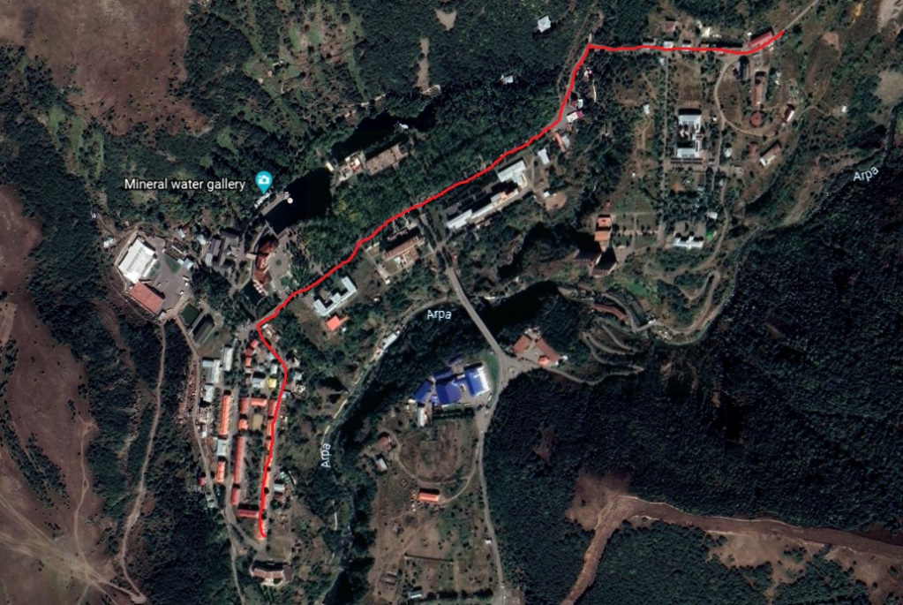

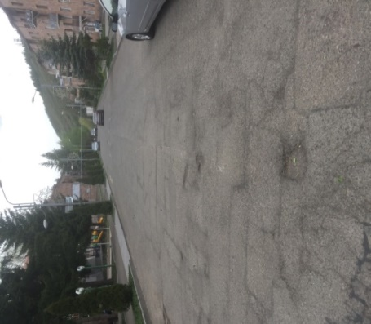
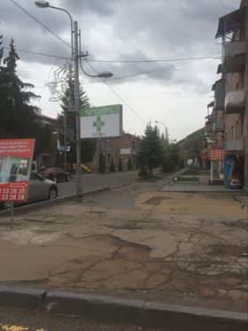
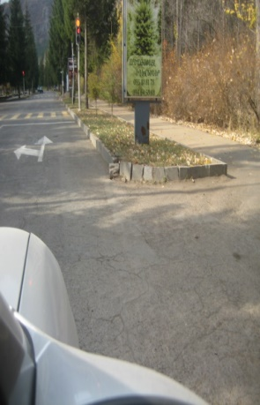
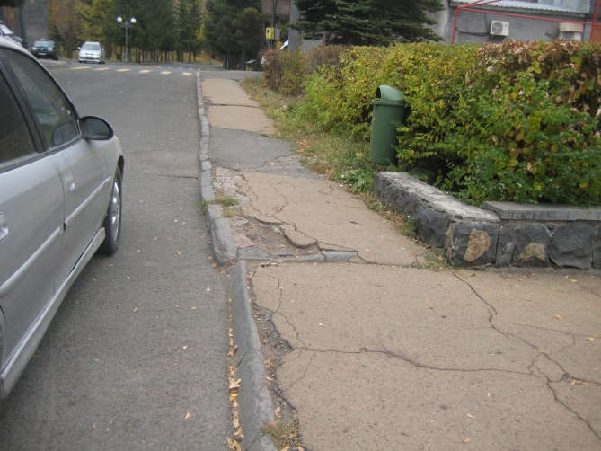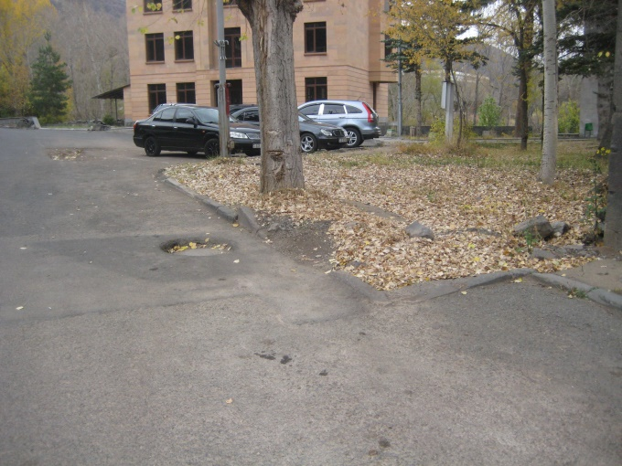

Attachment 2: Permission for construction waste disposal

Non-official translation of the above document:

Construction waste generated during the construction works under the “Rehabilitation and improvement of Shahumyan street” sub-project should be transported to the Ziraki landfill which is located 5 km far from the construction site of the city of Jermuk and 15 km far from the construction site of Gndevaz.

Head of community Sealed/Signed V.Hovhannisyan

Attachment 3: Minutes of the public consultation on the draft Environmental and Social Management Plan
On April 2, at 11.00 am, a public consultation was held by Zoom online platform on the Environmental and Social Management Plan of the “Rehabilitation and improvement of Shahumyan and Myasnikyan Streets in Jermuk city” sub-project.
The announcement of the public consultation was posted on the ATDF website (atdf.am), on the Jermuk community social network page and the municipality's information board on March 26, 2021.
The public consultation meeting was carried out by ATDF Social Specialist Knarik Grigoryan and environmental specialist Asya Osipova. The meeting was joined by the designer Torosyan Jirair and Armen Shishanyan; overall 11 participants participated in the meeting, among which 5 women.
Knarik Grigoryan presented the main purpose of the discussion and the agenda. The representatives of the design company presented the planned construction works.
Asya Osipova presented the possible environmental impacts and the mitigation measures. The anticipated environmental impacts, especially accumulation of construction waste, which must be transported to a place permitted by the local government, noise and dust, were mentioned. The health and safety measures and working hours were presented; also the frequency of monitoring visits and the procedures of monitoring of the implementation of environmental and social impacts mitigation measures were presented.
Mandatory measures to prevent the spread of Covid-19, which are applied on the construction sites, were presented.
Knarik Grigoryan noted that no negative social impacts are expected, as any use of private land is not predicted. Closure of the road during construction works is not planned. K. Grigoryan mentioned that the shops located on the first floors of the buildings along Myasnikyan Street will be provided with safe and continuous access during the civil works.
The GRM procedures were presented. Knarik Grigoryan introduced the local focal point Garnikyan Arsen to the participants of the meeting. All the contact information of the GRM was presented.
K. Grigoryan asked participants to raise questions and concerns relating to the sub-project.
A question was raised when the tender of Construction Company will be announced. K. Grigoryan answered that as soon as the design is approved by all the state authorities the tender will be announced, most likely by the end of the month.

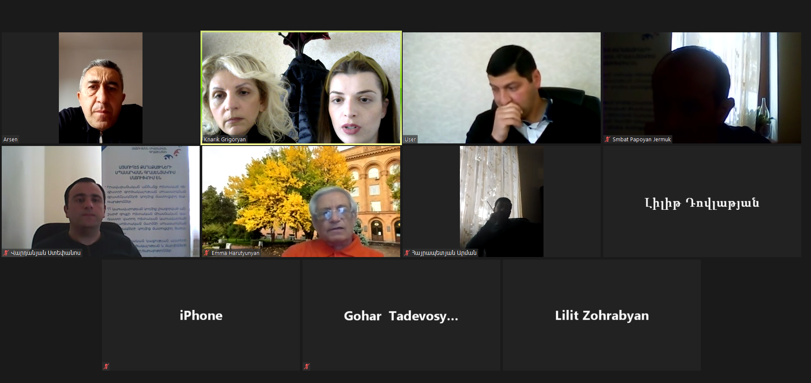
List of participants
Name/surname | Community/ organization
Garnikyan Arsen | Jermuk municipality office, specialist
Zorabyan Lilit | Jermuk municipality office, specialist
Papoyan Smbat | Jermuk municipality office, specialist
Hayrapetyan Arman | Jermuk municipality office, specialist
Vardanyan Stepanos | Jermuk municipality office, specialist
Zorabyan Lilit | Jermuk community, resident
Tadevosyan Gohar | Jermuk community, resident
Torosyan Jirayr | Designer
Shishanyan Armen | Designer
Grigoryan Knarik | ATDF, social specialist
Osipova Asya | ATDF, environmental specialist

Announcement links
http://atdf.am/Content/UploadedFiles/LEID/Shahumyan,Gndevank_eng.docx
https://www.facebook.com/events/2703573639933648

Attachment 4: Construction permits
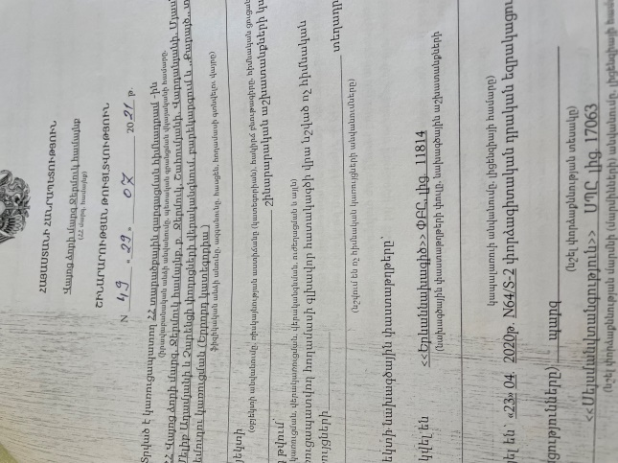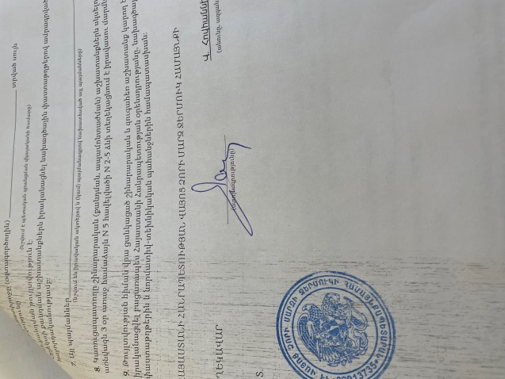
Non-official translation of the above attached document:

Republic of Armenia
Vayoc dzor Region, Jermuk Community
Construction Permit N49, 29.07.2021
This is given for the Provision of Utility Infrastructure for “Rehabilitation and improvement of Shahumyan and Myasnikyan Streets in Jermuk city”
The design documents are
1. Developed by “Erevannakhagic” LLC, license 11814
2. The reconstruction will be implemented within 18 month.

V. Hovhannisyan Sealed/Signed

Toxic / hazardous material includes but is not limited to asbestos, toxic paints, noxious solvents, removal of lead paint, etc.

