REPUBLIC OF ARMENIA
LOCAL ECONOMY AND INFRASTRUCTURE DEVELOPMENT PROJECT

ENVIRONMENTAL AND SOCIAL MANAGEMENT PLAN
Major Rehabilitation of the Road LEADING to Marmashen Monastic Complex and Improvement of the Adjacent Area

July 2023

PART A: General Project and Site Information
INSTITUTIONAL & ADMINISTRATIVE
Project title | LOCAL ECONOMY AND INFRASTRUCTURE DEVELOPMENT (LEID)
Subproject number and title | TUR-15  Major Rehabilitation of the Road Leading to Marmashen Monastic Complex and Improvement of the Adjacent Area
Municipality, community | Shirak marz of RoA, Akhuryan consolidated community , Vahramaberd settlement
Scope of site-specific activity | The sub-project consists of two components.  Component 1. TUR-15. 1 “Major Rehabilitation of the Road to Marmashen Monastic Complex, Organization of Parking Lot and Establishment of Tourist Infrastructure”.  The following works are envisaged under the Component1: major rehabilitation of the 2.4 km long motor way to the monastic complex; removal of the reinforced concrete construction waste from road edges; improvement of the road edge zone; construction of a one-way 1 m wide sidewalk; installation of road signs and tourist signboards; equipment of the road with drainage system; construction of an external lighting system; construction of a parking lot within the boundaries of the community land; construction of a toilet and a guard stand in the area adjacent to the parking lot; construction of a water supply (2.4 km) and a sewer line for the toilet; installation of a local sewage treatment plant (with a capacity of 4 m³/day); construction of a sales platform, installation of sales pavilions. According to the design, the biological treatment plant is provided with a drainage well covered with a layer of gravel. At the treatment plant, the filtered and treated water will be piped into the drainage well. The connection point of the water line is located at the beginning of the road leading to Marmashen monastery, according to the technical condition given by "Veola Jur" CJSC.  Construction of a 40 kVA cage-style dead-end substation and power supply of the substation will be implemented through a 2660 m long underground cable from the last pole of the “Direction 10 KV TE4099” branch of the 110/35/10 KV “Vank” substation. Improvement of the toilet and market site and of the area adjacent to “Heghnar” spring; furnishing with benches, trash cans, tourist signboards will be conducted.  Component 2. TUR-15. 2 “Improvement of the Area of Marmashen Monastic Complex and Establishment of a Rest Zone in the Riverside Area”.  The following works are planned under the Component 2: installation of guard post - stand for selling candles near the road entering the territory of the Marmashen Monastic Complex; installation of a bollard to prevent the entry of vehicles inside the complex; reconstruction and paving of the entrance road (by stone slabs - marble limestone); improvement/ reconstruction of the access paths leading to the churches and rest zone; paving the paths with basalt slabs; removal of the construction debris left after archeological excavations and backfilling of the foundations of the northern and round churches opened as a result of excavations.  At the riverside area: construction of an observation deck with a metal railing; construction of stairs with basalt stones (1500x325mmx150mm and 2250x300mmx150mm); installation of benches, trash cans, external lighting of the monastery complex area; installation of signboards; construction of trenches along the slope to protect the structures of the monastic complex from surface water runoff; extension of the existing drainage system.
Institutional arrangements (WB) | Task Team Leader:  Tafadzwa Dube |  | Safeguards Specialists:  Oksana Rakovych (Environment)  Lusine Gevorgyan (Environment)  David Jijelava (Social)
Implementation arrangements (RoA) | Implementing entity:  ATDF  Asya Osipova (Environment)  Knarik Grigoryan (Social) | Works supervisor:  HALDI Consult LLC |  | Works contractor:  Merdzmoskovyan OJSC
SITE DESCRIPTION
Name of institution whose premises are to be rehabilitated | Akhuryan consolidated community
Address and site location of institution whose premises are to be rehabilitated | Shirak marz, Akhuryan consolidated community, Vahramaberd settlement
Who owns the land?  Who uses the land (formal/informal)? | The construction works planned for the Component 1 will be conducted on the land plots owned by Akhuryan community. The territory of the monastic complex represents a state historical and cultural land. The monastic facilities were handed over to the Armenian Apostolic Church with the right of free use for indefinite time under the Resolution of the Government of the RA, thus the construction works planned under the Component 2 will be conducted on the land plots adjacent to the monastery complex proposed for the toilet and landscaping works is the property of Armenian Apostolic Church.  Part (300 m2) of the land plot planned for the parking lot area to be asphalted is privately owned. The total size of the land plot is 5000 m2, the size of the land plot to be donated is 300 m2, which is the 6% of the total land plot. The land plot to be donated is not used for any purpose, it is asphalted area. The donor will benefit from the sub project, because the sub project implementation will positively affect his assets, and create new opportunities and restored infrastructures for future initiatives.  The owner of the land plot lives out of the country. The Akhuryan municipality office has contacted him by phone, informed and proposed compensation for the land plot. The land owner refused compensation offered by the community, and proposed to voluntary donate the land plot for use under the Sub project. The land owner has no access to mailing.The owner has sent a letter of attorney (see Attachment 4 ) with his consent to the donation of the land plot to the community. The declaration on voluntary donation written by the authorized person is attached to the ESMP.  The subproject will not result in the temporary or permanent loss of crops, fruit trees, and/or household infrastructure. There are no shops, kiosks or other businesses on the sub-project site or along the road to be rehabilitated.
Description of physical and natural environment around the site | The Marmashen monastic complex is located in the Shirak region of the Republic of Armenia, 2.0 km south-west of the Vahramaberd village of the Marmashen community, and on the left bank of the Akhuryan river. This is one of the best monuments of Armenian architecture, which was the cultural and religious center of medieval Armenia. The Marmashen Monastery is included in the state list of Historical and Cultural Monuments of RA. The road to be repaired starts from the main road H-32 Gyumri-Kaps-Amasiya and ends at the entrance to the Marmashen monastery. This is a dilapidated road with remnants of old asphalt pavement and broken curbs. There is no vegetation along the entire road, only small bushes. At the entrance to the proposed parking lot, there are inoperative shopping pavilions. On the left, on the hill, is the memorial of “Kheghnar Akhbyur” water spring. At the entrance to the monastery and in the area around the monastery, large trees are planted, which will not interfere with the restoration of the road and will not be cut down. Down (150 m) from the monastery complex flows the Akhuryan river.  The cemetery is located southeast of the monastery complex.  The Marmashen Monastery Complex is included in the regional tourist routes of Gyumri as an important historical and cultural monument.  Even though, the churches are not functioning for daily religious purposes and they don’t belong to the Armenian Church,masses, weddings and baptisms are still held here by the Armenian Apostolic Church.
LEGISLATION
National & local legislation & permits that apply to sub-project activity | The following Armenian legislation defines a legal framework applicable to project activities:  - Law on Atmospheric Air Protection of RoA (1994)  The purpose of the Law on Atmospheric Air Protection is to define the main principles of the RoA, directed to the provision of purity of atmospheric air and improvement of air quality, prevention and mitigation of the chemical, physical, biological and other impacts on air quality and regulation of public relation. This Law also regulates the emission licenses and provides maximum allowed loads/concentrations for atmospheric air pollution, etc.  According to this law, the contractor shall undertake construction activities as well as transportation and temporary storage of waste the way to minimize dust and other emissions.  - Law on Waste of RoA (2004)  The law provides the legal and economic basis for the collection, transportation, disposal, treatment, re-use of wastes as well as prevention of negative impacts of waste on natural resources, human life and health. The law defines the roles and responsibilities of the state authorized bodies as well as of waste generator organizations in waste management operations.  According to this law, the waste generated from construction activities should be recycled as appropriate or disposed of in designated locations.  Disposal of the construction waste and excess material in selected locations must be approved by the local municipality in writing.  - Law on Environmental Impact Assessment and Expertise of RoA (2014)  The law defines the type of activities that are subject to environmental impact assessment and environmental expertise.  According to this law, the proposed reconstruction and Improvement works are subject to an environmental impact assessment and expertise, because the proposed work will be carried out in the territory of Marmashen monastery, which is included in the state list of Historical and Cultural Monuments .  - Law on Urban Development of RoA (1998)  According to this law, planned works requires obtaining the construction permit.  - Law on the Preservation and Use of Immovable Monuments of History and Culture and the Historical Environment (1998).  According to this Law the allocation of lands for construction, agricultural and other types of works in the areas of the monuments, development and design projects, engineering communication routes are coordinated with the authorized body in the prescribed manner. The Marmashen Monastery is included in the state list of Historical and Cultural Monuments. In accordance with the established procedure the design task and the design sketch of the sub project were approved by the Scientific Methodical Group of the Ministry of Education, Science, Culture and Sport of RA. The minutes of the session are attached to the design package.
PUBLIC CONSULTATION
When / where the public consultation process will take /took place | The draft ESMP was disclosed and discussed at the public consultation held on March 14, 2023 in Vahramaberd settlement with the participants from the community administrative office and local population.  Draft ESMP was disclosed in Armenian and English languages on the ATDF website (www.atdf.am) and in the Armenian language on the beneficiary's website (www.akhuryan.am). Brief information on the planned works and contact information for addressing questions and grievances will be placed at the worksite, on the information board of the Vahramaberd administrative office and/or in its immediate surroundings.
ATTACHMENTS
Attachment 1: Site map/photo
Attachment 2: Permission for backfilling of soft subsoil
Attachment 3: Copy of permit for construction waste disposal
Attachment 4: Positive conclusion of the Environmental Impact Assessment and State Expertise
Attachment 5: Letter of Attorney of the donation of the land plot
Attachment 6: The Declaration on the voluntary donation signed by the authorized person of the land ownerAttachment
7: Minutes of the public consultation on the draft of ESMP
Attachment 8: Construction permit

PART B: safeguards information
ENVIRONMENTAL /SOCIAL SCREENING
Will the site activity include/involve any of the following? | Activity/Issue | Status | Triggered Actions
Will the site activity include/involve any of the following? | - Building rehabilitation | [ ] Yes [x] No | If “Yes”, See Section A below
Will the site activity include/involve any of the following? | - Road rehabilitation | [x] Yes [ ] No | If “Yes”, see Section A below
Will the site activity include/involve any of the following? | - New construction | [x] Yes [] No | If “Yes”, See Section A below
Will the site activity include/involve any of the following? | - Individual wastewater treatment system | [x] Yes [] No | If “Yes”, See Section B below
Will the site activity include/involve any of the following? | - Historic building(s) and districts | [x] Yes [ ] No | If “Yes”, See Section C below
Will the site activity include/involve any of the following? | - Unexpected need for land take | [ ] Yes [x] No | If “Yes”, See Section D below
Will the site activity include/involve any of the following? | - Hazardous or toxic materials | [ ] Yes [x] No | If “Yes”, See Section E below
Will the site activity include/involve any of the following? | - Impacts on forests and/or protected areas | [ ] Yes [x] No | If “Yes”, See Section F below
Will the site activity include/involve any of the following? | - Traffic and pedestrian safety | [x] Yes [ ] No | If “Yes”, See Section H below
Will the site activity include/involve any of the following? | - Social risk management | [x] Yes [ ] No | If “Yes”, See Section I below
PART C: Mitigation measures
ACTIVITY | PARAMETER | MITIGATION MEASURES
0. General Conditions | Notification and Worker Safety | - The local construction and environment inspectorates and communities are notified of upcoming activities  - The public is notified of the works through appropriate notification in the media and/or at publicly accessible sites (including the site of the works)  - All legally required permits are acquired for construction and/or rehabilitation  - The Contractor formally agrees that all work will be carried out in a safe and disciplined manner designed to minimize impacts on neighboring residents and environment.  - Workers’ personal protection equipment complies with international good practice (always hardhats, as needed masks and safety glasses, harnesses and safety boots)  - Appropriate signposting of the sites informs workers of key rules and regulations to follow.
A. General Rehabilitation and /or construction activities | Air Quality | - During earth works, dust is suppressed by ongoing water spraying and/or installing dust screen enclosures at site.  - The surrounding environment (sidewalks, roads) is kept free of debris to minimize dust.  - There is no open burning of construction / waste material at the site.  - There is no excessive idling of construction vehicles at sites.
A. General Rehabilitation and /or construction activities | Noise | - Construction noise is limited to restricted times agreed to in the permit.  - During operations, the engine covers of generators, air compressors and other powered mechanical equipment are closed, and equipment placed as far away from residential areas as possible.
A. General Rehabilitation and /or construction activities | Water Quality | - Appropriate erosion and sediment control measures are applied such as e.g. hay bales and / or silt fences to prevent sediment from moving off site and causing excessive turbidity in nearby streams and rivers.  - Rainwater is removed from the construction site using a rainwater drainage system.
A. General Rehabilitation and /or construction activities | Waste Management | - Waste collection and disposal pathways and sites are identified for all major waste types expected from demolition and construction activities.  - Mineral construction and demolition wastes are separated from general refuse, organic, liquid and chemical wastes by on-site sorting and stored in appropriate containers.  - Construction waste is being collected and disposed properly by licensed collectors.  - Whenever feasible, appropriate and viable materials (except asbestos) are reused or recycled.
 | Earth Works | - Excess material and topsoil generated from earth works will be stored separately and used for backfilling and site reinstatement  - Topsoil layer not thicker than 30 m will be stripped separately and temporary piled on-site  - Stockpile height will not exceed 3.0 m, and the slope angle will not exceed 34o  - Temporary stockpile will be compacted and covered with a tarp to prevent erosion caused by rain runoff  - Topsoil will be re-used for backfilling to facilitate re-cultivation of the land plot  - Excess amount of subsoil will be disposed at the agreed-upon locations.
B. Individual wastewater treatment system | Water Quality | - The approach to handling sanitary wastes and wastewater from building sites (installation or reconstruction) is approved by the local authorities.  - Before being discharged into receiving waters, effluents from individual wastewater systems are treated in order to meet the minimal quality criteria set out by national guidelines on effluent quality and wastewater treatment.  - Monitoring of new wastewater systems (before/after) is carried out.  - Construction vehicles and machinery are washed only in designated areas where runoff will not pollute natural surface water bodies.
C. Historic building(s) | Cultural Heritage | - If the building is a designated historic structure, very close to such a structure, or located in a designated historic district, notification is made, and approvals/permits be obtained from local authorities and all construction activities planned and carried out in line with local and national legislation.  - Provisions are put in place so that artifacts or other possible chance finds encountered in excavation or construction are noted and registered, responsible officials contacted, and works activities delayed or modified to account for such finds.
H. Traffic and pedestrian safety | Direct or indirect hazards to public traffic and pedestrians by construction  activities | (a) In compliance with national regulations, the construction site is properly secured, and construction related traffic regulated. This includes but is not limited to  - Signposting, warning signs, barriers and traffic diversions: site will be clearly visible, and the public warned of all potential hazards.  - Traffic management system and staff training, especially for site access and near-site heavy traffic. Provision of safe passages and crossings for pedestrians where construction traffic interferes.  - Adjustment of working hours to local traffic patterns, e.g. avoiding major transport activities during rush hours or times of livestock movement.  - Active traffic management by trained and visible staff at the site, if required for safe and convenient passage for the public.  - Ensuring safe and continuous access to office facilities, shops and residences during renovation activities, if the buildings stay open for the public.
I. Social risk management | Public relationship management | - Assign local liaison person in charge of communication with and receiving requests/ complaints from local population.  - Consulted local communities to identify and pro-proactively manage potential conflicts between an external workforce and local people.  - Rise local community awareness about sexually disease risks associated with the presence of an external workforce and includes local communities in awareness activities.  - Inform population about construction and work schedules, interruption of the services, traffic detour routes and provisional bus routes, blasting and demolition, as appropriate.  - Limit construction activities at night. When necessary, carefully schedule night-time works and inform affected community so they can take necessary measures.  - At least five days in advance of any service interruption (including water, electricity, telephone, bus routes), advice affected community through postings at the project site, at bus stops, and in affected homes/businesses.
I. Social risk management | Labor management | - To the extent possible, locate work camps away from local communities.  - Undertake sitting and operation of worker camps in consultation with neighboring communities.  - Recruit unskilled or semi-skilled workers from local communities to the extent possible. Where and when feasible, provide worker skills training to enhance participation of local people.  - Provide adequate lavatory facilities (toilets and washing areas) in the work site with adequate supplies of hot and cold running water, soap, and hand drying devices. Establish temporary septic tanks for any residential labor camp and without causing pollution of nearby watercourses.  - Raise awareness of workers on overall relationship management with local population, establish the code of conduct in line with international practice  - and strictly enforce them, including the dismissal of workers and financial penalties of adequate scale.
 | Grievance Management | - GRM is established and advertised at the local level. The Contractor is informed of his responsibility to register and communicate to the PIU received verbal and non-verbal grievances.  - GRM contact information, including local focal points, has been posted at the construction site and the local community’s administrative office.  The Contractors' local liaison person receives and registers grievances from the population in the GRM log and communicates the grievances to the PIU regularly.

PART D: Monitoring Plan
Activity | What  (Is the parameter to be monitored?) |  | Where  (Is the parameter to be monitored?) | How  (Is the parameter to be monitored?) | When  (Define the frequency / or continuous?) | Why  (Is the parameter being monitored?) |  | Who  (Is responsible for monitoring?)
CONSTRUCTION PHASE
Supply of construction materials | Purchase of construction materials from the licensed suppliers |  | In supplier’s office or warehouse | Verification of labels of the materials and/or certificates if any | During conclusion of supply contracts | Ensure reliability of construction materials and their safety for human health |  | ATDF  Technical supervision  company
Transportation of construction materials and waste;  Movement of construction vehicles and machinery |  | - Technical condition of construction vehicles and machinery;  - Adequate protection of truckloads with lining;  - Movement of construction vehicles and machinery according to predefined traffic routes and within working hours: 9AM-6PM. | -Construction site  -Routes of transportation of construction materials and wastes | Inspection of pre-defined movement routes, entrances and exits of construction sites | Unannounced monthly inspection during work hours and beyond | -Avoid pollution of soil and air from dust and solid matter emissions;  -Limit nuisance to local communities;  -Minimize traffic disruption, ensure pedestrian safety and prevent accidents. |  | ATDF  Technical supervision  company
Maintenance of construction equipment | - Washing of cars and construction equipment outside the construction site or on maximum distance from natural streams;  - Refueling or lubrication of construction equipment outside the construction site or at the predetermined confined area. |  | Construction site | Inspection of activities | Selective inspections during work hours | -Avoid pollution of water and soil with oil products due to operation of equipment;  -Timely localize and decrease expected damage in case of fire. |  | ATDF  Technical supervision  company
Generation of construction waste | - Temporary storage of waste at the pre-defined areas of construction site;  - Timely disposal of waste to the formally designated locations. |  | Construction site  Waste disposal site | Inspection of site | Unannounced monthly inspection during entire construction phase | -Prevent pollution of soil, surface water and ground water;  - Avoid accidents at the construction site due to scattered fragments of construction materials and debris;  - Retain esthetic appearance of the construction site and its surroundings. |  | ATDF  Technical supervision  company
Deploying manpower for construction | - Provision of uniforms and safety gears to workers and enforcement of their use by the constructor;  - Provision of work-site safety instruction to contractor’s personnel and instructions proper recording;  - Installation of fencing;  - Provisions of nuisance activities within working hours from 9AM-6PM and in accordance with allowed norms of noise and vibrations. |  | Construction site | Inspection | Periodically during construction and upon its completion | -Minimize probability of accidents  -Protect workers’ health;  -Limit nuisance to local communities from noise and vibration. |  | ATDF  Technical supervision  company
Works near privately-owned land plots and other property | - Avoid trespassing or incidentally damaging of private property (using small-size machinery or manual labor near walls and fences, stockpiling of construction material and waste away from private property; etc.);  - In case of unintended damage to private property, quickly restore it to the original or better status;  - In case of expected temporary impact on privately-owned property, inform owners upfront and guarantee restoration, acquire written consent of owners for intervention, and promptly restore the damage to the original or better status. |  | Works near privately-owned land, buildings and other assets | Monitoring and inspection | Entire period of construction | -Reduce the probability of damages on private property;  -Exclude temporary or permanent violation of ownership and/or user rights on the private property. |  | ATDF  Technical supervision  company
Construction site re-cultivation and landscaping | Final cleaning of the rehabilitated site and permanent access roads and landscaping-greening of the area as required. |  | Construction site and access roads | Inspection of activities | Final period of construction | Reduce loss of aesthetical value of the landscape due to construction activities. |  | ATDF  Technical supervision  company
Solid waste management | Trash bins placement and arrangement on periodical transportation of waste. |  | Construction site | Inspection | Total period of works | - Prevent pollution of soil, water;  - Retain esthetic appearance of the sites area and its surroundings. |  | ATDF  Technical supervision  company  Akhuryan community
Dust generation | Dust suppression measures at worksites. |  | Construction site and access roads | Visual inspection | Recurrent | Prevent off-site dust spreading and pollution ;  -Reduce health risks to the workers and neighboring communities. |  | ATDF  Technical supervision  company
Handling of chance finds | - Stoppage of works promptly upon encountering of chance finds;  - Formal communication with Agency for the Protection of Monuments and Historical Sites of RA on chance finds;  - Timely arrangements made for the conduct of required excavation and site conservation. |  | Construction site | -Inspection of chance find sites;  - Inspection of filed documentation. | Entire period of construction | Ensure cultural heritage is not damaged by the construction works |  | ATDF  Technical supervision  company  Agency for the Protection of Monuments and Historical Sites
Earthwork | - Temporary storage of excavated soil at determined places;  - Backfilling of the excavated ground as needed and disposal of the excess mass to the places, approved in writing. |  | Construction site | Inspection of activities | During earth works | Limit pollution with contaminated soil of surface and ground waters. |  | ATDF  Technical supervision  company
COVID-19 preparedness in the work site | - Provision of hand wash facilities in the work site with adequate supplies of running water, hand soap, alcohol-based hand sanitizer and hand drying devices;  - Worksite entrance procedure and medical checks;  - Regular disinfection of public rooms, equipment, tools, and waste;  - Work practices to reduce or minimize contact between workers;  - Provision of face masks and other relevant PPE to all project workers at the entrance to the project site. |  | Construction site | Inspection of activities | Total period of works | Reduce the COVID-19 infection risk at worksites |  | ATDF  Technical supervision  company
Operation of Grievance Redress Mechanism | - Public right to complaints or questions about the project.  - Appeal to the head of local government (community authorities)  - The appointment by the authorities of the Coordinator for the consideration of complaints (receiving complaints, reviewing and explaining, registering complaints in the logbook and trying to resolve them on the spot.  - Appeal to ATDF by hot-line (010 24 01 59), postal letter (Yerevan 0037, K.Ulnetsi 31), official web page (http://atdf.am/hy/Home/ContactUs), e-mail (support@atdf.am). |  | Construction site | Inspection of activities | Entire period of construction | -Monitor compliance with project aspects;  -Timely resolve questions and complaints in the field. |  | ATDF  Technical supervision  company
Traffic and pedestrian safety | - Signposting, warning signs, barriers and traffic diversions;  - Provision of safe passages and crossings for pedestrians where construction traffic interferes. |  | Construction site | Inspection of activities | During the works | Reduce probability of accidents to constructors and local population․ |  | ATDF  Technical supervision  company
OPERATION PHASE
Operation and maintenance of outdoor lighting system | Regular servicing of the lighting system is being undertaken. |  | Street lighting network | Periodic Inspection | Total period of operation | Maintenance of lighting system in safe and operable condition. | Akhuryan community
Exploitation and maintenance of road | - Cleaning road surface and shoulders from litter deposited out of moving vehicles and from bodies of animals accidentally overrun by vehicles;  - Timely confinement, deactivation, and removal of liquid or powder spills of cargo in case of road accidents;  - Collection and timely disposal of waste from road maintenance works to a designated landfill. |  | Carriageway of the road | Visual inspection | As required in response to an accident  Regular, to be determined by local municipality | -Ensure safety of traffic and prevent environmental pollution;  -Ensure aesthetic appearance of the road. | Akhuryan community
Maintenance of drainage system | Keeping road drainage system operational |  | Carriageway of the road | Visual inspection | Regular, to be determined by local municipality | Ensure safety of traffic and decrease frequency and costs of road rehabilitation | Akhuryan community
Operation and maintenance of local sewage biological treatment plant | - Leakages of waste water from sewage scheme;  - Smoothly operation of sewage water treatment plant. |  | Installed treatment facility | Instrumental quality testing of treated sewage according to approved safety parameters | During operation phase | - Prevent water-borne diseases;  - Prevent pollution of surface and ground water, soils. | Akhuryan Community

Attachment 1: Sites maps and photos

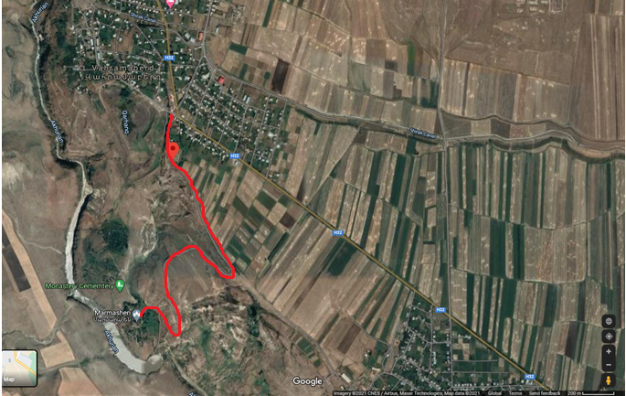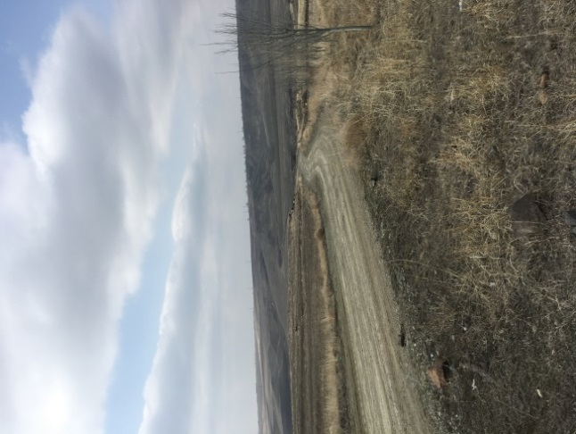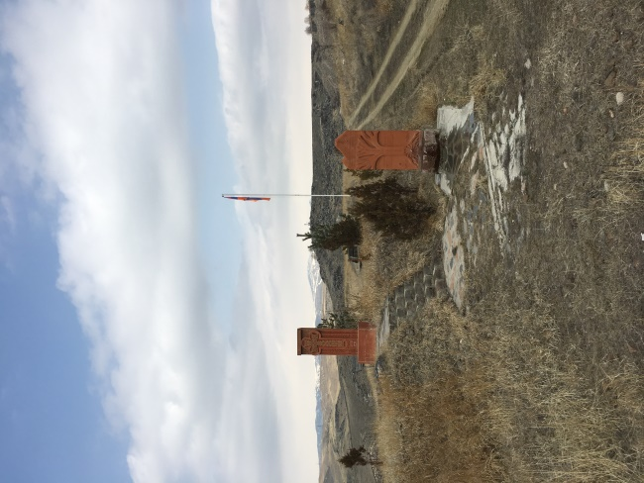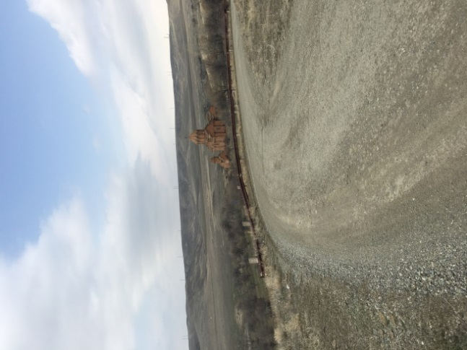
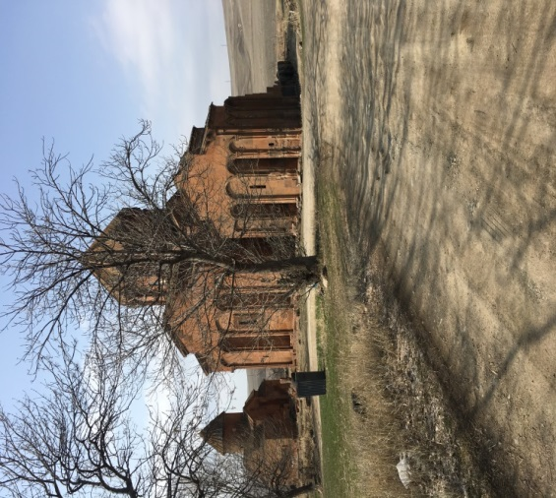
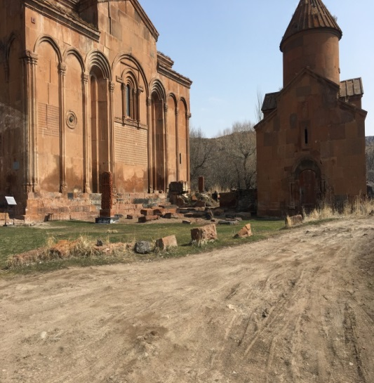

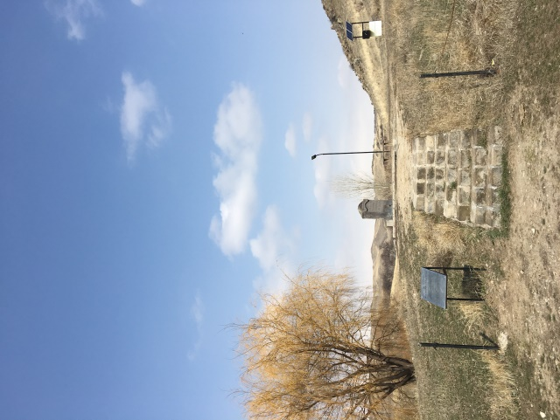
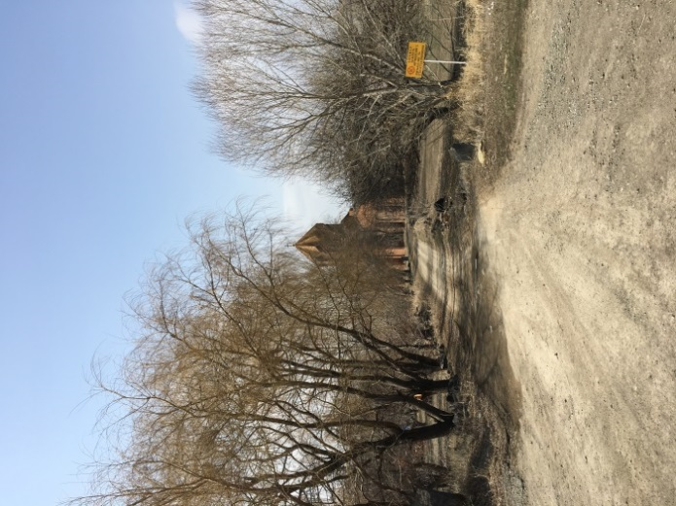

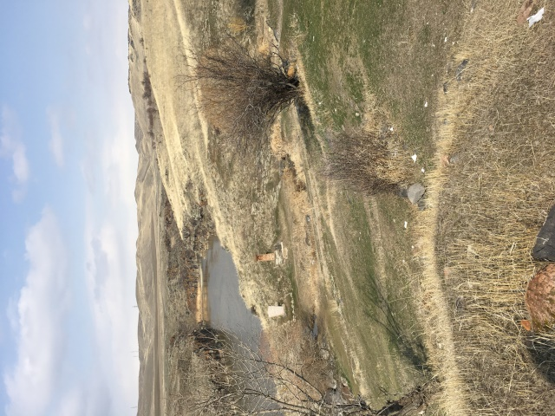
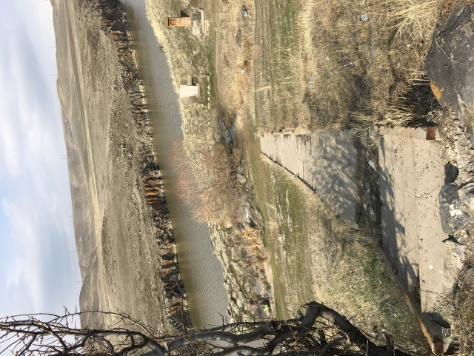
Attachment 2: Permission for backfilling of soft subsoil
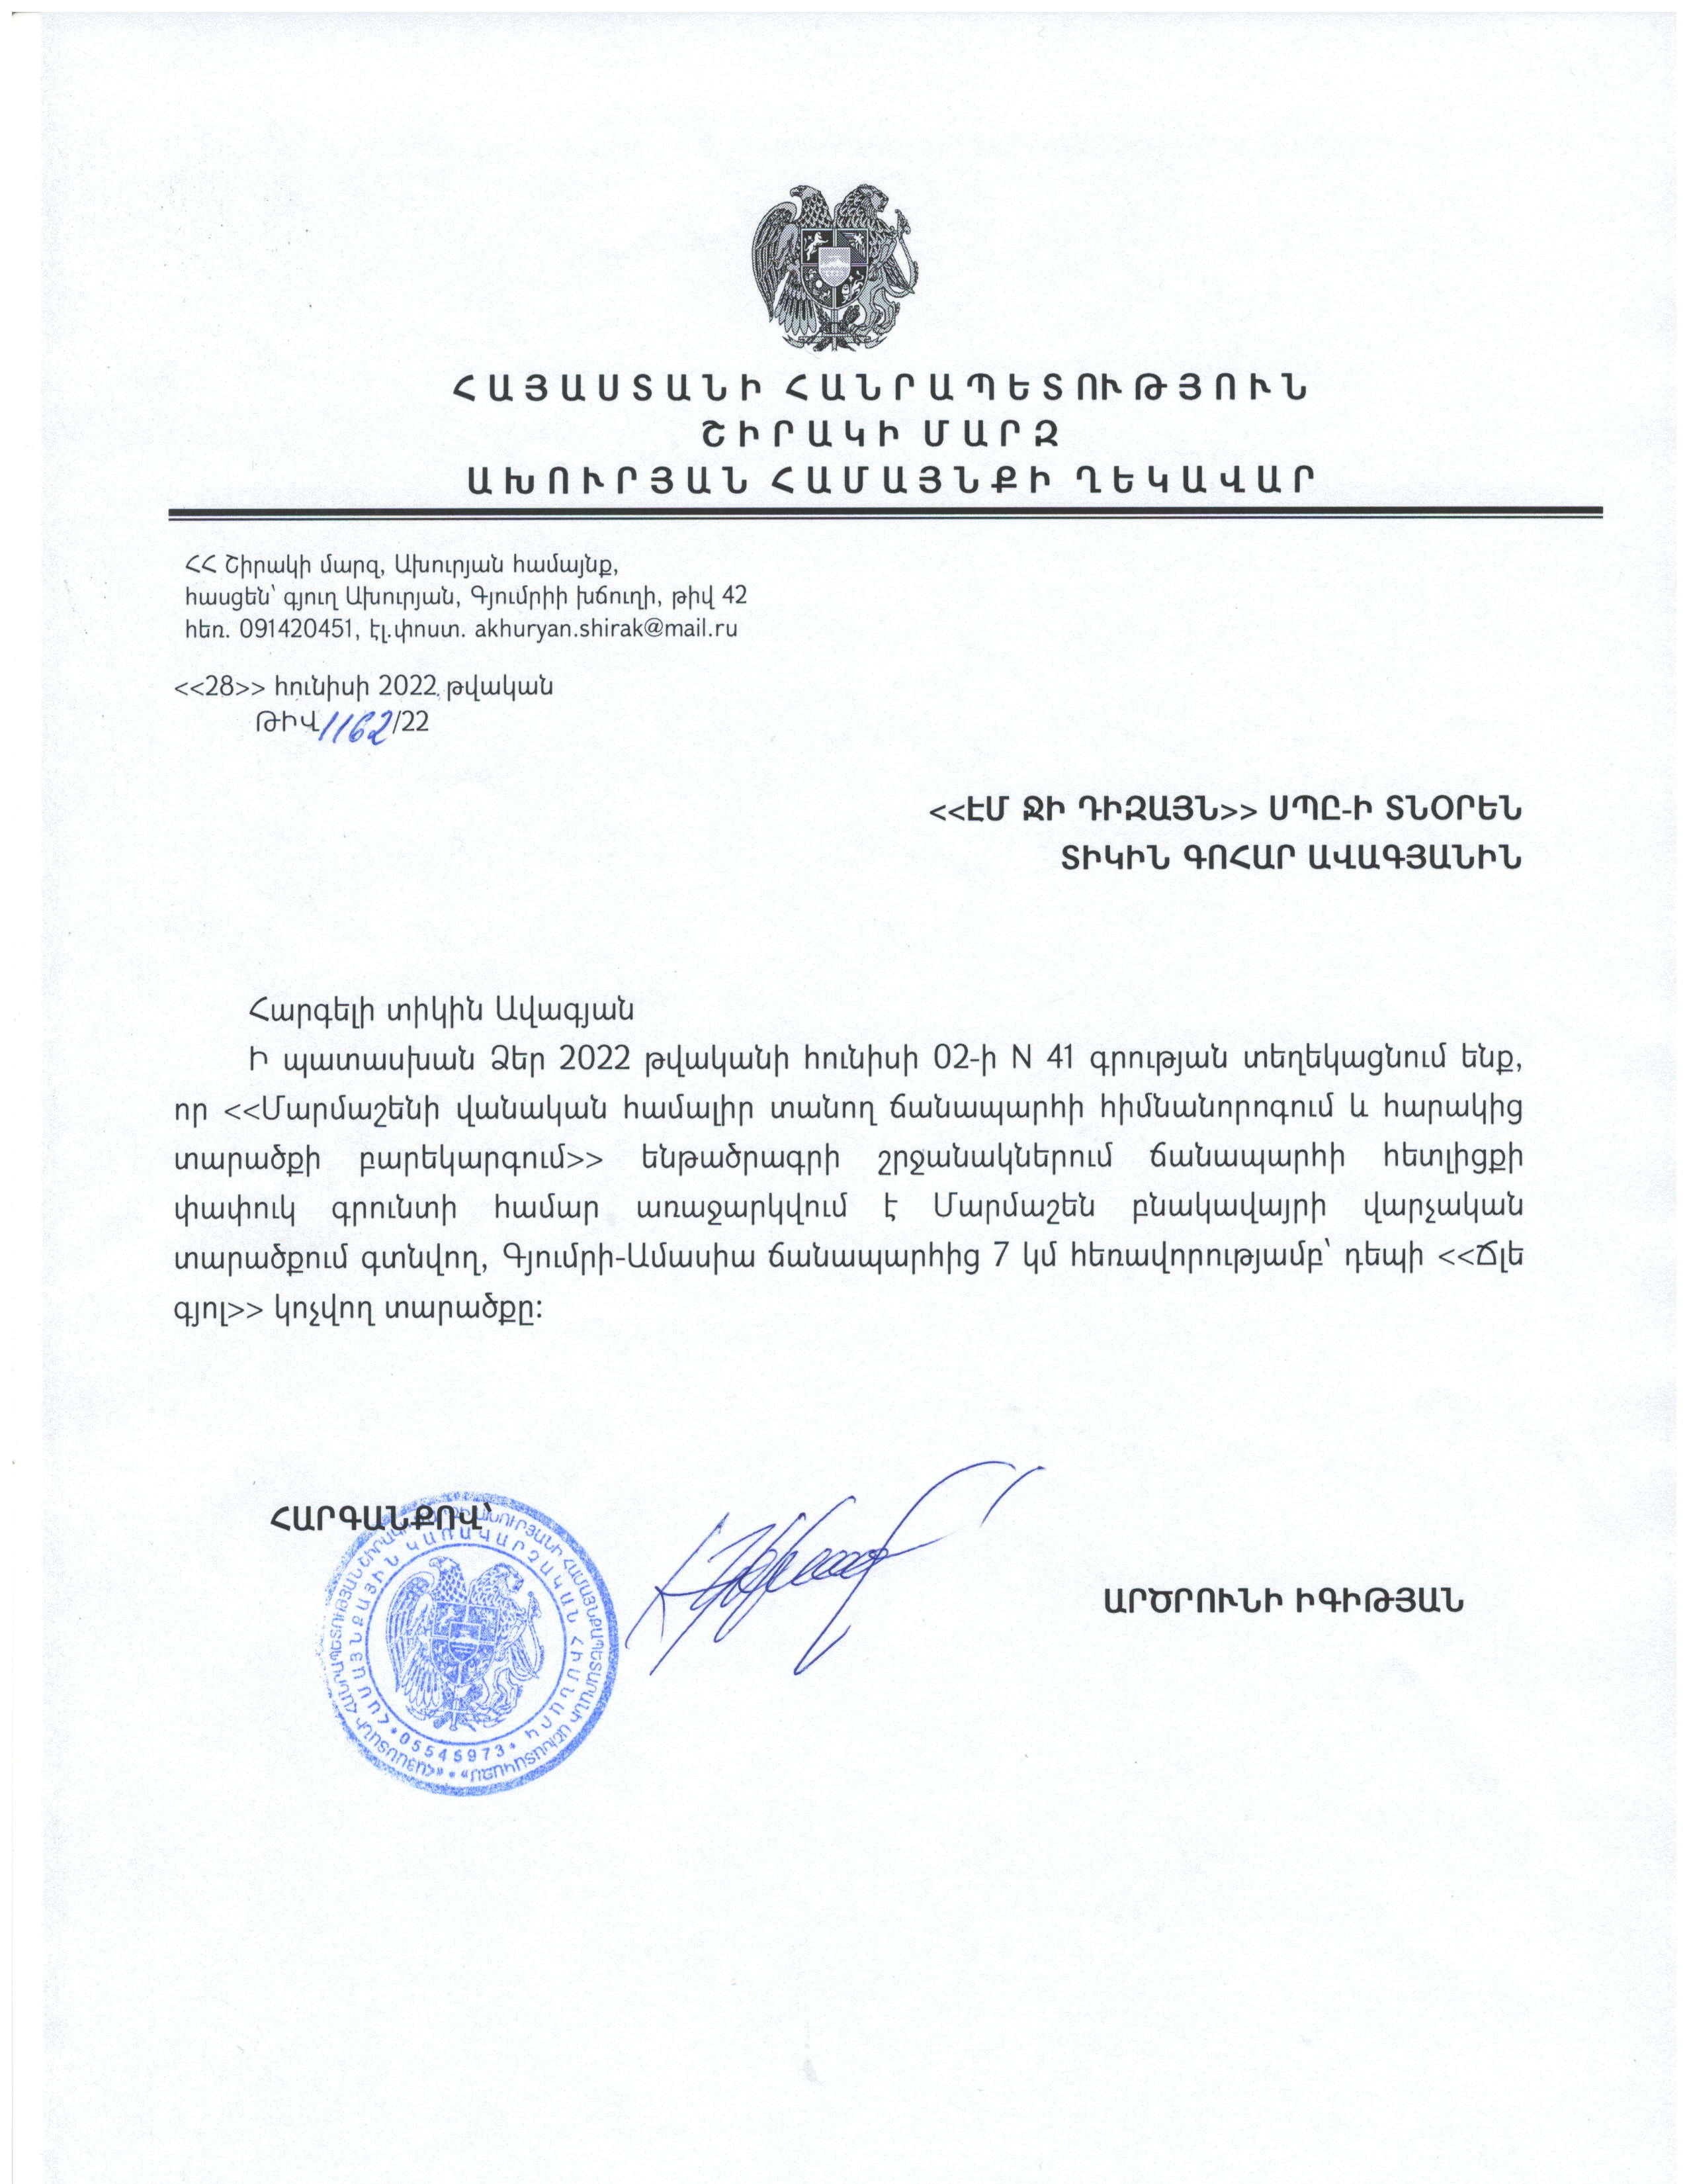

Non-official translation of the above document:
Reference:
28.06.2022
N1162/22
The site called ''Tchle gyol"which is located 7 km far from the Gyumri-Amasya highway. is proposed for subsoil uptake for backfilling activities under “Major Rehabilitation of the Road Leading to Marmashen Monastic Complex and Improvement of the Adjacent Area ” sub-project. at
Head of community Sealed/Signed A.Igityan

Attachment 3: Permission for construction waste disposal
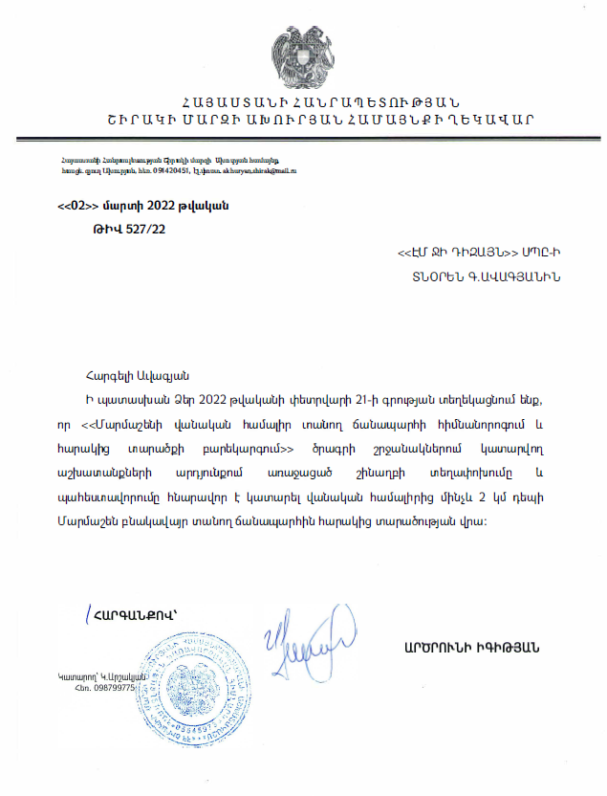
Non-official translation of the above document:
Reference
02.03.2022
N527/22
Construction waste generated during the rehabilitation works under the “Major Rehabilitation of the Road Leading to Marmashen Monastic Complex and Improvement of the Adjacent Area ” sub-project should be transported to the landfill which is located 2 km far from the construction site and adjacent to road leading to Marmashen settlement.

Head of community Sealed/Signed A. Igityan
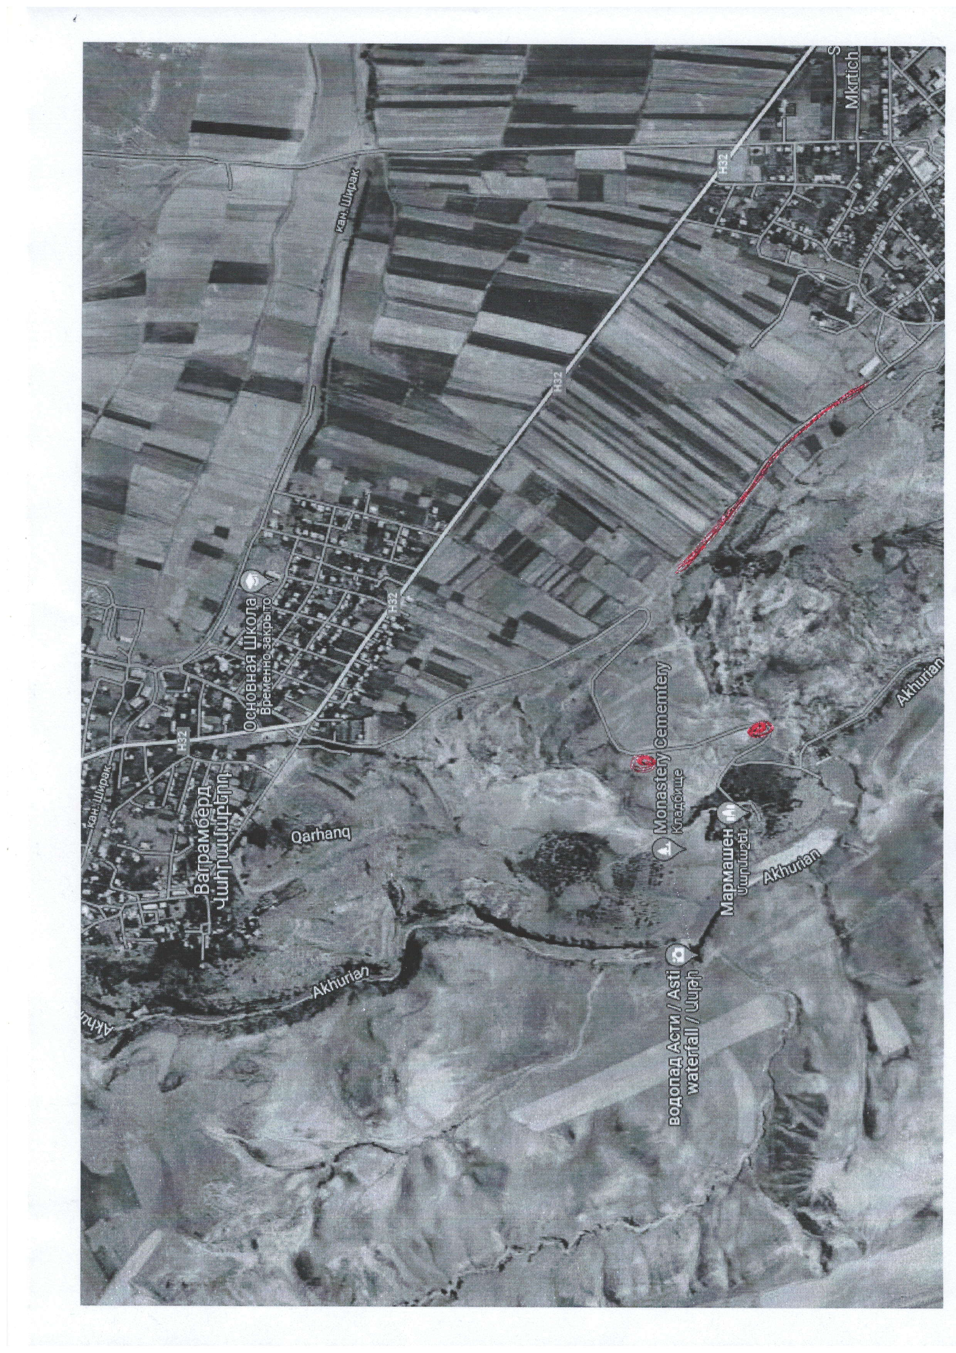
Location of the landfill

Attachment 4: Positive conclusion of the Environmental Impact Assessment State Expertise
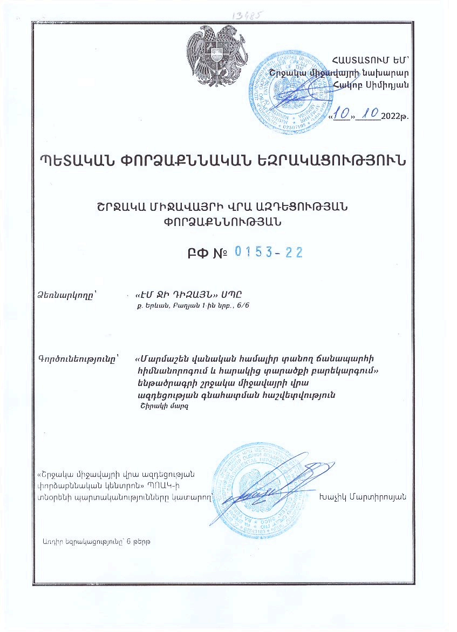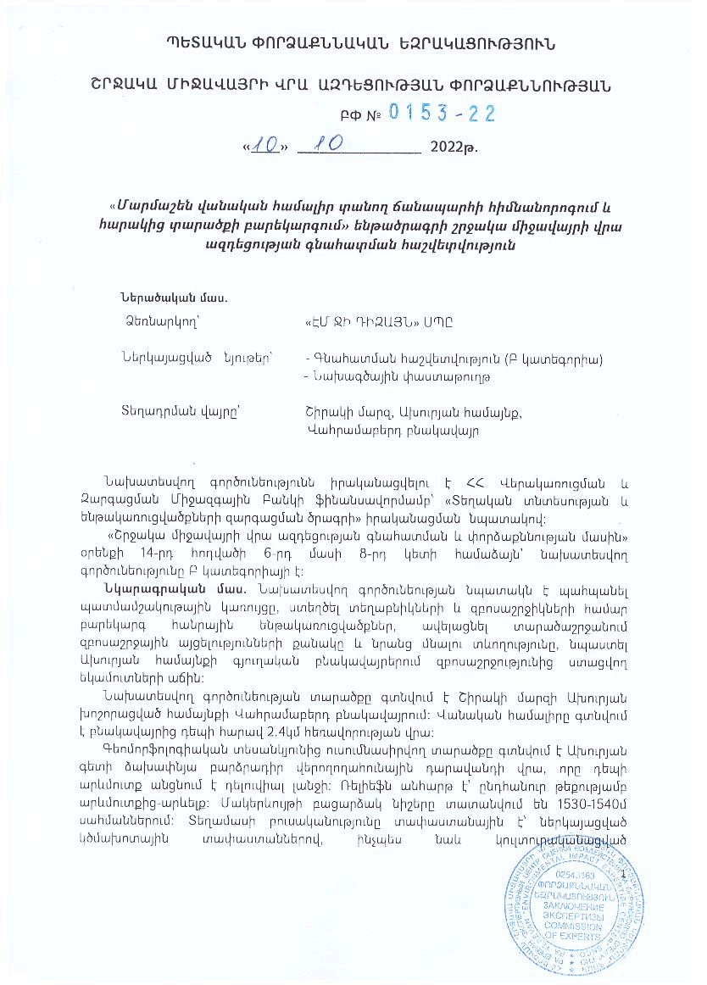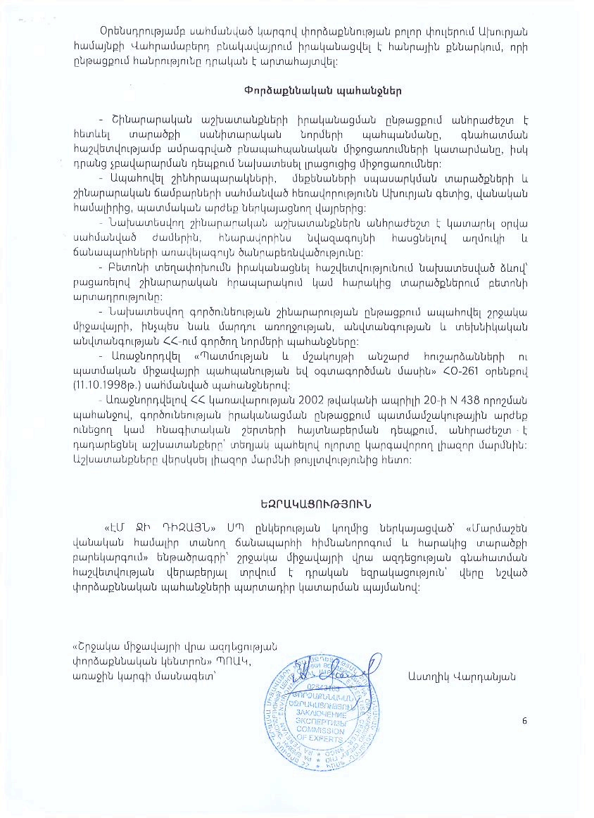
Summary of the above document
EE No 0153-22
Date issued: 10.10.2022
Expertise Initiator: "MG Design "LTD, Yerevan, Baghyan str.1,6/6
Type of activity: Environmental Impact Assessment Report for the Major Rehabilitation of the Road Leading to Marmashen Monastic Complex and Improvement of the Adjacent Area
The expertise requirements:
- During the implementation of the construction works, it is necessary to monitor the sanitary norms of the area, to implement the environmental measures specified in the assessment report, and in case of non-satisfaction, to plan additional measures.
- Ensure the specified distance of construction site, car maintenance areas and construction camps from the Akhuryan River, Monastery Complex, and historical monuments.
- It is necessary to carry out the planned construction works during the specified hours of the day, minimizing as much as possible the noise and the maximum load on the roads.
- Carry out concrete transportation in the manner specified in the report, excluding concrete production at the construction site or adjacent areas.
- During the construction works, ensure the requirements on the environment, as well as human health, safety and technical safety standards of the RoA.
- Be guided by the requirements set by the law "On the Preservation and Use of Immovable Monuments of History and Culture and Historical Environment".
- In accordance with the request of the RoA Government's decision N 438 dated April 20, 2002, in case of discovery of historical-cultural or archaeological layers during the implementation of activities, it is necessary to stop the works, and informi the authorized body regulating the sector. Resume the works only after the permission of the authorized body.

CONCLUSION
A positive opinion is given on the Environmental Impact Assessment report of the reconstruction of the Reconstruction of Tourism Infrastructure and Roads of Gyumri, submitted by the " EM JI DIZAYN " LTD, with the obligatory fulfillment of expert requirements.
"Environmental Impact Expertise Center" SNOC
Specialist of the first category Astghik Vardanyan.

Attachment 5: Letter of Attorney of the donation of the land plot
Summary of the above attached document:
Letter of Attorney
38AA3767428
Town Cheremkhovo Irkutsk region
The ninth of June of two thousand twenty-two year
In accordance with the approved plan, to separate 300 square meters of the land located in the Akhuryan community of Shirak Marz, RoA, sign a donation agreement, register all rights in the relevant register log, complete all declarations, give consent, submit all types of documents, sign on my behalf and perform all other types of actions related to this assignment.
Attachment 6: The Declaration on the voluntary land donation signed by the authorized person of the land owner
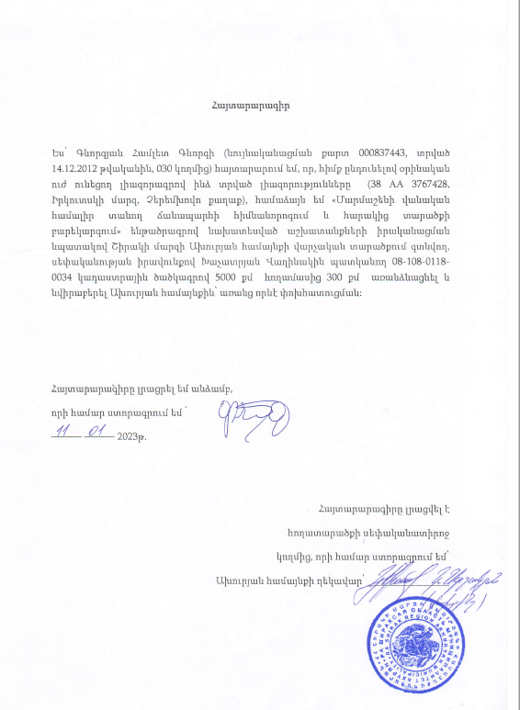
Translation of the document:
I, Gevorgyan Hamlet (identification card 000837443, issued on 14.12.2012, given by 030) declare that, based on the powers granted to me by a legally valid power of attorney (38 AA 3767428, Irkutsk Region, Chermekhovo City), I agree to separate 300 square meters of the 5000 square meter land plot with cadastral code 08-108-0118-0034 owned by Khachatryan Vaghinak in the administrative area of the Akhuryan community of Shirak marz and donate to the Akhuryan community without any compensation in order to carry out the works planned under the " Major Rehabilitation of the Road Leading to Marmashen Monastic Complex and Improvement of the Adjacent Area" sub-project.

Attachment 7: Minutes of public consultation on the draft Environmental and Social Management Plan
The public consultation (PC) meeting was held in Vahramaberd village on March 14, 2023. The head of Administrative office of Vahramaberd settlement, ATDF and the local residents participated in the meeting. Overall 12 people participated in the meeting, from which 6 women.
The Public consultation announcement was posted on ATDF web page and Akhuryan municipality web page and social media page on March 3, 2023.
The head of Vahramaberd settlement administrative office opened the meeting by presenting the aim of the meeting and purpose of the sub project.
ATDF social specialist presented the scope of construction works to be done under the sub project and the mitigation measures provided under the ESMP. The expected environmental impacts were presented including generation of construction waste, noise, movement of vehicles and vibrations. As well as the mitigation measures were presented including construction waste transportation to designated landfill, management of working hours, management of the manpower and provision of safety measures, operation of vehicles, and transportation of construction materials under cover, as well as the watering of the construction site. The measures were presented to avoid pollution of the river during the construction works.
It was mentioned that voluntary donation of a land plot is planed under the sub project. The owner of the land plot has sent a letter of attorney, but the donation has not gone state registration yet.
The GRM procedures were presented. The focal point of the sub project was presented and additionally informed about his responsibilities.
A question was raised on the start of construction works. The ATDF representative K.Grigoryan mentioned that the construction company tendering will be announced after the final approval of the ESMP, and that the procurement of the Contractor will last two months.
Attachment 8: Construction permit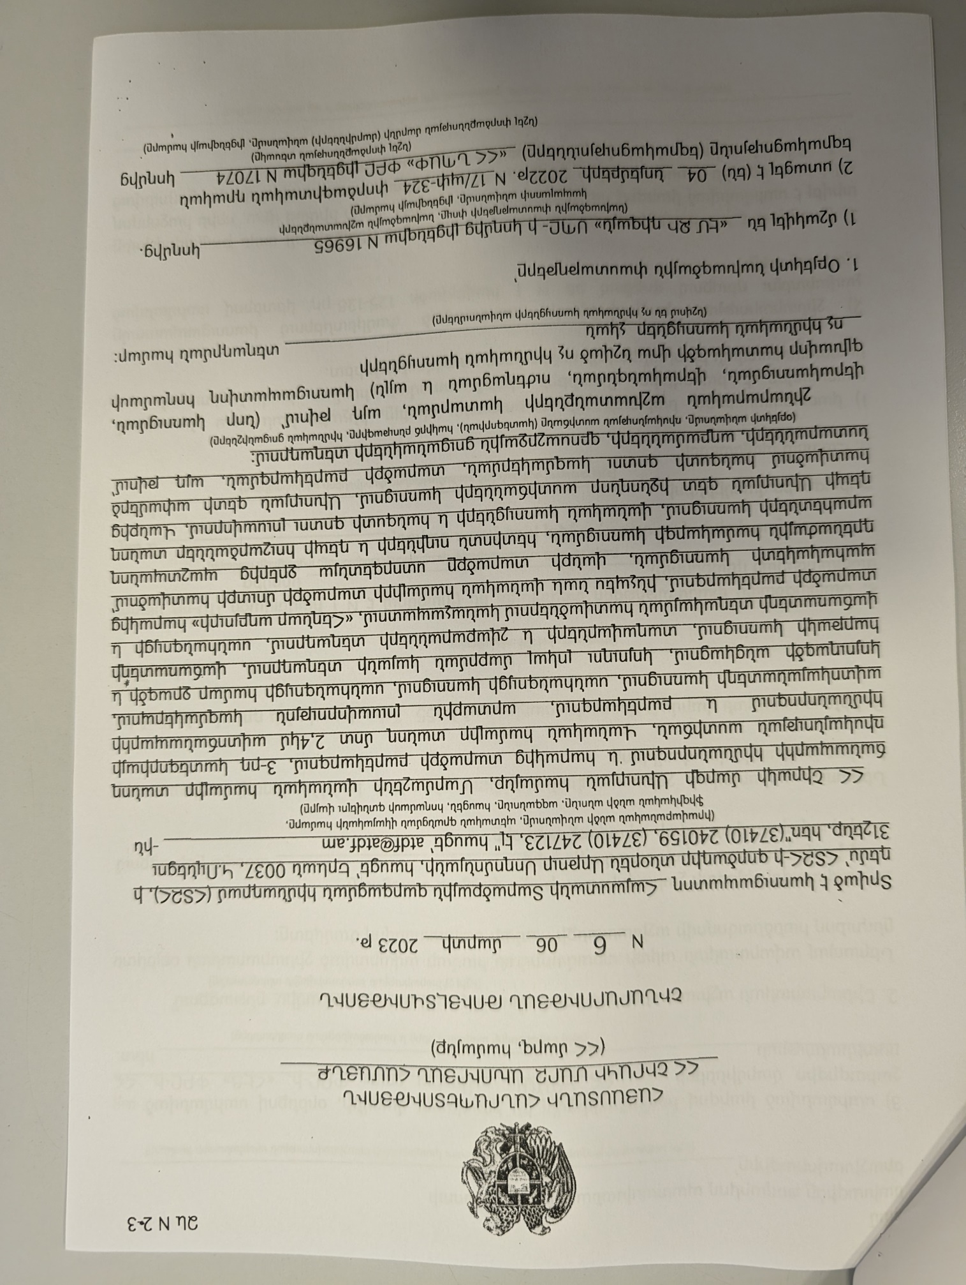
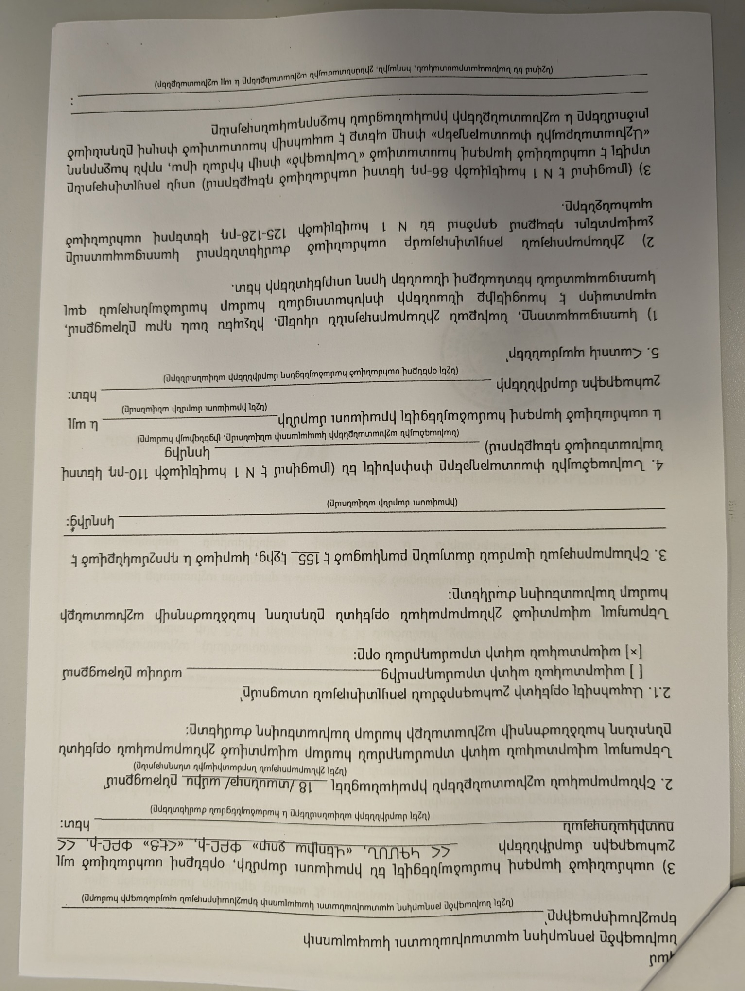
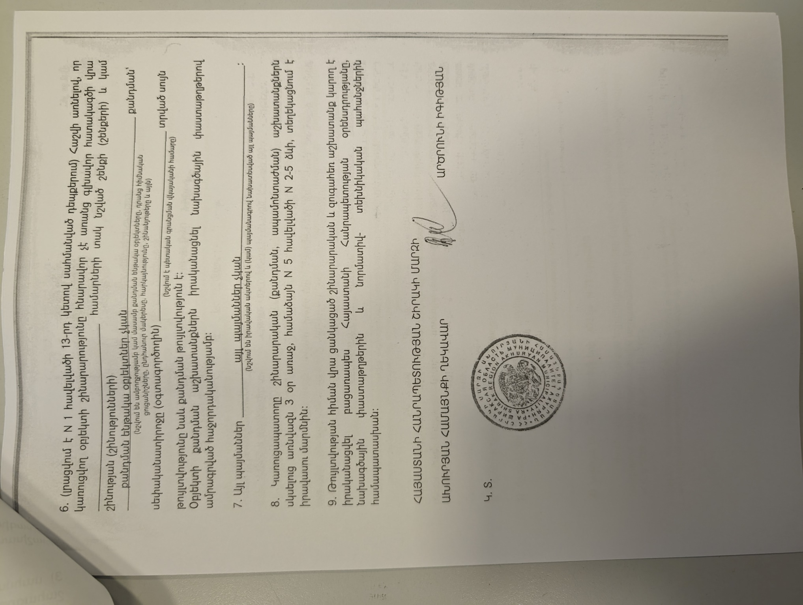
Summary of the above attached document:

Republic of Armenia
Shirak Region, Akhuryan Community
Construction Permit N6. 06.03.2023
This is given for the “Rehabilitation of the Road Leading to Marmashen Monastic Complex and Improvement of the Adjacent Area”.
The design documents are
1. Developed by “MG Design” LLC, License 16965
2. The reconstruction will be implemented within 18 month.

A.Igityan Sealed/Signed

Toxic / hazardous material includes but is not limited to asbestos, toxic paints, noxious solvents, removal of lead paint, etc.

