REPUBLIC OF ARMENIA
LOCAL ECONOMY AND INFRASTRUCTURE DEVELOPMENT PROJECT

ENVIRONMENTAL AND SOCIAL MANAGEMENT PLAN
TUR-PPI-04
Construction of external engineering infrastructures serving "Maymekh Resort" recreation and entertainment zone

September 2023

PART A: General Project and Site Information
INSTITUTIONAL & ADMINISTRATIVE
Project title | LOCAL ECONOMY AND INFRASTRUCTURE DEVELOPMENT (LEID)
Subproject number and title | TUR-PPI-04 Construction of External Engineering Infrastructures Serving "Maymekh Resort" Recreation and Entertainment Zone
Municipality, community | Vanadzor community, Lori marz
Scope of site-specific activity | The following construction works are designed to be done under the subproject:  Parking lot  The parking lot, covered with asphalt, is planned to be constructed at the entrance of the recreation and entertainment zone, in the territory belonging to the community. The parking lot surface is around 643m².  Approaching road  The approaching road, covered with asphalt, is envisaged between the parking lot and the lower landing of the stairs, leading to the recreation and entertainment area. The length of approaching road is around 41m, while the surface is 208m².  Walkway (alley)  Between the parking lot and lower platform of stairs, leading to the recreation and entertainment zone, it is planned to construct a walkway, paved with natural stones. The walkway length is 31m, while the surface is 54m².  Drinking water supply system  It is planned to mount 68m long and with DN40mm parameter polyethylene pipeline, which will be connected to DN280mm parameter waterline, passing across Hakobyan street. A pump will be mounted in a 1000mm parameter reinforced/concrete (r/c) manhole that is planned to be built in the area, adjacent to lower platform of stairs, leading to recreation and entertainment zone. Next to the latter one, another r/c manhole will be mounted for the water metering joint.  Wastewater removal system  For recreation and entertainment zone, wastewater removal polyethylene pipeline (403m long and with DN200mm) will be built. This pipeline will be connected to DN250mm sewerage pipeline that passes across Hakobyan street. According to the technical specifications, the start point of the sewage pipeline will be in 403m distance from the site. Along the constructed sewerage pipeline, in the design, it is planned to place 11 pcs. of r/c manholes, with the parameter of 1000mm will be mounted. The manhole to be mounted at the final point of the sewerage line will be mounted in the area adjacent to the lower platform of stairs, leading to recreation and entertainment zone.
Institutional arrangements (WB) | Task Team Leader:  Tafadzwa Dube |  | Safeguards Specialists:  Lusine Gevorgyan (Environment)  David Jijelava (Social)  Sonya Msryan (Social)
Implementation arrangements (RA) | Implementing entity:  ATDF | Works supervisor:  “HALDI consult” LLC |  | Works contractor:  “Khachmishshin” LLC
SITE DESCRIPTION
Name of institution whose premises are to be rehabilitated | Lori marz, Vanadzor community, Hakobyan street
Address and site location of institution whose premises are to be rehabilitated | Vanadzor community, Lori marz
The private entity | “Maymekh resort” LLC
Who owns the land?  Who uses the land (formal/informal)? | The land plot proposed for parking area construction (cadastral code: 06-001-3087-001) is located next to the applicant’s private land plot and the land plot is owned by the community (see Attachment 1, map1). The existing approaching road and the walking alley are owned by the community. The land plot to be affected under the subproject is used only by “Maymekh Resort” LLC. A private house is located next to the community owned land plot to be used for the construction of the approaching road and the parking area. The house has an alternative access road, as well as the owner has no grievances according to the activities proposed under the subproject. The household will benefit from the reconstructed road and sewage line construction.  There are several houses located on the road along which the sewer line will be laid. The houses are not connected to the main sewerage system; after the completion of the subproject houses can be connected to the sewer line built under the subproject.  The subproject does not impose activities reducing other people’s access to their economic resources. The subproject will not reduce people’s access to their private land, pasture, water, public services or other resources.
Description of physical and natural environment around the site | Vanadzor is an urban municipal community and the third-largest city in Armenia, located in Lori marz in the northern part of the country. It is located about 128 kilometers north of the capital Yerevan.  The climate of Vanadzor is characterized by cool summers and relatively mild winters. The average temperature in winter is −4.2 °C, while in summer it reaches up to 20 °C. Vanadzor climate is classified as humid continental. The absolute minimum temperature is -23⁰C, the absolute maximum is +38⁰C. The coldest month of the year is January, the warmest is July. The relief of the site is presented with the upwelling basin of the Agstev River and the foothills.  The site is located on the Hakobyan street, in front of the stadium. The area is used by “Maymekh Resort” LLC (the applicant of the PPI). 2 cottage-type two-story guest houses are operating on the territory of “Maymekh resort” LLC; those are owned and operated by “Maymekh Resort” LLC. The total area of the private land of “Maymekh Resort” LLC is ​​about 1.25 ha and consists of two plots: 0.294 ha and 0.955 ha. The construction of a restaurant with an attached kitchen part is in progress. According to the ownership certificates, the purpose of the land plots is residential and the type of the land plots is public construction.  The parking area and walking alley will be constructed on the land plot owned by the community, which is located on the front side of the applicant’s private land plot. A private house is located next to the community owned land plot to be used for the construction of the approaching road and the parking area. There are several houses located on the road along which the sewer line will be laid. The houses are not connected to the main sewerage system. All the utility connections will be done along communal roads.  In a straight line, the border of the Botanical garden of Vanadzor is approximately in 300 meter distance from the land plot to be used, thus the Botanical garden border is not intersect with the area, where the construction works will be carry out. The vegetation of the area is represented by endemic vegetation types: oak and hornbeam, as well as shrubs and cultivated tree species. The soils are mountain-forest, represented by mountain-forest brown soils of dry forests. The forest lands in the left side of the land plot owned by “Maymekh” LLC are state owned.  No waterways are located on the site or in near vicinity. There are no trees on the land plot to be affected under the subproject. The trees (poplars) closest to the site are growing on the land plot owned by “Maymekh Resort” LLC. No cultural monuments or natural protected areas are located in the vicinity of subproject site.
LEGISLATION
National & local legislation & permits that apply to subproject activity | The following Armenian legislation defines a legal framework applicable to project activities:  - Law on Atmospheric Air Protection of RA (1994)  The purpose of Law on Atmospheric Air Protection is to define main principles of the RA, directed to provision of purity of atmospheric air and improvement of air quality, prevention and mitigation of the chemical, physical, biological and other impacts on air quality and regulation of public relation. This Law also regulates the emission licenses and provides maximum allowed loads / concentrations for atmospheric air pollution, etc.  According to this law, contractor shall undertake construction activities as well as transportation and temporary storage of waste the way to minimize dust and other emissions.  - Law on Waste of RA (2004)  The law provides the legal and economic basis for collection, transportation, disposal, treatment, re-use of wastes as well as prevention of negative impacts of waste on natural resources, human life and health. The law defines the roles and responsibilities of the state authorized bodies as well as of waste generator organizations in waste management operations.  According to this law, the waste generated from construction activities should be recycled as appropriate or disposed of in designated locations.  Disposal of the construction waste and excess material in selected locations must be approved by local municipality in writing.  - Law on Environmental Impact Assessment and Expertise of RA (2023)  The law defines type of activities which are subject to environmental impact assessment and expertise. This Law’s Chapter 3 Article 12, presented a list of environmental assessment activities which is assumed environmental impact assessment. The works carried out are not included in that list, hence,according to this Law, the proposed restoration works are not subject to state environmental impact expertise.  - Law on Urban Development of RA (1998)  This law defines the principles and regulations of urban development activities in the RoA. According to this law, planned works require obtaining the construction permit.  - Labor Code of RA (2005)  This Code regulates collective and individual labor relations, defines the grounds for the origin, modification and termination of these relations and the procedure for their implementation, the rights and responsibilities of the parties to labor relations, as well as the conditions for ensuring the safety and health of employees. According to this law the Contractor must ensure the safety and health of the employees working on the construction site.  - Forest Code of RA (2005)  This Code regulates the sustainable management of forests and forest lands of the Republic of Armenia - protection, restoration, afforestation and efficient use, as well as the relations related to forest registration, monitoring; control and forest lands. According to this law forests can be used for cultural, health, sports; recreation and tourism purposes. In areas used for cultural, health, sports, recreation and tourism purposes, natural landscapes, fauna and flora, and water bodies must be preserved. The use of forest lands, the uprooting of trees and bushes in these lands, the construction of roads, pipelines, buildings and structures, the exploitation of mines, the collection of natural wood can be carried out only with the permission of the authorized body.  According to national legislation framework of RoA the subproject requires:  - Construction permit;  - Construction waste disposal permit.
PUBLIC CONSULTATION
When / where the public consultation process will take /took place | The draft ESMP was disclosed and discussed at the public consultation held in Vanadzor community on October 12, with the participation of the community administrative office and local population.  Draft ESMP was disclosed in Armenian and English languages on the ATDF website (www.atdf.am) and in the Armenian language on the beneficiary's website (www.vanadzor.am). Brief information on the planned works and contact information for addressing questions and grievances will be placed at the worksite, on the information board of Vanadzor administrative office and/or in its immediate surroundings.
ATTACHMENTS
Attachment 1: Site map/photo
Attachment 2: Copy of permit for construction waste disposal
Attachment 3: Minutes of the public consultation on the draft ESMP
Attachment 4: Construction permit

PART B: safeguards information
ENVIRONMENTAL /SOCIAL SCREENING
 | Activity/Issue | Status | Triggered Actions
 | - Road rehabilitation | [x] Yes [ ] No | See Section A below
 | - Individual wastewater treatment system | [ ] Yes [x] No | See Section B below
 | - Historic building(s) and districts | [ ] Yes [x] No | See Section C below
 | - Unexpected need for land take | [ ] Yes [x] No | See Section D below
 | - Hazardous or toxic materials | [ ] Yes [x] No | See Section E below
 | - Impacts on forests and/or protected areas | [x] Yes [] No | See Section F below
 | - Handling / management of medical waste | [ ] Yes [x] No | See Section G below
 | - Traffic and pedestrian safety | [x] Yes [ ] No | See Section H below
 | - Social risk management | [x] Yes [ ] No | See Section I below
PART C: Mitigation measures

ACTIVITY | PARAMETER | MITIGATION MEASURES
0. General Conditions | Notification and Worker Safety | - The local construction and environment inspectorates and communities are notified of upcoming activities  - The public is notified of the works through appropriate notification in the media and/or at publicly accessible sites (including the site of the works)  - All legally required permits are acquired for construction and/or rehabilitation  - The Contractor formally agrees that all work will be carried out in a safe and disciplined manner designed to minimize impacts on neighboring residents and environment.  - Workers’ personal protection equipment complies with international good practice (always hardhats, as needed masks and safety glasses, harnesses and safety boots)  - Appropriate signposting of the sites informs workers of key rules and regulations to follow.
A. General Rehabilitation and /or construction activities | Air Quality | - During earth works, dust is suppressed by ongoing water spraying and/or installing dust screen enclosures at site.  - The surrounding environment (sidewalks, roads) is kept free of debris to minimize dust.  - There is no open burning of construction / waste material at the site.  - There is no excessive idling of construction vehicles at sites.
A. General Rehabilitation and /or construction activities | Noise | - Construction noise is limited to restricted times agreed to in the permit.  - During operations, the engine covers of generators, air compressors and other powered mechanical equipment are closed, and equipment placed as far away from residential areas as possible.
A. General Rehabilitation and /or construction activities | Water Quality | - Appropriate erosion and sediment control measures are applied such as e.g. hay bales and / or silt fences to prevent sediment from moving off site and causing excessive turbidity in nearby streams and rivers.  - Rainwater is removed from the construction site using a rainwater drainage system.
A. General Rehabilitation and /or construction activities | Waste Management | - Waste collection and disposal pathways and sites are identified for all major waste types expected from demolition and construction activities.  - Mineral construction and demolition wastes are separated from general refuse, organic, liquid and chemical wastes by on-site sorting and stored in appropriate containers.  - Construction waste is being collected and disposed properly by licensed collectors.  - Whenever feasible, appropriate and viable materials (except asbestos) are reused or recycled.
 | Earth Works | - Excess material and topsoil generated from earth works will be stored separately and used for backfilling and site reinstatement  - Topsoil layer not thicker than 30 m will be stripped separately and temporary piled on-site  - Stockpile height will not exceed 3.0 m, and the slope angle will not exceed 34o  - Temporary stockpile will be compacted and covered with a tarp to prevent erosion caused by rain runoff  - Topsoil will be re-used for backfilling to facilitate re-cultivation of the land plot  - Excess amount of subsoil will be disposed at the agreed-upon locations.
F. Affected forests, wetlands and/or protected areas | Protection | - All recognized natural habitats, wetlands and protected areas in the immediate vicinity of the activity are not damaged or exploited; all staff is strictly prohibited from hunting, foraging, logging or other damaging activities.  - A survey and an inventory is made of large trees in the vicinity of the construction activity, large trees are marked and cordoned off with fencing; their root system protected, and any damage to the trees avoided.  - Adjacent wetlands and streams are protected from construction site run-off with appropriate erosion and sediment control feature to include by not limited to hay bales and silt fences.  - There is no unlicensed borrow pits, quarries or waste dumps in adjacent areas, especially not in protected areas.
H. Traffic and pedestrian safety | Direct or indirect hazards to public traffic and pedestrians by construction  activities | (a) In compliance with national regulations, the construction site is properly secured, and construction related traffic regulated. This includes but is not limited to  - Signposting, warning signs, barriers and traffic diversions: site will be clearly visible, and the public warned of all potential hazards.  - Traffic management system and staff training, especially for site access and near-site heavy traffic. Provision of safe passages and crossings for pedestrians where construction traffic interferes.  - Adjustment of working hours to local traffic patterns, e.g. avoiding major transport activities during rush hours or times of livestock movement.  - Active traffic management by trained and visible staff at the site, if required for safe and convenient passage for the public.  - Ensuring safe and continuous access to office facilities, shops and residences during renovation activities, if the buildings stay open for the public.
I. Social risk management | Public relationship management | - Assign local liaison person in charge of communication with and receiving requests/ complaints from local population.  - Consulted local communities to identify and pro-proactively manage potential conflicts between an external workforce and local people.  - Rise local community awareness about sexually disease risks associated with the presence of an external workforce and includes local communities in awareness activities.  - Inform population about construction and work schedules, interruption of the services, traffic detour routes and provisional bus routes, blasting and demolition, as appropriate.  - Limit construction activities at night. When necessary, carefully schedule night-time works and inform affected community so they can take necessary measures.  - At least five days in advance of any service interruption (including water, electricity, telephone, bus routes), advice affected community through postings at the project site, at bus stops, and in affected homes/businesses.
I. Social risk management | Labor management | - To the extent possible, locate work camps away from local communities.  Undertake sitting and operation of worker camps in consultation with neighboring communities.  - Recruit unskilled or semi-skilled workers from local communities to the extent possible. Where and when feasible, provide worker skills training to enhance participation of local people.  - Provide adequate lavatory facilities (toilets and washing areas) in the work site with adequate supplies of hot and cold running water, soap, and hand drying devices. Establish temporary septic tanks for any residential labor camp and without causing pollution of nearby watercourses.  - Raise awareness of workers on overall relationship management with local population, establish the code of conduct in line with international practice  - and strictly enforce them, including the dismissal of workers and financial penalties of adequate scale.
 | Grievance Management | - GRM is established and advertised at the local level. The Contractor is informed of his responsibility to register and communicate to the PIU received verbal and non-verbal grievances.  - GRM contact information, including local focal points, has been posted at the construction site and the local community’s administrative office.  - The Contractors' local liaison person receives and registers grievances from the population in the GRM log and communicates the grievances to the PIU regularly.

PART D: Monitoring Plan
Activity | What  (Is the parameter to be monitored?) | Where  (Is the parameter to be monitored?) | How  (Is the parameter to be monitored?) | When  (Define the frequency / or continuous?) | Why  (Is the parameter being monitored?) | Who  (Is responsible for monitoring?)
CONSTRUCTION PHASE

Supply of construction materials | Purchase of construction materials from the licensed suppliers | In supplier’s office or warehouse | Verification of labels of the materials and/or certificates if any | During conclusion of supply contracts | Ensure reliability of construction materials and their safety for human health | ATDF  Technical supervision  company
Transportation of construction materials and waste  Movement of construction vehicles and machinery | - Technical condition of construction vehicles and machinery;  - Coverage of loads when carrying soil, and construction waste;  - Movement of construction vehicles and machinery according to predefined traffic routes and within working hours: 9AM-6PM. | Construction site;  Routes of transportation of construction materials and wastes | Inspection of pre-defined movement routes, entrances and exits of construction sites | Unannounced monthly inspection during work hours and beyond | - Control emissions into the environment;  - Control nuisance to local communities;  - Minimize traffic disruption, ensure pedestrian safety and prevent accidents | ATDF  Technical supervision  company  Road Police
Maintenance of construction equipment | - Washing of cars and construction equipment outside the construction site or on maximum distance from natural streams;  - Refueling or lubrication of construction equipment outside the construction site or at the predetermined confined area. | Construction site | Inspection of activities | Selective inspections during work hours | - Avoid pollution of water and soil with oil products due to operation and maintenance of equipment and washing runoffs;  -Timely localize oil and lubricant spill-offs, and decrease expected damage in case of fire. | ATDF  Technical supervision  company
Generation of construction waste | - Temporary storage of waste at the pre-defined areas of construction site;  - Timely disposal of waste to the formally designated locations. | Construction site  Waste disposal site | Inspection of site | Unannounced monthly inspection during entire construction phase | -Prevent pollution of soil, surface water and ground water;  - Avoid accidents at the construction site due to scattered fragments of construction materials and debris;  - Retain esthetic appearance of the construction site and its surroundings. | ATDF  Technical supervision  company
Workers’ health and safety | - Provision of uniforms and safety gears to workers and enforcement of their use by the constructor;  - Provision of work-site safety instruction to contractor’s personnel and instructions proper recording;  - Installation of fencing;  - Ensuring fire extinguisher and medical aid kits at work site | Construction site | Inspection | Periodically during construction and upon its completion | - Exclude probability of accidents;  -Protect workers’ health. | ATDF  Technical supervision  company
Works near privately-owned land plots and other property | - Avoid trespassing or incidentally damaging of private property (using small-size machinery or manual labor near walls and fences, stockpiling of construction material and waste away from private property; etc.);  - In case of unintended damage to private property, quickly restore it to the original or better status;  - In case of expected temporary impact on privately-owned property, inform owners upfront and guarantee restoration, acquire written consent of owners for intervention, and promptly restore the damage to the original or better status. | Works near privately-owned land, buildings and other assets | Monitoring and inspection | Entire period of construction | -Reduce the probability of damages on private property;  -Exclude temporary or permanent violation of ownership and/or user rights on the private property. | ATDF  Technical supervision  company
- Tree preservation | - Inventory of existing trees on Sub project site;  - Existing trees shall be marked and cordoned off with fencing, their root system protected, and any damage to the trees avoided;  - Permit will be obtained from the Vanadzor municipality before removal of any tree, bush and stump. | - Construction site | - Visual inspection | - Entire period of construction | - Avoid damage to existing vegetation | - ATDF  - Technical supervision  - company  - Vanadzor community
Construction site re-cultivation and landscaping | Final cleaning of the rehabilitated site and permanent access roads | Construction site and access roads | Inspection of activities | Final period of construction | Reduce loss of aesthetical value of the landscape due to construction activities. | ATDF  Technical supervision  company
Solid waste management | Trash bins placement and arrangement on periodical transportation of waste | Construction site | Inspection | Total period of works | - Prevent pollution of soil, water;  - Retain esthetic appearance of the sites area and its surroundings. | ATDF  Technical supervision  company  Vanadzor community
Dust generation | - Ensuring water spraying measures at site, and timely removal of construction debris;  - Storing bulk materials with the use of banners at site | Construction site and access roads | Visual inspection | Total period of construction | -Prevent off-site dust spreading and pollution;  -Reduce health risks to the workers and neighboring communities related to dust exposure. | ATDF  Technical Supervision Company
Handling of chance finds | - Stoppage of works promptly upon encountering of chance finds;  - Formal communication with the Ministry of Education, Science, Culture and Sports (MoESCS) of RA on chance finds;  - Timely arrangements made for the conduct of required excavation and site conservation. | Construction site | -Inspection of chance find sites;  - Inspection of field documentation | Entire period of construction | Ensure cultural heritage is not damaged by the construction works. | ATDF  Technical Supervision Company  MoESCS
Earthwork | -Topsoil removal and temporary stockpiling for re-cultivation of the land;  -Temporary storage of excavated soil at determined places;  -Backfilling of the excavated ground as needed and disposal of the excess mass to the places, approved in writing. | Construction site | Inspection of activities | During earth works | -Limit loss of vegetation and soil due to ground piling and minimization of potential pollution of surface water reservoirs with particles; | ATDF  Technical Supervision Company
Operation of Grievance Redress Mechanism | - Public right to complaints or questions about the project.  - Appeal to the head of local government (community authorities)  - The appointment by the authorities of the Coordinator for the consideration of complaints (receiving complaints, reviewing and explaining, registering complaints in the logbook and trying to resolve them on the spot.  - Appeal to ATDF by hot-line (010 24 01 59), postal letter (Yerevan 0037, K.Ulnetsi 31), official web page (http://atdf.am/hy/Home/ContactUs), e-mail (support@atdf.am). | Construction site | Inspection of activities | Entire period of construction | -Monitor compliance with project aspects;  -Timely resolve questions and complaints in the field. | ATDF  Technical supervision  company
OPERATION PHASE
Maintenance and protection of site | Non-authorized construction and land use | Parking lot , the reconstructed alley and the road | Visual inspection | Total period of operation | Prevent the loss of aesthetical and recreational value of the area |  | Vanadzor administrative office
Solid waste management | Trash bins placement and arrangement on periodical transportation of waste | Parking lot | Inspection of activities | Total period of operation | - Reduce exposure to waste and disease-carrying rodents and insects;  - Maintain safe sanitary condition and prevent environmental pollution. |  | Vanadzor administrative office
Operation and maintenance of utility networks (drinking water supply and sewage pipelines) | Regular servicing of the utility networks being undertaken | Constructed pipelines | Regular technical inspections | Total period of operation | - Maintenance of utility networks in safe and operable condition;  - Avoid disruption of operation of area and inconveniences to residents. |  | Vanadzor administrative office

Attachment 1: Site maps/photos
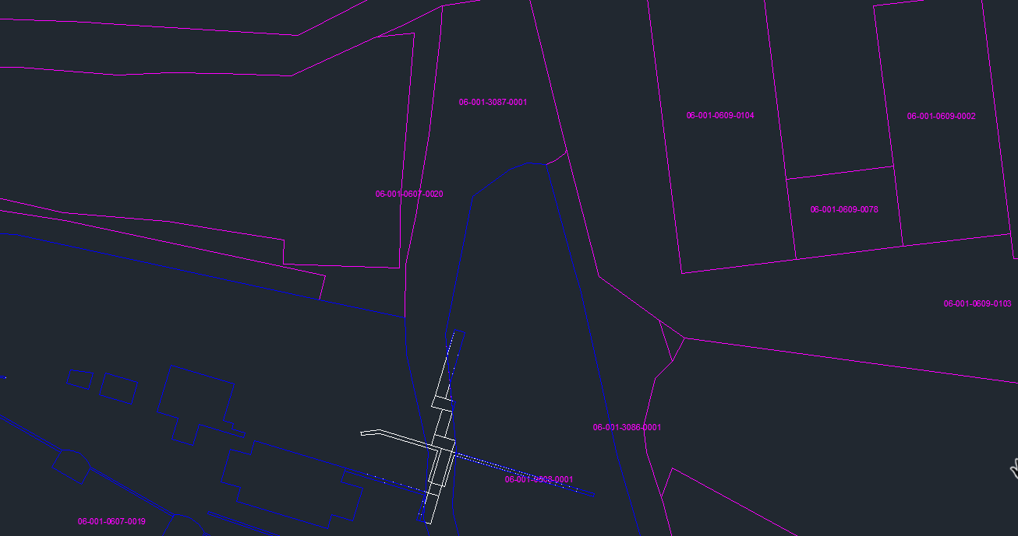
Map 1: Cadastral map
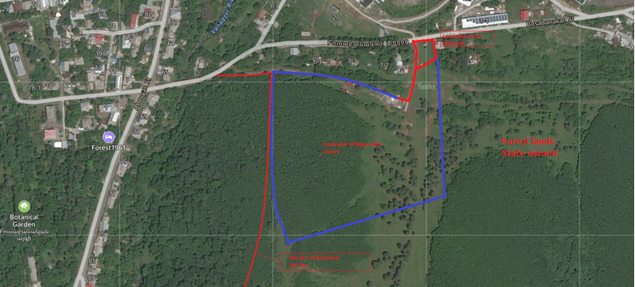
Map 2: Yandex map snapshot

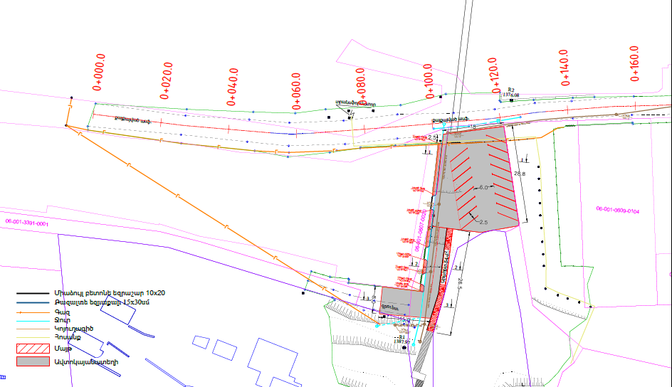
Map 3: Snapshot from the design
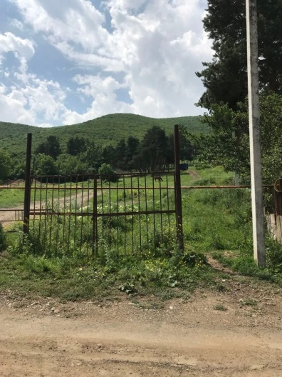  Picture 1. Entrance of the site | 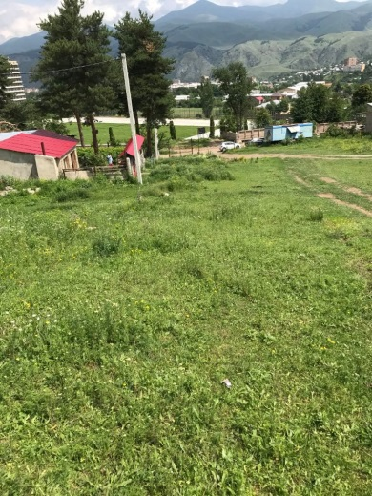  Picture 2. Land plot for the parking area | 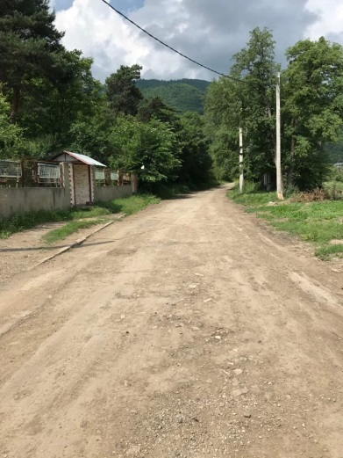  Picture 3. The leading road
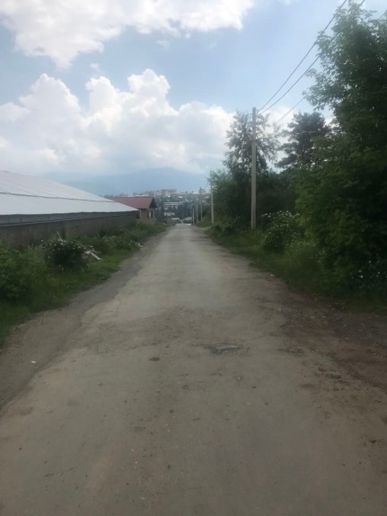  Picture 4. The sewer pipeline route | 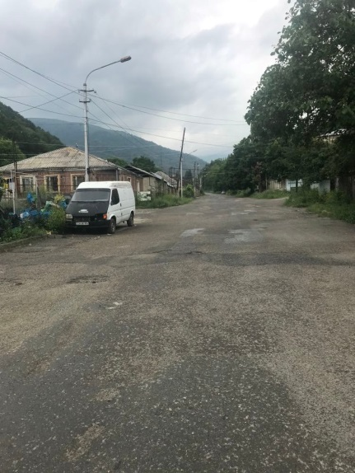  Picture 5. The sewer pipeline route | 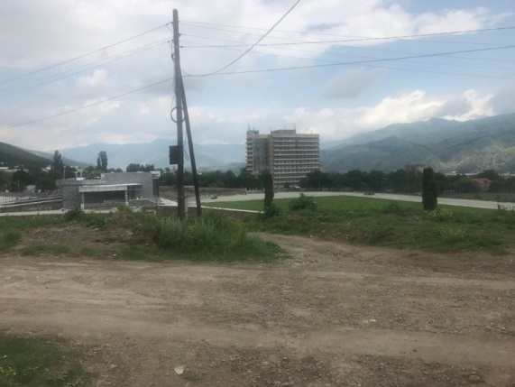  Picture 6. The Stadium

Attachment 2: Copy of permit for construction waste disposal
Summary of the above document
Construction waste generated during the construction works of external engineering infrastructures serving “Maymekh resort recreation and entertainment zone” should be transported to Taron 4, Tajiki district of Vanadzor city, the distance from which to the construction site is 12 km.

Attachment 3: Minutes of the public consultation on the draft ESMP
On October 12, 2023, a public consultation meeting was held in Vanadzor municipality with the participation of ATDF environmental and social specialists, the head of urban construction and architecture department of Vanadzor municipality, personnel of the municipality and Vanadzor residents. Overall, 10 people participated in the meeting, of which 7 were women.
The announcement of the public consultation was posted on the webpage of Vanadzor community on October 4, 2023.
Suren Abovyan, the head of urban construction and architecture department of Vanadzor municipality, opened the meeting and presented the purpose of the meeting and the concept of the subproject.
Marine Vardanyan, the ATDF informed the participants that the ATDF had prepared an Environmental and Social Management Plan (ESMP) for subproject “Construction of external engineering infrastructures serving “Maymekh Resort” recreation and entertainment zone”. The public consultation meeting is held in Vanadzor to disclose the draft ESMP to the community so that the community will be informed of the conducted activities, can raise their concerns and make suggestions. She noted that the ESMP includes all possible environmental, social, health and safety impacts and their mitigation measures to be implemented during the construction works.
Marine Vardanyan presented the expected temporary environmental and social impacts, including the generation and transportation of construction waste, noise and dust generation due to construction works. The safety measures to be provided were also presented, including the fencing of the construction site, installation of caution tapes in dangerous areas of the construction site and traffic management, as well as the safety signs installation requirements. The measures for safety of labor were presented, including uniform wearing and personal protective equipment, as well as the requirements on the supply of construction materials and maintenance of construction equipment. She mentioned that no negative social impacts are envisaged under the project, including involuntary resettlement or temporary land use during the construction period. The works will be carried out on community lands for which the community had provided agreement.
Armine Gabrielyan, the ATDF environmental specialist presented the environmental norms and regulations related to construction works. She mentioned that the envisaged works will not have any impact on protected areas or cultural monuments.
Armine Gabrielyan explained how the monitoring of compliance of the civil works to the requirements of the presented ESMP would be carried out.
The Grievance Redress Mechanism (GRM) of the LEID project was presented to the participants of the meeting. The ATDF safeguard specialists explained the necessity to have a GRM focal point in the municipality who will be responsible for GRM registration and submission to the ATDF.
Suren Abovyan was suggested and selected as a GRM focal point. The procedures of submitting Grievance, its registration in the provided GRM log, examining and reviewing the grievances were presented. It was mentioned that the information on the GRM should be posted on the information board of the Vanadzor administrative office and the subproject information board to be installed at the entrance of the construction site.
There were no questions related to environmental, social, health and safety impacts and their mitigation measures.
The photos are presented below.

Photos (not subject to publication)
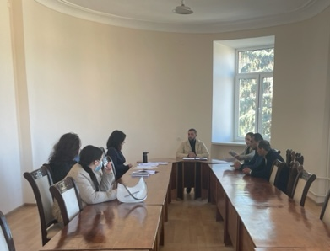  List of participants (not subject to publication)  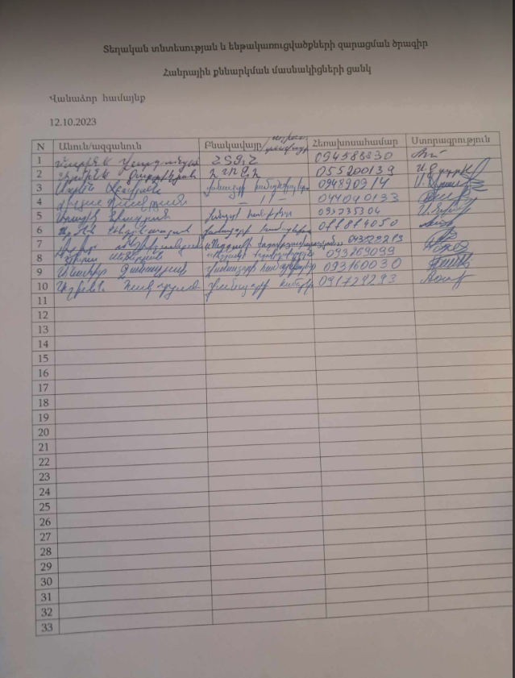 | 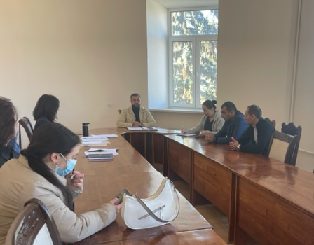

Attachment 4: Construction permit
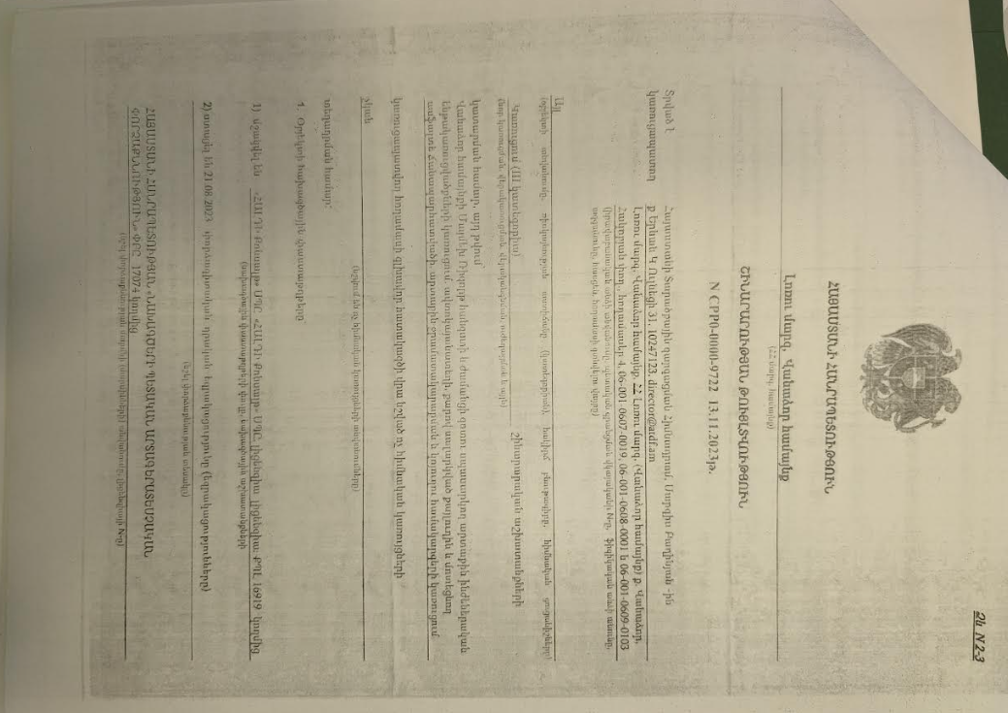

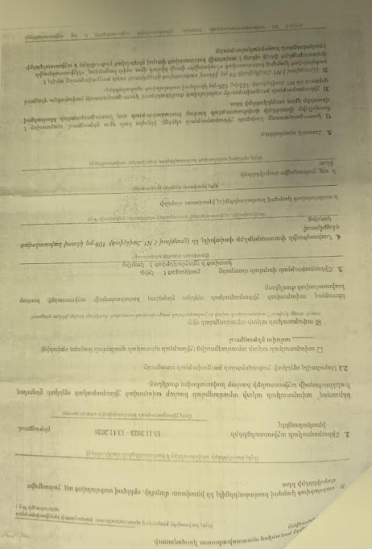
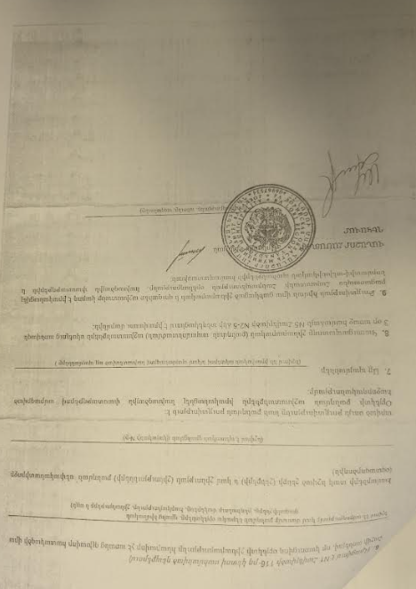

Summary of the above attached document:

Republic of Armenia
Lori Region, Vanadzor Community
Construction Permit NCPPO-0000-9722. 13.11.2023
This is given for the “Construction of External Engineering Infrastructures Serving "Maymekh Resort" Recreation and Entertainment Zone”.
The design documents are
1. Developed by “HALDI Consult” LLC, License 16919
2. The reconstruction will be implemented within 36 month.

A.Peleshyan Sealed/Signed

Toxic / hazardous material includes but is not limited to asbestos, toxic paints, noxious solvents, removal of lead paint, etc.

